Wong, Marvin Dale S. 11/19/2019

2ECE-A 31 ECE2112

Experiment 7

NUMPY

1. Normalization

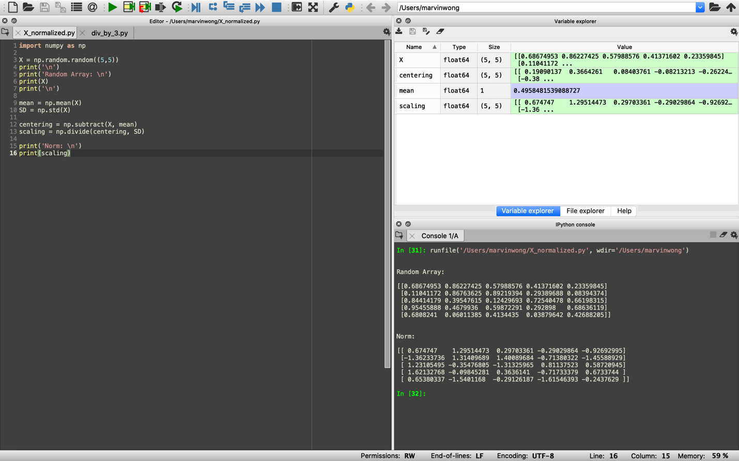

2. Divisible by 3

