Wong, Marvin Dale S. 11/19/2019

2ECE-A 31 ECE2112

Experiment 8

PANDAS

PROBLEM 1

First five rows of cars:

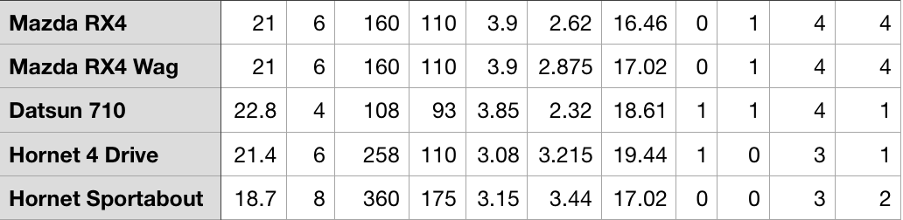

Last five rows of cars:

PROBLEM 2

a) df.iloc[0:5, [1,3,5,7,9,11]]

b) df[df[‘Model’]==’Mazda RX4’]

c) df.loc[[23],[‘Model’,’cyl’]]

Camaro Z28 has 8 cylinders.

d) df.loc[[1,18,28],[‘Model’, ‘cyl’, ‘gear’]]

Mazda RX4 Wag has 6 cylinders and a gear type of 4.

Honda Civic has 4 cylinders and a gear type of 4.

Ford Pantera L has 8 cylinders and a gear type of 5.