Proposal Guard → e-GP Tender-to-Fit OS
  - Project Preservation, Repair Strategy and Revised Development Plan
MOCK / DRAFT — pending_approval

My recommendation is to retain Proposal Guard as the main application, repair its existing decision and verification systems, and add a complete Bangladesh e-GP-specific feature set inside the same project.
We should not rebuild Proposal Guard from scratch, remove existing modules, or replace its architecture with a collection of independent AI agents.
The objective is to develop one integrated application that can discover e-GP opportunities, evaluate a company’s tender eligibility, identify missing evidence, support bid preparation, and produce traceable, human-approved decisions.

1. Review of the attached development plan
The attached plan is directionally sound. Its strongest decision is to separate mandatory eligibility from strategic opportunity scoring. It also correctly prioritizes source freshness, evidence verification, and human approval over generating more AI features.
I recommend four modifications to that plan:
- Make e-GP a dedicated feature domain, not a replacement for existing Proposal Guard functionality.
- Treat Release 011 as a repair candidate, because your earlier terminal output confirms 34 passing tests twice, but does not yet establish that the patched files have been integrated into this attached project.
- Move preservation and compatibility verification ahead of further changes. Every existing component, route, workflow, database record, report, and export must be accounted for.
- Build complete e-GP functionality in stages, with manual official-document import available independently of automated tender discovery.
The attached plan identifies the relevant services and describes three previous safety failures.

2. The architecture we should preserve and extend
PROPOSAL GUARD
Existing application, components, workflows and data preserved

↓
Existing core  Sources, documents, scoring, verification, workflow, reporting and export | New e-GP domain  Tender intake, company profiles, qualifications, matching and bid readiness
↓
Shared evidence and approval controls
Source versions → Eligibility rules → Verification → Human approval → Controlled outputs

This is a proposed target architecture, not a claim that every displayed component is already implemented.
Archive inspection limitation: I have been able to review the attached Markdown plan and your Release 011 test logs, but the local archive inspection tool returned an error when attempting to open `Proposal Guard (2).zip`. Therefore, I cannot yet honestly certify a file-by-file audit of the ZIP, its complete dependency graph, or whether the patched services are present in that copy.
The technical recommendations below distinguish documented functionality from proposed additions.

3. Current components: preservation and repair matrix
Based on the service names in the plan and Release 011 logs, these are the primary areas to retain. File existence and exact behavior still need confirmation against the ZIP.
Existing component | Preservation decision | Required repair or extension
bid_score_service.py | Preserve | Separate mandatory eligibility and opportunity scoring
verification_service.py | Preserve | Require valid evidence; reject stale verification
source_service.py | Preserve | Add document versioning, hashing and amendment detection
workflow_service.py | Preserve | Enforce approval gates and freshness checks
report_service.py | Preserve | Generate e-GP-specific eligibility and gap reports
export_service.py | Preserve | Prevent unapproved reports from appearing client-ready
Existing UI/screens | Preserve | Add e-GP pages without removing current functionality
Existing data storage | Preserve | Add versioned e-GP data structures and safe migrations
Existing tests | Preserve | Add e-GP regression tests alongside existing tests

The plan should explicitly prohibit deleting or silently renaming existing modules, replacing API contracts, dropping database fields, or changing historical approvals.

Release 011 assessment
Your supplied results show:
- Initial run: 34 tests passed.
- Independent rerun: 34 tests passed.
- Both runs exited successfully.
- Changes were prepared in a temporary development copy.
That is encouraging evidence for Stage 0 safety remediation, but it is not a complete integration certification.
Release 011 disposition: candidate for controlled integration, subject to source diff, compatibility, and full regression verification.

4. What a complete e-GP feature should contain
I recommend one integrated e-GP Tender Intelligence & Bid Readiness module, containing eight functional areas.
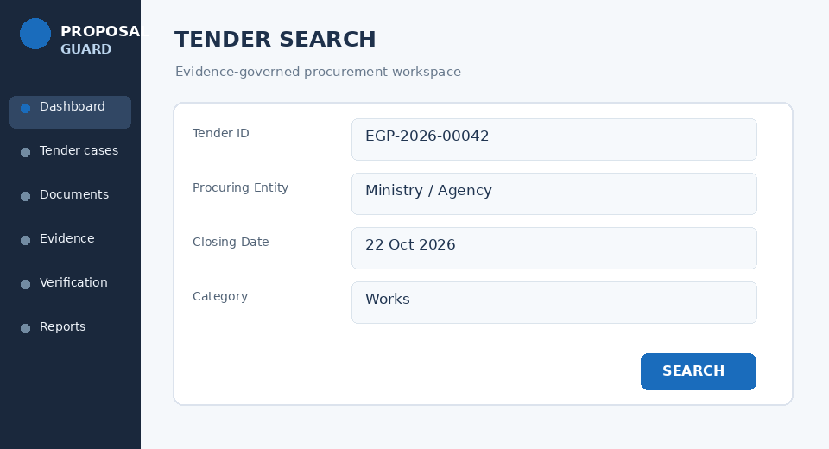 | 01 — Official e-GP Tender Intake  Import tender ID, reference number, procuring entity, procurement method, published date, deadline, and official documents. Support manual import first, plus authorized automated retrieval when validated.

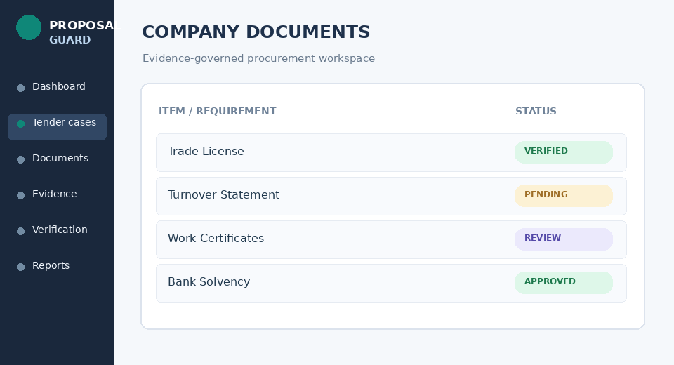 | 02 — Company Qualification Vault  Store company registration, financial capacity, historical turnover, similar work experience, personnel, equipment, bank facilities, certificates, and supporting records. Include expiry dates and evidence verification.

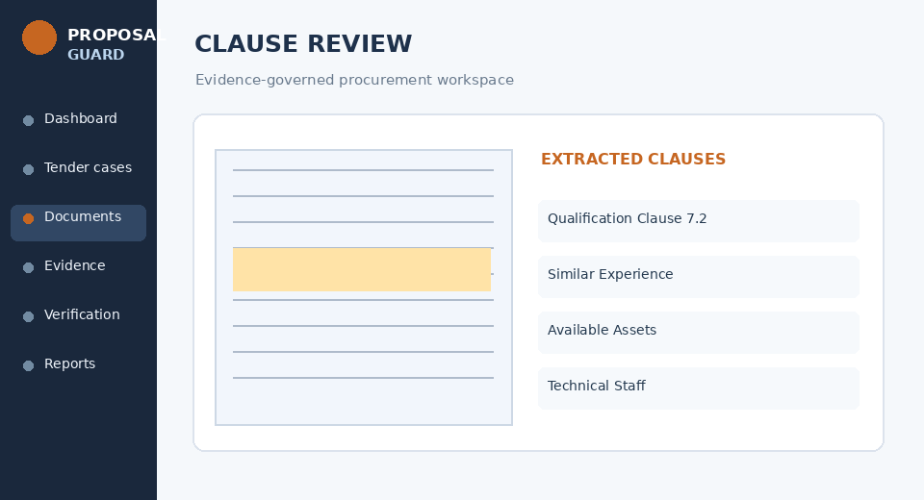 | 03 — Tender Document & Clause Analyzer  Extract qualification requirements from uploaded e-GP documents. Every extracted rule needs its source, page or clause, value, unit, and confirmation status. AI suggestions must be reviewable.

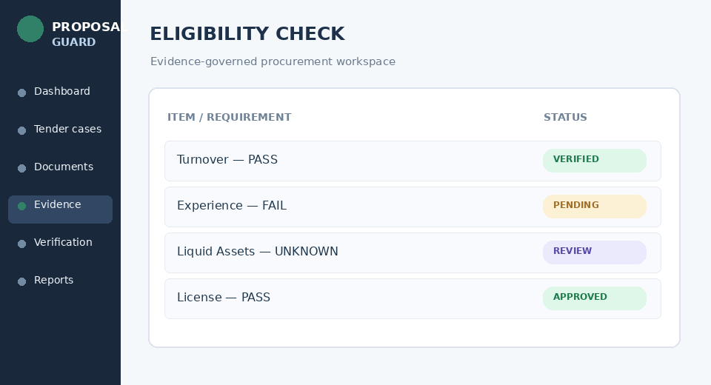 | 04 — Deterministic Eligibility Engine  Compare tender requirements with the company’s verified evidence. Separately assess mandatory criteria, missing documentation, and strategic attractiveness.

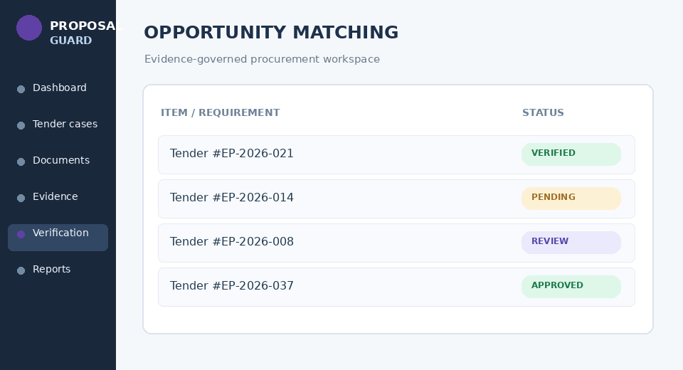 | 05 — Tender-to-Fit Matching  Rank relevant tenders by eligibility, sector, location, capacity, time remaining, and commercial fit. A high score cannot override a failed qualification.

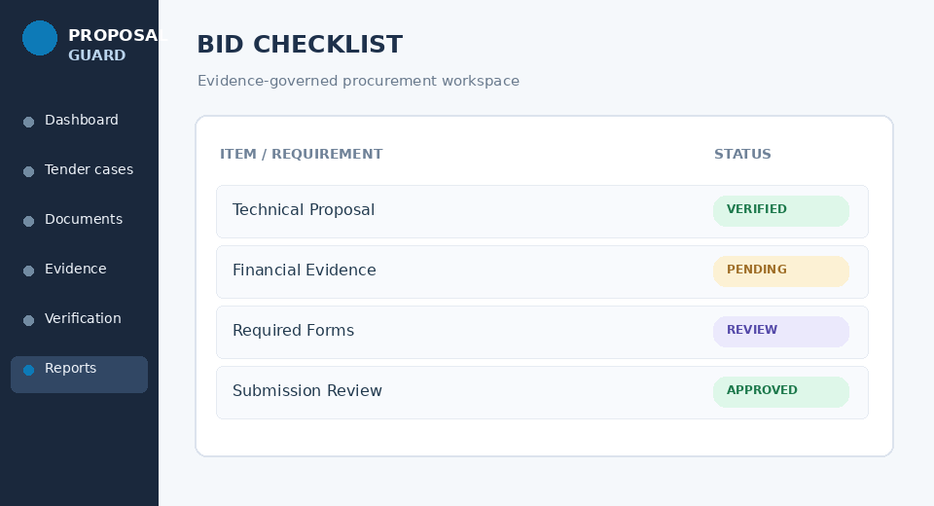 | 06 — Bid Readiness Workspace  Track required forms, documentary evidence, technical requirements, financial attachments, clarifications, and responsible reviewers. Reuse existing tasks, workflow and verification services.

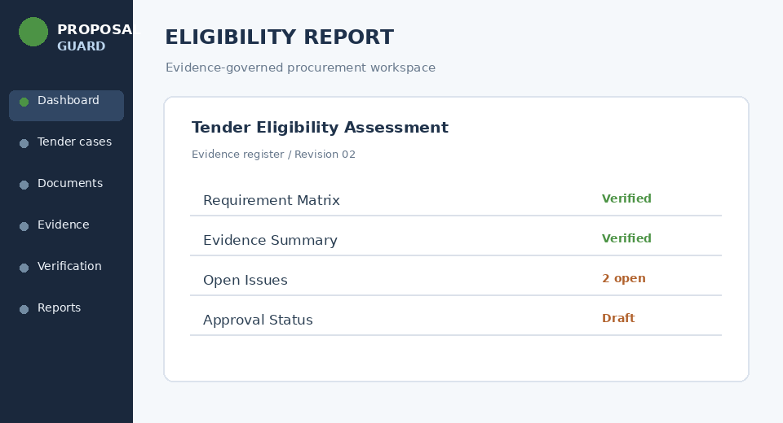 | 07 — Evidence-Based Reports and Exports  Produce eligibility matrices, risk reports, gap lists, deadline checklists, bid/no-bid assessments, and evidence inventories. Clearly label draft versus approved results.

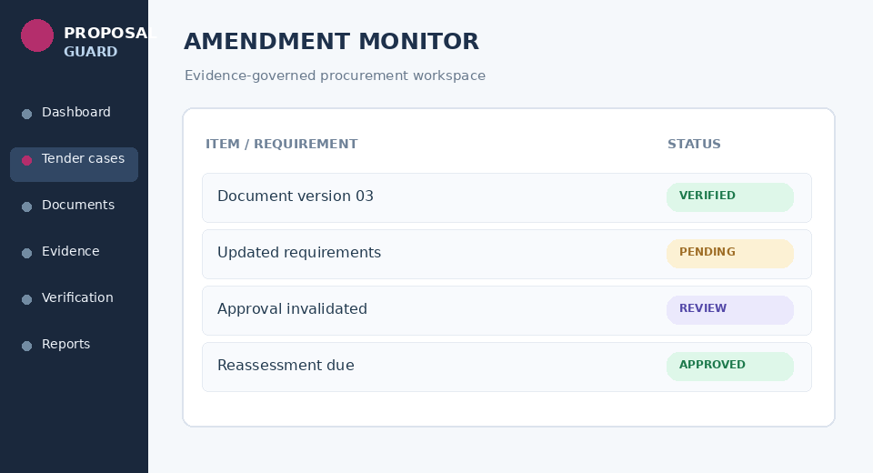 | 08 — Amendment Monitoring and Approval Control  Monitor revised tender documents, addenda, deadline changes, and other relevant source updates. Trigger reassessment and invalidate dependent decisions when required.

These images illustrate the intended interface types; they are not screenshots of your current application.

Official e-GP sources and regulatory boundaries
I checked the Bangladesh e-GP and BPPA websites. They support the feasibility of an e-GP-specific solution:
- Official advanced eTender/eProposal search includes tender identification, procurement categories, procuring entities and publication/closing-date filters. https://eprocure.gov.bd/resources/common/AllTenders.jsp?lang=bn_IN
- Official eExperience search provides work-history-related fields relevant to qualification checks. https://eprocure.gov.bd/resources/common/SearcheCMS.jsp?v=advSearch
- Official eContracts search exposes award and contract search information. https://eprocure.gov.bd/resources/common/AdvSearchNOA.jsp
Importantly, PPR 2025 became effective on September 28, 2025. Therefore, the new e-GP domain must be designed for current procurement rules and applicable tender-specific eSTDs, not hard-coded around older procurement assumptions.
The public search pages do not themselves prove the existence of a supported programmatic API. Until permitted, reliable retrieval is established, manual upload and operator-assisted import should remain fully functional.
The new feature should support bid preparation and review inside Proposal Guard. It should not claim to submit bids directly to e-GP, automate credentials, bypass CAPTCHA, or perform authenticated portal actions without separately verified authorization and integration support.

5. Repair the decision engine before expanding it
The most important architectural change is a deterministic, evidence-governed eligibility engine.
Official e-GP tender + verified company profile

↓
Requirement-by-requirement evaluation

↓
PASS  Fully verified | FAIL  Mandatory gap | UNKNOWN  Evidence missing
↓
Verification and human approval gate
Only fully verified, current decisions can receive positive bid clearance

Recommended precedence:
Eligibility | Recommendation | Workflow outcome
Verified PASS | PURSUE or REVIEW based on fit | Await human approval
Confirmed FAIL | DO_NOT_PURSUE | Positive clearance prohibited
UNKNOWN | REVIEW | Evidence blocker
Source amended | Reassessment required | Previous clearance invalid
Approval missing | No release clearance | Draft only

A source amendment should invalidate the affected checks and every decision that depends on them, while preserving earlier records for audit.

Implementation details that matter
The engine needs to distinguish numeric comparisons, dates, document completeness, experience type, legal qualification, and tender-specific exceptions. `NOT_APPLICABLE` must require an explicit reason; it must never become an automatic pass.
For example, a BDT 3 crore minimum turnover requirement can be evaluated mathematically only when the correct accounting period, verified turnover figure, and applicable tender clause are known.

6. Revised implementation roadmap
The original six-stage plan should be reorganized into seven approval-gated releases. This avoids treating the entire e-GP system as one large, difficult-to-verify change.
Release | Priority | Deliverable | Verification gate
011A — Preservation | P0 | Inventory, backups, Release 011 diff and baseline | Existing components and data preserved
012 — Safety Integration | P0 | Mandatory blockers, source freshness, approval controls | Negative and regression tests pass
013 — e-GP Foundation | P1 | Tender intake, identifiers, official sources, company profiles | Reliable manual import and provenance
014 — Eligibility Engine | P1 | Clause matrix, evidence matching, deterministic qualification | No unsupported PASS
015 — Bid Readiness | P1 | Gap analysis, matching, tasks, checklist, deadlines | End-to-end pilot passes
016 — Reporting & AI | P1 | Evidence-based reports, optional AI extraction | Human benchmark and approval
017 — Source Automation | P2 | Authorized e-GP monitoring, amendments, alerts | Reliability, compliance and freshness tests

The complete target feature set is Release 017; Releases 012–015 establish the essential usable e-GP workflow.

Proposed extensions inside the current project
The exact directory layout must first be confirmed. Using the existing `tenderproof` service pattern as an architectural reference, I would add an isolated e-GP feature domain instead of redesigning the core:
tenderproof/
services/
bid_score_service.py # Preserve + repair
verification_service.py # Preserve + repair
source_service.py # Preserve + extend
workflow_service.py # Preserve + verify
report_service.py # Preserve + extend
export_service.py # Preserve + extend
egp/
tender_intake_service.py
tender_document_service.py
company_profile_service.py
qualification_service.py
tender_matching_service.py
bid_readiness_service.py
amendment_service.py
tests/
test_release_011.py
test_egp_intake.py
test_egp_eligibility.py
test_egp_workflow.py
test_egp_regression.py
These are proposed names, not confirmed existing paths. Actual package placement and API integration should follow the inspected repository’s architecture.

7. Data preservation and integration requirements
The new e-GP domain should add records without destructively changing old ones.
Proposed additions include `EGPTender`, `EGPTenderDocument`, `CompanyQualificationProfile`, `EligibilityRequirement`, `EligibilityAssessment`, `EvidenceLink`, `TenderAmendment`, and `BidReadinessRecord`.
Each new record should have traceable relationships to the existing case, document, task, evidence, and verification models wherever equivalent records already exist. Avoid duplicating their responsibility.
For safety:
- Back up the complete project and persistent storage before applying changes.
- Use additive, versioned database migrations with rollback checks.
- Preserve original source documents and record SHA-256 hashes.
- Record assessment versions and the exact evidence snapshot used.
- Keep historical approvals, but prevent their reuse against changed source versions.
- Test report and export consumers after every model change.
These safeguards are particularly important because a successful test run in a temporary development copy does not verify the original project’s database state.

8. Proposed end-to-end e-GP acceptance test
An example, using synthetic data:
Sample tender assessment
MOCK
Bangladesh e-GP works tender — illustrative criteria, not an actual tender.

Requirement | Minimum | Verified company | Result
Annual turnover | Tk 3 crore | Tk 5 crore | PASS
Similar experience | Tk 2 crore | Tk 1 crore | FAIL
Liquid assets | Tk 50 lakh | Not provided | UNKNOWN
Required certificate | Valid | Valid | PASS

Strategic attractiveness: 91/100
Eligibility clearance: NOT ELIGIBLE
Expected result: DO_NOT_PURSUE
The system must explain the confirmed mandatory failure, separately identify missing evidence, prevent a positive bidding clearance, and create an auditable report.

The complete integration test should also verify that uploading an amended tender document triggers reassessment, that the earlier approval cannot authorize a new client-ready export, and that unrelated existing Proposal Guard cases remain unchanged.

9. Approval and next-action checklist
Proposed verification tasks
☐ Inventory all project files, modules, UI screens, dependencies and persistent data
☐ Compare Release 011 patched files against the current project
☐ Create and verify a restorable project and database backup
☐ Integrate safety repairs without removing existing components
☐ Run full tests and verify old UI and API workflows
☐ Implement e-GP tender intake and company profile storage
☐ Implement deterministic eligibility and source-linked evidence
☐ Implement matching, bid readiness, reports and approval gates
☐ Validate authorized official-source automation and pilot acceptance
Copy verification checklist
Checkboxes are for planning and manual tracking; marking them does not verify that code changes or tests have been completed.

Final recommendation
Keep the current Proposal Guard application intact and evolve it into Proposal Guard with a complete e-GP Tender-to-Fit module.
The next approval should cover Release 011A — Preservation and Integration Audit, not unrestricted implementation of all features.
The approval status remains `pending_approval`. Once the archive can be inspected and the preserved baseline is demonstrated, the next controlled deliverable should be a file-level implementation manifest identifying exactly which files to retain unchanged, repair, extend, or add—without sacrificing existing functionality.
This is the lowest-risk path toward a functional e-GP-specific system while preserving the investment already made in Proposal Guard.

