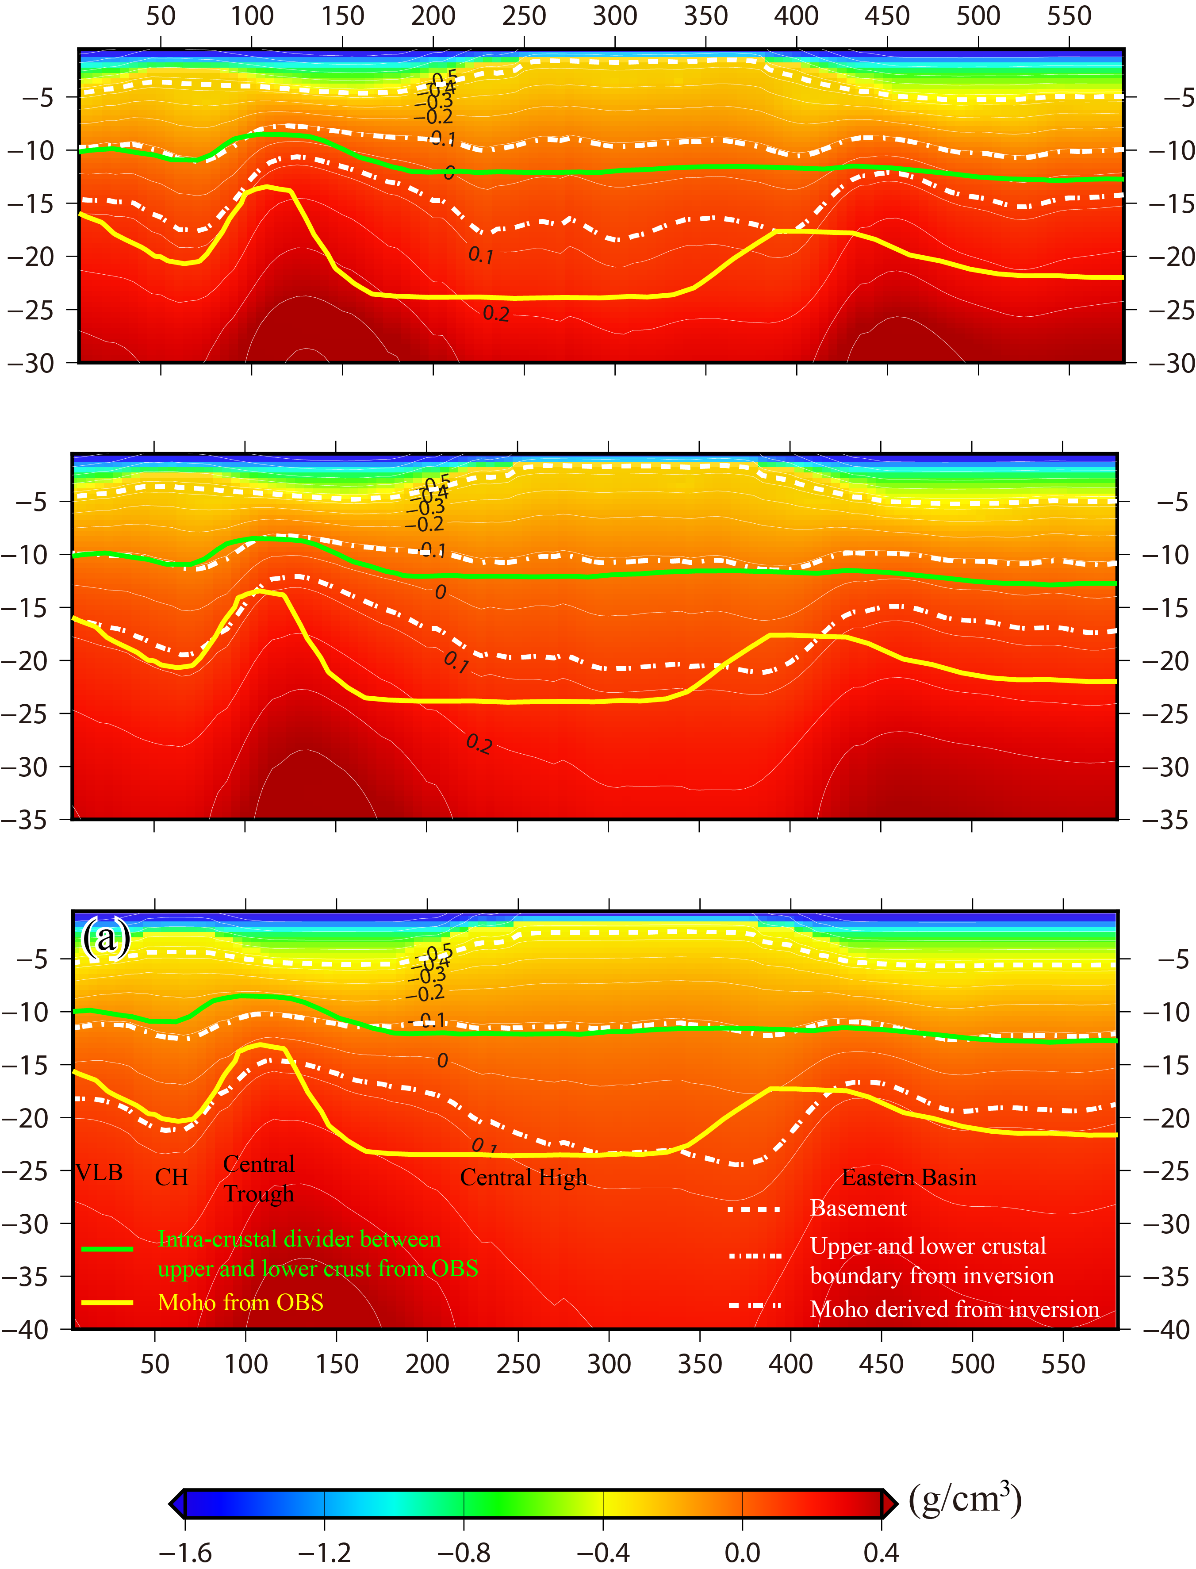
Fig. S1. Cross-sections of the inverted 3-D density anomaly model along the ACRUP profile using different mesh depths of 30 km, 35 km and 40 km. According to the Moho and intra-crustal diver.
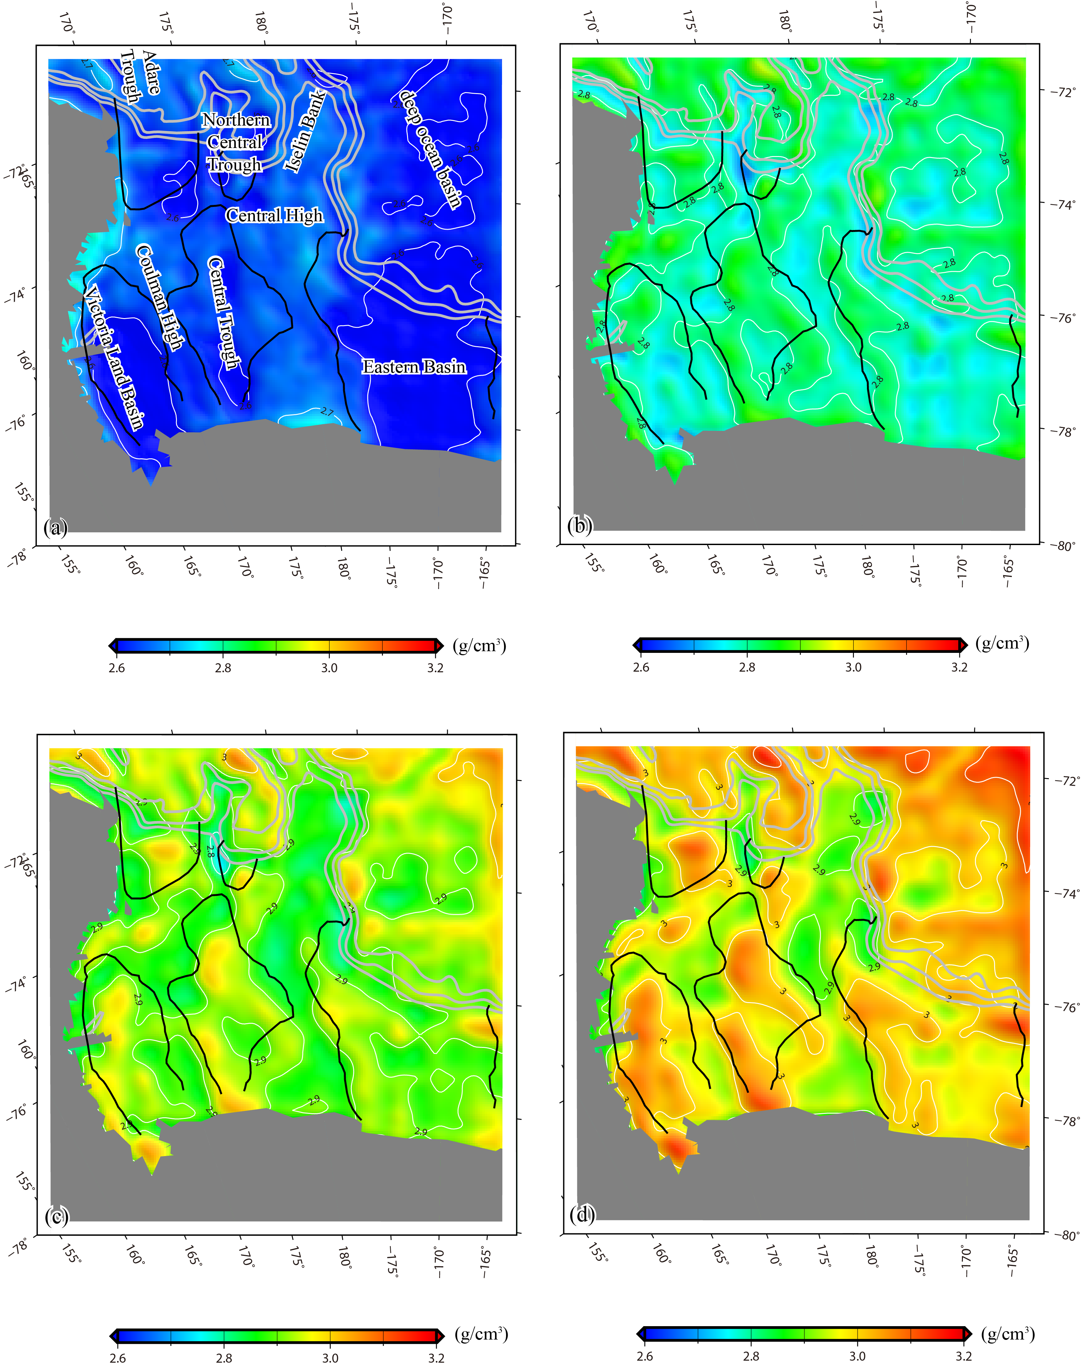
Fig. S2. Average crustal density variations estimated from final inverted 3D density anomaly model at 5-10 km (a), 10-15 km (b), 15-20 km (c), 20-25 km (d).

