

*Geophysical Research Letters*

Supporting Information for

**[Bathymetry beneath ice shelves of western Dronning Maud Land, East Antarctica, and implications on ice shelf stability]**

H. Eisermann1, G. Eagles1, A. Ruppel2, E. C. Smith1 and W. Jokat1,3

1Alfred-Wegener-Institute, Bremerhaven, Germany.

2Federal Institute for Geosciences and Natural Resources, Hannover, Germany

3Department of Geosciences, University of Bremen, Bremen, Germany.

**Contents of this file**

Text S2

Figures S1 and S2.1, S2.2, S2.3

**Introduction**

Supporting Information S1 shows the sea level equivalent of ice in the catchment area of the Ekström, Atka, Jelbart, Fimbul and Vigrid ice shelves (Figure S1).

Materials and methods for bathymetry modeling are outlined in more detail in Supporting Information S2. This includes description of gravimetric, magnetic and ice thickness radar data acquisition, as well as the 3D modeling of gravity data for bathymetry beneath the ice shelves. A detailed error estimation of models is given in the end.

Supporting Information S1: Catchment area in western Dronning Maud Land

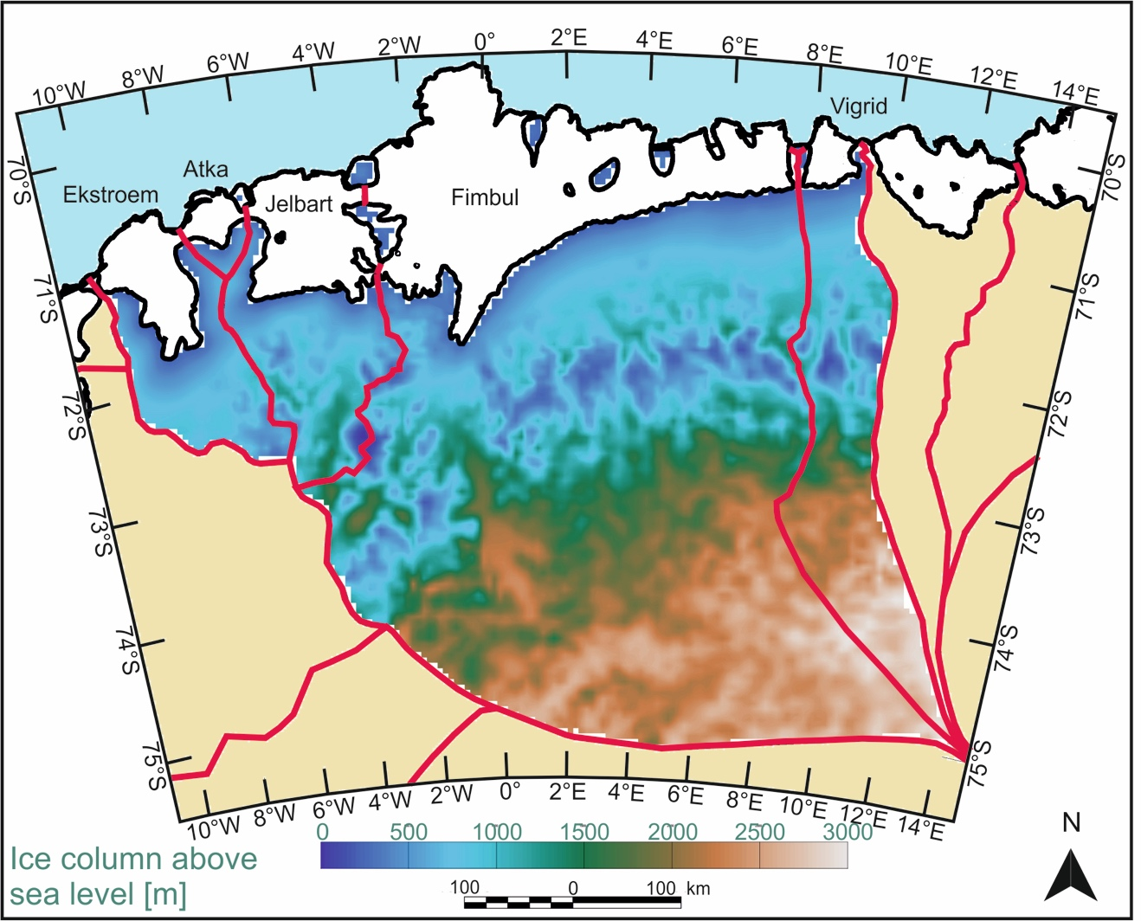

**Figure S1** Ice divides (red), grounding lines and calving fronts (black) of ice shelves in western Dronning Maud Land after Mouginot et al. (2017a). Beige: grounded ice outside the wDML catchments; white: ice shelves; blue: ocean. The gridded data set shows the height of the ice column above sea level, whose loss as water to the ocean would contribute to a rise in sea level. These thicknesses are inferred from AWI radar data (Riedel et al., 2012) and ice surface elevation from Howat et al. (2019). The catchment area is 260,000 km2 and the mass of the ice held above sea level is 341,000 Gt. The sea level equivalent of this mass is ~0.95 m.

Supporting Information S2: Materials and Methods

**S2.1 Ice thickness radar data**

The radar system uses two short backfire antennae and operates with a 150 MHz signal burst with durations of 60 or 600 ns. To calculate ice thicknesses, a perpendicular radar wave propagation is assumed and ice thicknesses are determined with the average radar wave propagation speed in ice of 1.68 *10^8 m/s. A firn correction is applied to account for higher velocities within the upper layer of an ice sheet (Blindow, 1994). For the determination of ice thicknesses an error estimate of +/- 20 m is defined; this estimate includes the user variability in picking reflectors and inaccuracies of 0.5 % concerning propagation speed. The calculated ice thicknesses are subtracted from the Reference Elevation Model of Antarctica (REMA) of Howat et al., 2019, to determine the base ice position. Ice thicknesses from VISA campaigns are incorporated from Riedel et al. (2012).

**S2.2 Magnetic data**

Airborne campaigns across Dronning Maud Land included magnetic data acquisition using Scintrex Cs-2 (VISA campaigns, Riedel et al., 2013) and Scintrex Cs-3 (GEA campaign) cesium magnetometers. A base station magnetometer was used to subtract the diurnal variations of the magnetic field and generated a consistent grid using tie-line leveling techniques (Figure 2d). The mean error at line-intersections during VISA campaigns is 8.8 nT with a standard deviation of 7.3 nT (Riedel et al., 2013). The GEA campaign has a mean error of 0.2 nT above the Ekström and Atka ice shelves with a standard deviation of 7.4 nT.

**S2.3 Gravity data**

Gravity data sets handled in this paper were acquired with two different gravimeters. The airborne gravimeter GT-2A (S/N 012) was implemented during the GEA campaign that covered the Ekström, Atka and part of the Jelbart Ice Shelf. The GT-2A system is decoupled from aircraft motion noise by a shock mount and GPS- and gyro-assisted adaptive orientation systems. The sampling rate is 2 Hz. A spatial resolution of 3.5 km is achieved with a GPS filter length of 100 s and a flight speed of 70 m/s.

A ZLS Ultrasys modified LaCoste & Romberg Air/Sea gravimeter (S/N 56) was used during the VISA campaigns across the Jelbart, Fimbul and Vigrid ice shelves. It was affixed using gimbal locks and recorded gravity data with a lower sampling rate of 1 Hz. A GPS filter length of 180 s combined with flight speeds of 70 m/s results in a spatial resolution of 6.3 km (Riedel et al., 2012). A repeatability experiment flown in 2014 shows that the RMS error in estimated gravity free air anomalies with the GT-2A system is 0.52 mGal (Figure S2.1). The ZLS Ultrasys gravity meter is more limited, with an RMS error of 4.3 mGal and a standard deviation of 5.2 mGal on crossover analysis of the VISA dataset (Riedel et al., 2012). The differing data quality implies contrasting bathymetry model uncertainties.

General processing steps of gravity data included cutting flight lines into straight segments; removing turns (both meters) and significant changes in altitude (ZLS meter) to eradicate artificial gravity anomalies. The measured gravity anomaly data are corrected for aircraft motion effects using differential (GT-2A meter) and precise-point-positioning (ZLS meter) processed GPS data, for latitude, instrument drift, and flight level to obtain the free air anomaly (FAA, Figures 2 and 3). FAA data above the Jelbart Ice Shelf are compiled from both campaigns, using the GEA flight lines as tie-lines to level the VISA dataset in a statistical levelling process.

**S2.4 Bathymetry modeling**

The presented bathymetry models are based on iteratively matching model gravity responses to the observed gravity data. The gravity responses are to theoretical ice, water, rock and subsurface bodies that are designed on the basis of independently-observed constraints from ice thickness radar data, shipborne bathymetry along the calving fronts, and seismic reflection data beneath Ekström and Fimbul from Smith et al. (2020) and Nøst (2004), respectively. The gravity anomaly inversions use a 3D modeling approach implementing methods introduced by Parker (1972).

Where available, reference points beneath the ice shelves extracted from seismic data sets, swath bathymetry and ice thickness radar data in grounded areas are used to generate very coarse starting assumptions about the expected wavelengths and orientations in sub-ice bathymetry. The gravity data are then filtered to discard features that do not match these assumptions on the assumption that they are primarily of non-bathymetric (i.e. geological) origin.

In this way, we prepared FAA data for the Ekström and Atka ice shelves using a high-pass filter of 70 km and directional filtering using a cosine function to suppress wavelengths trending N45°E, the strike of seaward-dipping basalt bodies developed across Ekström and identified in seismic reflection data by Kristoffersen et al. (2014). The directional filtering improves the overall resemblance of gravity data to bathymetric data known from sparse seismic profiles (Figures 2b and 2c).

Gravity anomaly data over the Fimbul and Vigrid ice shelves were band-pass filtered with a lower flank of 6 km and a high flank of 150 km (Figure 3d). The filter was directionally isotropic. The 6 km short cutoff was designed to suppress short-wavelength artefacts induced by aircraft motion in the ZLS data set, whose highest resolution is nominally at 6 -7 km (Riedel et al., 2012). Compiled free air anomaly data above the Jelbart Ice Shelf are similarly band-pass filtered with a lower flank of 6 km and a high flank of 100 km (Figure 3b), reflecting the mixture of gravity meters used during the VISA and GEA campaigns. No distinct geological strike angle can be inferred beneath the Jelbart or Fimbul ice shelves, and therefore no directional filters are applied.

Geosoft’s module *GM-SYS 3D* software is used to generate the bathymetry models. Positions of ice surface and ice base in the modeled area are extracted from RES data. The bathymetry is known at constrained points through seismic (Nøst, 2004, Smith et al., 2020), multibeam and radar data in grounded areas (Figure 1b, 2c and 3e). We have assigned a model base of -10 km and constant densities of 915 and 1030 kg/m3 for ice and water, respectively. A DC shift to the gravity anomaly data is applied using these constraints with a typical density value for the upper crust of 2670 kg/m3. The remaining gravity residuals are used to calculate varying crustal densities at constraints, which are subsequently interpolated across the whole model area (Figure S2.2). This approach appears reasonable where constraints are not further apart than 15 km. Using only every other reference point beneath the Fimbul Ice Shelf during bathymetry modeling (roughly equaling 30 km distance), resulted in uncertainties of up to +/-100 m at reference points not considered during the modelling process. In areas with sparse or no constraints (south and east of Fimbul, Jelbart and Vigrid ice shelves) density values are extrapolated using similarities in magnetic signatures of constrained areas: Jurassic intrusions inferred from magnetic data correlate quite well with relatively high densities in constrained areas (Fig S2.2). Nonmagnetic areas with magnetic anomalies around 0 nT show similar densities in constrained areas as well. The density models work well within the context of forward modelling the bathymetries, but should not build the basis for a geological interpretation. A DC shift, directional and high-pass filters applied to the gravity data certainly eradicated sub-surface structures that are not represented in these density models. The main emphasis was to locate relative density changes within this area to allow fur a successful modeling process.

Estimated errors for the generated bathymetry models stem from instrumental inaccuracies and uncertainties within the modeling process. Gravity data quality, ice thickness estimation errors, unconstrained geological variations and the difference from observed to calculated gravity anomalies are considered and result in error envelopes of ±175 m for the Ekström and Atka ice shelves, ±225 m for the Jelbart Ice Shelf and ±210 m for the Fimbul and Vigrid ice shelves. The following section considers the error envelope in more detail.

S2.5 Error estimation of 3D Models

The error envelope in generated bathymetry models arises from instrumental inaccuracies in data acquisition, limitations during data processing and uncertainties within the modeling process. Different data qualities suggest there should be contrasting error estimates for the Ekström and Atka ice shelves (GT-2A), the Jelbart Ice Shelf (compilation of GT-2A and ZLS data), and Fimbul and Vigrid ice shelves (ZLS Ultrasys system). Crossover errors give an indication of the meters’ performance under Antarctic field conditions. Riedel et al. (2012) showed a standard deviation (SD) at intersections of 5.2 mGal in the gravity data acquired with the ZLS Ultrasys system. For the GEA survey in 2015/2016 covering Ekström and Atka ice shelves, the standard deviation at intersections amounts to 2.4 mGal. The gravity data above the Jelbart Ice Shelf is a compilation of both data sets and owns a standard deviation of 5.8 mGal. A higher standard deviation compared to the VISA dataset is most likely due to differing along-track resolutions of the two meters, resulting in higher crossover errors, especially in regions with a high gravity gradient.

Along-track resolution and line spacing are great indicators on how good the inversion can be at best, when compared to the actual bathymetry. Cross-track interpolation might induce gridding artefacts impairing generated bathymetry models and along-track resolution highly depends on acquisition parameters. Since the along track-resolution of GEA gravity data and VISA data are 3.5 km and 6.3 km with line spacings of 2 - 5 km and 5 - 10 km, respectively, the final bathymetry model will be supplied with a resolution of 5 x 5 km grid cells as a representation on how good the generated bathymetry model can be.

Errors in ice thicknesses estimated from radio echo sounding data are ±20 m. These errors occur at points used for calibration of the gravity models and thus their effects have the potential to propagate widely within the resulting bathymetric models. The density contrast between ice and water (115 kg/m3) is significantly lower than the density contrast between water and the mean density of rock (1640 kg/m3) so that, by careful choice of an equal mixture of calibration points in both grounded and free-floating ice, RES-based ice thickness errors translate to about ±10 m uncertainty in the final bathymetry model.

Further model uncertainties may arise from unrecognized geological variations. We relied on magnetic data to make assumptions about geologic variations and take account of them, but some variability is certain to persist. We account for this in our error envelope by assuming the presence of residual density contrasts of +/- 100 kg/m3 compared to the generated density model. Changing densities by this factor in areas with various depths led to mean gravity residuals of 9 mGal.

The availability of seismic reference points improves the reliability of bathymetric models significantly. Smith et al. (2020) estimate errors of about ±35 m in their seismically-determined bathymetry beneath the Ekström Ice Shelf. Nøst (2004) estimated an envelope of ±70 m for the bedrock elevation beneath the Fimbul Ice Shelf. Only the stations of seismic point reflection data are used, where a clear ice base and seabed has been identified to limit inaccuracies inflicted in these seismic references. While modeling, depth reference points are limited to move within their corresponding error envelopes.

It can be argued that the water-seabed interface is the biggest contribution to model inaccuracies due to its relatively high density contrast of 1640 kg/m3 (assuming a mean bedrock density of 2670 kg/m3) compared to a low density contrast at the ice-water interface (115 kg/m3). A Bouguer slab calculation using the density contrast of the water-seabed interface is performed after combining the following uncertainties.

The standard deviations of gravity residuals (Fig S2.3) between the calculated and observed gravity anomalies across the ice shelves (2 mGal for Ekström and Atka; 3 mgal for Jelbart, Fimbul and Vigrid) are smaller than the crossover errors (2.4 mGal at the Ekström and Atka ice shelves, 5.8 mGal at the Jelbart and 5.2 mGal at Fimbul and Vigrid ice shelves). The standard deviations at crossovers can thus be taken as the most conservative estimates of likely error in the gravity data and added to the expected errors due to unconstrained densities (9 mGal). Based on the Bouguer slab method, and after combination with the RES-based ice thickness uncertainties, the models are thus likely to be uncertain within ±175 m beneath the Ekström and Atka ice shelves, ±225 m beneath the Jelbart Ice Shelf and ±210 m beneath the Fimbul and Vigrid ice shelves.

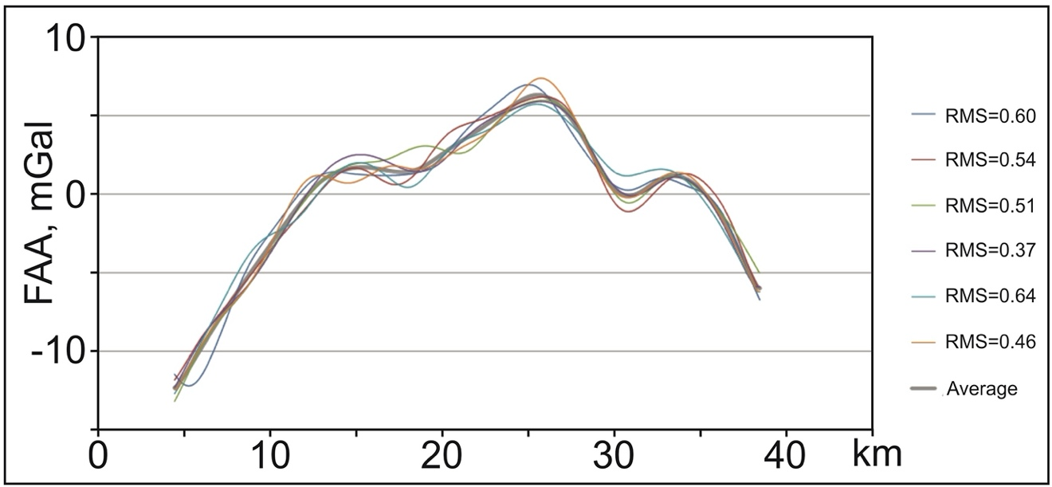

**Figure S2.1** Repeatability experiment with the GT-2A gravimeter setup flown in 2014 close to Bremerhaven, Germany. One profile with a length of about 35 km is flown six times and resulted in an average RMS error value of 0.52 mGal.

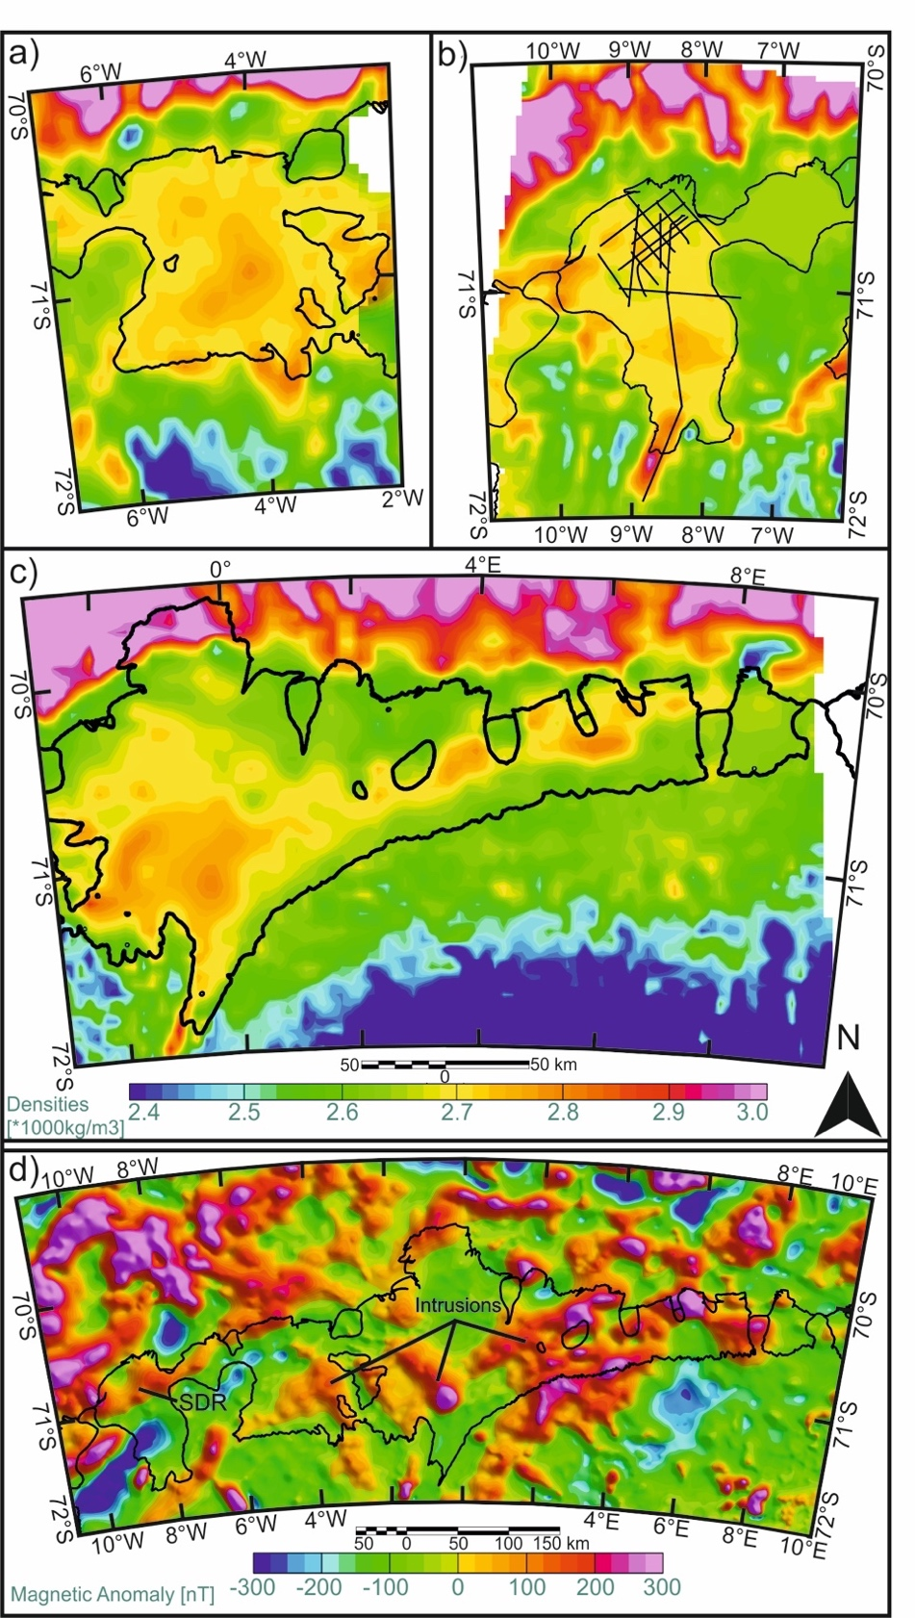

**Figure S2.2** Densities inferred during 3D modeling for (a) Jelbart, (b) Ekström and Atka ice shelves and (c) Fimbul and Vigrid ice shelves, showing a high correlation to the magnetic data (Mieth and Jokat., 2014; Golynsky et al. 2018) in (d). Jurassic intrusions in (d) can be correlated quite well to higher densities in the density models (a-c). The seaward dipping basalts beneath the Ekström Ice Shelf (labeled ‘SDR’ here and depicted in high-resolution magnetic data in Fig. 2d) are not reflected in the density map, due to their suppression by the directional pre-processing filter.

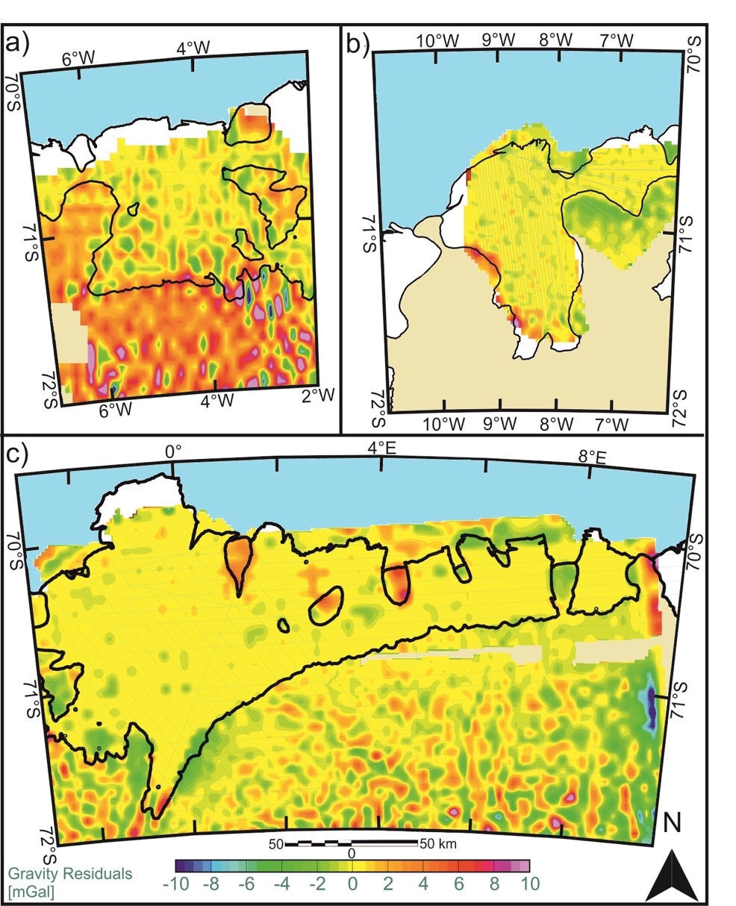

**Figure S2.3** Gravity residuals between observed and modeled gravity data for (a) Jelbart, (b) Ekström and Atka and (c) Fimbul and Vigrid ice shelves. Short-wavelength fluctuations of gravity residuals across the areas of grounded ice sheets can be explained by the differing resolutions between ice thickness radar data and gravity data.