

*Geophysical Research Letters*

Supporting Information for

Constraining geothermal flux at coastal domes of the Ross Ice Sheet, Antarctica

T.J. Fudge1, Surabhi Biyani1, David Clemens-Sewall2, Bob Hawley2

1 Earth and Space Science, University of Washington.

2 Earth Sciences, Dartmouth College.

Corresponding author: T.J. Fudge ([tjfudge@uw.edu)](mailto:tjfudge@uw.edu))

**Contents of this file**

Text S1 to S3

Table S1

Figures S1 to S4

**Introduction**

This supplement provides additional details on the Roosevelt Island temperature measurements (S1), the Siple Dome surface temperature (S2) and the Byrd geothermal flux (S3).

**S1 Roosevelt Island Basal Temperature**

The Roosevelt Island Ice Core was drilled at the summit of Roosevelt Island (Figure S1). A few minutes of data were collected in 2013 and 2014 with the sensor sampling at 3 Hz about 2 cm above the bed. No entrained debris was reported in the ice core. The standard deviation of the measurements was 0.03°C. Thus the 0.1°C uncertainty is primarily from the calibration. A 0.1°C uncertainty in the basal temperature has a < 1 mW m-2 impact on the inferred geothermal flux and is neglected from the uncertainty analysis (Main Text 2.2.3 and S3).

**S2 Siple Dome Surface Temperature**

Because the modeled firn has a lower thermal conductivity (Cuffey and Paterson, 2010, p. 400) due to the increase in air content, the near surface temperature gradient is large enough to cause a 0.45°C difference between the surface and 20m depth (Figure S2), which Engelhardt (2004) report as the mean annual surface temperature, -25°C. To account for this difference, we rounded to 0.5°C and set the surface temperature in the model to -25.5°C so approximately match the temperature at 20m depth.

**S3 Byrd geothermal flux**

Inferring the geothermal flux at the Byrd ice core site is challenging both because of the ice has travel a long distance from a divide (~160 km) and the unknown basal condition. The ice core has 4.8m of refrozen ice at the bottom, but it is unknown if the base is currently melting or refreezing. Complicating matters further, the bedrock rises nearly 400m in the final 8 km, allowing the possibility of hydraulic supercooling causing the refrozen ice. Here we outline our reasoning for why hydraulic supercooling is not the likely cause of the refrozen ice and thus the heat conduction in the basal ice is close to the geothermal flux.

The surface slope is 11 times more important at driving water flow than the bed slope. Water flowing up a bed slope must warm to remain at the pressure melting point. If the geothermal flux and other heat sources such as friction from basal sliding are in balance with heat conduction in the basal ice, the heat needed to keep the water at the pressure melting point is primarily supplied by the latent heat of refreezing (viscous heating is small). Alley et al. (1997) calculated the latent heat release and basal freeze-on rate for the Byrd ice core assuming a flowline (for ice and water) where the upper 60km of the flowline was melting at a rate of 1mm a-1 and refreezing occurred on the upward slope for the final 100 km of the flowline. Assuming a basal sliding rate of 1 m a-1, Alley et al. (1997) found that 0.5 m of ice would accrete in the 100,000 years to travel the final 100 km, with a latent heat transfer approximately 3 orders of magnitude less than a typical geothermal flux (i.e. 50 mW m-2).

The amount of refrozen ice depends upon the flux of water. The Alley et al. (1997) calculation does not account for the possibility that water is preferentially routed to beneath the Byrd ice core path. Using the water routing of LeBrocq et al. (2013) derived from Bedmap2 surface and bed topography (Fretwell et al., 2013), Figure S4 shows the water pathways and basal topography in the vicinity of the Byrd ice core and flowline. The flowline is computed using the Bedmap2 surface topography after smoothing at 9 km length scale (~3 ice thicknesses). The flowline agrees well with that in Whillians (1977, 1979) from a single line of velocity measurements. Note that satellite-derived velocities (e.g. Rignot et al., 2011) are not accurate for this relatively slow flowing region and were not used. Figure S4 shows that there is little water flow along the portions of the bed that slope upwards until nearly 130 km upstream from the core. At 10 km to 8km, the water is routed around the bedrock high which forms the steep reverse bed slope. This does not mean that no water flows up the bed slope, but it does eliminate a large flux of water derived from upstream. Thus, the amount of freeze-on from hydraulic supercooling is likely low.

**Additional References not in Main Text**

Whillans, I.M., 1977. The equation of continuity and its application to the ice sheet near “Byrd” Station, Antartica, Journal of Glaciology, 18(80), 359-371.

Whillans, I.M., 1979. Ice flow along the Byrd Station strain network, Antarctica, Journal of Glaciology, 24(90), 15-28.

|  |  |  |  |  |  |  |  |  |  |  |  |  |  |  |
| --- | --- | --- | --- | --- | --- | --- | --- | --- | --- | --- | --- | --- | --- | --- |
| **Table S1: Modeled Geothermal Flux in mW m-2** | | | | | |  |  |  |  |  |  |  |  |  |
| Model Run ID | 1 |  | 2 | 3 | 4 | 5 | 6 | 7 | 8 | 9 | 10 | 11 | 12 | 13 |
|  | **Base** | Un-cert-ainty | +2°C | -2°C | A +20% | A -20% | LGM -5°C 40% | LGM -15°C 40% | LGM -5°C 67% | LGM -15°C 67% | Thin 10% | Thick 10% | Only Divide | Only Flank |
| Siple Dome | **71** | 10 | 66 | 76 | 74 | 68 | 64 | 76 | 66 | 81 | 76 | 67 | 65 | 71 |
| Difference from Base |  |  | -5 | 5 | 3 | -3 | -7 | 5 | -5 | 10 | 5 | -4 | -6 | 0 |
|  |  |  |  |  |  |  |  |  |  |  |  |  |  |  |
| Shabtaie Ridge (Max) | *75* | 10 | 69 | 81 | 79 | 71 | 73 | 79 | 74 | 84 | 79 | 72 | 68 | 76 |
| Difference from Base |  |  | -6 | 6 | 4 | -4 | -2 | 4 | -1 | 9 | 4 | -3 | -7 | 1 |
|  |  |  |  |  |  |  |  |  |  |  |  |  |  |  |
| Engelhardt Ridge (Max) | *85* | 11 | 79 | 92 | 89 | 82 | 83 | 91 | 84 | 96 | 91 | 83 | 79 | 87 |
| Difference from Base |  |  | -6 | 7 | 4 | -3 | -2 | 6 | -1 | 11 | 6 | -2 | -6 | 2 |
|  |  |  |  |  |  |  |  |  |  |  |  |  |  |  |
| Roosevelt Island | **84** | 13 | 77 | 91 | 88 | 80 | 74 | 90 | 79 | 95 | 88 | 80 | 74 | 86 |
| Difference from Base |  |  | -7 | 7 | 4 | -4 | -10 | 6 | -5 | 11 | 4 | -4 | -10 | 2 |
| Siple Dome and Roosevelt Island (bold) have measured basal temperatures. | | | | | | | | |  |  |  |  |  |  |
| Shabtaie and Engelhardt Ridges(italics) assumed pressure melting. | | | | | | |  |  |  |  |  |  |  |  |

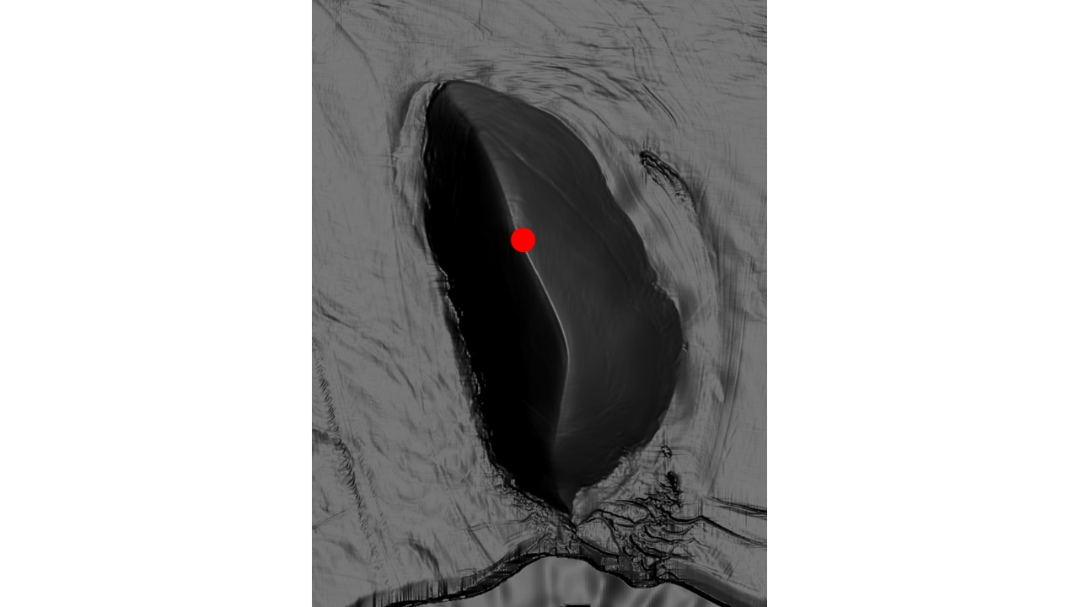

**Figure S1**: Image courtesy of Ted Scambos showing the ice core location at the summit of Roosevelt Island.

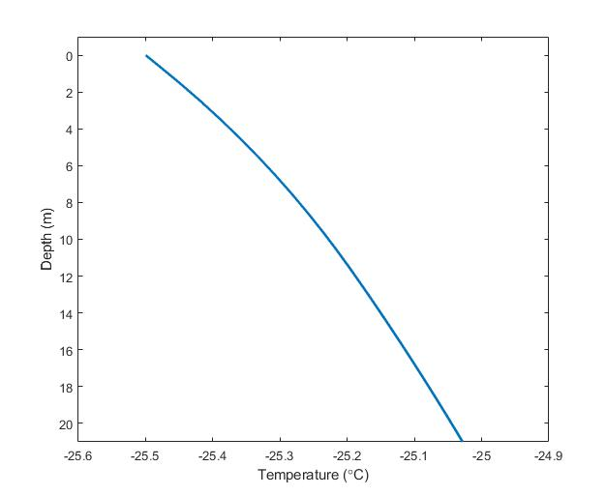

**Figure S2**: Modeled temperature in the upper firn showing a 0.45°C difference between the surface and 20m depth.

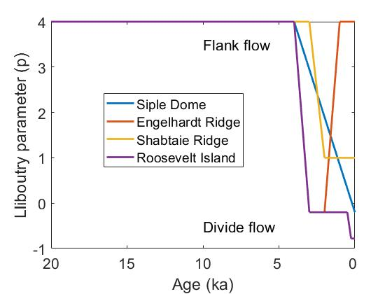

**Figure S3**: Assumed history of Lliboutry parameter, *p*, for calculating vertical velocities for the four sites. Reasoning for each site is described in main text.

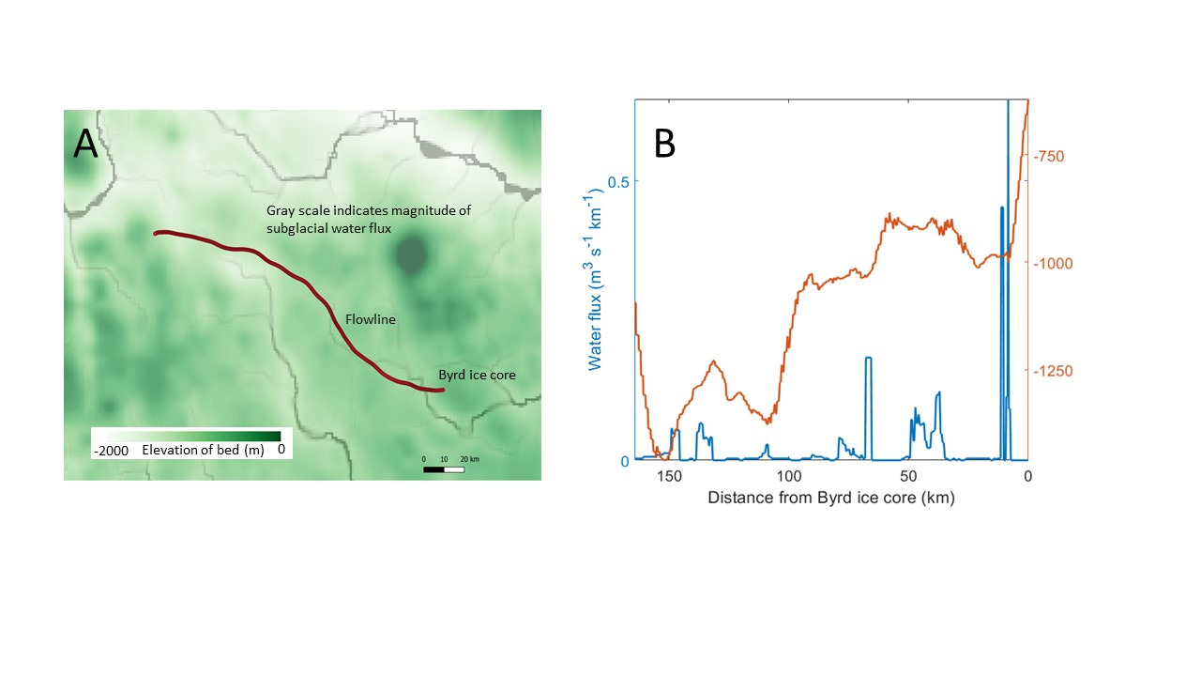

**Figure S4**: A) Bedrock elevation (Fretwell et al., 2013) shown in white-green color scale. Byrd flowline is in red. Amount of water routing is shown with gray scale (LeBrocq et al., 2013). B) Water flux (blue) and bedrock elevation (red) for Byrd flow line. Areas of an upward sloping bed do not have substantial water flow except at 130 km upstream.