**Extended Data**

**Extended Data Fig. 1: Relationship between sedimentary basin likelihood with the current ice thining rate and ice velocity in Antarctica. a,** Sedimentary basin likelihood overlying ice thinning rate as estimated by satellite laser altimetry data20. **b,** Sedimentary basin likelihood overlying the fast ice flow region.

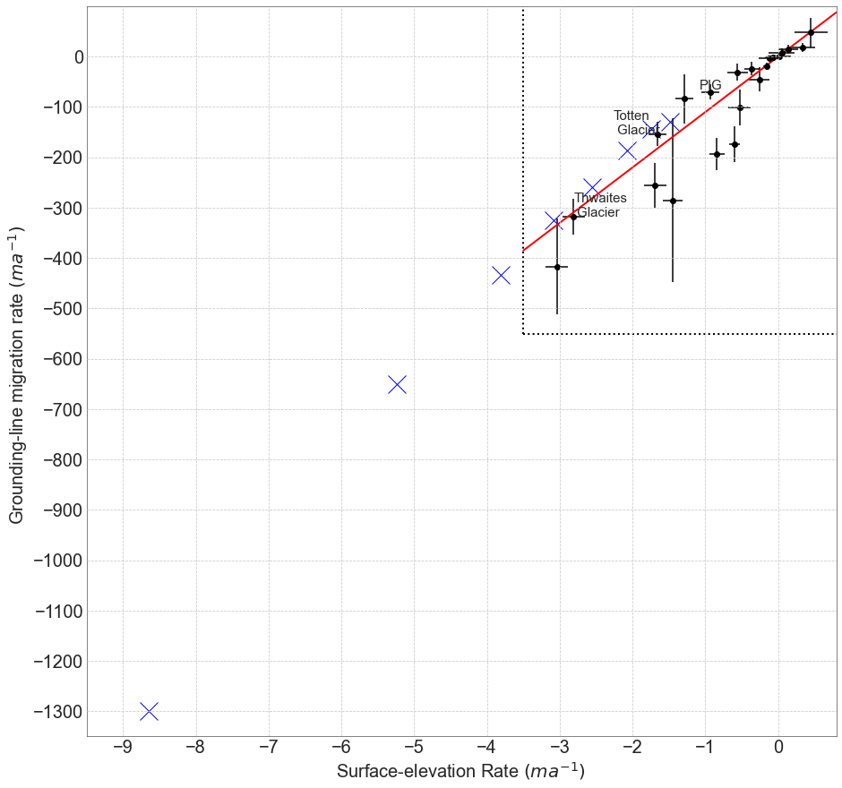

**Extended Data Fig. 2: Rate of grounding-line migration rate versus rate of ice thinning.** The dash box and black dot show the estimated continental wide grounding-line retreat rate versus ice thinning rate43. The blue cross mark shows the grounding-line retreat rate that we used in hydro-mechanical modelling. Detail of the estimation of groundline-line migration and ice thinning rate are shown in Supplementary Information 2.1.2.