**Ministero dell'Università e della Ricerca  
Programma Nazionale di Ricerche in Antartide**

**PNRA Call 2019 – A Line**

**Marine surveys in the Southern Ocean on the Italian vessel Laura Bassi in 2020- 2022**

**Sommario**

1 Research proposal 3

1.1 Line 3

1.2 Coordinator 3

1.3 Abstract 3

1.4 Title 3

2 Objectives to be reached in accordance with the provisions as stated in Article 1 3

3 International involvement 4

4 Description of the planned activities and their temporal development plan 4

5 Description of the technical-logistic requirements 4

6 Request for use of the national system for large common infrastructures (GIC) among the existing ones and / or proposals for new acquisitions 4

7 Description of the estimated costs for the realization of the proposed project and how this requested contribution will be used 4

8 Description of pursued objectives and expected results 5

9 Description of the program for collecting, storing and managing data, and the use of the national Antarctic Interlaboratory System (SIA) 5

10 Description of the outreach and education program 5

11 Description of the composition of the scientific and technical team, both Italian and foreign 5

12 Financial contributions from foreign partners 6

# Research proposal

## Line

A1 - Marine surveys in the Southern Ocean on the Italian vessel Laura Bassi during 2020- 2022.

Research activities in Geology and Marine Geophysics (24 months max)

## Coordinator

Camilla Palmiotto (ISMAR-CNR of BOLOGNA)

## Abstract

The Balleny Islands are part of a linear volcanic chain parallel to the Southern Balleny Fracture Zone (Ross Sea, Antartica), the inactive extension of a transform that offsets the South-East Indian Ridge by roughly 330 km. This region is poorly known due to its extreme geographical location. Balleny islands may be the result of vertical tectonics along the fracture zone with a possible contribution of a mantle thermal and / or compositional anomaly. Our research proposal aims at clarifying the origin of the Balleny islands and their relationship to the adjacent fracture zone. We plan to carry out a morpho-bathymetric survey of the region adjacent to the islands, plus acquisition of magnetietric, gravimetric and seismic data and sampling of sediments / fragments of rocks from the deeper points of the transform valley.

## Title

Geology and Geophysics of the Southern Balleny Fracture Zone (Ross Sea, Antartica)

# Objectives to be reached in accordance with the provisions as stated in Article 1

**Introduction.** Oceanic islands can be divided, according to their origin, in volcanic and tectonic. Volcanic islands are due to excess volcanism caused by mantle melting anomalies either along mid-ocean ridges (i.e.Iceland in the Atlantic) or within oceanic plates (i.e. Hawaiian Islands in the Paciﬁc) (Wilson, 1963; Morgan, 1972). Islands can also form due to volcanism caused by supra-subduction ‘wet’ mantle melting (i.e.Tonga Islands in the Paciﬁc). Non-volcanic, or "tectonic" islands, are made of mantle ultramaﬁc and crustal gabbroic and basaltic rocks. They are formed mainly due to vertical tectonic motions of blocks of oceanic lithosphere along transverse ridges flanking transform faults at slow and ultraslow mid-ocean ridges (Menard and Atwater, 1969; Bonatti, 1977; Bonatti et al., 1983, 1994a,b, 2005; Palmiotto et al., 2013; Maia et al., 2016).

Oceanic volcanic and tectonic islands evolve along two distinct lines (Palmiotto et al., 2017). Volcanic islands are characterized by a ‘linear’ evolution: they grow, evolve and drown. Their life expectancy before drowning ranges from 5 to 20 Ma, depending on plate velocity and intensity of volcanism. In contrast, oceanic tectonic islands tend towards a ‘cyclical’ evolution, with stages of uplift – emersion – erosion – subsidence – deposition, triggered by de-activation – reactivation of tectonic forces along oceanic fracture zones, as testiﬁed by their carbonate stratigraphy (Corda and Palmiotto, 2015). Renewed tectonics along the active transform zone can trigger a new life-cycle for tectonics. Sunken oceanic tectonic islands have been identified by seismic profiles along the eastern fossil zone of the Romanche megatransform in the equatorial Atlantic (Fig.1). Examples of modern oceanic tectonic islands are the Cayman and Swan Islands along the Oriente and Swan transform faults in the Caribbean Sea, and the San Peter and Paul Archipelago along the St. Paul multi-fault transform system in the equatorial Atlantic(Fig.1).

**Rationale and state of the art.** Most morphological and seismic profiles perpendicular to transform valleys show a strong asymmetry due to a greater elevation of one of the two flanks of the valley: these reliefs are known as transverse ridges. They are among the most important positive topographic anomalies of the ocean floor: they are one or more kilometers shallower than the adjancent “normal” crust of equivalent age and frequently they are shallower than axial spreading ridges in the same area. Geophysical and petrographical data acquired from different oceanic fracture zones suggest that transverse ridges are not the result of excess volcanism, but rather of tectonic uplift of upper mantle and crustal blocks (Bonatti, 1977). They are the results of large vertical uplift caused by tectonics along slow and ultraslow oceanic fracture zones due to a reorganization of the geometry of the plate boundaries, with transition from a transcurrent tectonics to a transtensive and / or transpressive tectonics. When the summit of a transverse ridges reaches above sea level, it forms an oceanic non-volcanic island. Although tectonic deformation can explain the uplift of transverse ridges, several other mechanisms have been proposed (Fig.2): lateral heat transfer (Chen, 1988; Louden and Forsyth, 1976); viscodynamic forces. (Collette, 1986); thermal stress (Collette, 1986; Turcotte et al., 1974; Parmentier and Haxby, 1986; erosion of a lithosphere plate (Basile & Allemand, 2002); differential thermal subsidence (Sandwell and Schubert, 1982); friction – related heating (Chen, 1988); ultramafic diapirism (Komor et al., 1985; Bonatti, 1977; Cannat, 1996).

Questions to be addressed are: 1) is there a tectonic response in the inactive-fossil fracture zones from tectonic processes taking place in the active transform zone due to reorganization of plate boundaries; 2) what is the life cycle of oceanic tectonic islands along intermediate and / or fast transform faults; 3) what are the relationships between tectonics and magmatism along oceanic fracture zones.

We plan to explore the Southern inactive-fossil zone of the Balleny fracture zone, close to the Balleny Islands (Fig.3; Ross Sea, Antartica). This archipelago is formed by 5 large volcanic islands and several smaller ones, and form a linear chain striking NW-SE for about 200 km; it has been suggested that they represent an earlier track of the Balleny plume (Johnson et al., 2012). However, according to Berg et al. (X) their origin are not well established and possible explanations include: 1) leaky transform; 2) propagating fracture; 3) laterally-moving hotspot. We will carry out multibeam, sub-bottom, magnetics, gravity, reflection seismic surveys, as well as core sampling (Fig.4).

**Objectives.** The main objective of this research proposal is collecting multidisciplinary data in a poorly studied area in order to understand the origin and the evolution of the Balleny Islands and the interaction of their volcanism with transcurrent tectonics. The scientific main goals of our study are:

1. Processing multibeam data, create an high resolution bathymetric map and define the regional;
2. Processing and interpret seismic data (sub-bottom and multichannel seismics) in order to define the structural framework of the region;
3. Sample the transform valley in order to determine the nature of the sediments, to detect type and age of the regional volcanism, to analyse the stratigrapghy, the micropalaeontology and palaeomagnetics;
4. Construct a map of regional sediment thickness from seismic profiles in order to obtain the Mantle Bouguer Anomaly removing from the Free Air Anomaly the effect of the crust, assumed 5-6 km thick, and the components due to the water and to the sediments;
5. Create magnetic and gravimetric models of the region in order to understand the nature and the age of the oceanic lithosphere.

# International involvement

A team of the New Zeland (GNS Science) will participate in this research. Their contribution will include the acquisition of shipboard gravity data.

# Description of the planned activities and their temporal development plan

The research will involve the following steps:

1. Study of the geological and geophysical background of the Southern Balleny Fracture Zone region;
2. Acquisition of new geological and geophysical data during a forthcoming cruise aboard of the R/V Laura Bassi. The proposal is based on the acquisition of multibeam, chirp, magnetic and gravity data along 10 lines parallel to the transform valley (Fig.4). Each line is 180 km-length, for a total length of 972 nmi; the velocity of the research vessel during the acquisition can be 10 nmi. The time for this acquisition is ~ 4 days and half. The proposal also requires the acquisition of 4 seismic lines, perpendicular to the transform valley (Fig.4). The total length of the lines is 416 km or 22,4 nmi; the velocity of the research vessel during the acquisition can be 5 nmi. The time for seismic survey is ~ 2 days. Finally we will collect 4 cores in 4 different points of the region based on the results of the bathymetric and seismic surveys (~ 1 day).
3. Processing, analysis and interpretation of all the multidisciplinary data acquired in order to produce international research papers.

# Description of the technical-logistic requirements

Most of the technical-logistic requirements for this research will be aboard the Research Vessel Laura Bassi: 1) Multibeam full ocean depth; 2) Sub Bottom Profiler; 3) Magnetometer; 4) Low-capacity seismic source; 5) Gravity core. The gravimeter will be provided by the GNS of New Zeland…….

# Request for use of the national system for large common infrastructures (GIC) among the existing ones and / or proposals for new acquisitions

# Description of the estimated costs for the realization of the proposed project and how this requested contribution will be used

This research requires a total budget of 160,000 euro, subdivided as follow:

* First Year: 50,300 € for a research scientist expert in geophysical acquisition and processing.
* Second Year: 50,300 € for a research scientist expert in geophysical acquisition and processing; 5,000 € for shipping of samples to Italy; X € for transport of the gravimeter; 20,000 € for elemental and isotopic chemistry of selected core components; 5,000 € for granulometry; X € for micropalaeontological analysis; 5,000 € for palaeomagnetism; 5,000 € for publication; 5,000 for scientific national and international meetings.

# Description of pursued objectives and expected results

The main objective of this research proposal is collecting multidisciplinary data in a poorly studied area in order to understand the origin and the evolution of the Balleny Islands and the interaction of their volcanism with transcurrent tectonics.

# Description of the program for collecting, storing and managing data, and the use of the national Antarctic Interlaboratory System (SIA)

# Description of the outreach and education program

The results of this research will be submitted for publication in major international journals and will also be communicated in scientific national and international meetings (i.e. SGI-SIMP, EGU, AGU).

# Description of the composition of the scientific and technical team, both Italian and foreign

This research will be composed by four different units:

**UNIT 1 - CNR – ISMAR of Bologna:** 1) Camilla Palmiotto (Geophysical acquisition, processing and interpretation); 2) Maria Filomena Loreto (Geophysical acquisition, processing and interpretation); 3) Marco Ligi (Geophysical processing and interpretation); 4) Enrico Bonatti (Geophysical interpretation); 5) Stefania Romano (Geophysical acquisition and sedimentological analysis); 6) Luigi Vigliotti (Palaeomagnetic analysis); 7) Alessandra Asioli (Palaeontological analysis).

**UNIT 2 - INGV of La Spezia**: 1) Filippo Muccini (Magnetic data acquisition, processing and interpretation).

**UNIT 3 - Università di Pavia**: 1) Alessio Sanfilippo (Volcanic analysis); 2) Riccardo Tribuzio; 3) Camilla Sani.

**UNIT 4 - GNS of New Zeland:** 1) Fabio Caratori Tontini (Gravimetry data acquisition, processing and interpretation).

# Financial contributions from foreign partners

There are no financial contributions from foreign partners.

References

Basile, C., and P. Allemand (2002), Erosion and flexural uplift along transform faults, Geophys. J. Int., 151, 646 – 653.

Bonatti, E., 1977. Vertical tectonism in oceanic fracture zones. Earth Planet. Sci. Lett., 37, 369 – 379.

Bonatti, E., Sartori, R. and Boersma, A., 1983. Vertical crustal movements at the Vema Fracture Zone in the Atlantic: evidence from dredged limestones. Tectonophysics, 91, 213 – 216.

Bonatti, E., Ligi, M., Gasperini, L., Carrara, G. and Vera, E., 1994a. Imaging crustal uplift, emersion and subsidence at the Vema Fracture Zone. EOS Trans. Am. Geophys. Union, 75, 371 – 372.

Bonatti, E., Ligi, M., Gasperini, L., Peyve, A., Raznitsin, Y. and Chen, Y.J., 1994b. Transform migration and vertical tectonics at the Romanche fracture zone, equatorial Atlantic. J. Geophys. Res., 99, 21779 – 21802.

Cannat, M. (1996), How thick is the magmatic crust at slow spreading oceanic ridges?, J. Geoph. Res., 101, 2847 – 2857.

Chen,Y. (1988), Thermal model of oceanic transform faults, J. Geoph. Res., 8, 8839 – 8851.

Collette, B.J. (1986), Fracture zones zones in the North Atlantic; morphology and a model, J. Geol. Soc. of London, 143, 5763 – 777.

Corda, L. and Palmiotto, C., 2015. Rhodalgal – foramol facies in equatorial carbonates: insights from Miocene tectonic islands of the central Atlantic. Palaeogeogr. Palaeclimatol. Palaeoecol.,428, 21 – 30.

Komor, S. C., D. Donelthon, and J. F. Casey (1985), Serpentinization of cumulate ultramafic rocks from the north arm mountain massif of the bay of wads ophiolite, Geochimica et Cosmichimica Acta, 49, 233 l – 2338.

Louden, K. E., and D. W. Forsyth (1976), Thermal Conduction across Fracture Zones and Gravitational Edge Effect, J. Geophys. Res., 81, 4869 – 4874.

Menard, H.W. and Atwater, T., 1969. Origin of fracture zone topography. Nature, 222, 1037 – 1040.

Morgan, W.J., 1972. Deep mantle convection plumes and plate motions. AAPG Bull., 56, 203 – 213.

Palmiotto, C., Corda, L., Ligi, M., Cipriani, A., Dick, H.J.B., Douville, E., Gasperini, L., Montagna, P., Thil, F., Borsetti, A., Balestra, B. and Bonatti, E., 2013. Nonvolcanic tectonic islands in ancient and modern oceans. Geochem. Geophys. Geosyst., 14, 4698 – 4717.

Palmiotto, C., Corda, L.,. and Bonatti, E., 2017. Oceanic tectonic islands. Terra Nova, 29, 1-12.

Parmentier, E. M., and W. F. Haxby (1986), Thermal Stresses in the Oceanic Lithosphere: Evidence from Geoid Anomalies at Fracture Zones, J. Geophys. Res., 91, 7193 – 7204.

Sandwell, D.S, and G. Schubert (1982), Litospheric flexure at fracture zones, J. Geoph. Res., 87, 4657 – 4667.

Turcotte, D. L. (1974), “Are Transform Faults Thermal Contraction Cracks?”, J. Geophys. Res. 79, 2573–2577.

Wilson, J. Y. (1965), A new class of faults and their bearing on continental drifts, Nature, 207, 343

– 347.

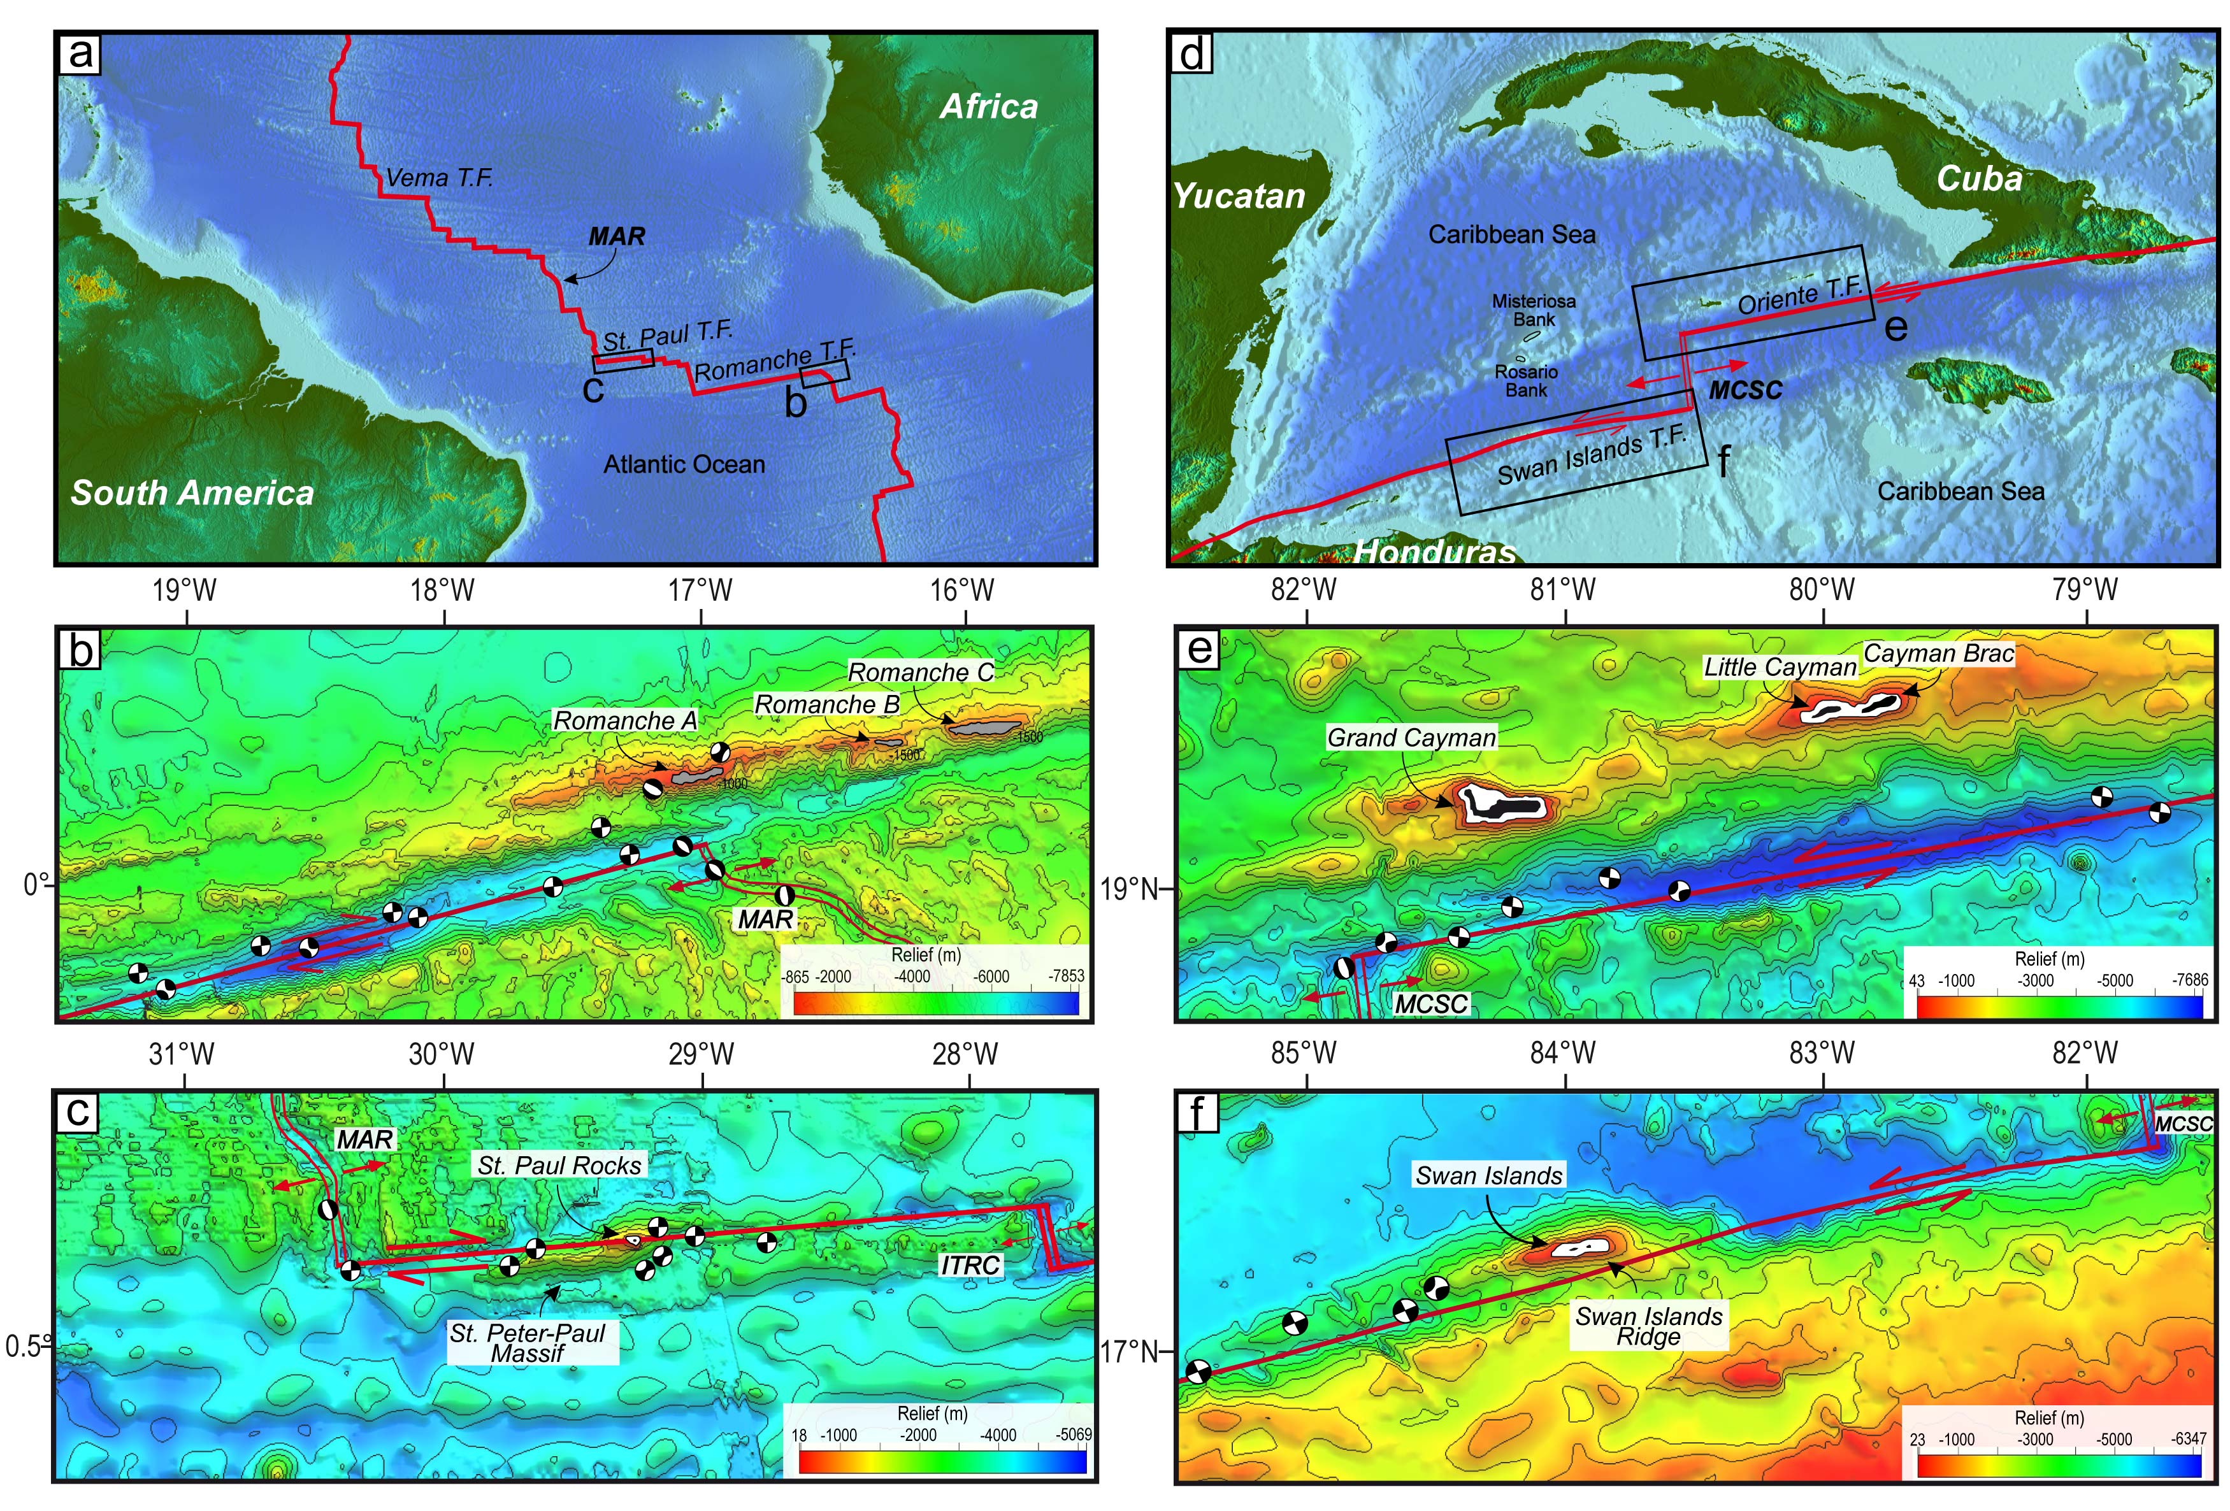

Fig. 1 (a) Geographical – geological setting of the central Atlantic. The two black boxes – detail shown in (b) and (c) – indicate (b) areas along the Romanche megatransform with sunken tectonic islands, and (c) St. Peter – Paul Rocks along the St. Paul transform. (b) Bathymetric image of the eastern part of the Romanche Megatransform and of the eastern intersection of the Romanche Megatransform with the Mid-Atlantic Ridge. (c) Bathymetric image of the northern part of the St. Paul Transform and its northern intersection with a segment of the Mid-Atlantic Ridge (ITRC). (d) Geographical – geological setting of the Caribbean Sea. The two black boxes – detail shown in (e) and (f) – indicate the areas along the Oriente and Swan Islands transforms where (e) Cayman, Misteriosa and Rosario, and (f) the Swan Islands are located. (e) Bathymetric image of the western part of the Oriente transform (Caribbean Sea) and of the northern intersection between the Oriente and the Mid-Cayman Spreading Centre. (f) Bathymetric image of the eastern part of the Swan Islands transform and of the southern intersection between the Swan Islands and the Mid-Cayman Spreading Centre. Red lines indicate modern plate boundaries; contour lines are every 1000 m; light grey, white and black areas have depths of < 1000, < 120 m and < 0 m, respectively. T.F., Transform Fault; MAR, Mid-Atlantic Ridge; ITRC, Intra-Transform Ridge C; MCSC, Mid-Cayman Spreading Centre. Red lines indicate modern plate boundaries; red arrows indicate relative plate motion. Maps were created with the GMT software system (GMT 5, <https://www.soest.hawaii.edu/gmt>).

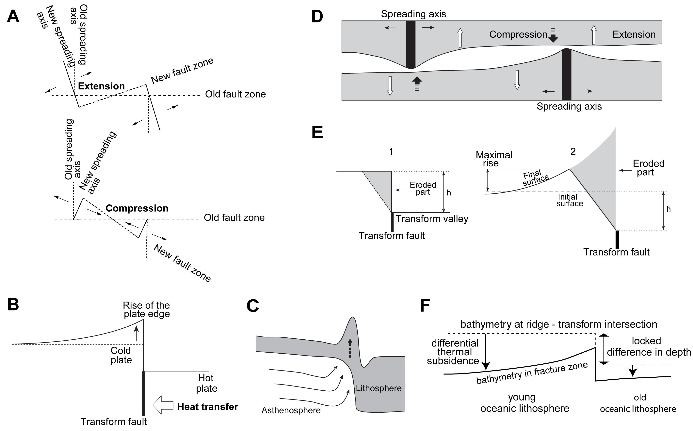

Fig.2 Models of vertical movements with formation of transverse ridges [modified from Peive, 2005]. A. tectonic factors; B. the thermal effect; C. longitudinal melt ﬂow; D. thermal stress; E. erosion of the lithospheric plate; F. differential thermal subsidence.

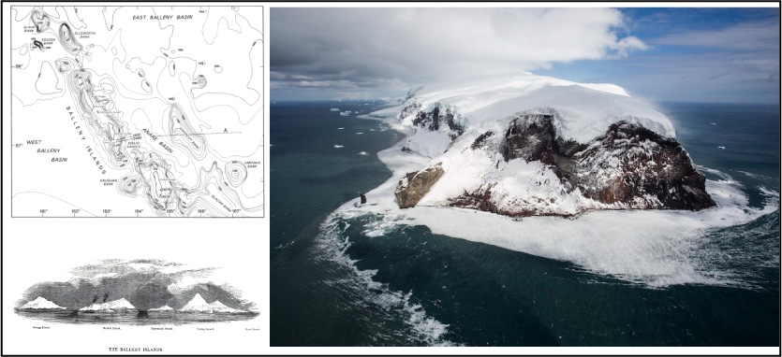

Fig.3 Geography and aerial view of the Balleny Islands (Ross Sea, Antartica).

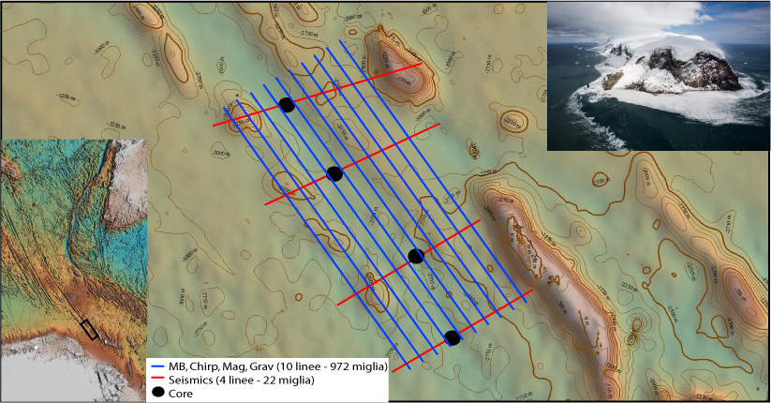

Fig.4 Free Air Anomaly of the Southern Balleny fracture zone close to the Balleny Islands (Ross Sea, Antartica).