

Geophysical Research Letters

Supporting Information for

**A Geothermal heat flux map of Antarctica empirically constrained by seismic structure**

Weisen Shen1, Douglas Wiens2, Andrew Lloyd2,3, Andy Nyblade4

1. Stony Brook University, SUNY, Stony Brook, NY, 11794

2. Washington University in St Louis, St Louis, MO, 63112

3. Now at Lamont Doherty Earth Observatory, Columbia University, New York, NY, 10964

3. Penn State University, University Park, PA 16802

**Contents of this file**

Text S1 to S5

Figures S1 to S5

**S1. Lithosphere structure of Antarctica**

Lithospheric structure of the continental Antarctica is obtained by combining the two most recent 3-D models of the crust and uppermost mantle. Within the areas of West and central Antarctica, we use the 3-D model constructed by surface wave dispersion (both from ambient noise and earthquakes) and receiver functions made from the seismic data in the past two decades (Shen et al., 2018, referred as Shen2018 model hereafter). The horizontal resolution of the 3-D model is on the order of ~ 100 km. Off the coverage of Shen model, we use the 3-D model constructed using a full-waveform inversion method using earthquake records (Lloyd et al., 2019, referred as Lloyd2019 model hereafter). Both models have been corrected to 1 sec frequency through the physical dispersion correction described by Kanamori and Anderson (1977). In the correction, the form

*C*(ω) = *C*(ω*r*)[1 + (1/π*Qm*) In (ω/ω*r*)]

Was used, in which C(ω) is the phase velocity of either body waves, surface waves, or free oscillations, ω is the angular frequency, ωr is the reference angular frequency, and Qm is the path averaged Q for body waves or Q of a surface wave or a mode of angular frequency ω; During the correction, Qm was assumed to be 150 for shear velocity (Shen et al., 2018).

In West and central Antarctica where both models are available, we found that the large scale features in the two models are similar, although more details of the crustal and Moho structures are seen in the Shen2018, mainly due to the fact that short period (<25 sec) ambient noise derived surface wave and receiver functions were used. Fig. S1 highlights the uppermost mantle structures from both models by showing the Vs at 80 km depth. For the overlapping area, the mean difference is -1.13 m/sec, and standard deviation is ~74.09 m/sec, which is less than 0.5% of the measured Vs).

**S2. Goethermal heat flux and lithosphere structure of North America**

Geothermal heat flux (GHF) of the continental US is obtained from the published map (Blackwell et al., 2011). The raw map (Fig. S2a) contains observed GHF at > 10,000 sites, and thus contain local variations that are caused by volcanism and hydrological circulations. Particularly, the hydrological circulation near the Black Hills has generated a dipole-shaped GHF anomaly in the state of the South Dakota (Gosnold, 1990). In order to capture the GHF variations at larger scale that is mainly caused by the thermal state of the lithosphere, we smoothed the raw GHF map using a Gaussian smoothing filter (with half-width of ~ 25 km) and removed the anomaly in South Dakota (see Fig. S2 b). We note that some areas in Florida and along the Appalachians may also contain such type of anomalies from surface hydro-circulations, but a test with a few points shows that the effect is negligible compared with the final uncertainties.

Seismic lithospheric structure of the continental US is obtained through a Monte Carlo joint inversion of surface wave dispersion, horizontal to vertical ratios (H/V), and receiver functions based on the seismic records of Earthscope/USArray between 2008 and 2015 (Shen et al., 2016). the 3-D model extends from surface to ~ 200 km depth, and a simple model parameterization was used. This model is chosen from a set of seismic models of the crust and uppermost mantle beneath the US (e.g., Lin et al., 2014;) since it is built based on the same method used to construct West/central Antarctic model.

**S3. Structurally Similar Region (SSR) and final GHF**

In this paper, we define the structurally similar regions (SSR) for any given continental Antarctica point as the 0.5% of the continental US where their uppermost mantle structure is most similar to that point. The similarity functional between two models is defined as:

In which and are the shear wave velocity at location in Antarctica and North America, respectively. is defined as where are the crustal thickness for the two respective models. The difference is integrated from 5 km below the deeper Moho to 150 km beneath the surface. 150 km is used in the integration as the uppermost 150 km of the US crust and uppermost mantle are well constrained. In this study, instead of using the whole crust and uppermost mantle Vs and crustal thickness (e.g., Shapiro and Ritzwoller (2004)), we define the similarity functional by comparing only the uppermost mantle Vs from near Moho to ~ 150 km. This choice is made based on the observation that GHF is more sensitive to upper mantle Vs rather than crustal Vs or seismic crustal thickness. Although the amount of heat production in the crust depends on the crustal thickness, but a less systematic knowledge of the heterogeneity in the crustal composition (especially for Antarctica) prevents us from fully incorporating crustal thickness into the calibration (e.g., Shapiro and Ritzwoller, 2004). Additionally, the crustal thickness of the continental US also shows a weaker correlation with observed GHF compared with the uppermost mantle (Fig. S3). This is indicative of a more complex relationship between the crustal thickness and GHF, which calls for further sophisticated studies to the crustal composition and heat elements concentration (e.g., Hasterok et al., 2018).

In this study, we use a portion of the continental US areas that have the most similar uppermost mantle structure to form the GHF distribution for local Antarctica points. The portion is set to be 0.5% of the whole continental US. Other choices of areas are also tested and the results for two points (the South Pole, and the West Antarctica) are presented in Fig. A4. The general result shows that the smaller an SSR is defined, the smaller uncertainties are obtained, reflecting less number of local GHF values that are used to form the distribution. The reduction in uncertainties increases the risk that the estimated GHF is biased by local non-tectonic factors such as shallow hydrological circulation. The greater an SSR is chosen, we observe that the uncertainties approach a relatively constant value, but the estimated mean is biased towards the continental GHF mean, reducing the resolution of the final GHF map. As a result, 0.5% of the continental US is chosen to maintain a balance between local fluctuation effect and resolution.

Based on the distribution of GHF values from SSR, the final GHF value for the Antarctic location is defined by a weighted average scheme:

in which the is the GHF value of the ith model in the SSR, and the weighting factor is defined as the reciprocal of the similarity functional : This scheme allows the final GHF approximates to the observed North American GHF value at the most similar location.

In this study, the uncertainty defined by the 1-std of the distribution is also only a proxy: low uncertainty simply means that for all the regions in the continental US that are similar to a given point in Antarctica, their locally measured GHFs are also quantitatively similar to each other; and a higher uncertainty means that for the areas with similar mantle structure, their GHFs may vary more significantly. We also note that this definition of the final GHF value may differ from the value defined as the median/most likely GHF since the GHF distribution may not be Gaussian (see Fig. 2), although for most areas the distributions are Gaussian-like, if not perfectly Gaussian. Future investigation to these distributions should be performed to develop further understanding their physical meanings.

**S4. Comparison with earlier published GHF map**

The comparison with earlier Antarctica GHF maps is shown in Fig. S5. On average, the map shows a lower GHF in the West Antarctica and a higher GHF in the East Antarctica. It also reveals more regional variations within each province. For example, the earlier map shows one high GHF anomaly across the majority of the West Antarctic Rift system, while we show the high GHF values along the Transantarctic Mountains and the Marie Byrd Land but modest values near the Siple Coast region as well as inner part of the Ross Ice Shelf. Within the East Antarctica, variations at scales of ~ 100-300 km are also observed, and elevated GHF values (~ 60-70 mW/m2) are seen near the Dronning Maud Land. Moreover, the uncertainties of the new map (~ 9 mW/m2) is significantly smaller than the old map (~ 30 mW/m2), as we use a much better observed GHF map in the continental US, while the earlier studies used a low-resolution global seismic model and global GHF map. We also include the geomagnetically derived maps from Fox-Maule et al. (2005) and Martos et al., (2017) for comparison.

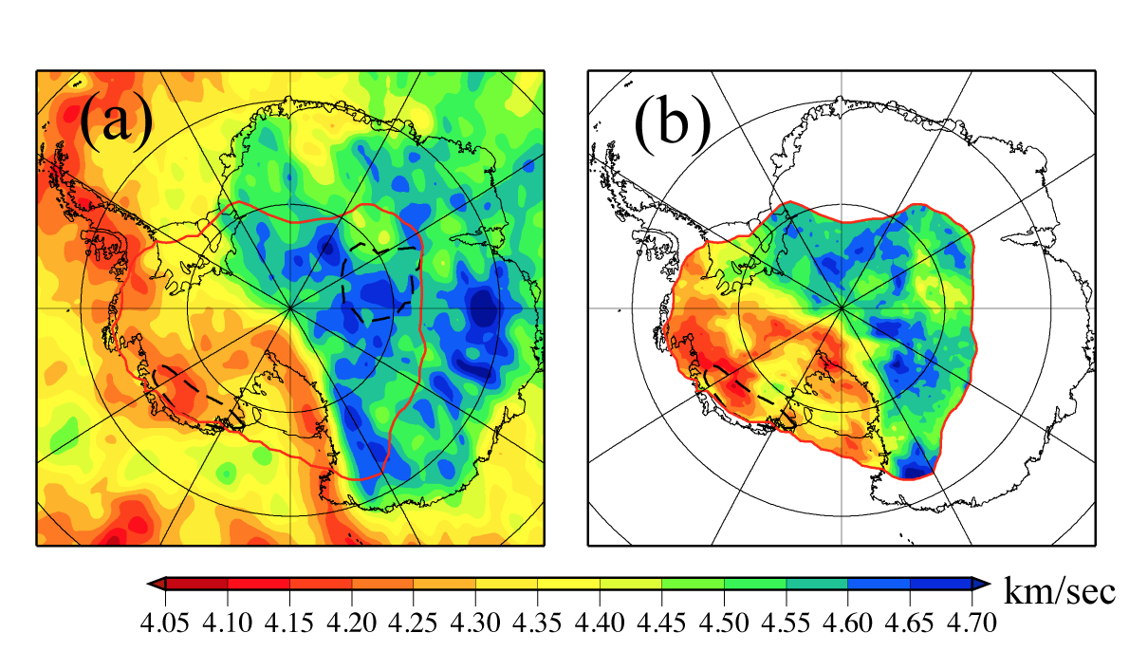

Fig. S1 Uppermost mantle structures from Lloyd et al., 2019 (a) and Shen et al., 2018 (b). Shear velocity (Vs) at 80 km is shown for both models. The red contour shows the region where Shen et al. 2018 model is available.

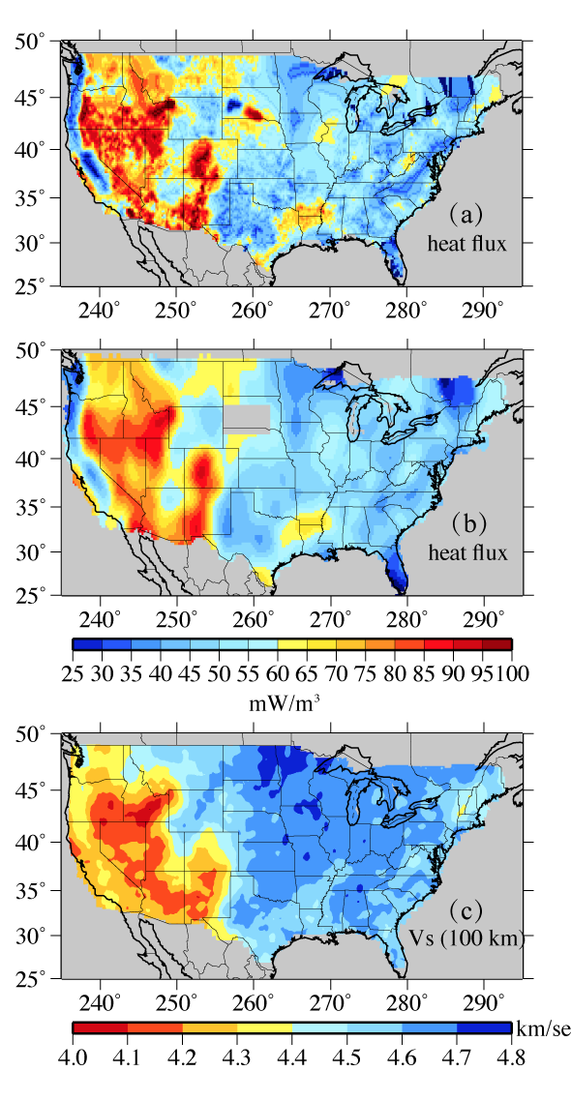

Fig. S2 Observed GHF map of North America: (a) raw map; (b) map which is Gaussian smoothed. The uppermost mantle seismic speed from Shen et al., 2016 is shown in (c). The grey area in S. Dakota in (b) is where the observed GHF is affected by local hydrothermal circulation.

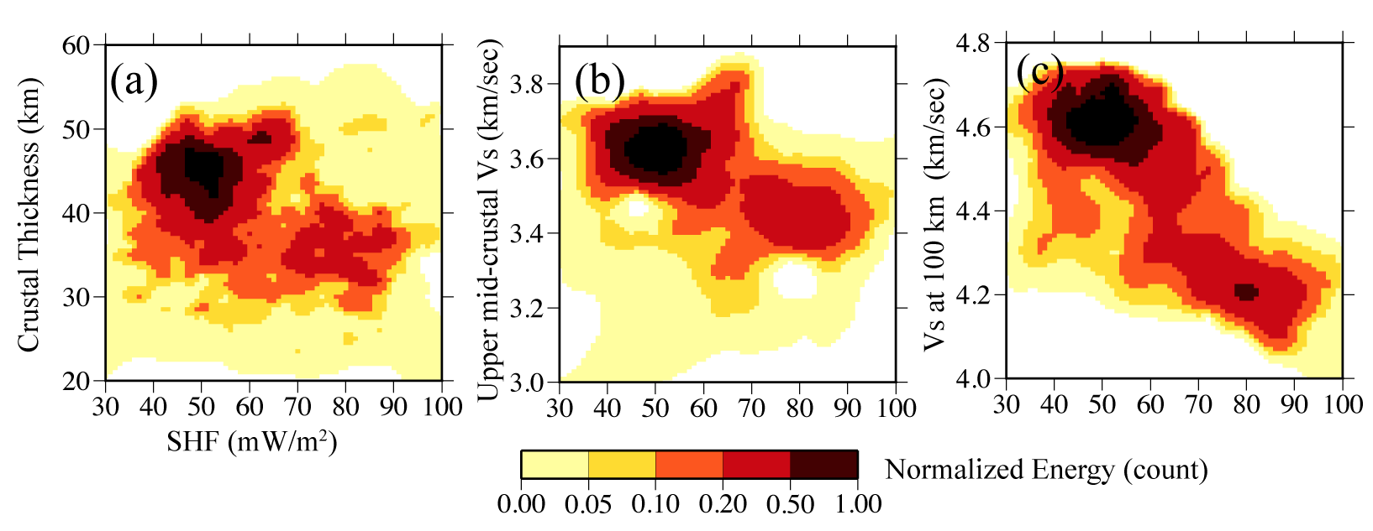

Fig. S3. 2-D histograms for North America surface heat flux and crustal thickness (a), crustal Vs (b), and Vs at 100 km (c). The GHF’s value is taken from the compiled map of Blackwell et al., 2011 shown in Fig. A2b.

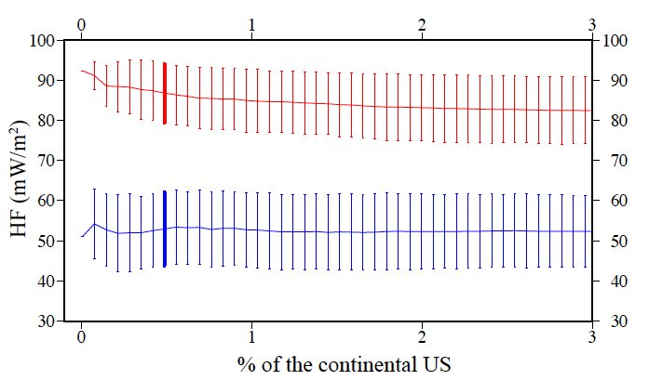

Figure S4. Average and standard deviation of the GHF estimate for the West Antarctica point (red curve and error bars) and the South Pole (blue curve and error bars) as a function of different definition of the structurally similar regions (SSR). The bold solid error bars show the average and standard deviation that are used to construct the GHF and uncertainty maps.



Figure S5. Comparison of the GHF map and uncertainties with earlier studies. Green line represents the TAM-PM front range which is regarded as the boundary between the West and East Antarctica. Earlier studies include the seismologically determined GHF maps (Shapiro and Ritzwoller, 2004) and geomagnetically determined maps (Fox-Maule et al., 2005 and Martos et al., 2017). Note that the regions with high GHF in the West Antarctica do not cross the TAM-PM front range in these geomagnetically determined maps, which did not take account of the lithospheric delamination beneath the Southern Transantarctic Mountains.

Reference List:

Dahl-Jensen, D., Morgan, V.I. and Elcheikh, A., 1999. Monte Carlo inverse modelling of the Law Dome (Antarctica) temperature profile. Annals of Glaciology, 29, pp.145-150.

Decker, E. R., and G. J. Bucher. "Geothermal studies in the Ross Island-Dry Valley region." Antarct Geosci 4 (1982): 887-894.

Dmitriev, Andrei N., Alexey V. Bolshunov, and Aleksei V. Podoliak. "Assessment of ice borehole temperature conditions at interface with subglacial Lake Vostok (Antarctica)." International Journal of Applied Engineering Research 11, no. 11 (2016): 7230-7233.

Gosnold, W.D., 1990. Heat flow in the Great Plains of the United States. *Journal of Geophysical Research: Solid Earth*, *95*(B1), pp.353-374.