

*Geochemistry, Geophysics, Geosystems*

Supporting Information for

**GlobSed: Updated Total Sediment Thickness in the World’s Oceans**

E. O. Straume1, C. Gaina1, S. Medvedev1, K. Hochmuth2, K. Gohl2, J. M. Whittaker3, R. Abdul Fattah4, J.C. Doornenbal4, J. R. Hopper5

1Centre for Earth Evolution and Dynamics, Department of Geosciences, University of Oslo, Norway.

2Alfred Wegener Institute, Helmholtz-Centre for Polar and Marine Research, Bremerhaven, Germany.

3Institute for Marine and Antarctic Studies, University of Tasmania, Hobart, Australia

4 TNO, The Geological Survey of the Netherlands, Utrecht, The Netherlands.

5Geological survey of Denmark and Greenland, Copenhagen, Denmark

**Contents of this file**

Text S1: Cubic polynomial analytical approximation models

Text S2: Description of individual drillsites in the Indian Ocean

Text S3: Comparison with NE Atlantic drillsites

Figure S1: Datasets used to compile the NE Atlantic sediment thickness grid

Figure S2: Analytical approximation formulas with higher number of terms

Figure S3: Comparison with drillsites in the NE Atlantic Ocean

**Additional Supporting Information**

Data Set S1: <http://earthdynamics.org/data>/GlobSed. (GlobSed)

Data Set S2: <http://earthdynamics.org/data>/GlobSed. (GlobAge_CEED)

**Introduction**

This supplementary material addresses

1. Location of datasets used to compile the NE Atlantic sediment thickness grid (Fig. S1).
2. How the analytical approximation (presented in the main text, section 4.3) improves only slightly when cubic polynomials with higher number of terms are introduced (Text S1, Fig. S2).
3. Additional information on ground-truthing our results using ODP and IODP sites (Text S2, Text S3, and Fig. S3).

The new global ocean sediment thickness grid, GlobSed netCDF grid is described as Dataset S1.

The new global age of oceanic lithosphere, GlobAge netCDF grid is described as Dataset S2.

Text S1: Higher order polynomials in sediment thickness approximation model.

The clear and simple tendencies of the sediment thickness distribution, such as thickness increasing with age, along the equator, and towards the higher latitudes, lead us to consider an analytical representation of sediment thickness. Goswami (2015) and Olson et al. (2016) approximated sediment thickness by cubic polynomial of oceanic lithosphere age considering ages of 100 Ma and older. Our age range is smaller and approximation by a single term of square root of age (see eq. 2, section 3.3 in the main text) works as good as a cubic polynomial. Below we show our approximation model determined by a cubic polynomial (eq. S1), as an alternative to equation 2 in the main text (see Fig. S1 for RMS values). The latitude dependence is a more complicated and thus we approximate this dependence by a cubic polynomial. There are also crossing terms which indicate variations of, e.g., changes of age dependence with latitude. The resulting dependence is calculated using the least square method:

 (S1)

Where *Z* is approximated sediment thickness in meters, *τ* is oceanic lithosphere age in Ma, and *λ* is latitude in radians. We use radians for latitude here normalize large powers of *λ* involved, this result also in the coefficients of approximately same orders and illustrates importance of each term in the equation.

Text S2: Inspection of individual outliers of the Indian Ocean Drillsites.

In the main text, we have presented a comparison between calculated bathymetry constructed using our analytical approximation of sediment thickness and observed drillsite bathymetry (Section 4.3). There are two prominent outliers marked 1 and 2 (Fig. 13) with 914 m and 1053 m mismatch, respectively. Number one is DSDP leg 28 site 274 in the Southern Ocean 250 km Northeast from Cape Adare, close to the Balleny Islands. Our calculated vs. the observed sediment thickness difference is 175 m, and the modeled oceanic lithospheric age is the same as the observed (~35.3 Ma), therefore, the major cause for the large difference of 1066 m originates elsewhere. From Figure 6 we see a positive residual bathymetry region of ~1000 m, which is not within our interpreted LIP regions. This excess residual high matches the low shear-wave velocity anomalies in the upper mantle and seamount distribution in the region, indicating that mantle dynamics plays a role (Wobbe et al., 2014). The second outlier is from ODP Leg 115 site 715 on the East Maldives Ridge. The mismatch here is the largest of all the drill sites (~1053 m). There are only 42 m difference between the calculated and observed sediment thickness, however, the difference in modeled vs. observed age is ~5 Myrs, which affects the calculated depth. Inspecting this site, we also discovered some inconsistencies in the location of the site provided by Sykes et al. (1998) and the location given initial scientific report by Backman et al. (1987), but this was corrected for. The drill sites lies at the eastern slope of a narrow ridge, so we suspect that the mismatch could be caused by gridding resolution, as the ridge may not be properly resolved by the gridded bathymetry.

Text S3: Comparison with NE Atlantic Drillsites

We inspect the NE Atlantic sediment thickness with respect to observations from drill sites using the same approach as for the Indian Ocean (section 4.2 in the main text). We have selected ten drill sites on oceanic lithosphere that provides information on the total sediment thickness and age of the oceanic basement within reasonable error (Fig. S3). Figure S3a shows a rather loose correlation between the observed drill site sediment thickness and the compiled gridded sediment thickness. The grid has generally higher sediment thicknesses than the observed sediment thicknesses measured at drill sites. Note that not all the selected wells reach basement and the grid should yield equal or higher sediment thicknesses. However, some drill sites show higher sediment thickness than the sediment thickness grid (see map in Figure S2).

Figure S3b and S3c shows the correlation of the observed and gridded age, and observed bathymetry and ETOPO1 bathymetry, respectively, where both correlate well. Note that we use ETOPO1 here and not GEBCO_2014 like in the Indian Ocean. This is because it correlates very well with the drill site measured bathymetry (Fig. S3c), so there was no need of using the most recent gridded bathymetry. Some drill site ages are younger than the gridded age, however, this is not surprising as many of the drill site-ages are derived from the oldest sediments, which must be younger than the igneous basement it rests upon.

We also compare our calculated sediment thickness with the observed sediment thickness which shows a good correlation slightly skewed towards higher observed sediment thickness (Fig. S3d). This is expected as some of the drill sites lies within 200 km from the continental margin which was excluded when deriving the formula used here because oceanic lithosphere near margins generally shows very high sediment thicknesses. Also, we use the global formula for oceanic lithosphere younger than 82 Myrs, which was derived excluding high northern and southern latitudes giving a weaker latitude dependence on calculated sediment thickness, that may influence the slightly low sediment thickness predictions.

Finally, Figure S3e shows our predicted bathymetry constructed using calculated sediment thickness correlates with the observed bathymetry with and without adding the residual bathymetry. We chose to add the residual signal of the entire NE Atlantic region because the bathymetry is anomalously shallow due to the dynamic support from the Iceland Plume, which presumably influence a region spanning several thousands of kilometers (e.g. Jones et al., 2014). This is visible in Figure S3e where our predicted bathymetry from normal thermal subsidence of oceanic lithosphere isostatically corrected with our calculated sediment thickness predicts way too deep bathymetry when the crustal and dynamic bathymetry-component is not accounted for.

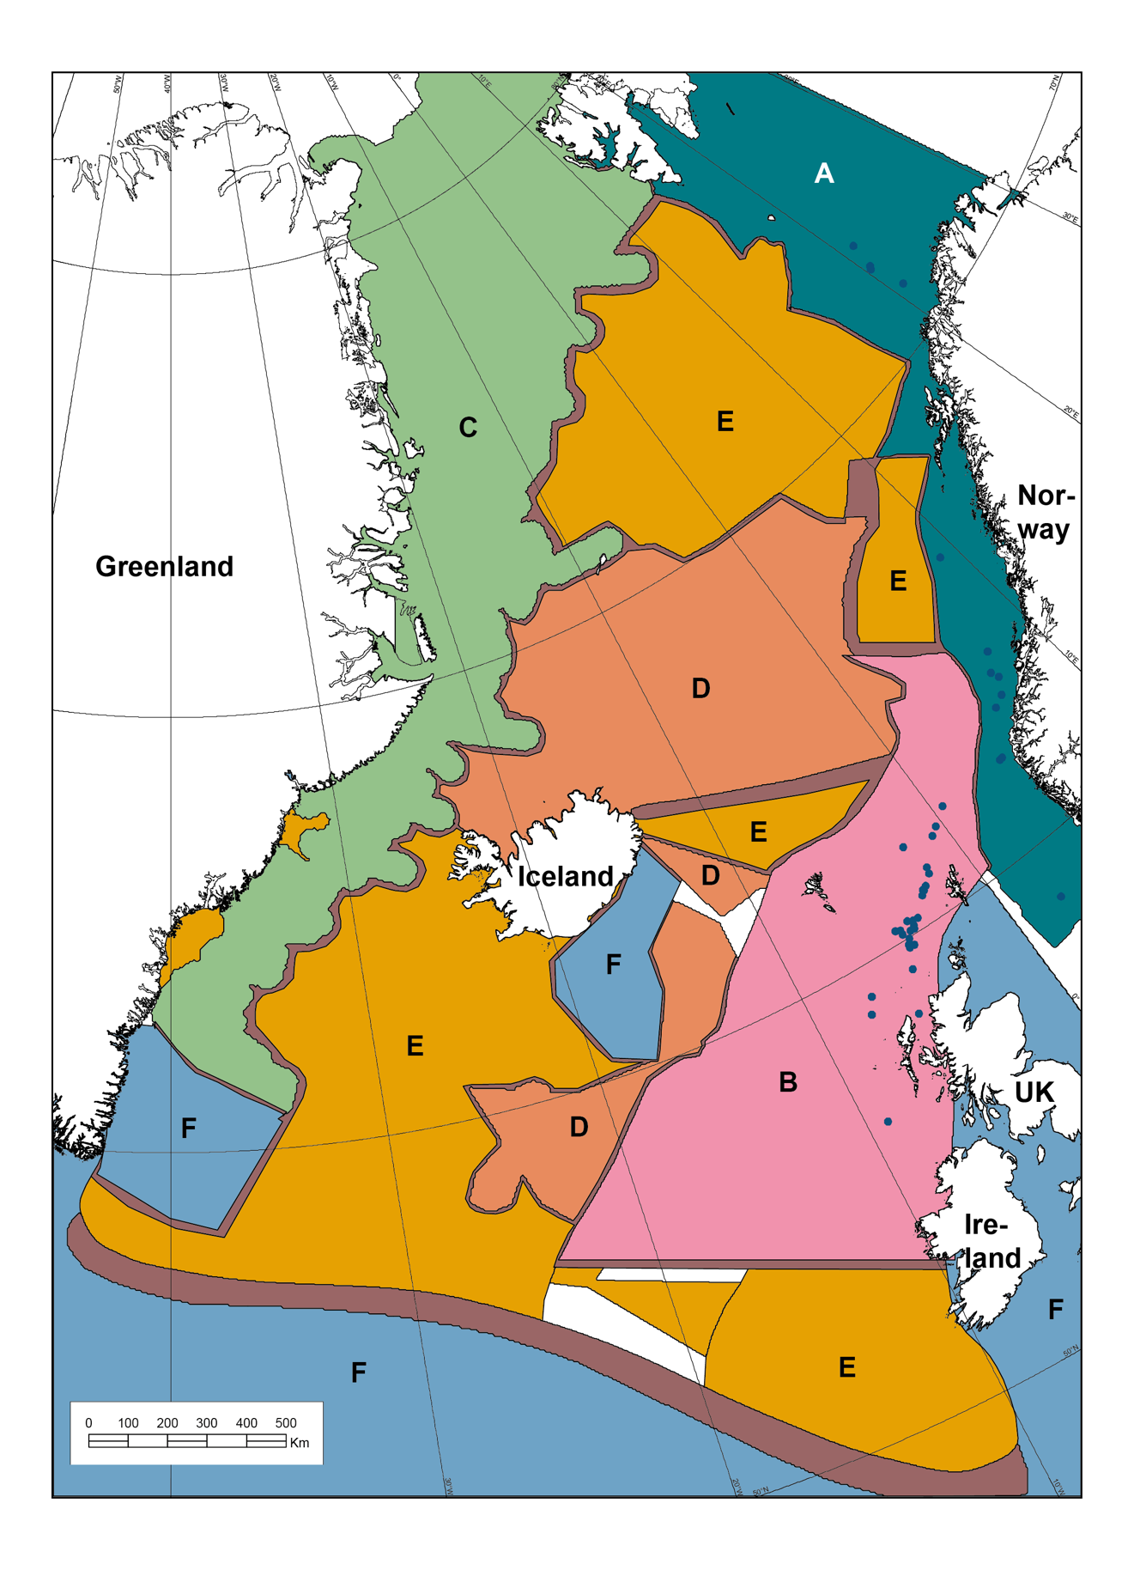

**Figure S1**. Sources of the grids used for compilation of the NE Atlantic total sediment thickness grid, modified from Hopper et al. (2014). Letters indicates the different sources listed in table 1 in the main text. A=Ebbing and Olsen (2009), B=BGS, C=GEUS/AWI, D=ISOR, E=NAG-TEC refraction data, F=Oakey and Stark (1995).

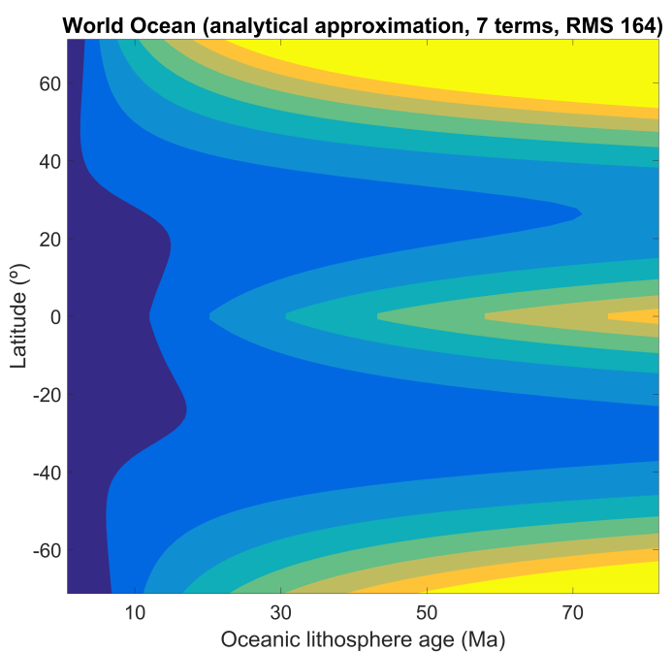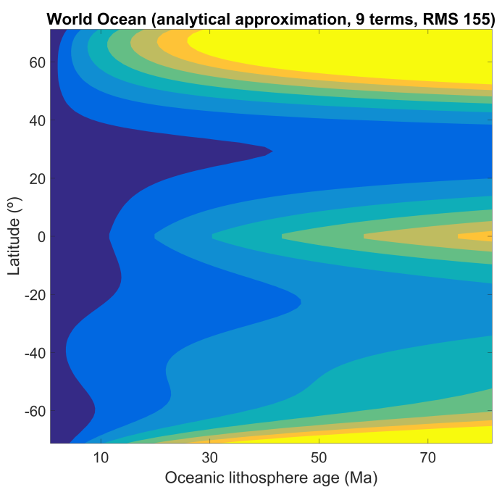

Figure S2. Any visible improvement of match average sediment thickness of 11a requires more complicated analytical impressions (at last double of free parameters compare to 11b).

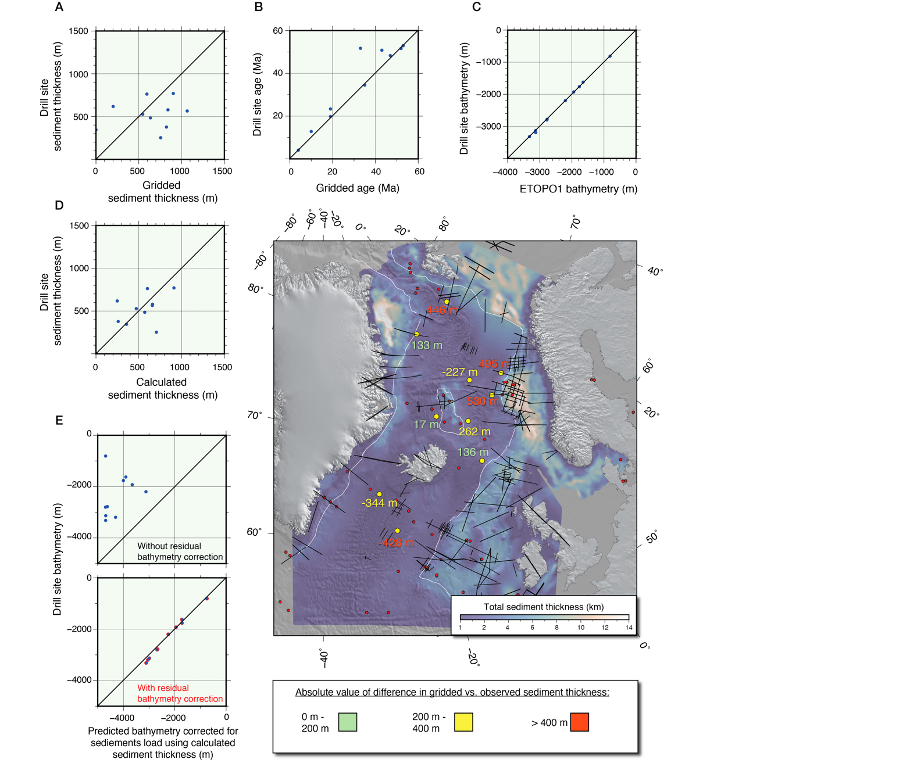

**Figure S3:** NE Atlantic drill site data plotted versus gridded and calculated data, shown with 1:1 linear regression line. The center map shows the drill sites and location of refraction lines used to identify depth to basement. The yellow circles are used in calculations here (numbers next to them shows the difference between the gridded and observed sediment thickness), red circles are locations of all other ODP/IODP/DSDP drill sites in the NE Atlantic Ocean. White lines are interpreted COBs. Background: transparent gridded sediment thickness draped on ETOPO1 bathymetry. A) Drill site sediment thickness versus gridded sediment thickness. B) Drill site age versus gridded age of the oceanic crust. Note that some of the dill sites are dated based on the oldest recovered sediment, which may yield too low observed ages. C) Drill site bathymetry plotted versus ETOPO 1 bathymetry. D) Drill site sediment thickness plotted versus calculated sediment thickness, using the formula for sediment thickness younger than 82 Ma. E) Drill site bathymetry vs. predicted bathymetry corrected for calculated sediment load, with and without adding the residual bathymetry.

Data Set S1.

<http://earthdynamics.org/data/GlobSed>

Total sediment thickness grid of the world’s oceans and marginal seas. 1 arc minute resolution, GMT netCDF format (32-bit float).

Data Set S2.

<http://earthdynamics.org/data/GlobSed>

Global oceanic lithospheric age grid. 1 arc minute resolution, GMT netCDF format (32-bit float).