LAB FINAL CODE

Set:A

A Line with DDA algorithm

Scaling the given triangle using 2D transformation

Submitted to:

S.M. Shahzad Hossain

Lecturer

Department of Computer Science and Engineering

Daffodil International University

Submitted by:

Md. Tanvir Hossain

ID: \*\*\*-\*\*-\*\*\*\*

Department of Computer Science and Engineering

Section: C



Daffodil International University

Dhaka, Bangladesh

Date of Submission: 03/08/2019

Question-1: Write a program to draw a line with DDA algorithm.

Solve:

#include<stdio.h>

#include<conio.h>

#include<graphics.h>

#include<math.h>

#include<dos.h>

int main()

{

float x,y,x1,y1,x2,y2,dx,dy,step;

int i,gd = DETECT, gm;

initgraph(&gd, &gm, "C:\\TC\\BGI");

printf("Enter the value of x1 and y1: ");

scanf("%f%f", &x1,&y1);

printf("Enter the value of x2 and y2: ");

scanf("%f%f", &x2,&y2);

dx = abs(x2-x1);

dy = abs(y2-y1);

if(dx>dy){

step = dx;

}

else{

step = dy;

}

dx = dx/step;

dy = dy/step;

x = x1;

y = y1;

i = 1;

while(i<=step){

putpixel(x,y,GREEN);

x = x + dx;

y = y + dy;

i = i+1;

delay(10);

}

getch();

closegraph();

return 0;

}

Output of question-1:

Taking input value

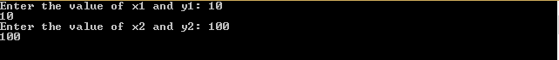

Output figure:



Question-2: Write a program to scale the given triangle using 2D transformation.

Solve:

#include<stdio.h>

#include<conio.h>

#include<graphics.h>

#include<math.h>

#include<dos.h>

int main()

{

int x3,y3,x1,y1,x2,y2,sx,sy,ch;

int i,gd = DETECT, gm;

initgraph(&gd, &gm, "C:\\TC\\BGI");

printf("Enter the value of 1st coordinate x1 and y1: ");

scanf("%d%d", &x1,&y1);

printf("Enter the value of 2nd coordinate x2 and y2: ");

scanf("%d%d", &x2,&y2);

printf("Enter the value of 3rd coordinate x3 and y3: ");

scanf("%d%d", &x3,&y3);

line(x1,y1,x2,y2);

line(x2,y2,x3,y3);

line(x1,y1,x3,y3);

printf("Enter the value of scaling factor sx and sy : ");

scanf("%d%d", &sx,&sy);

printf("Your option >>\n1. Zoom In\n2. Zoom out");

scanf("%d",&ch);

switch(ch){

case 1:

cleardevice();

setcolor(YELLOW);

line(x1\*sx,y1\*sy,x2\*sx,y2\*sy);

line(x2\*sx,y2\*sy,x3\*sx,y3\*sy);

line(x1\*sx,y1\*sy,x3\*sx,y3\*sy);

break;

case 2:

cleardevice();

setcolor(YELLOW);

x1 = abs(x1/sx);

y1 = abs(y1/sy);

x2 = abs(x2/sx);

y2 = abs(y2/sy);

x3 = abs(x3/sx);

y3 = abs(y3/sy);

line(x1,y1,x2,y2);

line(x2,y2,x3,y3);

line(x1,y1,x3,y3);

break;

default:

printf("Wrong choice !");

break;

}

getch();

closegraph();

return 0;

}

Output of Question-2:

Taking Input:

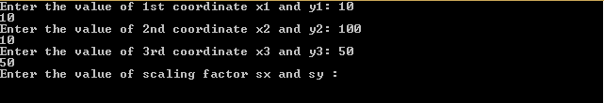

Original Triangle:



Option:

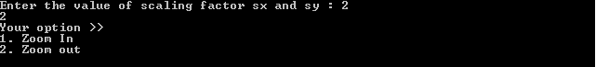

Zoom In:

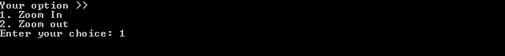

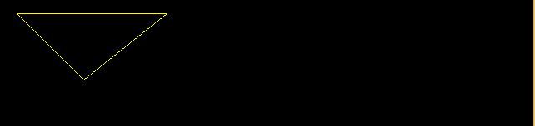

Zoom out:



