**LINUX COMMANDS**

**1.Pwd**: - Displays the current working directory.

**2.Ls:** Displays information about files in the current directory.

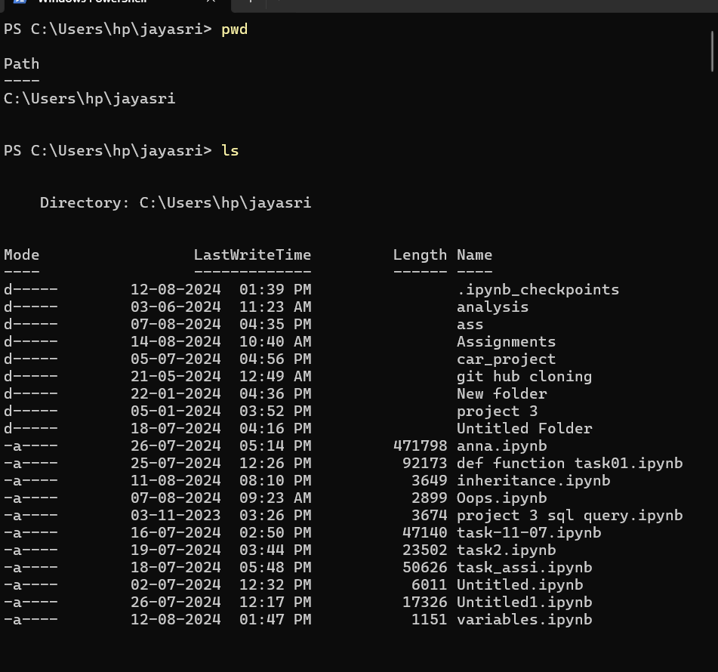

**3.Mkdir:** Creates a directory.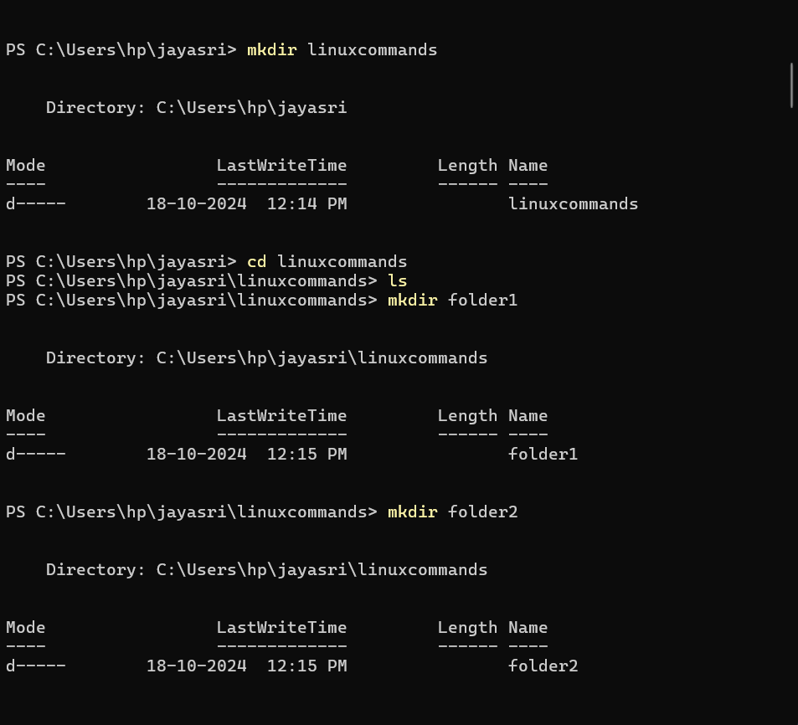

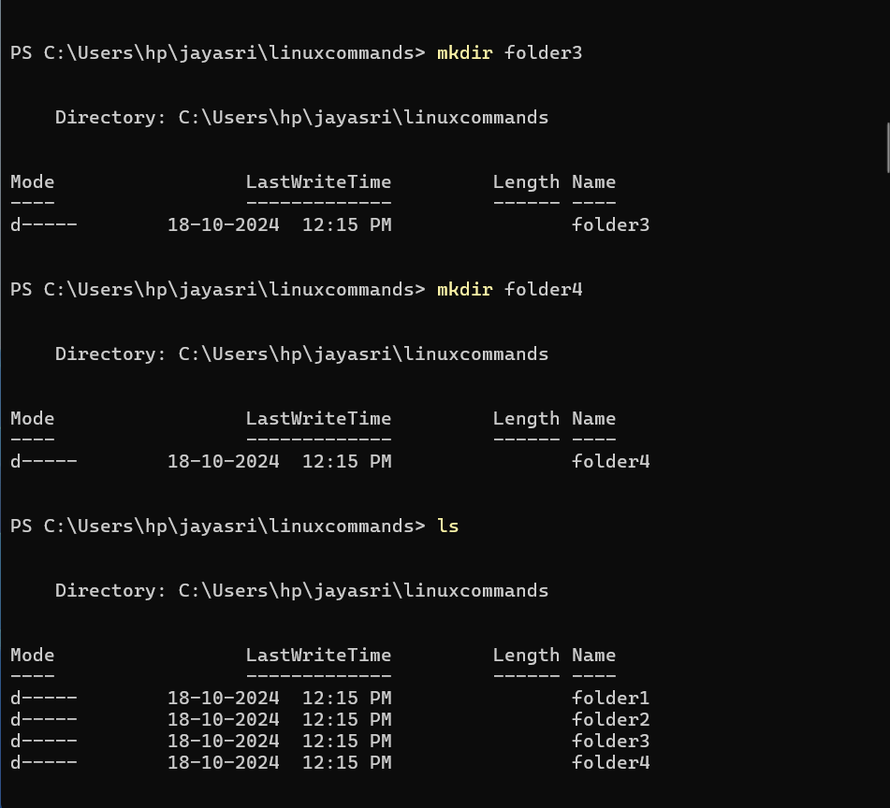

4.Cd: To navigate between different folders.

5.Cat: creates a file.

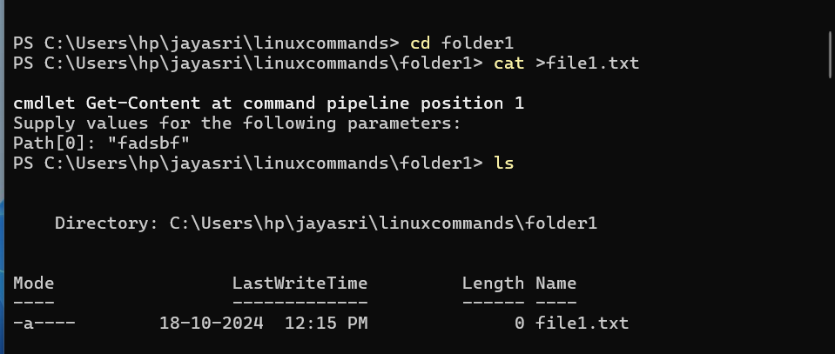

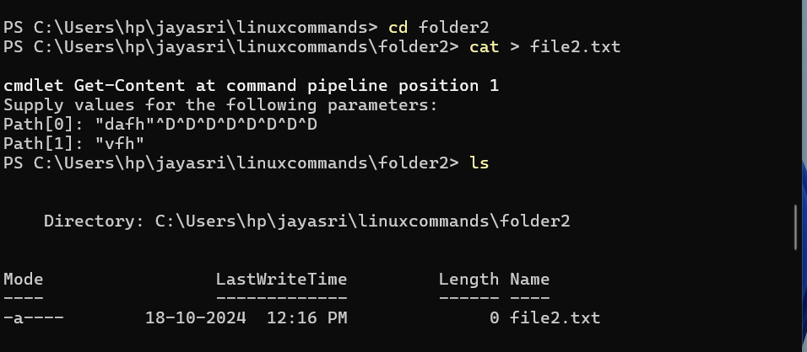

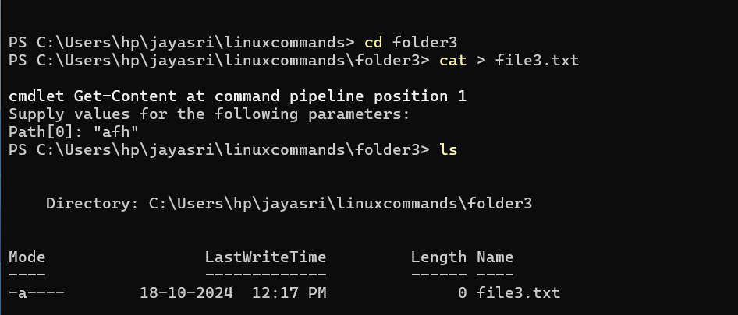

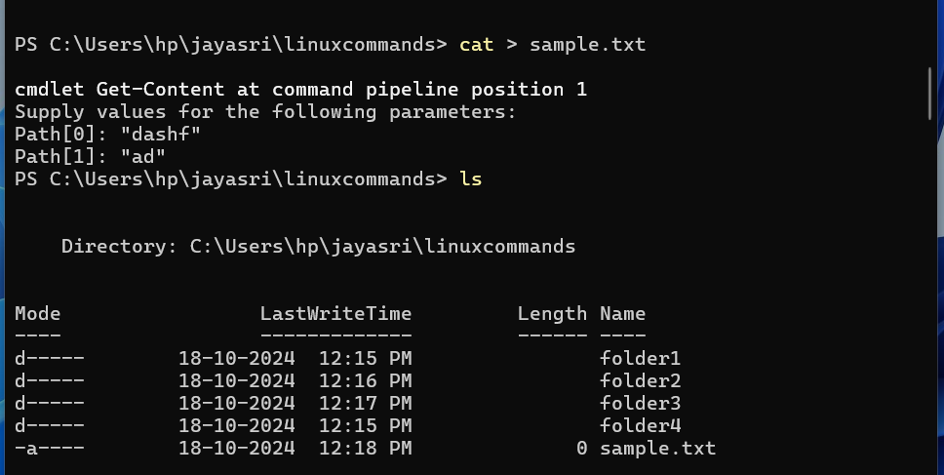

6.Mv: move folder one place to another place.

Mv souce_folder to Destination_folder

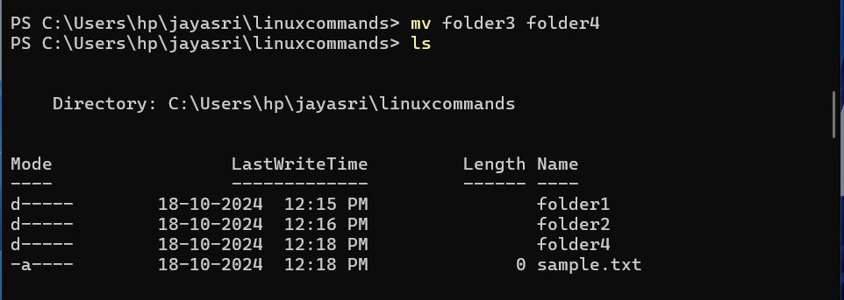

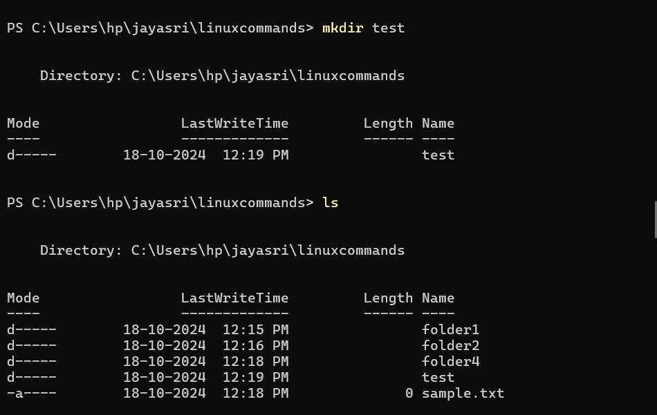

7.Cp: copy files/folders

Cp source_folder to destination_folder.

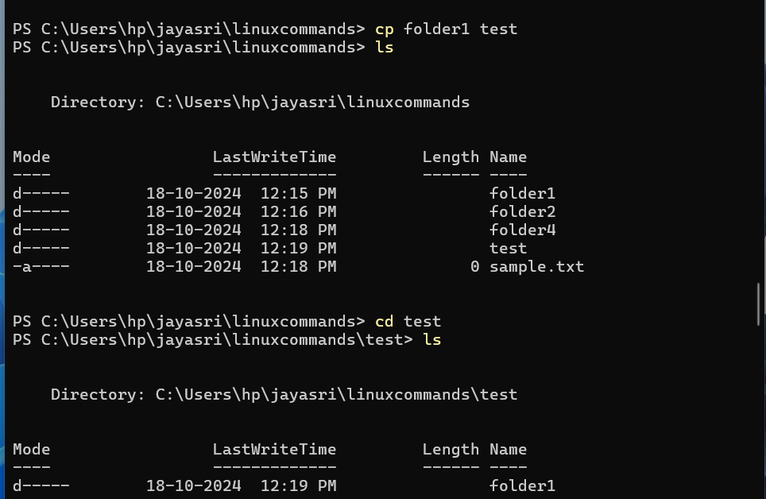

8.Cp: Copy files/folders

Copy source file to destination folders

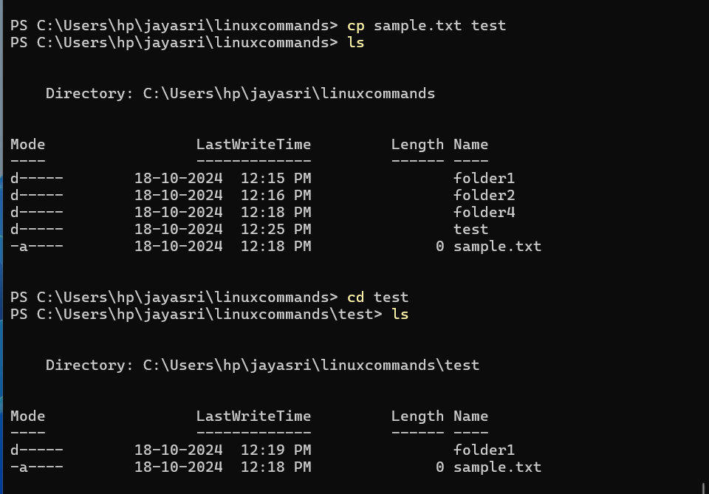

9.Cd .. :- change directory to backwards.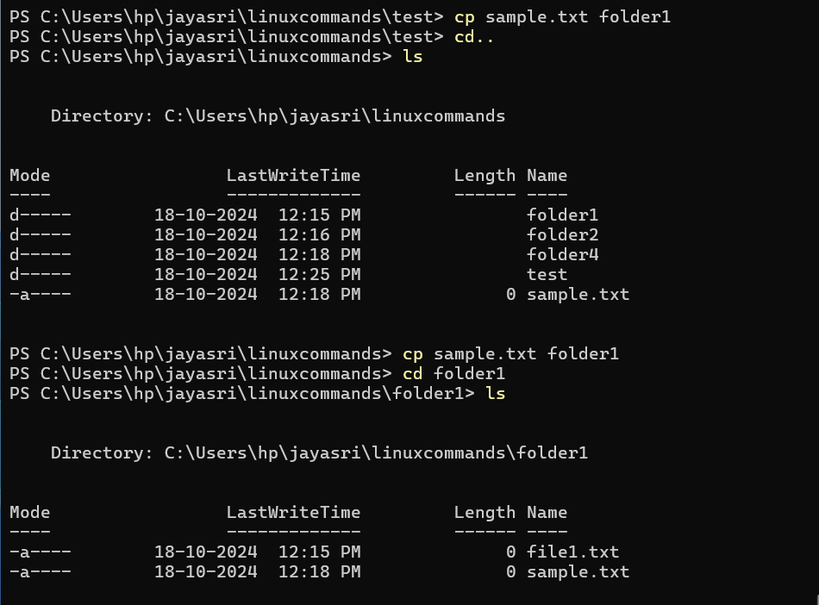

10.Rmdir :-- Removes empty directories from the directory lists.

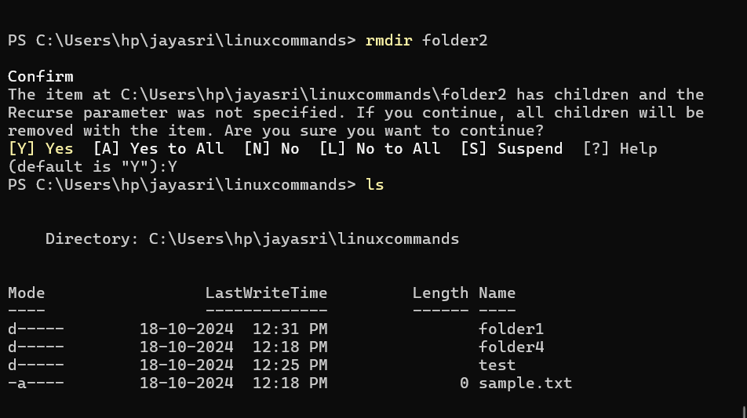

11.Rm :-- Delete files

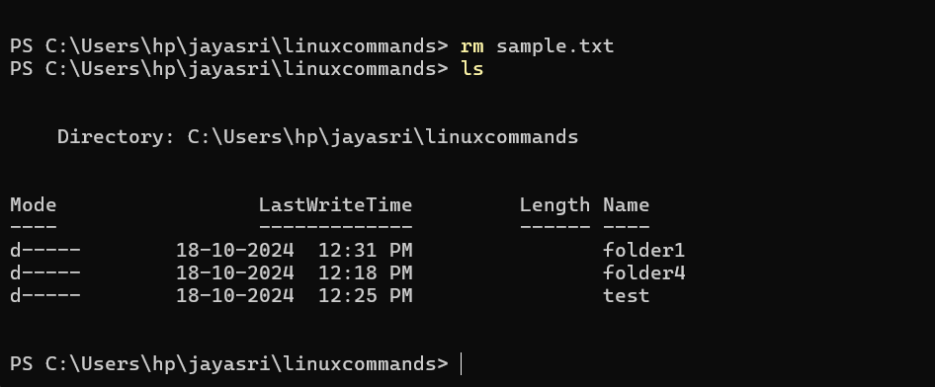

12.Clear: -- Clear terminal

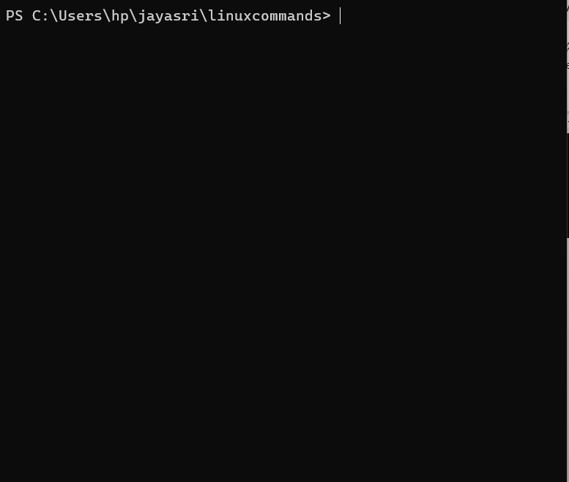s