**Installing and running Solr standalone server**

Step 1: download Solr 6.1 from below URL

<http://archive.apache.org/dist/lucene/solr/6.1.0/solr-6.1.0.zip>

Step 2: copy **default** directory from

<<Hybris Home>>/config/solr/instances/default/configsets

to

<<Solr Home>>/server/solr/configsets/

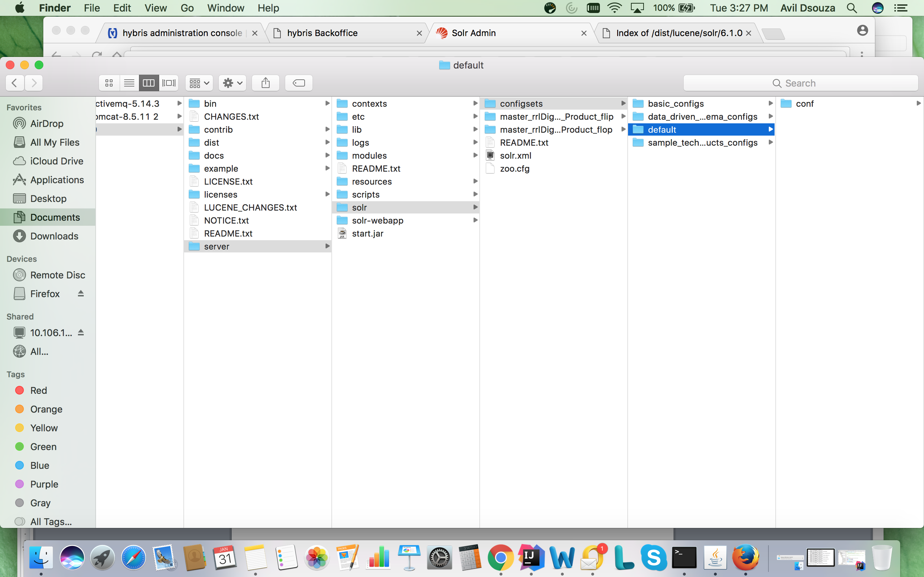

Step 3: Open schema.xml from the path

<<Solr Home>>/server/solr/configsets/default/conf/

comment all the lines which have class = “de.hybris….

Step 4: Open solrconfig.xml from the path

<<Solr Home>>/server/solr/configsets/default/conf/

comment all the lines which have “de.hybris….

Step 5: Hybris 6.X runs Solr server as standalone server on port 8983. But Solr is packaged with Hybris. This step will prevent Hybris to run Solr as part of Hybris server start.

Open local.properties from the path

<<Hybris Home>>/config/

update the file with below line and save the file

#Solr config

solrserver.instances.default.autostart=false

Step 6: Run Solr server

Execute below command on directory <<Solr Home>>/bin

Solr start –p 9992

Now Solr server will start on port 9992.

Step 7: Build and run Hybris

Step 8: Import Solr.impex

Note: Please update the url in Solr.impex to point to Solr server and port (which you have specified at step 6).

Example :

**INSERT_UPDATE SolrEndpointUrl;**solrServerConfig(name)[unique=**true**]**;**url[unique=**true**]**;**master[unique=**true,**default=**false**]  
**;**$serverConfigName**;**http**:**//localhost**:**9992/solr**;true**