Question
Chapter 03: Avoiding the Problems

Question 1

Who are the main players in an IS development project?

Three main types of player are involved in an IS development project:
- Those who will benefit from the system’s outputs, directly or indirectly (end-users)
- Those who commission the project, pay for it or have the power to halt it (owners or sponsors)
- Those who will produce the software (developers)

Question 1

What are the main phases of general problem-solving model? Mention objective of each phase?

The main phases of general problem-solving model:
- Data gathering
- Problem redefinition
- Finding ideas
- Finding solutions
- Implementation

Data Gathering and Problem Redefinition is concerned with understanding what the problem is about.

Problem redefinition attempts to identify ideas that help us to understand more about the nature of the problem and possible solution.

Finding solution is concerned with providing a solution.

Implementation puts the solution into practice.

Question 2

Show the general problem solving model in a figure.

General problem-solving model can be viewed as in figure below:
Problem definition
Data gathering
Problem Redefinition
Finding Ideas
Finding Solution
Implementation
Figure: General problem solving model

Question 3

What are main tasks in information systems development process?

The information system development process may be subdivided into three main tasks:
- Identifying what is required.
- Planning how to deliver what is required.
- Delivering what is required.

Question 4

Mention the advantages of subdividing the development process?

Answer:

An advantage of subdividing the development process is that techniques and skills required specific to the different phases can be identified. Teams of developers with these specialized skills can be allocated to the particular phases or activities, maximizing the chance of that the activities are completed as well as possible.

Subdividing the development process results in smaller tasks and smaller tasks can be managed more easily to achieve the appropriate quality standards and to stay within the allocated resource budget.

Question 5

What is life cycle model?
Life cycle model: Subdividing the process of software development process is known as a life cycle model.

Question 6

Differentiate systems development and software development.

Answer:

Systems development incorporates human, software and hardware elements and, Software development is primarily concerned with software systems. Thus software development focused solely on producing a software system that will satisfy the user requirements whereas systems development has a wider scope and may not even include software as a part of solution.

Question 7

What are the two activities those are carried out before start of IS development project to ensure the developed system will be appropriate for the organization? Mention their purposes.

Answer:

The two activities precede the information systems development project are – Strategic information systems planning and Business modelling

Strategic Information Systems Planning: It is carried out in order to strategic plans are developed for the organization are developed as a whole and within their context a strategic view of information systems needs can be formed.
Business Modelling: It is carried out in order to determine how an information system can support a particular business activity.

Question 8

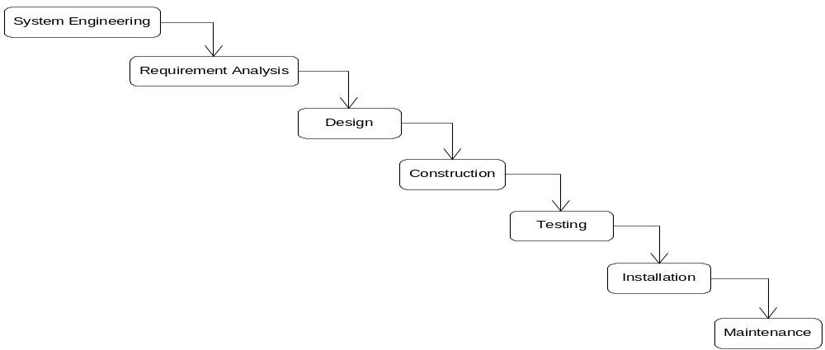Show the traditional life cycle model in a figure.

Question 9
Name the phases of Waterfall life cycle model. Mention activities (objectives) and deliverables in each phase.

The phases of Waterfall life cycle model are:
- System Engineering
- Requirement analysis
- Design
- Construction
- Testing
- Installation
- Maintenance

The table below shows activities and deliverables of each step:
Phase | Activities (Objectives) | Deliverables
System Engineering | To identify major requirements for the system  Then to identify those parts of the system that are best implemented in software, those parts that are best implemented in hardware and those parts that should be allocated to human participants | High Level Architectural Specification
Requirement Analysis | Those parts will be implemented in software is main focus in this phase. Objective is to find what the users require from the software elements. Various fact-finding techniques are used here. | Requirements Specification  Functional Specification  Acceptance Test Specifications
Design | To determine how best to construct a system delivers the requirements identified in earlier stage.  To define the specification of the software architecture and relationships of various software components | Software architecture specification  System test specification  Design specification  Sub-system test specification  Unit test specification
Construction | To translate the completed design into program code | Program code
Testing | To test the system that it satisfies the user requirements accurately and completely. Individual components are tested first, then are tested together as a sub-system, then sub-systems are tested together as a whole system. User may perform some acceptance testing. | Unit test report  Sub-system test report  System test report  Acceptance test report  Completed system
Installation | To deliver and install the system for use | Installed System
Maintenance | To correct errors in the system  To complete those components those have not yet been fully implemented  To accommodate change in requirement changed due to change in environment | Change requests  Change request report

Question 10
Write down the advantages and disadvantages of TLC.

Advantages of TLC:
- Teams with specialized skills can be assigned to tasks in particular phases.
- Project progress evaluated at the end of each phase.
- Attendant risk can be controlled and managed.
Disadvantages of TLC:
- Real projects rarely follow such a simple sequential life cycle.
- Iterations are almost inevitable.
- Time elapses between system engineering and the final installation.
- The design is unresponsive to business changes during the project.

Question 11

What are corrective maintenance, perfective maintenance, and adaptive maintenance?

Answer:
Corrective maintenance: The delivered system may operate erroneously and various corrections may have to be made to the software. These are called corrective maintenance.
Perfective maintenance: Certain aspects of the system may have not been fully implemented for cost or time constraints for instance and these are completed in during maintenance phase. These are called perfective maintenance.
Adaptive maintenance: The operating environment of the system may change causing requirement changes and these are accommodated throughout the maintenance phase. These are called adaptive maintenance.

Question 12
What is a prototype? Mention advantages and problems of prototyping.

Prototype: A prototype is a system or a partially complete system that is built quickly to explore some aspects of the system requirements. It is not intended as the final working system.
Advantages of prototyping:
- Early demonstrations of system functionality help identify any misunderstandings between developer and client.
- Client requirements that have been missed are identified.
- Difficulties in the interface can be identified.
- The feasibility and usefulness of the system can be tested, even though, by its very nature, the prototype is incomplete.
Problems with prototyping:
- The client may perceive the prototype as part of the final system.
- The prototype may divert attention from functional to solely interface issues.
- Prototyping requires significant user involvement.
- Managing the prototyping life cycle requires careful decision making.

Question 13
What are the phases of USDP?
Main phases of USDP
- Inception is concerned with determining the scope and purpose of the project
- Elaboration focuses requirements capture and determining the structure of the system
- Construction's main aim is to build the software system
- Transition deals with product installation and rollout

Question 14
How can the users be involved in a information system development project?
Answer:
Users can be involved in various ways
- User can be part of the development team so that they have a significant opportunity to influence how development process proceeds and can identify difficulties, suggest alternatives.
- Users can be involved as participants in fact gathering.
- Users can be involved through consultative purpose

Question 15

What is a methodology?

Methodology: A methodology consists (comprises) of an approach to software development, a set of techniques and notations that supports the approach, a life cycle model to structure the development process and a unifying set of procedures.

Question 16
What is case tool? Write down typical features provided by the CASE tool

CASE tool: Computer aided software engineering (CASE) tools that can execute, animate, and translate models are becoming more readily available. Upper-CASE tools provide support for the analysis and design. Lower-CASE tools are connected with the construction and maintenance of software.

CASE tools typically provide a range of features including:
      - checks for syntactic correctness
      - repository support
      - checks for consistency and completeness
      - navigation to linked diagrams
      - layering
      - traceability
      - report generation
      - code generation
      - system simulation
      - performance analysis

