s
PassengerId Pclass
Name
Sex Age SibSp Parch
Ticket
0
892
3
Kelly, Mr.
James
male 34.5
0
0
330911
Wilkes,
Mrs. James (Ellen Needs)
Myles,
Mr. Thomas Francis
Next steps: Generate code with s
New interactive sheet

from google.colab import drive
drive.mount('/content/drive')
Drive already mounted at /content/drive; to attempt to forcibly remoun
import numpy as np import pandas as pd
s=pd.read_csv('/content/drive/MyDrive/Tuhin_1370_Final/Titanic - Mach

1 | 893 | 3
2 | 894 | 2

female | 47.0 | 1 | 0 | 363272
male | 62.0 | 0 | 0 | 240276

3 | 895 | 3 | Wirz, Mr.  Albert | male | 27.0 | 0 | 0 | 315154
Hirvonen,
Mrs.
4 | 896 | 3 | Alexander (Helga E Lindqvist) | female | 22.0 | 1 | 1 | 3101298

import numpy as np import pandas as pd
import matplotlib.pyplot as plt import seaborn as sns

from sklearn.model_selection import train_test_split
from sklearn.preprocessing import LabelEncoder, StandardScaler
from sklearn.metrics import classification_report, confusion_matrix,

from sklearn.linear_model import LogisticRegression from sklearn.neighbors import KNeighborsClassifier from sklearn.tree import DecisionTreeClassifier

from sklearn.ensemble import RandomForestClassifier from sklearn.svm import SVC
df = pd.read_csv('/content/drive/MyDrive/Tuhin_1370_Final/Titanic - M print("Shape:", df.shape)
df.head()
Shape: (418, 11)
PassengerId Pclass
Name
Sex Age SibSp Parch Ticket
Fa
0
892
3
Kelly, Mr.
James
male 34.5
0
0 330911 7.82
1
893
3
Wilkes,
Mrs. James (Ellen Needs)
female
47.0
1
0 363272 7.00
Next steps: Generate code with df
New interactive sheet
data = df.copy()

# Remove duplicates
data = data.drop_duplicates()

# Fill missing values data['Age'].fillna(data['Age'].median(), inplace=True) data['Fare'].fillna(data['Fare'].median(), inplace=True)
data['Embarked'].fillna(data['Embarked'].mode()[0], inplace=True)

# Drop Cabin (too many missing) if 'Cabin' in data.columns:
data.drop(columns=['Cabin'], inplace=True) data.isnull().sum()

/tmp/ipython-input-3510454086.py:7: FutureWarning: A value is trying t The behavior will change in pandas 3.0. This inplace method will never

For example, when doing 'df[col].method(value, inplace=True)', try usi

data['Age'].fillna(data['Age'].median(), inplace=True)
/tmp/ipython-input-3510454086.py:8: FutureWarning: A value is trying t The behavior will change in pandas 3.0. This inplace method will never

For example, when doing 'df[col].method(value, inplace=True)', try usi

data['Fare'].fillna(data['Fare'].median(), inplace=True)
/tmp/ipython-input-3510454086.py:9: FutureWarning: A value is trying t The behavior will change in pandas 3.0. This inplace method will never

For example, when doing 'df[col].method(value, inplace=True)', try usi

data['Embarked'].fillna(data['Embarked'].mode()[0], inplace=True)

0
PassengerId 0
Pclass 0
Name 0
Sex 0
Age 0
SibSp 0
Parch 0
Ticket 0
Fare 0

Embarked 0

dtype: int64

drop_cols = ['PassengerId','Ticket','Name'] for col in drop_cols:
if col in data.columns: data.drop(columns=[col], inplace=True)

data.head()


Next steps: Generate code with data
New interactive sheet
le = LabelEncoder()
data['Sex'] = le.fit_transform(data['Sex'])

# One-hot for Embarked
data = pd.get_dummies(data, columns=['Embarked'], drop_first=True)

data.head()
Next steps: Generate code with data
New interactive sheet
Pclass | Sex | Age | SibSp | Parch | Fare | Embarked
0 3 | male | 34.5 | 0 | 0 | 7.8292 | Q
1 3 | female | 47.0 | 1 | 0 | 7.0000 | S
2 2 | male | 62.0 | 0 | 0 | 9.6875 | Q
3 3 | male | 27.0 | 0 | 0 | 8.6625 | S
4 3 | female | 22.0 | 1 | 1 | 12.2875 | S

Pclass | Sex | Age | SibSp | Parch | Fare | Embarked_Q | Embarked_S
0 3 | 1 | 34.5 | 0 | 0 | 7.8292 | True | False
1 3 | 0 | 47.0 | 1 | 0 | 7.0000 | False | True
2 2 | 1 | 62.0 | 0 | 0 | 9.6875 | True | False
3 3 | 1 | 27.0 | 0 | 0 | 8.6625 | False | True
4 3 | 0 | 22.0 | 1 | 1 | 12.2875 | False | True

# Separate features and target
X = data.drop('Sex', axis=1) y = data['Sex']

# Standard Scaling
scaler = StandardScaler()
X_scaled = scaler.fit_transform(X)

# Train–Test Split
X_train, X_test, y_train, y_test = train_test_split( X_scaled,
y, test_size=0.20, random_state=42, stratify=y
)

X_train.shape, X_test.shape

((334, 7), (84, 7))
def evaluate_model(model, X_test, y_test, model_name): y_pred = model.predict(X_test)

print(f"\n===== {model_name} =====")
print("Classification Report:\n", classification_report(y_test, y

cm = confusion_matrix(y_test, y_pred) sns.heatmap(cm, annot=True, fmt="d", cmap="Blues") plt.title(f"{model_name} - Confusion Matrix") plt.show()

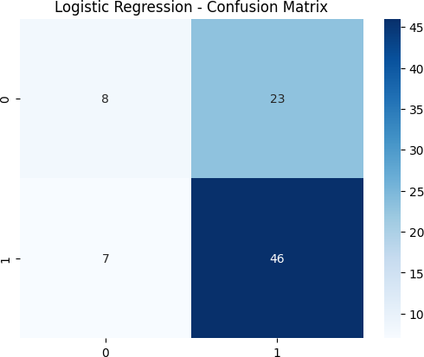
log_model = LogisticRegression() log_model.fit(X_train, y_train)
evaluate_model(log_model, X_test, y_test, "Logistic Regression")

===== Logistic Classification | Regression Report: precision | =====  recall | f1-score | support
0 | 0.53 | 0.26 | 0.35 | 31
1 | 0.67 | 0.87 | 0.75 | 53
accuracy |  |  | 0.64 | 84
macro avg | 0.60 | 0.56 | 0.55 | 84
weighted avg | 0.62 | 0.64 | 0.60 | 84

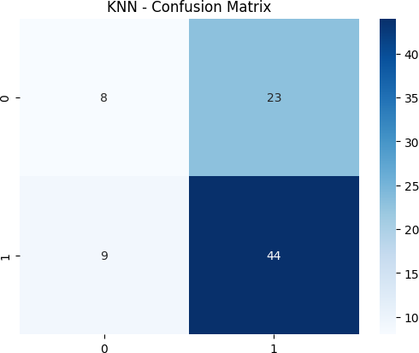
knn = KNeighborsClassifier(n_neighbors=5) knn.fit(X_train, y_train) evaluate_model(knn, X_test, y_test, "KNN")

===== KNN =====
Classification Report:
precision recall f1-score support

0 0.47 0.26 0.33 31
1 0.66 0.83 0.73 53
accuracy 0.62 84
macro avg 0.56 0.54 0.53 84
weighted avg 0.59 0.62 0.59 84

dt = DecisionTreeClassifier() dt.fit(X_train, y_train)
evaluate_model(dt, X_test, y_test, "Decision Tree")

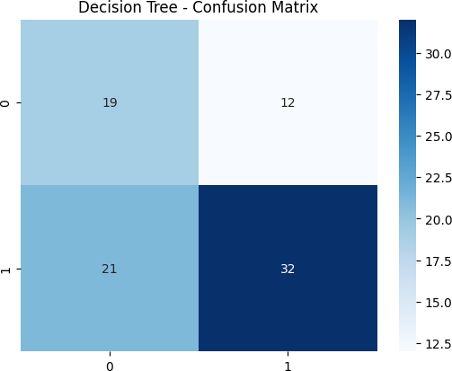
===== Decision Classification | Tree ===== Report: precision | recall | f1-score | support
0 | 0.47 | 0.61 | 0.54 | 31
1 | 0.73 | 0.60 | 0.66 | 53
accuracy |  |  | 0.61 | 84
macro avg | 0.60 | 0.61 | 0.60 | 84
weighted avg | 0.63 | 0.61 | 0.61 | 84

rf = RandomForestClassifier() rf.fit(X_train, y_train)
evaluate_model(rf, X_test, y_test, "Random Forest")

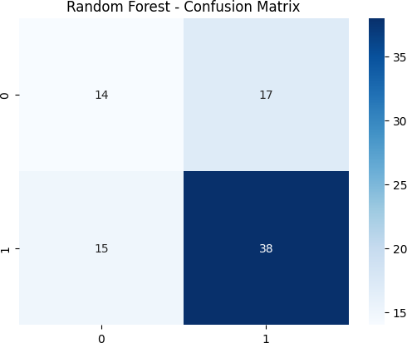
===== Random Forest =====

Classification | Report: precision | recall | f1-score | support
0 | 0.48 | 0.45 | 0.47 | 31
1 | 0.69 | 0.72 | 0.70 | 53
accuracy |  |  | 0.62 | 84
macro avg | 0.59 | 0.58 | 0.59 | 84
weighted avg | 0.61 | 0.62 | 0.62 | 84

svm = SVC(probability=True) svm.fit(X_train, y_train) evaluate_model(svm, X_test, y_test, "SVM")

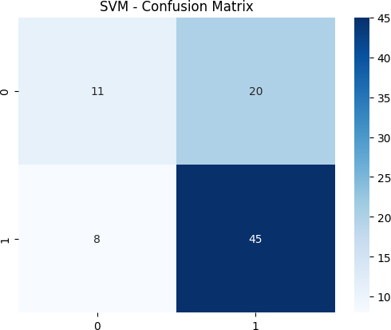
===== SVM =====  Classification | Report: precision | recall | f1-score | support
0 | 0.58 | 0.35 | 0.44 | 31
1 | 0.69 | 0.85 | 0.76 | 53
accuracy |  |  | 0.67 | 84
macro avg | 0.64 | 0.60 | 0.60 | 84
weighted avg | 0.65 | 0.67 | 0.64 | 84

y_pred_prob = log_model.predict_proba(X_test)[:,1]

fpr, tpr, _ = roc_curve(y_test, y_pred_prob) roc_auc = auc(fpr, tpr)

plt.plot(fpr, tpr, label=f"AUC = {roc_auc:.3f}") plt.plot([0,1], [0,1], linestyle="--") plt.xlabel("False Positive Rate") plt.ylabel("True Positive Rate")
plt.title("ROC Curve - Logistic Regression") plt.legend()
plt.show()

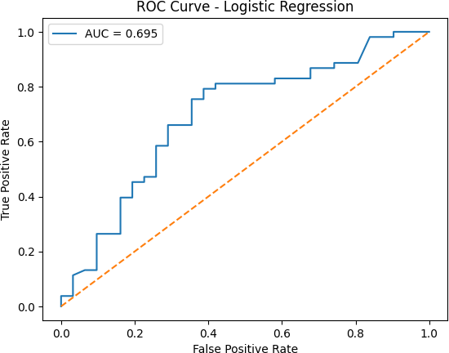
df.hist(bins=20, figsize=(10,6)) plt.show()

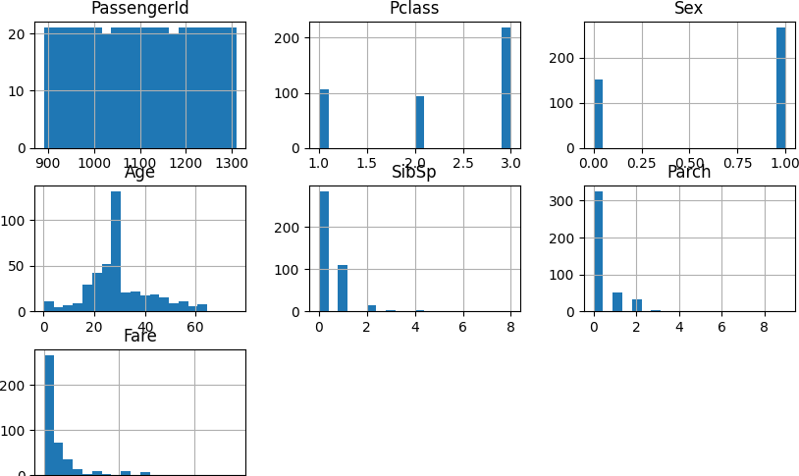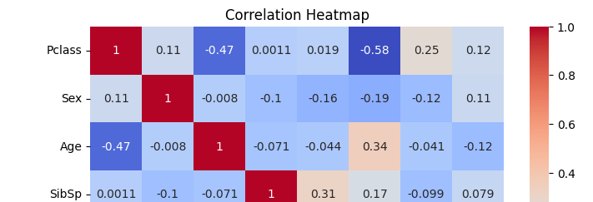

plt.figure(figsize=(8,6))
sns.heatmap(data.corr(), annot=True, cmap="coolwarm") plt.title("Correlation Heatmap")
plt.show()

