ABM Coursework Report

Modelling hospital-acquired infections

Mateusz Iwo Dubaniowski*[1]*

PhD Researcher

Future Resilient Systems – Singapore-ETH Centre

31 January 2016

# Introduction

The aim of this report is to describe the work undertaken as part of the Agent-Based Modelling (ABM) coursework, and to demonstrate, together with the accompanying MATLAB simulation file, the understanding of the topic. We take the approach learned throughout the course, and apply this approach to a real-life situation. We apply the agent-based approach to model spreading of hospital-acquired infections (HAIs). This allows us to better understand the problem, and derive solutions or guidelines that could help in tackling the problem of HAIs in the future. Similarly, the model described in this report can be used to predict the optimal hospital set-up for a set of specific initial conditions.

This report is accompanied by a MATLAB simulation file *main.m*, which contains the simulation model. Furthermore, a version tracking tool *git* is used with a public *github* repository, which can be accessed via the following link:

<https://github.com/mduban/ABMProject>

“*stable*” branch is the repository branch to be used for the purpose of assessment of this report and coursework.

# Research problem

In this section, we describe the problem selected for the coursework. We define what hospital-acquired infections are. Furthermore, we present the motivation for modelling how hospital-acquired infections spread, and what issues in this field could be solved with modelling.

## What are hospital-acquired infections (HAIs)?

Hospital-acquired infections, also known as HAIs, or nosocomial infections are defined as infections acquired in hospitals and other healthcare facilities. To be classified as a nosocomial infection, the patient must have been admitted for reasons other than the infection. He or she must also have shown no signs of active or incubating infection. (Stubblefield)

## Motivation

Hospital-acquired infections are becoming a major problem for healthcare providers in the developed world. Especially, since patients tend to live longer and attend more procedures than ever at hospitals. As such, the exposure of patients and staff to other patients is increasing. This results in more and more HAIs being contracted by patients while they remain in hospitals for unrelated treatments or tests.

It is estimated that in 2011, 75’000 patients in the US died due to hospital-acquired infections. 4% of all patients admitted to hospitals in the US contract at least one hospital-acquired infection. (Centers for Disease Control and Prevention) These numbers signify that it is not a marginal issue and that significant improvements in preventing hospital-acquired infections can be achieved.

Furthermore, it is widely understood that bedding arrangements in hospital wards have a large influence on how HAIs spread. The number of beds in a hospital ward, and the frequency of turnover of patients both influence the rate of spread of HAIs. (Ellison)

Therefore, we model the spread of HAIs in hospitals based on the bedding arrangement used in the hospital and the ratio of staff to patients. Specifically, we look at how spreading of HAIs changes with varying numbers of beds in hospital wards. This would improve our understanding of how hospital-acquired infections spread, and will allow us to facilitate better hospital design and management strategies.

## Objective

Our objective is to devise an agent-based model that accurately represents spreading of hospital-acquired infections in a hospital. The model achieves this for a particular, specified design of hospital wards, and a given number of beds in each room. This model will then be utilized to see what bedding arrangements in wards are the most beneficial to combating hospital-acquired infections. Furthermore, the simulation could also be compared, in the future, with empirical data to verify how accurate the model is.

Moreover, this model would allow us to come up with an ideal ratio of staff to patients, and an ideal number of beds per ward. Similarly, it would help us to devise an optimal number of sanitary facilities in a hospital and their desired locations.

# Model

In this section, we present the model that we devised and implemented to simulate the spreading of hospital-acquired infections. This is an agent-based model, which uses the cellular automata approach to model HAIs in a given hospital environment. The hospital environment in this case is understood as the outline of a hospital floor together with a number of beds prescribed to each ward, and a given total number of staff (medical and otherwise) attending these wards.

To model spreading of infections in a hospital we use a model based on the SIRS (Susceptible-Infected-Recovered-Susceptible) model. This allows us to monitor the total number of patients that are at any point infected, and at the same time to monitor the number of patients that are not infected yet, or which have only just recovered.

In our model, we use the following guiding principles and general assumptions about the hospital environment:

* Hospital is modelled as a grid of rooms containing a fixed number of *n* patients and varying number of staff.
* Infection spreads to susceptible patients or staff through interaction i.e. remaining in the same room as an infected person with a given probability.
* Staff moves between rooms, patients stay immobilized.
* No interaction between separate rooms.
* Recovered patients become susceptible eventually. This happens soon after recovery.
* Staff carries infections between separate rooms.
* Staff should attempt to go through sanitary process to disinfect themselves.

The above assumptions reflect the real-life principles behind infections spreading in a hospital. Hospitals consist of many wards, which consist of different numbers of beds. These wards are attended by various numbers of staff. Persons remaining in the same room can contract infections from each other. This is reflected in the above principles.

Similarly, staff can move between different wards and thus spread infections. Patients remaining in bed can only infect those around them without spreading the infection to other parts of a hospital. Rooms are tightly sealed so that there is no possibility of contracting infection from one room to another other than through a member of staff carrying it on their body or outfit. Recovered patients become susceptible almost immediately, as HAIs are in fact often different unrelated and independent infections.

There is also a sanitary process protocol in place. Staff should attempt to conform to the protocol but this is not always practical and feasible. Therefore, the model reflects the fact that staff members might attend the sanitary room or might decide to skip it. The above principles are graphically presented on Figure 1. We can see on the figure a sample hospital enviornment, where staff can move freely around the hospital, attending to patients in wards. The wards have different numbers of beds. Also, there is a sanitary room, where staff can disinfect themselves to prevent them from spreading infections further.

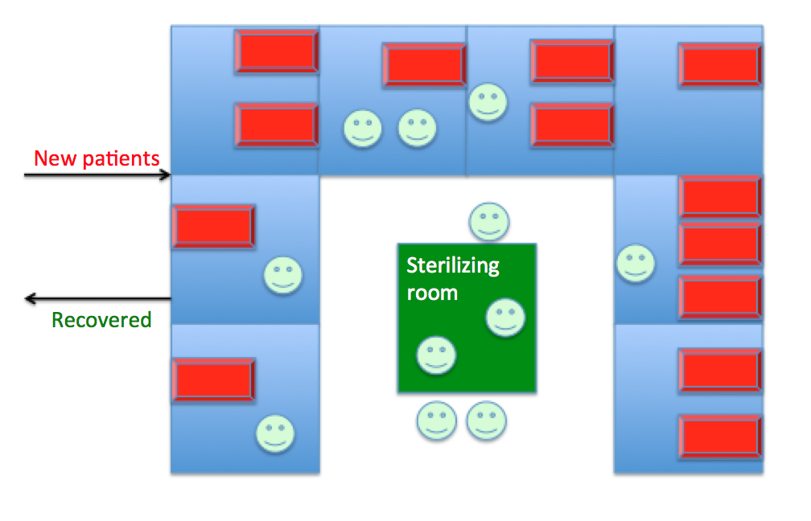

Figure 1: Hospital environment

In our model patients and staff member are both agents. Both these groups have different properties and this is represented in the MATLAB simulation. We use one matrix to keep track of all the agents. The matrix is called *agents* in our MATLAB simulation. Each row of the matrix corresponds to one agent, while columns signify what type is a given agent (patient or staff), their location (room number), and their state (Susceptible, Infected, Recovered). A sample of this matrix can be seen on Figure 2. We see from the figure that the first column signifies whether it is a staff member or a patient, second column states agent’s location, and third column informs us of the agent’s status.

Similarly, an outline of the hospital – a map of the hospital is represented as a matrix stating, which wards contain how many beds and where they are located. This matrix is called *WARDSMAP* in our MATLAB simulation.

To use the agent-based modelling technique, we iterate in the simulation over time. The number of steps is defined by *TIMESTEPS* constant. Subsequently, we iterate over agents. While iterating over agents, the MATLAB script checks for different charactersistics of the agent. Based on these characteristics, the status of infection of the agents is updated. There are distinct probabilities defined in MATLAB file that specify state transition probabilities of agents.

Furthermore, there is a probability specified, with which the staff members enter and perform disinfection in the clean room. Attending the clean room results in immediate transfer from infected to recovered state.

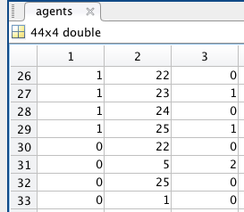Similarly, there is a probabilities matrix – *movementProbMat* – which defines probabilities of transfer of staff agents from one cell of the map to another. This simulates the hospital staff walking around a hospital attending to various patients.

Figure 2: Matrix keeping track of the agents - *agents* matrix

To sum up, in Table 1, we specify paramters that could be varied in the model with their descriptions. We also specify default values for these parameters that we used in the simulation unless noted otherwise.

Table 1: Simulation parameters

|  |  |  |
| --- | --- | --- |
| **Parameter Name** | **Description** | **Value** |
| TIMESTEPS | How long the simulation runs? | 200 |
| NSTAFF | Number of staff | 15 |
| WARDSMAP | Map of wards in hospital with beds per ward | varied |
| infectionPatient | Probability of patient getting infected | 0.1 |
| infectionStaff | Probability of staff getting infected | 0.05 |
| recoverPatient | Probability of patient recovering | 0.1 |
| recoverStaff | Probability of staff recovering | 0.8 |
| recoverStaffCleanRoom | Probability of staff recovering in clean room | 1 |
| susceptiblePatient | Probability of patient becoming susceptible again | 0.8 |
| susceptibleStaff | Probability of staff becoming susceptible again | 0.92 |
| movementProbMat | Probability of matrix of transitions between wards | random |

# Results

In this section, we present some of the results that we obtained when running the above model with a specific set of paramters. Moreover, we suggest further improvements to the model that could make it more accurate and reliable.

To present the results, we use a heatmap, where colours correspond to different numbers of infected patients in each ward at each given point in time. The heatmap is complemented with a graph of number of agents with each status versus time. This graph is being drawn in real-time, and shows how the number of infected patients varies as simulation progresses.

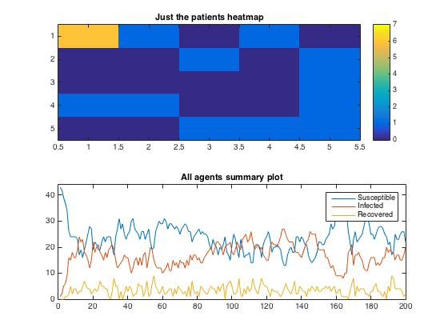

Figure 3: Heatmap and graph of infections vs. time for one large 7-bed ward and rest small 1-bed wards

On Figure 3, we can see how the infection spreads through a hospital, when the map of the hospital is as shown on Figure 4. We can see from Figure 4, that there is one room in the top left corner containing 7 beds, and the other wards contain only one bed per ward. This map allows us to produce the simulation in accordance with principles described in the previous chapter. The results suggest that in such environment, hospital-acquired infections will spread continously with no foreseeable end. We can see that the number of infected patients stabilizes around 20 and remains such for the whole duration of the simulation. Consequently, we can conclude that such a hospital setup is not beneficial to decreasing the prevalance of HAIs.

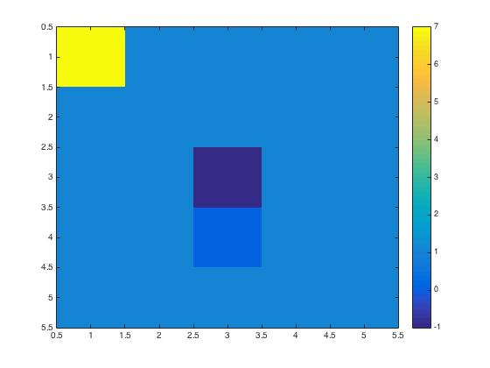

Figure 4: Map of the hospital with one 7-bed ward and rest 1-bed wards

To find out an optimal setup, or number of beds per ward, we vary the map of hospital in the simulation. By looking at the graph of infected patients, we can deduce, wether such setup is beneficial in the given hospital setting. Below, on Figure 5, a graph showing a more optimal setup is presented. We can see that the infection becomes eradicated at around 100 timesteps. This map was simulated 10 times, each time presenting similar results. This result allowed us to infer that such setup is beneficial to limiting the spread of HAIs. On Figure 6, we can see the map of a hospital for Figure 5 results.

The simulation in MATLAB together with analysis of results such as presented above enables us to derive a recommended number of hospital beds per ward. This could be done by running several maps with different numbers of beds per ward each. After running the simulation with various maps, we noticed that the threshold tends to be at 3-bed and 4-bed wards. For 3-bed wards most of the runs ended with HAI being eradicated after 200 timesteps, while for 4-bed wards HAIs still remained in circulation after 200 timesteps. This result suggests that hospital wards with 3-beds or less are significantly less prone to an HAI epidemic.

The above results hold true for the probabilities and parameters presented in Table 1. Variation of these parameters influences the simulation outcomes. The extent to which these paramters coincide with actual values is debatable, and further investigations and observations of these parameters in hospital settings would be required to arrive with accurate values. Moreover, a consultation with field experts would help in ensuring the reliability of these parameters.

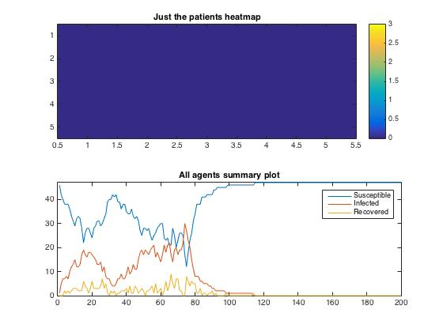

Figure 5: Heatmap after 200 timesteps, and a graph of infections vs. timesteps for a hospital map of 3-bed and 2-bed wards.

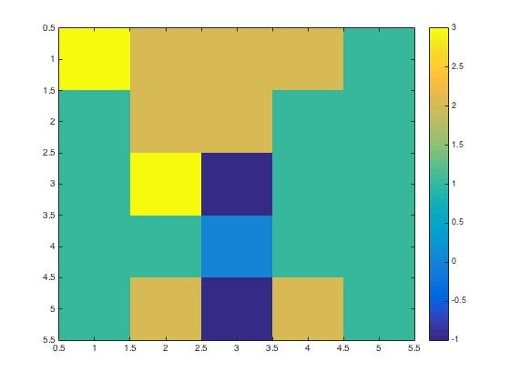

Figure 6: Map of hospital with 3-bed, 2-bed, and 1-bed wards only

# Conclusions

In this chapter, we present summary of the project. Furthermore, we present conclusions derived from the project, and suggest further work that could be carried on the subject.

Hospital-acquired infections (HAIs) are a serious issue in modern hospitals. These infections contribute to many diseases and reduced standard of healthcare at many facilities. It is estimated that 4% of patients admitted into US hospitals acquire a HAI.

We developed a MATLAB simulation model following the agent-based modelling principles that simulates spreading of HAIs within hospitals of a particular outline of wards and number of beds per ward. The model uses various parameters for acquiring the infection and simulating transfers between wards. These parameters, when established correctly would allow us for a given hospital design arrive with the optimal number of beds in wards that would prevent spreading of hospital acquired infections. These depend on various factors which could differ from hospital to hospital and an expert input along with observation of the environment would be required to devise correct parameters.

Our model would help to design better hopsitals, which reduce the spread of HAIs. Similarly, it would allow to arrive with the number of beds per ward for a given hospital design that reduces the spread of hospital acquired infections. For the paramters used in this report, the threshold between HAIs spreading indefinitely, and HAIs diminishing before 200 timesteps of simulation showed up to be between 3-bed wards and 4-bed wards. This suggests that reducing the number of beds per ward to 3, we can decrease the risks of HAIs spreading throughout the hospital significantly.

## Future work

Finally, we present several ideas that could contribute to the project and extend its scope. These could be implemented in the next stage of the project, time permitting:

* Validation of parameters – validating simulation parameters with expert opinions and observation of hospital environment.
* Introducing mechanism for isolating infected patients – in real-life setting of a hospital infected patients might be attempted to be isolated from the general population of the hopsital. This mechanism could be introduced into the simulation.
* Paramters drawn from a distribution – each of the simulation parameters could be drawn from a distribution devised specifically for this parameter.
* New/discharged patients – introducing a mechanism to simulate new patients entering the hospital as well as patients being discharged.

# Bibliography

Stubblefield, Heaven. Healthline. Ed. George Krucik. 16 01, 2014. 18 01, 2016 <http://www.healthline.com/health/hospital-acquired-nosocomial-infections#Overview1>.

Centers for Disease Control and Prevention. Healthcare-associated Infections (HAIs). 15 10, 2015. 18 01, 2016 <http://www.cdc.gov/HAI/surveillance/>.

Ellison, Jennifer et al. “Hospital ward design and prevention of hospital-acquired infections: A prospective clinical trial.” The Canadian Journal of Infectious Diseases & Medical Microbiology 25.5 (2014): 265-270.

1. iwo.dubaniowski@frs.ethz.ch