1) **Agency Name**

Open Pantry Community Services/Loaves and Fishes Community Kitchen

The Salvation Army Food Pantry

The Care Center

Macedonia Church

Home City Housing/ Liberty Hills Townhomes

Amherst Survival Center

Community Survival Center

Open Pantry

The Gray House Market

Christina’s House

Stone Soup Café & Community Free Store

Parish Cupboard

Martin Luther King Jr Family Services, Inc.

Longmeadow Food Pantry (Longmeadow Adult Center)

Boys & Girls Club of Chicopee

Seniority House

Ronald McDonald House of Springfield

Domus OUR HOUSE

Franklin County Community Meals Program

Springfield Housing Authority

First Baptist Church Food Pantry

Northampton Survival Center

**4) What type of Agency are you?**

Forms response chart. Question title: 4) What type of Agency are you? Check all that apply
. Number of responses: 22 responses.

7) **Has the number of clients you serve changed in the past year?**

Forms response chart. Question title: 7) Has the number of clients you serve changed in the past year?
. Number of responses: 22 responses.

**8) If the answer to Question 7 is "Yes", please tell us by how much in raw number or percent. Please indicate if your answer is a raw number (ie. 200/week) or a percent (ie. 45%/wk).**  
(14 responses)

We are serving more than 100 individuals/month than last year and that is a raw number

About 30%

Overall 54% increase in the number of clients served between 2023 and 2024 (looking at first 6 months)

N/A

Increase of 150 households per month

Increase of about 8 - 12% across both programs

10% in both operations yearly, % 100% over last three years

We are up by about 9% in overall unique individuals.

50%/month

**9) Do you expect your # of clients to change in the next year?**

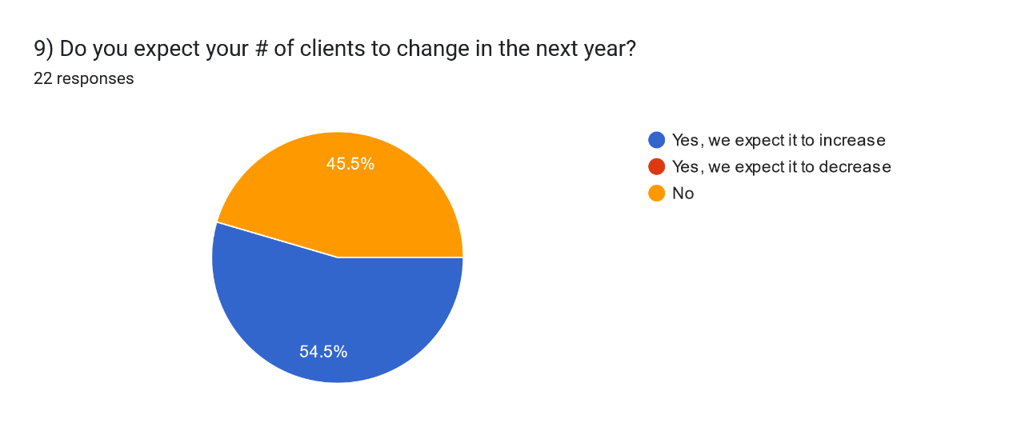

**10) If the answer to Question 9 is "Yes" please tell us by how much in raw number or percent. Please indicate if your answer is a raw number (ie. 200/week) or a percent (ie. 45%/week).**

**(**12 responses)

This raw number is an estimate - probably another 50/month

100-200 per month

N/A

25%

Given the current economy we expect to see at least a 5% increase

10% year

Since we are on an upward trend, I would guess that the numbers may continue to rise, but there is really no way to know.

20%

10%

about 25-30%

50 % or more we are becoming a food pantry

approx. 5 per week (it's been steadily increasing over the past month; expected to continue when students return).

**11) In the past year have you purchased equipment, expanded your facility, or otherwise made changes allowing you to accept Food Types you couldn’t previously accept or that would allow you to accept more of a Food type?**

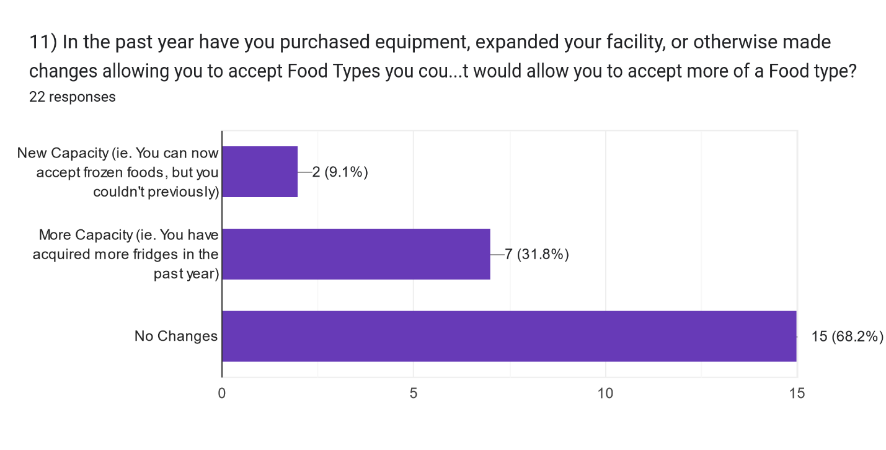

**12) Please indicate how many of each type of food storage equipment you have currently.**

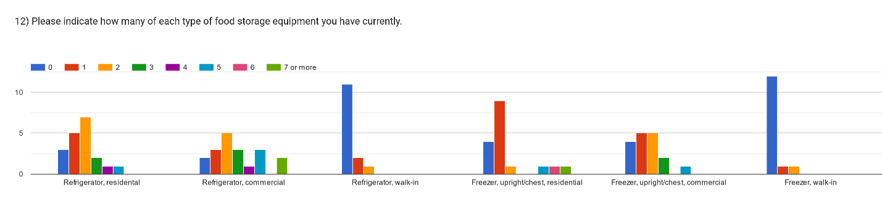

**13) Please check every food type you are able to accept.**

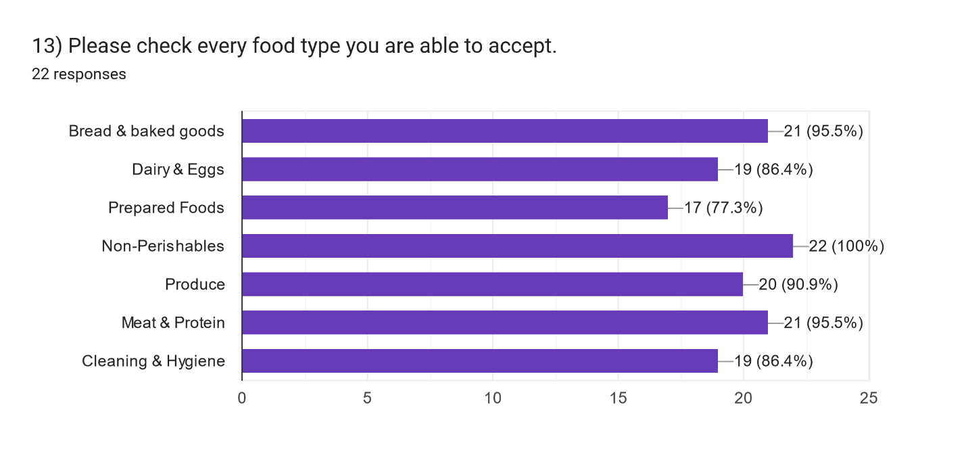

**14) Relative to your ability to accept different food types are there particular food types you want more of or less of because of the client population you serve or the amount you receive from all sources (not just Rachel’s Table)?**

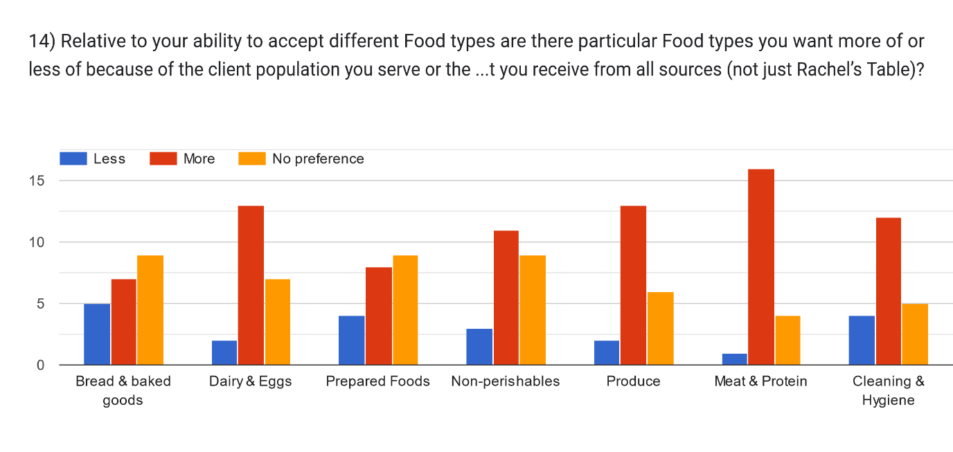

**15) The different food types can exist in different forms in the donations Rachel’s Table receives. We refer to this difference as “Ingredient” or “Prepared”**

Forms response chart. Question title: 15) The different Food types can exist in different forms in the donations Rachel’s Table receives. We refer to this difference as “Ingredient” or “Prepared”

Ingredient Dairy & Eggs might be: Sliced deli cheese, raw eggs, milk, yogurt.


Prepared Dairy & Eggs might be: Grilled cheese sandwiches, yogurt parfaits, cooked eggs

Ingredient Meat & Protein might be: Uncooked chicken, beef, seafood, sliced deli meat, peanut/almond butter

Prepared Meat & Protein might be: Turkey subs, tuna salad, fried chicken, frozen turkey pot pies

Ingredient Produce might be: Whole, uncooked produce; pre-cut produce

Prepared Produce might be: Chef’s salad, frozen vegetables

Can/will you accept:. Number of responses: .

**16) Are there culturally-relevant foods your client population would like to get? For example Halal foods or particular produce or meat products. Please be specific in food you would like to get as well as how much you think you might want on a weekly or monthly basis (ie 200 lb Halal meat/wk).** (13 responses)

a) No (Our House)

b) Halal foods - 20 lbs/month (Community Survival Center)

c) Halal (Open Pantry)

d) N/A (Care Center)

e) 50 lbs. meat weekly of hamburger meat or hot dogs or chicken drumsticks/thighs (Loaves & Fishes)

f) Halal frozen meat- 50 lbs per week, Masa harina- 5 cases per month, Rice noodles- 5 cases per month (Amherst Survival Center)

g) It would be wonderful to receive Halal meat on a regular basis. We currently use #280 of bone in skin on chicken thighs for one meal service. We use #150 of ground beef and or turkey for other meals. Meat protein is a major expense and it would be a great relief to be able to count on a monthly donation. The free store needs meat proteins that are packaged individually or in 3# or smaller potions. They distributed 160# of chicken thighs just last week. (Stone Soup Café)

h) Halal (Parish Cupboard)

i) Halal meat is helpful, canned or dried pigeon peas (Northampton Survival Center)

j) No requests. (FCCMP)

k) Meat (Home City)

l) Hispanic ingredients and vegan options. (Christina’s House)

m) 20lb Halal meat/week, onions and/or carrots 50lb/week (First Baptist Church Food Pantry)

**17) How much of the food we deliver to you ends up in the trash? Please be honest. Your answer will not change the amount of food you are offered.**

None (MLK)

-None (Our House)

-Occasionally we have to throw out bad produce, but not much at all. (Gray House)

-Almost none (Springfield Housing Authority)

-Nothing ends up in the trash unless it is moldy (Community Survival Center)

-15% (Open Pantry)

-If the product we receive is in good condition (not moldy, open, etc.), we distribute all of it; however, there are times when the items come to us already moldy and they have to be thrown away. Roughly 10-15% of product if I had to guess. (Salvation Army Food Pantry)

-Baked goods are very popular, bread not so much. Getting an excess of bread can result in some bread ending in the trash. (Care Center)

-None (Seniority House)

-All donated food items are used by the kitchen or given to the guests that we serve. Sometimes, if we get too many bagels, about 9-10 packages of pre-packed bagels will end up in the dumpster. (Loaves & Fishes)

-We have second recovery partners that take the food that we cannot serve. A lot of the meat that we get through RT from Big Y has puffed up and is not safe for our participants. (Amherst Survival Center)

-We have not been receiving any food other than gleaned lettuce this year (so Far) and we have not composted any of it. We stopped the Atlas Farm Store food delivery on Sunday because the food almost always needed to be composted or was of insufficient quantity to make a difference to either of our programs. (Stone Soup Café)

-10% not usable (Parish Cupboard)

-There is generally a small percentage of fresh produce from Aldi that is soft or moldy. However, we recently received hundreds of pounds of potatoes from Rachel's Table (don't know the source) which were all very soft and growing long shoots. They were not appropriate for human consumption. We let Kathy know about it. The meat delivery that is picked up at Big Y has a high percentage of waste. Probably 25-30% is not safe to give out - it is discolored or the package is puffed or torn open. (Northampton Survival Center)

-Some prepared foods when we receive prepared foods from Pride the quality is not the best sometimes needing to trash 5-10 items (BGCC)

-Most weeks, very little goes in the trash; however, once in a while, the clients (guest families) can't get through what was delivered, such as a large box of bread/sandwiches from Pride, and then we see about 20% being composted. (Ronald McDonald House)

-0% so far (FCCMP)

-None (Home City)

Nothing ends in the trash, we find takers for all of food. (Longmeadow Adult Center)

-None (Macedonia Church)

-0 (Christina’s House)

-0%. We get mostly frozen meat with is either given out or saved until the following week. (First Baptist Church Food Pantry)

**19) Please let us know if there are particular times of year when your programs are closed and can't accept food donations.**

Holiday's & weekends. (Gray House)

no closings (Our House)

The Pantry is closed the week between Christmas and New Year's Day (Community Survival Center)

Major Holidays (MLK)

Thursday, Saturday and Sunday (Open Pantry)

Our Emergency Food Pantry closes the month of December for our Toy for Joy program. (Salvation Army Food Pantry)

One week in December between the holidays and New year and one week in July that includes the 4th of July (Care Center)

We are closed on weekends (Seniority House)

Our kitchen does not open until 10:00 am daily. For mornings, the donation time would be 10:00 am - 1:00 pm daily. We are open every day of the year including holidays with the exception of Thanksgiving Day, Christmas Day and Easter Sunday Day. Receiving time in the afternoons would be 3:00 pm to 5:00 pm. (Loaves & Fishes)

The Amherst Survival Center is closed Labor Day, Thanksgiving, Christmas, New Year's Day, Martin Luther King Day, Memorial Day, Juneteenth, and July 4th. (Amherst Survival Center)

We are not always on site - our programs operate on Saturdays - the best way to receive food is to have a scheduled drop off time so that we can have a staff person present to accept them. (Stone Soup Café)

None except some holidays (Parish Cupboard)

We are open all year. (Northampton Survival Center)

Closed on holidays (BGCC)

We are open 24/7 365 days a year (Ronald McDonald House)

Sat and sun without coordination (FCCMP)

December and November (Home City)

Independence Day, Labor Day, Indigenous People's Day, Veteran's Day, PM day before thanksgiving, Thanksgiving, PM day before Christmas, Christmas, PM day before NY, NY, MLK Day, President's Day, Patriot's Day, Memorial Day, Juneteenth (Longmeadow Adult Center)

Christmas time (Macedonia Church)

Open all year long. except on Sunday, we don't have staff until much later (Christina’s House)

Unless a major holiday falls on Wednesday, we are open (First Baptist Church Food Pantry)

**20) If there is anything else we should know to help Rachel's Table serve you better please let us know.**

Our tenants are young and prefer to "grab and go" that food goes first

We appreciate everything you do for us and the volunteers are always helpful

N/A

Thank you!

Thank you for your support. (Care Center)

Thank you for all that you do for us and the community! We are greatly appreciative of the many donations that we receive. Again, thank you for your concern, support and thoughtfulness!

(Loaves & Fishes)

We are open to the public at 12:00 and our staff is busy at that time. Donations are much easier for us to accept before 12:00. Thank you! (Amherst Survival Center)

Thank you for your service to our community and to food justice. (Stone Soup Café)

Thank you for all you do (Parish Cupboard)

Thank you for all you do! On behalf of our clients, we are grateful for the food you bring us.(Northampton Survival Center)

We are working on getting another freezer so that we may be able to receive more frozen items. (BGCC)

We would love more milk, eggs, juice, even creamers. We never seem to have enough of these items for the families to enjoy. Thank you for asking and thank you for your invaluable service! (Ronald McDonald House)

We are happy to receive more food, esp. Shelf stable (FCCMP)

NA (Home City)

Our Food Pantry Distribution is Thursdays 2-4 PM (Longmeadow Adult Center)

We would like to have scheduled deliveries to be prepared to receive. Also more meats would be super helpful. (Christina’s House)