McPhase
Magnetism

- the World of-
Magnetism
McPhase

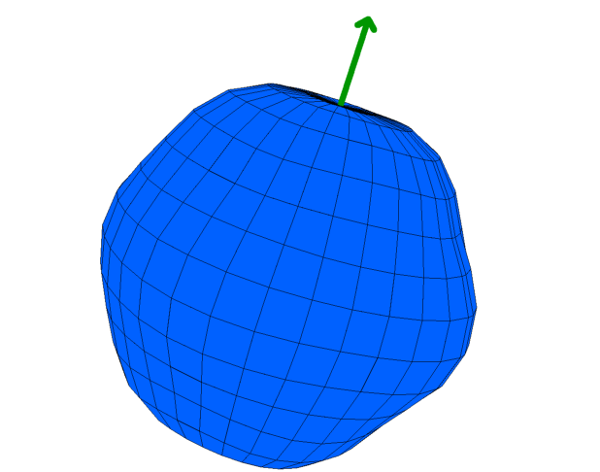
McPhase
USERS MANUAL

Software Suite for calculation of magnetic properties
Magnetization Magnetostriction Magnetic Phasediagrams
Elastic/Inelastic/Diffuse
Magnetic Structures Neutron Scattering
Cross Section
Crystal Field/Magnetic/Orbital Excitations
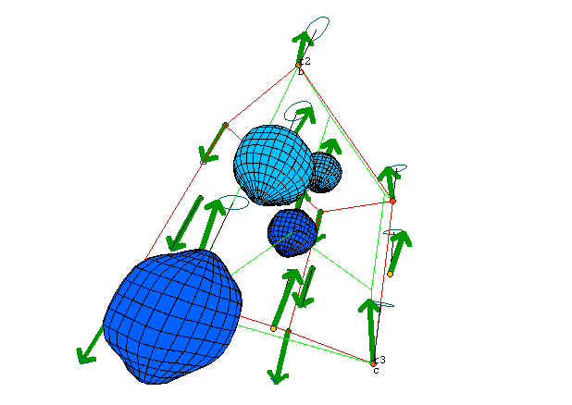
and much more....
McPhase runs on Linux and Windows and is available as freeware.
www.mcphase.de

