TACATDP Integrated M&E System and Monitoring Tool
Prototype status, dashboard evidence, user manual, SOP draft, and annex index
27 August 2026

Report with all system stages details
Date: 2026-08-27
System: TACATDP Integrated M&E System and Monitoring Tool
1. Executive summary
The current prototype demonstrates a Microsoft-hosted monitoring, evaluation, and reporting workflow for TACATDP. It includes an authenticated Power Pages portal, Dataverse-backed form and submission storage, a baseline import workflow, a beneficiary registry view, dashboard visualisation, reporting/export pathways, and role-based administration screens.
The cleaned TACATDP baseline dataset has been successfully imported through the prototype import workflow. The CRDB development environment has also been updated with the latest working portal build. The remaining CRDB-side activities are operational: seed or confirm the latest form version, import the cleaned baseline dataset through the portal, and verify CRDB permissions for the relevant user roles.
An important change was received from CRDB ICT on Tuesday: ICT is recommending a CRDB-hosted deployment strategy instead of continuing with the Microsoft Power Pages and Dataverse environment. That change affects the future production architecture. A rebuild has already started around the proposed CRDB-hosted strategy so that a working system can be ready when CRDB’s environment is available.
2. Development stages completed
Stage | Status | Details
Requirements discovery | Completed for prototype; revised for future deployment | TACATDP was treated as the first programme configuration for a broader MEL capability.
Prototype architecture | Completed | Power Pages hosts the app shell and authentication. Dataverse stores forms, submissions, baseline projections, beneficiary profiles, and configuration records.
Application shell | Completed | CRDB-branded navigation, top bar, content area, route separation, and footer are implemented.
Form runtime | Completed for prototype | The tool uses an XForms/web forms runtime to render the TACATDP form from a stored form version.
Latest form version | Implemented | Version 2608130924 is the expected active form version for baseline import and future data updates.
Baseline import | Completed for prototype | Cleaned baseline data was imported through the portal import workflow. The same import path is available in CRDB subject to user permissions.
Beneficiary registry | Implemented for prototype | Imported baseline data is projected into beneficiary-facing records and detail views.
Dashboard visualisation | Implemented for prototype | Dashboard cards use live baseline projections where the imported data supports the metric. Unsupported metrics remain explicitly pending.
Reporting/export | Implemented for prototype | Reporting rows and export pathways exist for imported submissions and projected baseline data.
User and access management | Implemented for prototype | User, role, access, and assignment concepts are represented. Automation depends on CRDB permissions and ownership.
CRDB environment update | Completed | Latest working Power Pages build was deployed to the CRDB development environment.
Production hardening | Pending | Depends on final deployment strategy, CRDB infrastructure, security review, and integration permissions.
3. Current environment state
Prototype baseline validation
The cleaned baseline data has been imported through the portal workflow and used to validate dashboard, beneficiary, reporting, and import behavior.
CRDB development environment
The CRDB development environment has been updated with the latest tested Power Pages build.
Known CRDB environment details:
Item | Value
Environment | TACATDP-CRDB-Dev
Environment URL | https://org5eb0379b.crm4.dynamics.com/
Portal URL | https://tacatdp-crdb.powerappsportals.com/
Website | TACATDP Monitoring Tool
Website ID | fccc0cc6-7f5e-4885-aeb8-2272e68130a3
Current form version | 2608130924
4. Baseline data status
The cleaned baseline dataset was prepared from the shared TACATDP DAP dataset folder.
Current cleaned-data profile:
Item | Count
Root beneficiary baseline rows | 1,246
Loan/value-chain child rows | 1,484
Value-chain cost rows | 7,585
GPS rows | 1,246
Regions | 29
Districts | 130
Wards | 415
Total reported loan amount in baseline | TZS 51.6B
The import treats each row as a form submission. This preserves the field-data lineage and keeps the platform ready for future follow-up data collection.
5. Dashboard status
The dashboard uses baseline-derived values only where the imported data supports the calculation.
Dashboard area | Current data source | Status
Beneficiary count | Imported baseline registry/projection | Available after import
Report rows | Imported submission report rows | Available after import
Reported loan amount | Baseline total_loan_amount and loan repeat data | Available after import
Regional map | Baseline region and amount fields | Available after import
Financed technologies/practices | Baseline technology fields and value-chain stage fallback | Available where source fields exist
Training metrics | Baseline training fields | Available where source fields exist
Climate outcome estimates | Baseline-supported calculations only | Available where source fields support a defensible calculation
Loan performance | Core banking/repayment feed | Pending
Monthly disbursement trend | Dated loan repeat records | Pending unless dated loan records are exposed to the dashboard projection
The dashboard does not present unsupported figures as official values. If a feed is missing, the UI shows a pending or unavailable state.
6. User roles represented in the prototype
Role | Prototype responsibility
Platform Administrator | Manage form version seed, baseline import, user/access setup, and environment checks.
M&E Manager | Review dashboard, reporting outputs, SOPs, and system readiness.
MEL Officer | Review dashboard, beneficiary records, submissions, and monitoring outputs.
Data Collector / Field Officer | Complete assigned TACATDP forms.
Reviewer / Approver | Review submitted data and verify reporting outputs.
ICT / System Administrator | Manage environment, permissions, deployment, hosting, and integration readiness.
7. Known limitations
• The prototype is not yet a full production system.
• CRDB permissions still control whether CRDB users can import, read, or update all required records.
• Power BI plugin/report creation depends on CRDB Power BI permissions.
• Mailbox-based notifications depend on an approved sender mailbox and Power Automate ownership.
• The proposed CRDB-hosted deployment strategy requires architectural rework away from the current Microsoft Power Pages/Dataverse-specific implementation.
8. Deployment strategy change
CRDB ICT has recommended moving toward CRDB-hosted infrastructure instead of continuing only with Microsoft Power Pages and Dataverse. This changes the production direction.
Implications:
• Authentication, hosting, database, workflow automation, deployment, and reporting integration must be revised.
• The current prototype remains valuable as a functional proof and requirements reference.
• Future implementation should be rebuilt around the approved CRDB-hosted environment.
• The client should sign off system requirements and system design documents before major implementation work starts.
9. Immediate next actions
• Capture final dashboard screenshots after CRDB baseline import verification.
• Seed or confirm latest form version 2608130924 in the CRDB environment.
• Import the cleaned baseline dataset into the CRDB environment.
• Verify CRDB user permissions for baseline import, dashboard read, beneficiary read, and reporting read.
• Deliver the documentation pack and annexes.
• Continue rebuilding the future system around the CRDB-hosted deployment strategy.

Dashboard interface screenshot
Date: 2026-08-27
Purpose
This document supports the required dashboard screenshot deliverable.
The dashboard screenshot shows the TACATDP monitoring dashboard after baseline data has loaded. The screenshot is prototype evidence and is not an official CRDB Bank or Green Climate Fund report.
Captured screenshots
The screenshots show the current deployed prototype build, including dashboard, beneficiary registry, baseline import, form runtime, and reporting/export capability.
File | Purpose
assets/01-dashboard-overview.jpg | Dashboard overview with baseline KPI projection, map, technology/practice chart, and baseline data-quality card.
assets/02-beneficiaries-list.jpg | Beneficiary registry/list view populated from imported baseline records.
assets/03-baseline-import.jpg | Baseline import route used by administrators to append or replace cleaned baseline data.
assets/04-form-runner.jpg | Field data collection form runtime.
assets/05-reporting-export.jpg | Reporting/export route for submitted baseline records.
Primary visual evidence:
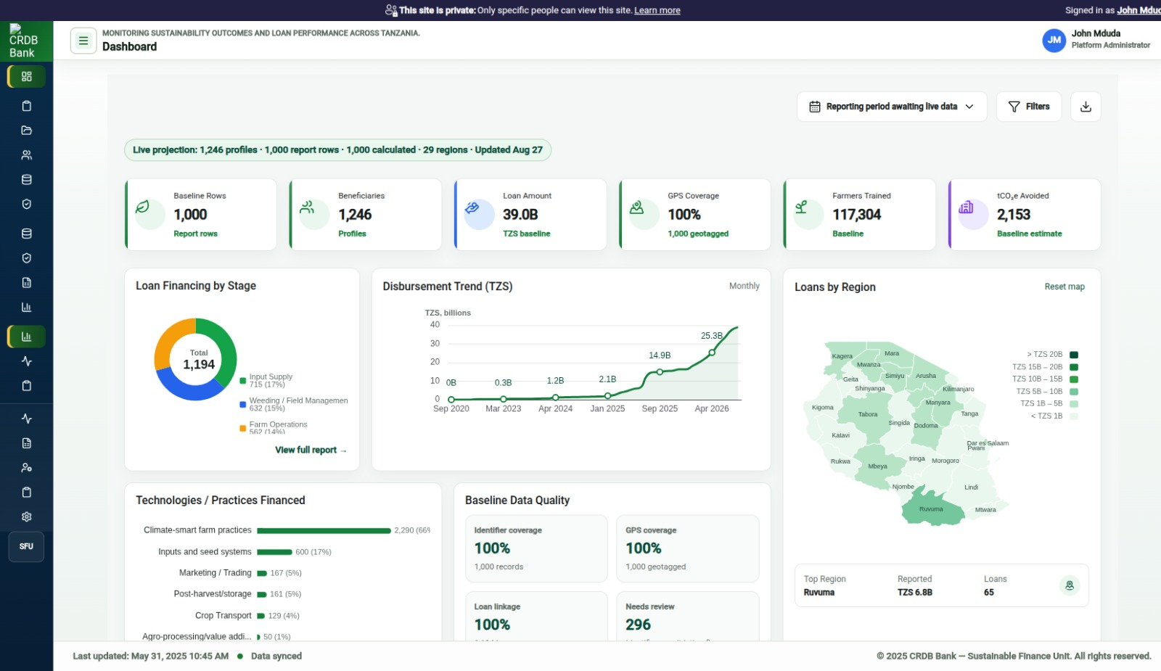
Dashboard overview
Additional prototype evidence:
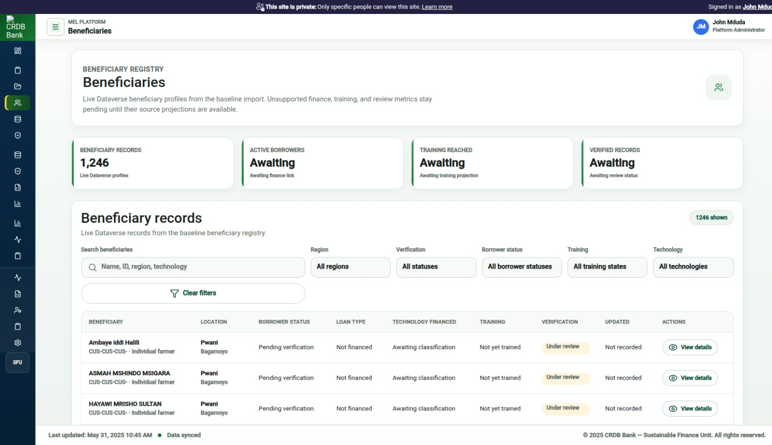
Beneficiaries list
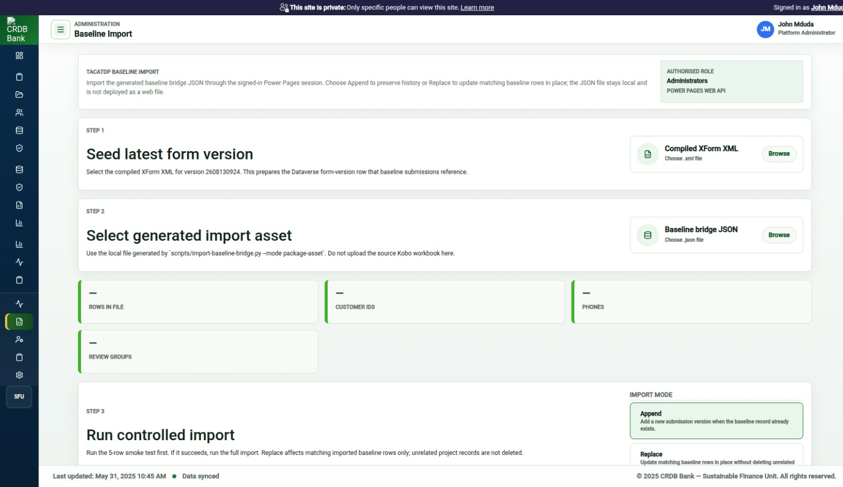
Baseline import route
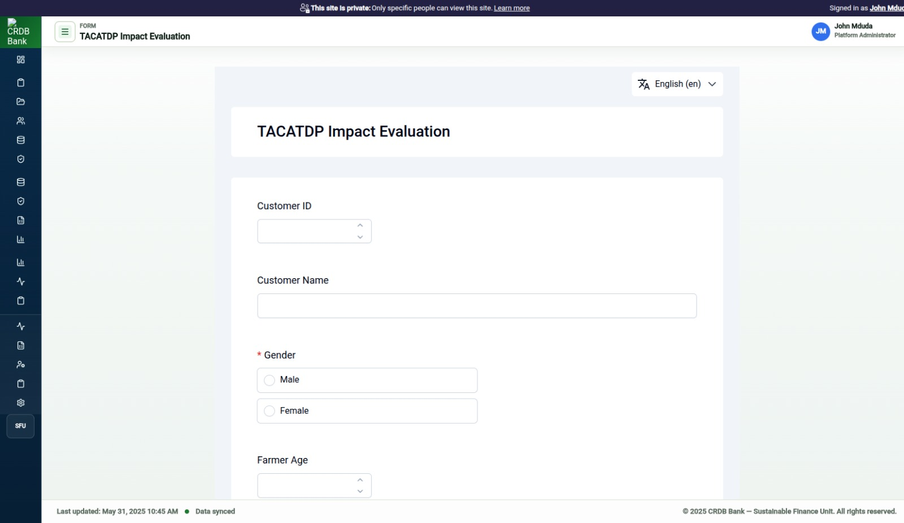
Field form runner
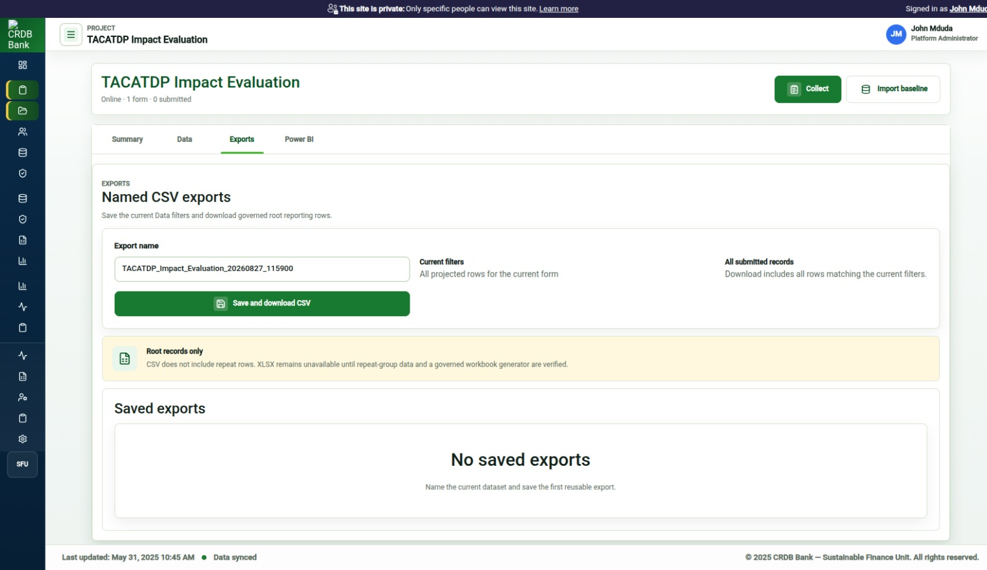
Reporting and export route
Required dashboard elements
The screenshot should show:
• CRDB/TACATDP application shell.
• Dashboard route.
• KPI summary row.
• Regional Tanzania map.
• Loan/financing or financed-stage card.
• Technologies/practices financed card.
• Training and climate outcome cards where data is available.
• Recent submissions or reporting-status card.
• Baseline data-quality summary replacing metrics that require unavailable CRDB operational feeds.
Screenshot notes to include in submission
Use this caption:
Dashboard interface showing prototype TACATDP baseline monitoring projections. Values shown are derived from imported baseline data where available. Metrics that require CRDB operational feeds are excluded from the dashboard until the approved source data is connected.
Metrics interpretation
Metric area | Interpretation
Beneficiaries | Imported baseline beneficiary profiles or report rows.
Reported amount | Reported loan amount from the baseline dataset.
Regional map | Baseline regional coverage and reported loan amount by region.
Technologies/practices | Baseline technology fields or financed value-chain stages where exact technology fields are unavailable.
Training | Baseline training fields where present.
Baseline data quality | Completeness and linkage checks derived from imported baseline records.
Disbursement trend | Requires dated loan records exposed to the dashboard projection.
Acceptance checklist
• [x] Screenshot is captured after the import completes.
• [x] Loading states have cleared where data exists.
• [x] Unsupported external-feed metrics are not presented as live results.
• [x] Browser zoom is normal.
• [x] The screenshot does not expose sensitive individual beneficiary details.
• [x] The screenshot caption states that the dashboard is a prototype baseline projection.

User manual
Date: 2026-08-27
1. Purpose
This manual explains how users operate the TACATDP Integrated M&E System and Monitoring Tool prototype.
The prototype supports authenticated access, form version setup, baseline data import, dashboard review, beneficiary review, and reporting/export review.
2. User roles
Role | Main tasks
Platform Administrator | Prepare the form version, import baseline data, manage access, and support users.
M&E Manager | Review dashboard outputs, reports, system status, and SOP compliance.
MEL Officer | Review monitoring dashboard, beneficiary records, submissions, and reporting projections.
Data Collector / Field Officer | Open assigned forms and submit data.
Reviewer / Approver | Review submitted records and confirm data readiness.
ICT / System Administrator | Manage environment access, deployment, permissions, and support.
3. Sign in
• Open the portal link.
• Select the Microsoft sign-in option.
• Sign in with the approved account.
• Confirm that the application shell loads.
If access is denied, contact the Platform Administrator or ICT administrator. A successful Microsoft sign-in does not automatically grant application access. The user also needs site visibility, web role, table permissions, and form assignment where applicable.
4. View the dashboard
• Open the portal.
• Select Overview or Dashboards.
• Wait for live baseline data to load.
• Review the KPI cards, map, financed practices, training, climate outcomes, and submission status.
If a card shows a pending state, the required source data may not be available yet. Do not treat pending values as zero.
5. Seed the latest form version
This task is for Platform Administrators only.
• Open #/baseline-import.
• In Step 1, select the compiled XForm XML file:
``text artifacts/xforms/tacatdp_impact_evaluation-2608130924.xml ``
• Confirm that the page reports form version 2608130924 as ready.
This step prepares the form version that baseline submissions and future data updates reference.
6. Import baseline data
This task is for Platform Administrators only.
• Open #/baseline-import.
• Confirm that Step 1 has already seeded form version 2608130924.
• In Step 2, select the generated baseline bridge JSON file.
• Select the import mode:
• Use Append to preserve history.
• Use Replace to update matching baseline rows in place.
• Run the smoke test first.
• If the smoke test succeeds, run the full import.
• Wait until the import reaches the final row count.
• Open the dashboard and reports to confirm that baseline projections refresh.
Do not upload the original Kobo workbook directly into the browser import control. The browser import expects the generated JSON bridge asset.
7. Review beneficiaries
• Open Beneficiaries.
• Use search or filters to find a region, beneficiary, technology/practice, or status.
• Open a beneficiary detail view.
• Review profile, finance, technology/practice, training, outcomes, location, and data-lineage sections.
The prototype beneficiary view is a registry projection from imported submissions. Production registry governance must be finalized during the next architecture phase.
8. Review submitted records and reports
• Open Data Submissions or Reports.
• Search or filter the available records.
• Confirm projection status and update dates.
• Export CSV where the route provides an export action.
If reporting reads fail, the user may be missing table permissions for the relevant Dataverse table.
9. Interpret pending states
Pending state | Meaning
Awaiting live data | The app has not received readable live rows yet.
Awaiting loan financing data | The required loan fields are not available in the current projection.
Awaiting dated loan records | Monthly trend cannot render until dated loan records are available.
Pending loan performance feed | Repayment and portfolio quality require CRDB operational loan-performance data.
Data unavailable | The current user may lack permission, or the source table may not be configured for Web API access.
10. Support notes
When reporting an issue, include:
• portal URL;
• signed-in user email;
• route name;
• action attempted;
• exact error message;
• screenshot;
• date and time.

Draft SOPs
Date: 2026-08-27
1. Purpose
These draft standard operating procedures define how different user levels operate the TACATDP Integrated M&E System and Monitoring Tool prototype.
The SOPs should be finalized after CRDB confirms the final system configuration, deployment strategy, user roles, and permission model.
2. SOP ownership
Area | Responsible role
System access and permissions | ICT / Platform Administrator
Form version control | Platform Administrator and M&E Manager
Baseline import | Platform Administrator
Data collection | Data Collector / Field Officer
Submission review | MEL Officer and Reviewer / Approver
Dashboard review | M&E Manager and MEL Officer
Reporting | M&E Manager and MEL Officer
Production support | ICT / System Administrator
3. Access management SOP
• ICT confirms that the user has an approved Microsoft account.
• The Platform Administrator confirms the required application role.
• ICT or the Platform Administrator grants portal access where the site is private.
• The Platform Administrator assigns the user to the required form or project.
• The user signs in and confirms that the expected routes are visible.
• The administrator records the access change for audit purposes.
4. Form version management SOP
• The M&E Manager approves the form version to be used.
• The Platform Administrator confirms the compiled XForm XML version.
• The Platform Administrator opens #/baseline-import.
• The Platform Administrator uploads the approved XML in Step 1.
• The Platform Administrator confirms that the portal reports the form version as ready.
• The M&E Manager confirms that data collectors should use the updated form.
Current approved prototype form version:
``text 2608130924 ``
5. Baseline import SOP
• The data owner confirms that the cleaned dataset is approved for import.
• The technical team generates the baseline bridge JSON from the cleaned dataset.
• The Platform Administrator opens #/baseline-import.
• The Platform Administrator selects the generated JSON file.
• The Platform Administrator runs the smoke test first.
• If the smoke test succeeds, the Platform Administrator runs the full import.
• The Platform Administrator waits for the final row count.
• The MEL Officer checks dashboard and reporting projections.
• The M&E Manager confirms that the imported baseline is acceptable for prototype reporting.
6. Data collection SOP
• The Data Collector signs in to the portal.
• The Data Collector opens the assigned form.
• The Data Collector completes required fields.
• The Data Collector reviews the form before submission.
• The Data Collector submits the form.
• The system stores the submission and versioned payload.
• The Data Collector reports any validation or submission issue to the MEL Officer.
7. Submission review SOP
• The MEL Officer opens submitted records or reports.
• The MEL Officer checks completeness, region, beneficiary profile, finance, training, and outcome fields.
• The Reviewer / Approver checks records that require validation.
• Corrections are requested where data is incomplete or inconsistent.
• Approved records are used for dashboard and reporting projections.
8. Dashboard review SOP
• The MEL Officer opens the dashboard.
• The MEL Officer waits for live data to load.
• The MEL Officer reviews beneficiary, reporting, financing, regional, training, and outcome cards.
• The MEL Officer records pending metrics and missing source feeds.
• The M&E Manager reviews dashboard screenshots and interpretation notes before external sharing.
Do not interpret missing data as zero. Pending states must be reported as pending.
9. Reporting SOP
• The MEL Officer opens the reporting route.
• The MEL Officer selects the relevant records or reporting period.
• The MEL Officer exports available data where required.
• The M&E Manager reviews the report for consistency.
• The final report includes notes on data source, limitations, and pending operational feeds.
10. Change management SOP
• Any change in hosting, architecture, role model, form structure, or source data must be documented.
• The client reviews and signs off requirements and design changes before implementation.
• The technical team implements approved changes in a test environment first.
• The M&E Manager validates the output.
• ICT approves deployment to the target CRDB environment.
11. Current SOP limitations
These SOPs are draft because the final CRDB deployment strategy is changing. They should be revised after CRDB confirms:
• final hosting model;
• database platform;
• authentication model;
• workflow engine;
• reporting stack;
• user roles;
• support owner;
• production deployment path.

Annex index
Date: 2026-08-27
Purpose
This document lists the annexes used to support the TACATDP Integrated M&E System and Monitoring Tool submission.
Do not include raw beneficiary data in an external sharing pack unless CRDB authorizes the recipient and channel.
Annex A: Requirements and scope
Annex | Source
Prototype acceptance scope | docs/powerpages-odk-webforms/prototype-acceptance-scope-20260812.md
Power Pages ODK/web forms requirements | docs/powerpages-odk-webforms/requirements.md
Acceptance criteria | docs/powerpages-odk-webforms/acceptance-criteria.md
Dashboard ECharts slice | docs/powerpages-odk-webforms/tacatdp-dashboard-echarts-slice-20260810.md
Annex B: Data and import
Annex | Source
Cleaned DTA baseline import plan | docs/powerpages-odk-webforms/cleaned-dta-baseline-import-plan-20260826.md
Baseline browser import route | docs/powerpages-odk-webforms/baseline-browser-import-mshirika-20260814.md
Baseline import dry run | docs/powerpages-odk-webforms/baseline-bridge-import-dry-run-20260814.md
Cleaned import dry-run summary | artifacts/import-assets/reference/tacatdp-cleaned-dta-dry-run.json
Latest compiled XForm XML | artifacts/xforms/tacatdp_impact_evaluation-2608130924.xml
Annex C: Architecture and deployment
Annex | Source
Microsoft environment permission map | docs/powerpages-odk-webforms/crdb-microsoft-environment-permission-map-20260813.md
CRDB Microsoft resources and permissions | docs/powerpages-odk-webforms/crdb-microsoft-resources-permissions-20260813.md
Power Pages deployment readiness | docs/powerpages-odk-webforms/crdb-deployment-readiness-20260730.md
ODK Central-inspired schema | schemas/dataverse/odk-central-inspired-mvp-schema.md
Beneficiary entity extension schema | schemas/dataverse/beneficiary-entity-extension-schema.json
Annex D: User access and roles
Annex | Source
Access management requirements | docs/powerpages-odk-webforms/access-management-requirements.md
Access permission matrix | docs/powerpages-odk-webforms/access-permission-matrix-20260721.md
User/access route implementation notes | docs/powerpages-odk-webforms/access-create-invite-assign-ux-20260722.md
Onboarding queue requirements | docs/powerpages-odk-webforms/access-onboarding-queue-requirements-20260724.md
Annex E: Screenshots
Captured screenshots:
Annex | File
Dashboard overview | docs/submission-pack-20260827/assets/01-dashboard-overview.jpg
Beneficiaries list | docs/submission-pack-20260827/assets/02-beneficiaries-list.jpg
Baseline import route | docs/submission-pack-20260827/assets/03-baseline-import.jpg
Field form runner | docs/submission-pack-20260827/assets/04-form-runner.jpg
Reporting/export route | docs/submission-pack-20260827/assets/05-reporting-export.jpg
Annex F: References used for documentation style
• Microsoft Writing Style Guide: scannable content and concise procedures.
• Microsoft step-by-step instruction guidance.
• M&E/SOP guidance: role-based procedures, data source clarity, and monitoring/reporting responsibilities.

