Feature Analysis: Write Up

**Feature 1: Recirculation Bullet**

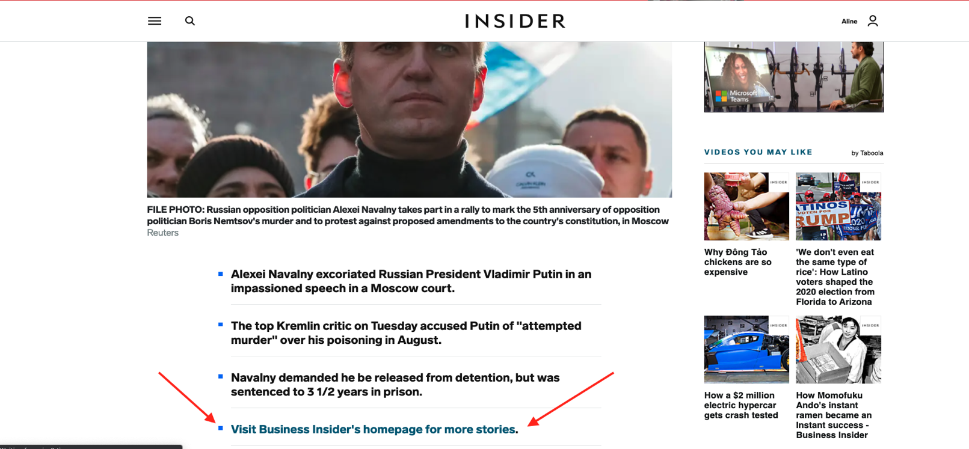

* The last bullet in a list of summary bullets at the beginning of every article.
* The feature is visible on both desktop and mobile devices.
* The **bullet is also visible on all platforms** outside of the direct site, such as Facebook Instant Articles, AMP, and a variety of distribution partners, such as Yahoo and MSN.

**Feature 2: “Back to homepage” button**

* 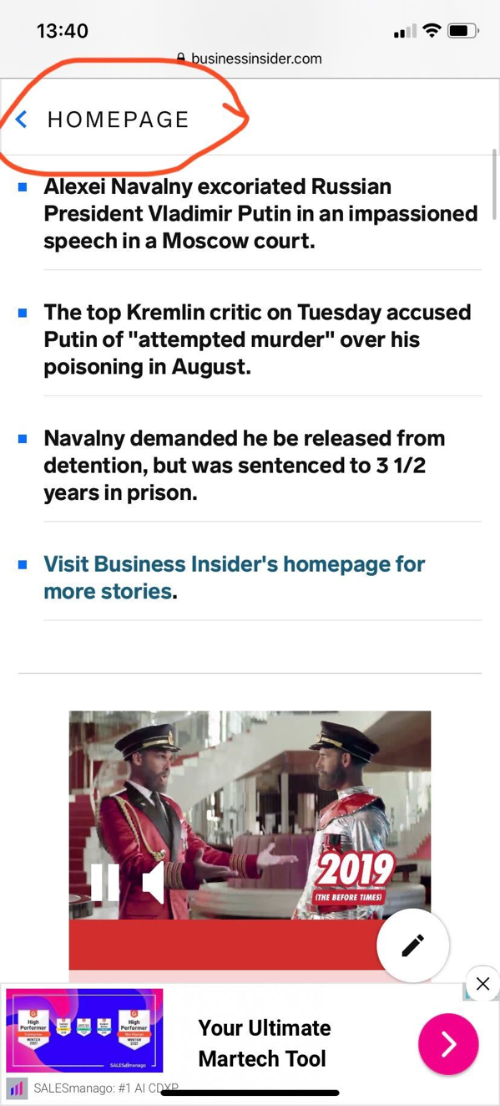Located on every post page in the top left corner.
* The button is only visible on mobile devices.
* The button is only visible on the direct sites and AMP.
* The button is **not visible** on platforms such as **Facebook Instant Articles** and our distribution partners, such as **Yahoo** and **MSN**.

**Analysis**

* The “Homepage” button is more effective in driving homepage visits as there is a stronger statistical relationship between the *number* *of homepage visits* and the *number of clicks on the “Homepage” button*.
* Below is a correlation matrix for the “Insider” homepage that indicates the strength of the relationship between the features.

Correlation Plot for Daily Clicks: Insider

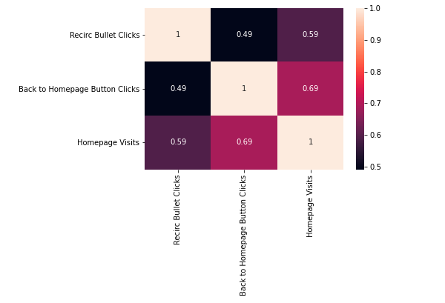

* The closer the number is to 1, the stronger the relationship.
* Here you can clearly see that “*Homepage Visits”* and “*back to homepage” button clicks* have a stronger relationship than homepage visits and recirculation button clicks.
* Because the “*Homepage”* button is only available on mobile devices, we can deduce that those users came from mobile. This could help the product team focus on mobile-first features, improving the mobile experience for users.
* This correlation is similar for the “Business Insider” page as well.

Correlation Plot for Monthly Clicks: Business Insider

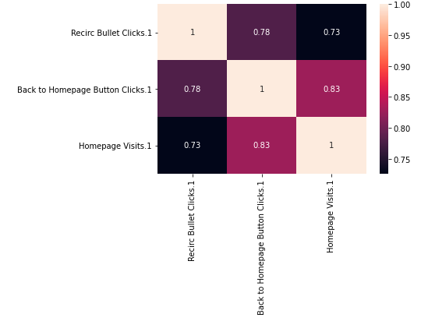

* It is clear that there is a stronger relationship between the number of homepage visits and the number of homepage button clicks.
* The below chart shows a time-series plot of daily activity.
  + Homepage visits will be generally higher as that number can be influenced by either treatments, as well as a number of other factors such as social sharing, email marketing, SEO, and more.
  + 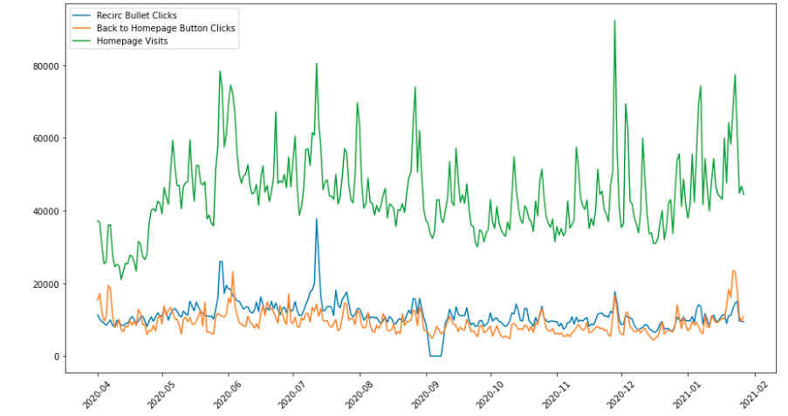From this chart, it is difficult to see which feature is helpful in driving Homepage visits, but it is helpful to see the aggregate activity.
* 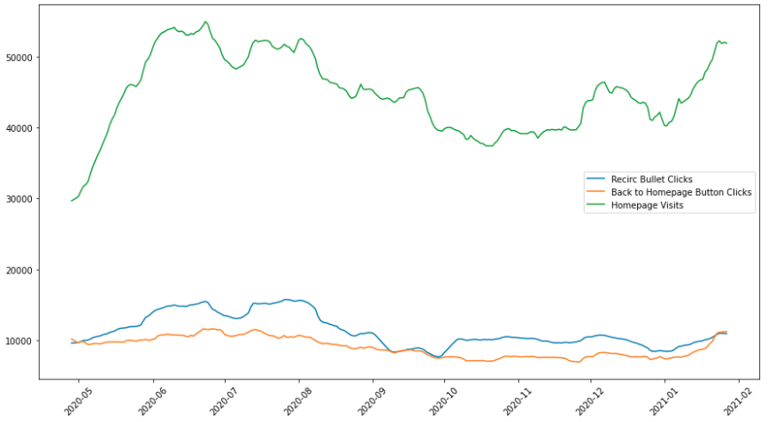The following chart shows the daily data with a 28-day aggregate
* The data does not show any seasonal trend, indicating that there is not a patter that relates to the time (i.e. does not grow every month/quarter then fall back down)