Duffy, Michael
COP 2373 – Debugging Exercise Report
- Error Observation
Upon initial inspection of the Python file in PyCharm, I could already see a potential mismatch in data types at line 18 due to PyCharm’s syntax highlighting.
I went ahead and ran the code, which partially confirmed my theory, because it showed two correct and complete outputs for the Laptop and Smartphone data, but then showed an error where the Tablet data should be displayed, and the Tablet dictionary value was where I saw the mismatch.
The first error references line 36, which is the call to the main() function, a line which appeared to have no glaring issues, so the error must originate deeper in the program’s execution. The next line referenced is line 26, so that is where I placed a breakpoint and began to run the debugger.

Below is the screenshot of the original error messages.
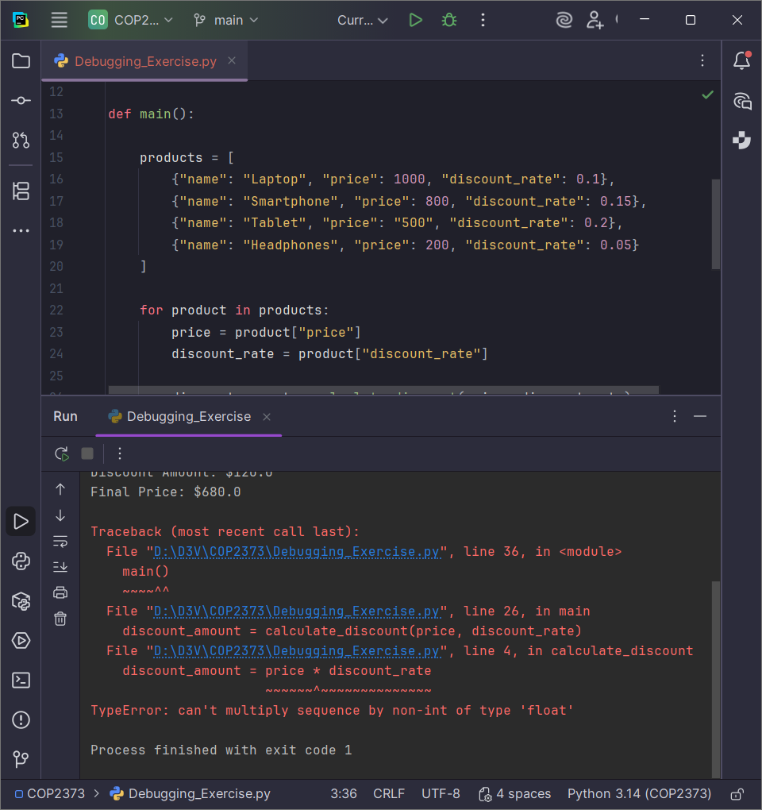

- Debugging and Analysis
I watched the console output as well as the variables while running the debugger. The first two iterations of the loop executed correctly, displaying valid output for the Laptop and Smartphone products.
Upon the third iteration of the loop, it can be seen that the actual failure occurs at line 4, wherein a mathematical calculation is attempted: discount_amount = price * discount_rate.
The error occurs because the value assigned to the price for the Tablet product is of the string data type, because the “500” is surrounded by double quotes.
When the values are passed to the calculate_discount() function, Python raises a TypeError because it cannot perform such an operation with a string and a float (the discount_rate).

Below is the screenshot of the point of failure during debugging.
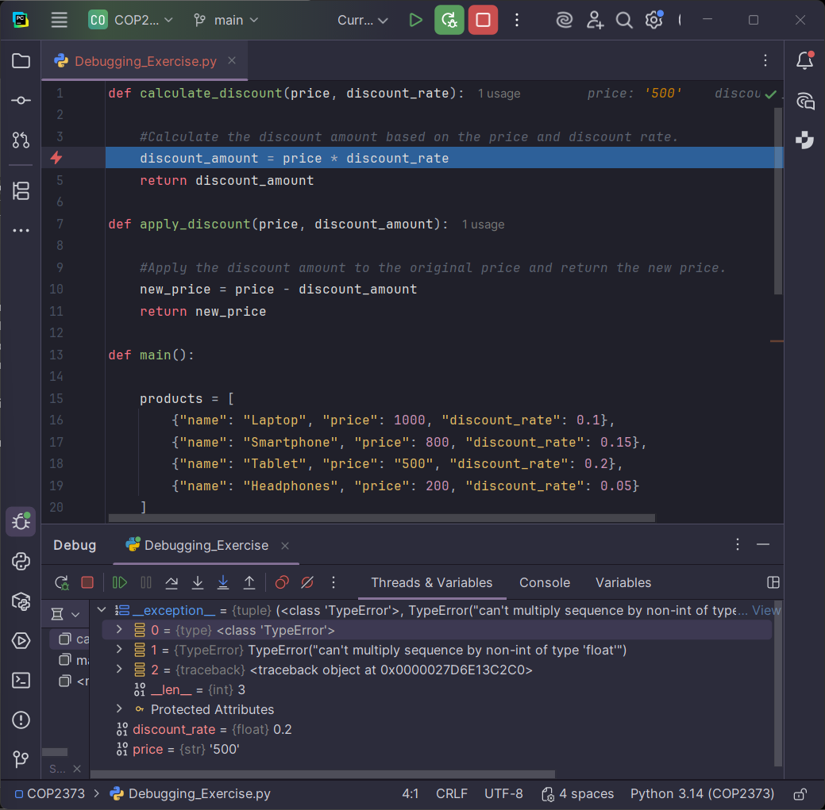
- Data Type Correction
To remedy this issue and ensure that the code for this discount calculator is robust enough to handle future potential input errors, we can implement a two-fold approach, rather than simply correcting the data in the dictionary, which would only fix this instance of the error.
The first change that I made was at the point where the data is read from the dictionary and assigned to the respective variables. To ensure that calculations are possible, I added the float() method around the numeric values taken from the dictionary so that all of the price information is considered to be of the correct data type before calculations are attempted. This alone is sufficient to make the code run without altering the dictionary values.

Below is the screenshot of the data conversion implementation.
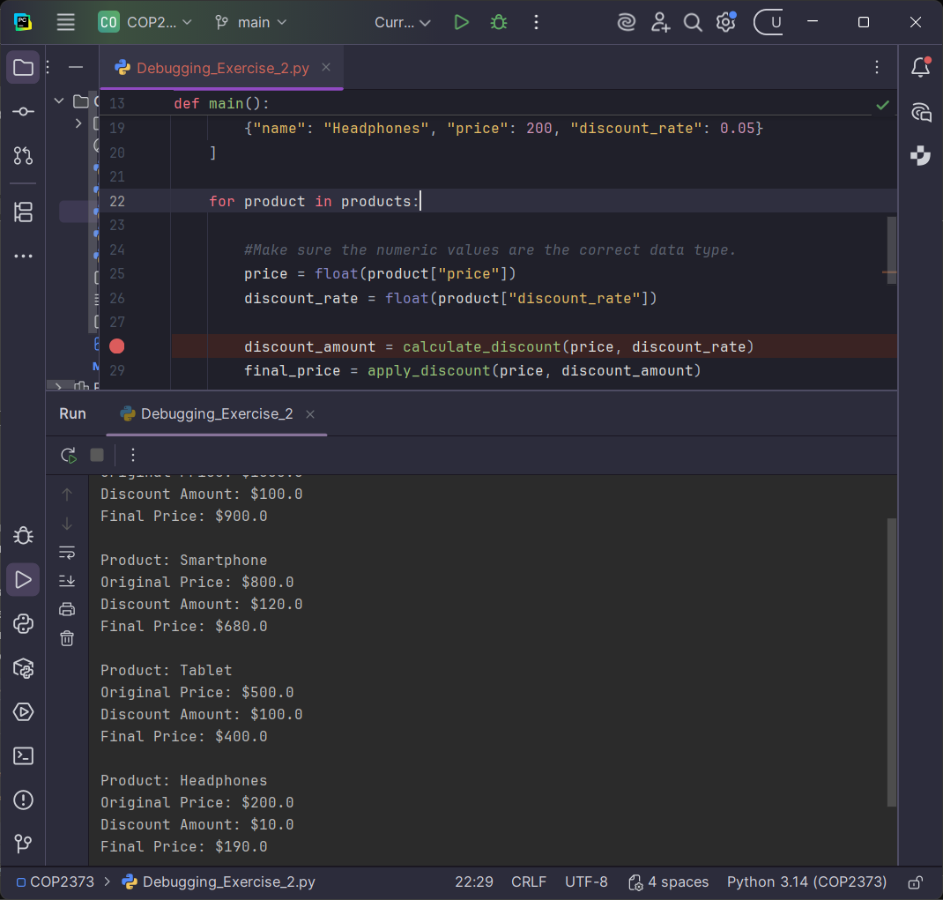

- Improved Error Handling
The second phase of modifications that I made was to put a try/except statement inside of the loop in the main() function. This ensures that, even if future bad data is sent through this code for processing, the calculations related to the bad data will be skipped over, the user will be provided with a meaningful error message, and the rest of the processing will continue as normal if possible.
After implementing these changes, the program was tested again and confirmed to correctly process valid products, skip invalid data, and continue execution without errors.

Below is a screenshot of the try/except implementation,
but not the associated error message, because the float()
conversion, which removes the error, is still in place.
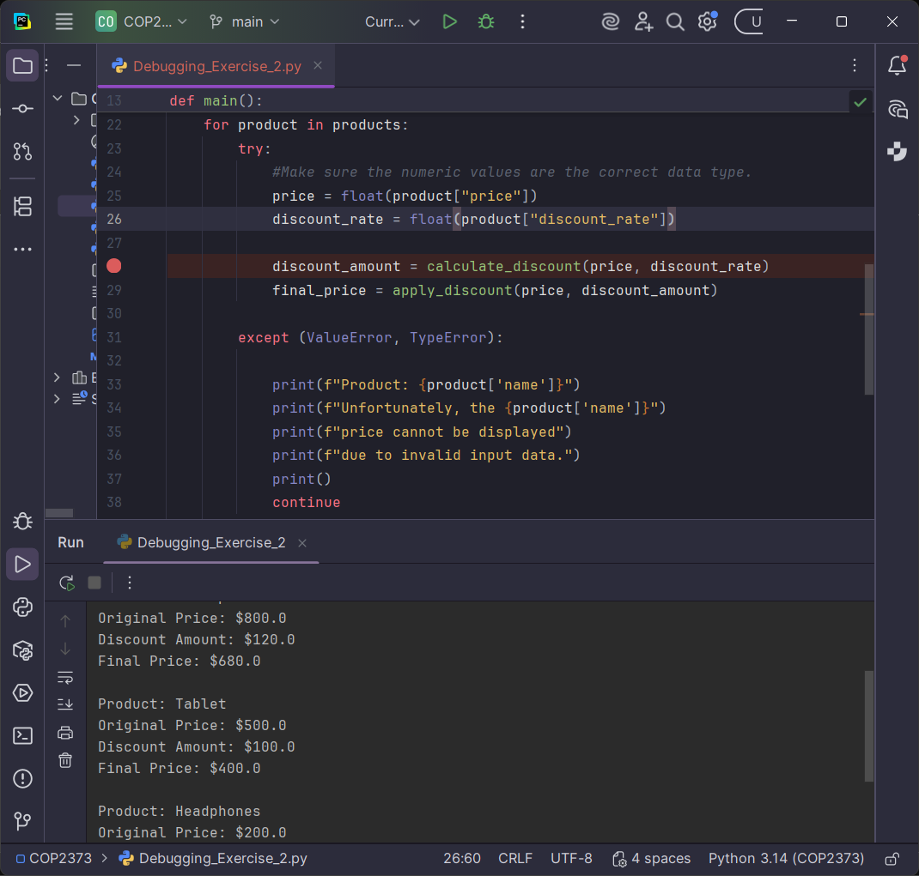

- Confirmation
This is what the output would look like with the new try/except statement if the float() method conversion was removed and the rest of the code was left unchanged.

Below is a screenshot of the new meaningful error message that would
print if a similar data error were to occur.
