# Noise Equivalent Bandwidth vs. 3 dB Bandwidth for First-Order IIR Filter

This document explains the mathematical relationship between the 3 dB bandwidth and the noise equivalent bandwidth (NEB) for a first-order IIR low-pass filter.

## Filter Definition

The first-order IIR low-pass filter is defined as:

y[n] = (1 - a) * y[n - 1] + a * x[n]

## 3 dB Bandwidth

f_3dB = -ln(1 - a) / (2*pi)

## Noise Equivalent Bandwidth (NEB)

NEB = a / (2 - a)

NEB(Hz) = a / [(2 - a) * 2*pi]

## Relationship Between NEB and 3 dB Bandwidth

NEB / f_3dB = [a / (2 - a)] / [-ln(1 - a)]

## Inverse Calculation Examples

From 3 dB Bandwidth:  
 a = 1 - exp(-2*pi * f_3dB)  
 Example: f_3dB = 1/10 Hz => a ≈ 0.467

From NEB:  
 a = 2 * NEB / (1 + NEB)  
 Example: NEB = 1/10 Hz => a ≈ 0.182

## Comparison Graph: 3 dB Bandwidth vs. NEB

This graph illustrates the relationship between the smoothing factor α and both the 3 dB bandwidth and noise equivalent bandwidth for a first-order IIR filter. NEB is consistently larger than the 3 dB bandwidth, especially for small α values.

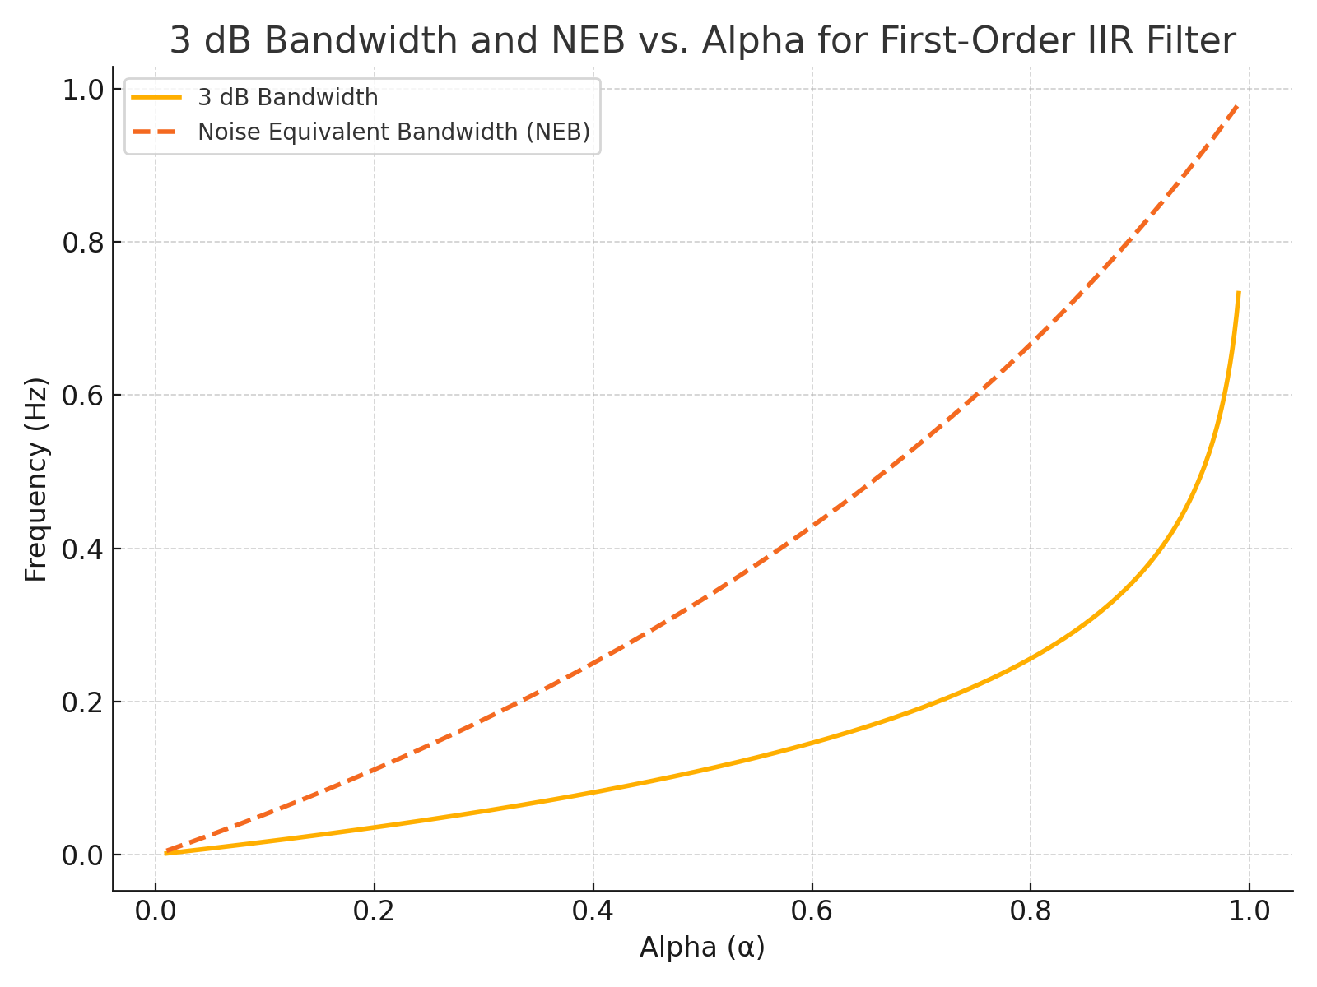

## Ratio of NEB to 3 dB Bandwidth vs. Alpha

This graph shows how the ratio NEB / f₃dB varies with the smoothing factor α. It highlights how NEB is consistently greater than the 3 dB bandwidth, especially for small values of α. This ratio is useful for rapid filter parameter estimation.

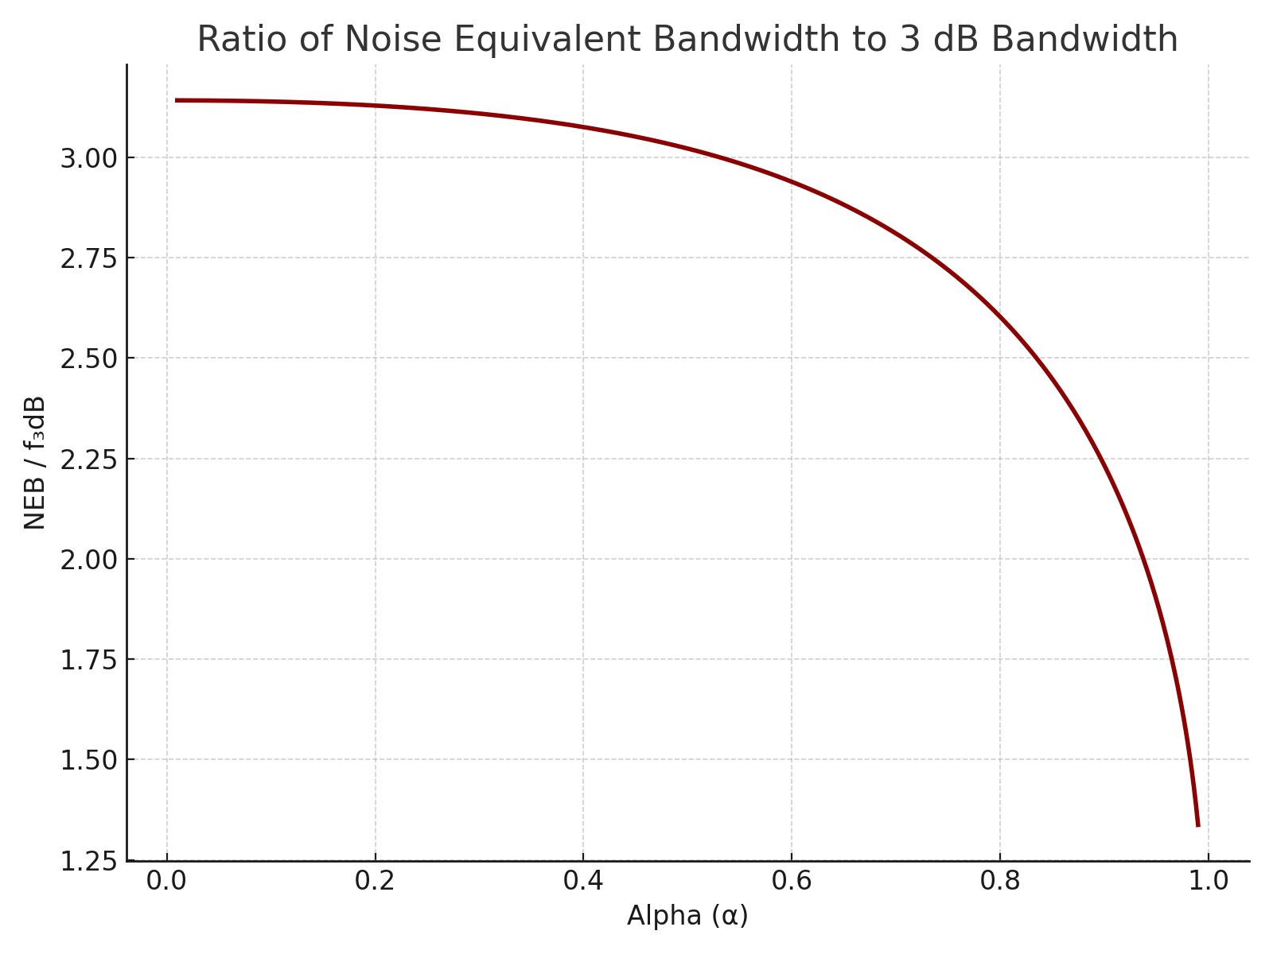

Generated by ChatGPT · OpenAI