# Relation Between 3 dB Bandwidth and Damping in Second-Order ADPLL

This document presents the analysis and a fitted approximation for the 3 dB bandwidth of a second-order ADPLL filter in relation to its damping factor ζ.

## Numerical Results

From simulated frequency response curves, the following 3 dB bandwidth values were obtained:

|  |  |
| --- | --- |
| Damping Factor (ζ) | 3 dB Bandwidth / fn |
| 0.70 | 2.04 |
| 1.00 | 2.46 |
| 1.25 | 2.86 |
| 1.50 | 3.28 |

## Fitted Relationship

A linear model was fit to the data:

BW/fn ≈ 0.925 + 1.56 · ζ

This equation can be used to approximate the 3 dB cutoff frequency of a second-order ADPLL filter, given a damping factor ζ and natural frequency fn.

## Graphical Illustration

The figure below shows the computed data points and the linear fit curve:

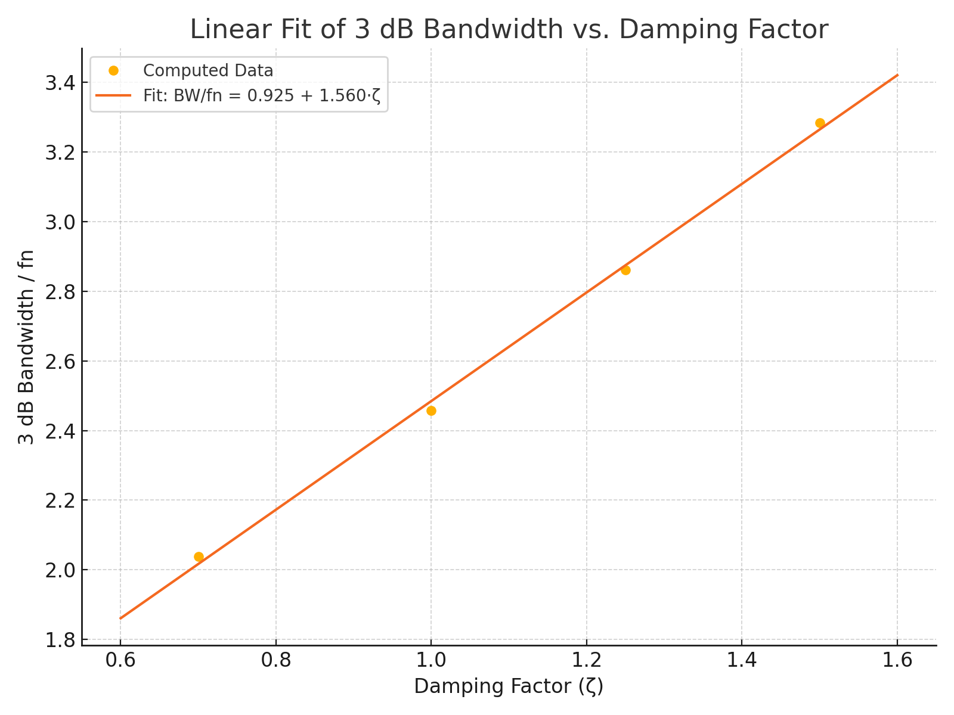

Generated by ChatGPT · OpenAI