# Relation Between 3 dB Bandwidth and Damping in Second-Order ADPLL

This document presents the analysis and a fitted approximation for the 3 dB bandwidth of a second-order ADPLL filter in relation to its damping factor ζ.

## Numerical Results

From simulated frequency response curves, the following 3 dB bandwidth values were obtained:

|  |  |
| --- | --- |
| Damping Factor (ζ) | 3 dB Bandwidth / fn |
| 0.70 | 2.04 |
| 1.00 | 2.46 |
| 1.25 | 2.86 |
| 1.50 | 3.28 |

## Fitted Relationship

A linear model was fit to the data:

BW/fn ≈ 0.925 + 1.56 · ζ

This equation can be used to approximate the 3 dB cutoff frequency of a second-order ADPLL filter, given a damping factor ζ and natural frequency fn.

## Graphical Illustration

The figure below shows the computed data points and the linear fit curve:

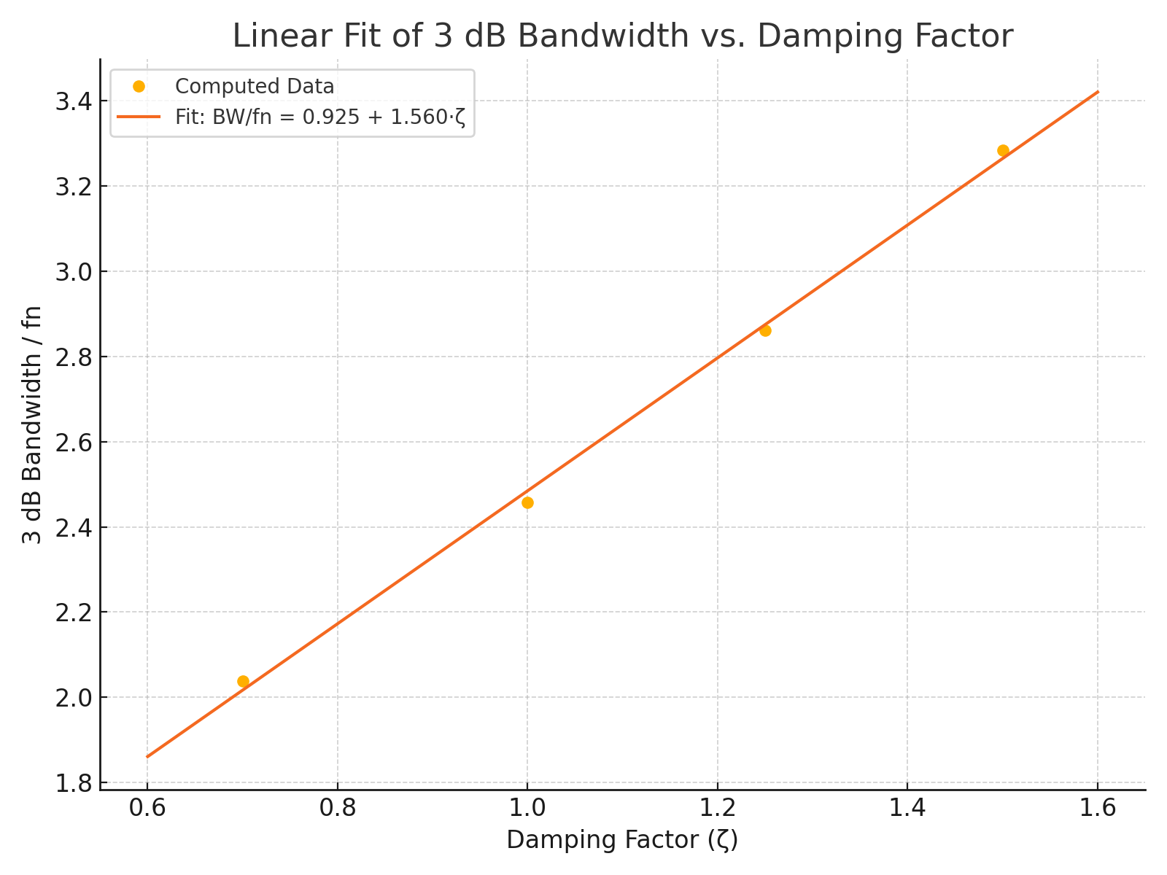

Generated by ChatGPT · OpenAI

## Frequency Response Curves

This figure shows the frequency response of the second-order ADPLL system for different damping factors ζ. The 3 dB points are visually confirmed in each case.

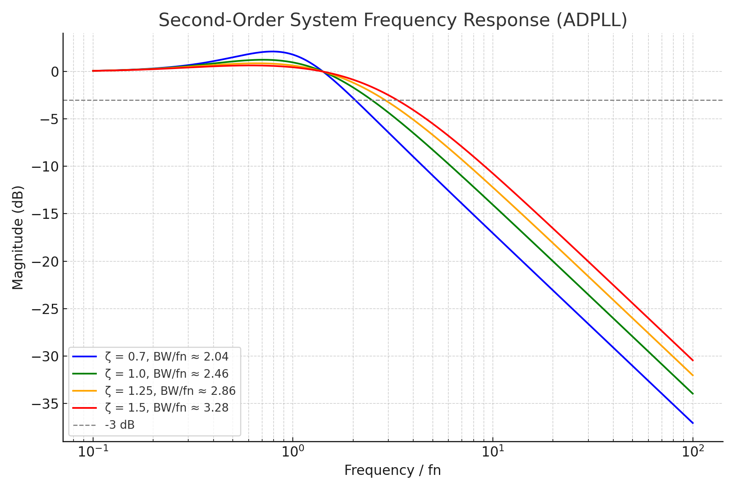

# Correct Derivation of Noise Equivalent Bandwidth (NEB) for Second-Order ADPLL

This document presents a corrected and complete derivation of the noise equivalent bandwidth (NEB) for a second-order low-pass system, including all unit conversions and an explanation of its relationship to the 3 dB bandwidth.

## Transfer Function

The second-order low-pass transfer function commonly used in ADPLL design is:

H(s) = (2ζωₙs + ωₙ²) / (s² + 2ζωₙs + ωₙ²)

## Noise Equivalent Bandwidth (rad/s)

The NEB is defined as the bandwidth of an ideal rectangular filter passing the same total noise power as the real filter. For a second-order system, the known result is:

NEB_rad/s = (π · ωₙ) / (2ζ)

## Conversion to Hz

To convert angular frequency to frequency in Hz, recall:

fₙ = ωₙ / (2π) → ωₙ = 2πfₙ

Then substitute into the rad/s formula and convert:

NEB_Hz = (1 / 2π) · (π · ωₙ / 2ζ)  
 = (π · 2πfₙ) / (4πζ)  
 = πfₙ / (2ζ)

## Final Correct Formula

NEB_Hz = π · fₙ / (2ζ)

## Interpretation and Comparison to 3 dB Bandwidth

It may seem surprising that NEB is slightly larger than the 3 dB bandwidth, especially for resonant second-order filters. This is because:

1. NEB measures total power passed across all frequencies.

2. 3 dB bandwidth only measures the frequency where the power drops by half.

3. For second-order systems with resonance, energy is concentrated near ωₙ, but still distributed around it.

Therefore, even with a resonance peak, the NEB can exceed the 3 dB bandwidth because it accounts for all the passed power — including side-lobes and roll-off regions. The corrected formula reconciles this, showing that NEB grows with lower damping.

Generated by ChatGPT · OpenAI