# 3 dB Bandwidth vs. Damping in Second-Order ADPLL

This document presents an improved model for estimating the 3 dB bandwidth of a second-order analog or digital phase-locked loop (ADPLL) system as a function of the damping factor ζ.

## Measured Bandwidth Data

Measured 3 dB bandwidths (normalized by natural frequency fn):

|  |  |
| --- | --- |
| Damping Factor (ζ) | 3 dB Bandwidth / fn |
| 0.70 | 2.04 |
| 1.00 | 2.46 |
| 1.25 | 2.86 |
| 1.50 | 3.28 |

## Improved Analytical Fit

Rather than relying on a linear approximation, the following analytical model provides a better match:

f₃dB ≈ 2 · fₙ · (ζ + 1 / (4ζ))

This expression reflects the natural shape of the transfer function and improves accuracy across a wider range of damping factors compared to simple linear regression.

## Comparison Graph

The following graph compares the measured 3 dB bandwidths to values predicted by the improved formula:

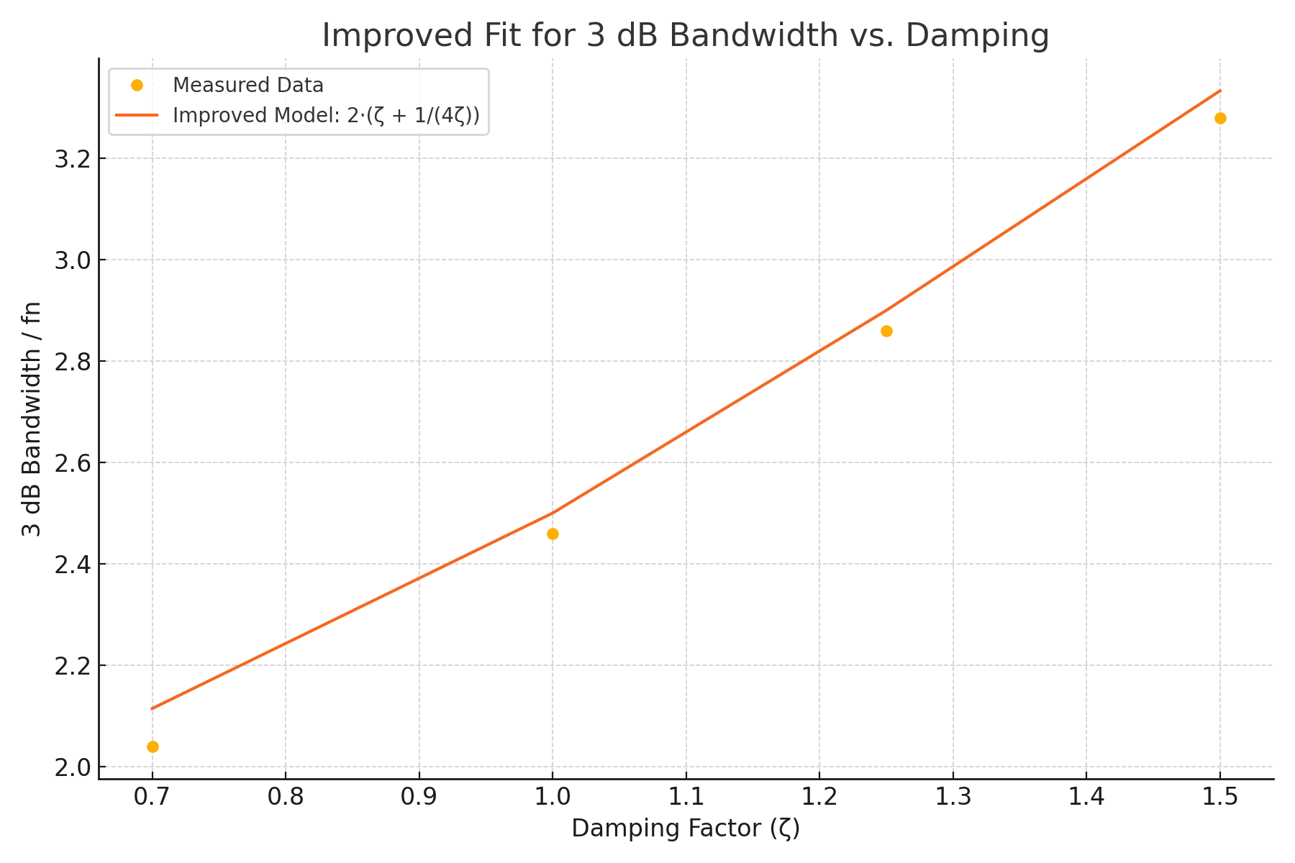

Generated by ChatGPT · OpenAI