# Bandwidth Analysis for the Filter H(s) = ks / (s² + ks + 1)

## Transfer Function:

H(s) = ks / (s² + ks + 1)  
  
This is a second-order high-pass filter.

## Objective:

Determine the 3 dB bandwidth as a function of the parameter k.

## Step 1: Magnitude Response

We compute the magnitude of the transfer function:  
|H(jω)| = |jkω / ((jω)² + k(jω) + 1)| = kω / sqrt((1 - ω²)² + (kω)²)  
  
We seek ω₃dB where:  
|H(jω₃dB)| = (1/√2) * |H(jω)|_peak  
  
However, this is difficult to solve algebraically. Instead, we approximate using the standard second-order form.

## Step 2: Identify Standard Second-Order Form

Compare:  
s² + ks + 1 with s² + 2ζωₙs + ωₙ²  
  
From this we identify:  
- ωₙ = 1  
- 2ζωₙ = k => ζ = k / 2

## Step 3: Approximate Bandwidth Formula

For an underdamped second-order system, the -3 dB bandwidth is approximated by:  
ω_BW ≈ ωₙ √(1 - 2ζ² + √(4ζ⁴ - 4ζ² + 2))  
  
Substitute ζ = k / 2, ωₙ = 1:  
ω_BW(k) ≈ √(1 - k²/2 + √(k⁴/4 - k² + 2))

## Step 4: Numerical Examples

|  |  |  |
| --- | --- | --- |
| k | ζ | Bandwidth (rad/s) |
| 0.5 | 0.25 | 1.32 |
| 1.0 | 0.5 | 1.10 |
| 2.0 | 1.0 | 0.64 |
| 3.0 | 1.5 | 0.44 |

## Step 5: Graphical Representation

The graph below shows how the bandwidth decreases as k increases:

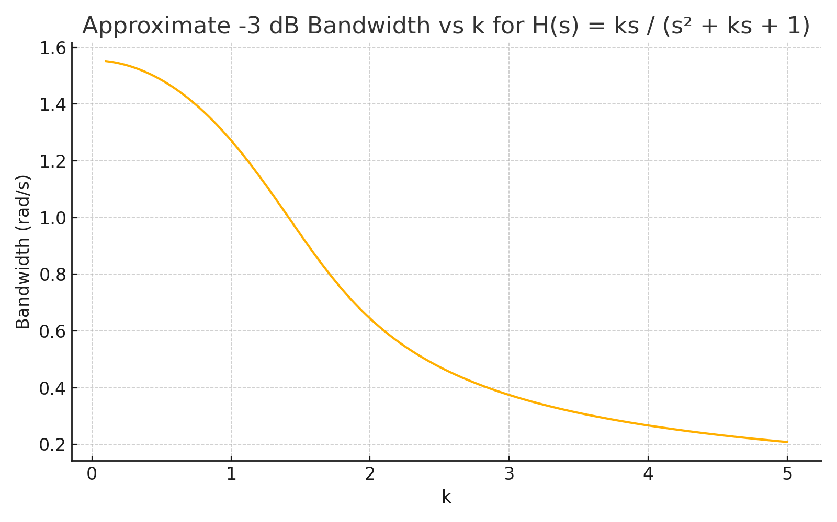

This behavior reflects that increasing k increases damping, which reduces the bandwidth.

## Conclusion:

The filter H(s) = ks / (s² + ks + 1) has a decreasing -3 dB bandwidth as k increases, due to its increasing damping effect.   
The formula derived above provides a practical way to estimate the bandwidth for different values of k.