# Relation Between Laplace and Z Transform in Exponential Filters

This document explains how the Laplace-domain representation of an exponential filter relates to its discrete-time Z-transform equivalent, particularly in the context of Brown's exponential smoothing.

## Continuous-Time (Laplace Domain)

A first-order low-pass filter in the Laplace domain is represented as:  
 H(s) = 1 / (τs + 1)  
Where:  
 • τ is the time constant,  
 • s is the Laplace transform variable.

## Discrete-Time (Z Domain)

The equivalent Z-domain representation of a single exponential smoother is:  
 H(z) = α / [1 - (1 - α) z⁻¹]  
Where:  
 • α ∈ (0, 1] is the smoothing factor,  
 • (1 - α) = β is the decay factor (memory).

## Mapping Between Domains

The approximate transformation from Laplace to Z-domain using backward Euler is:  
 s ≈ (1 - z⁻¹) / T  
Substituting into the Laplace transfer function yields:  
 H(z) ≈ 1 / [ (τ/T)(1 - z⁻¹) + 1 ]  
Letting α = T / (τ + T), this simplifies to:  
 H(z) = α / [1 - (1 - α) z⁻¹]

## Parameter Equivalence

To relate α and τ directly:  
 α = T / (τ + T)  
 τ = T * (1 - α) / α  
Thus, larger τ means slower response and smaller α (heavier smoothing).  
Smaller τ gives faster response and larger α (less smoothing).

## Interpretation of β

The term β = 1 - α represents the filter's memory. A larger β means the filter gives more weight to older samples, resulting in stronger smoothing.

## Example: Frequency Response

The graph below shows the frequency response of the Brown double exponential filter in dB for several α values. It demonstrates that smaller α values result in stronger attenuation of high-frequency components.

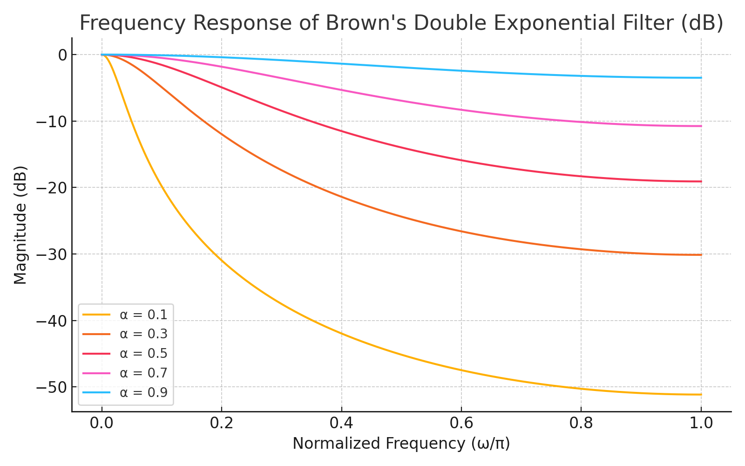

Figure: Frequency response (in dB) of Brown’s double exponential filter for various α values.

**Transfer function for the Trend measurement in the Brown double Filtering:**

**Brown Filter Response for the amplitude**

