# PLL Derivative and Brown Filter Analysis

This document illustrates the structure and frequency responses for a second-order PLL system's derivative output, with and without a second-order Brown low-pass filter applied.

## Block Diagram

The diagram below shows the signal flow and where each transfer function is measured:

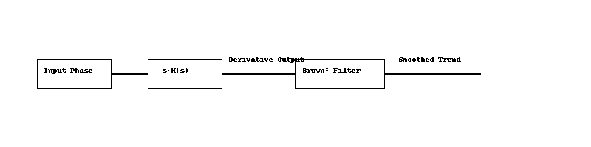

• The input phase on the picture is the PLL input signal.  
• The pre-integrator output is modeled by s·H(s) where H(s) is defined as:

The unit response for z=1, is:

And the frequency response and phase plot are:

• This output is optionally passed through a second-order Brown filter to produce a smoothed trend signal.

## Bode Plot

The plot below compares the frequency responses of the derivative output (red) and the filtered version (blue).

If the output derivative is filtered with a second order Brown low pass filter the system full response become a 4 order system with the following characteristic:

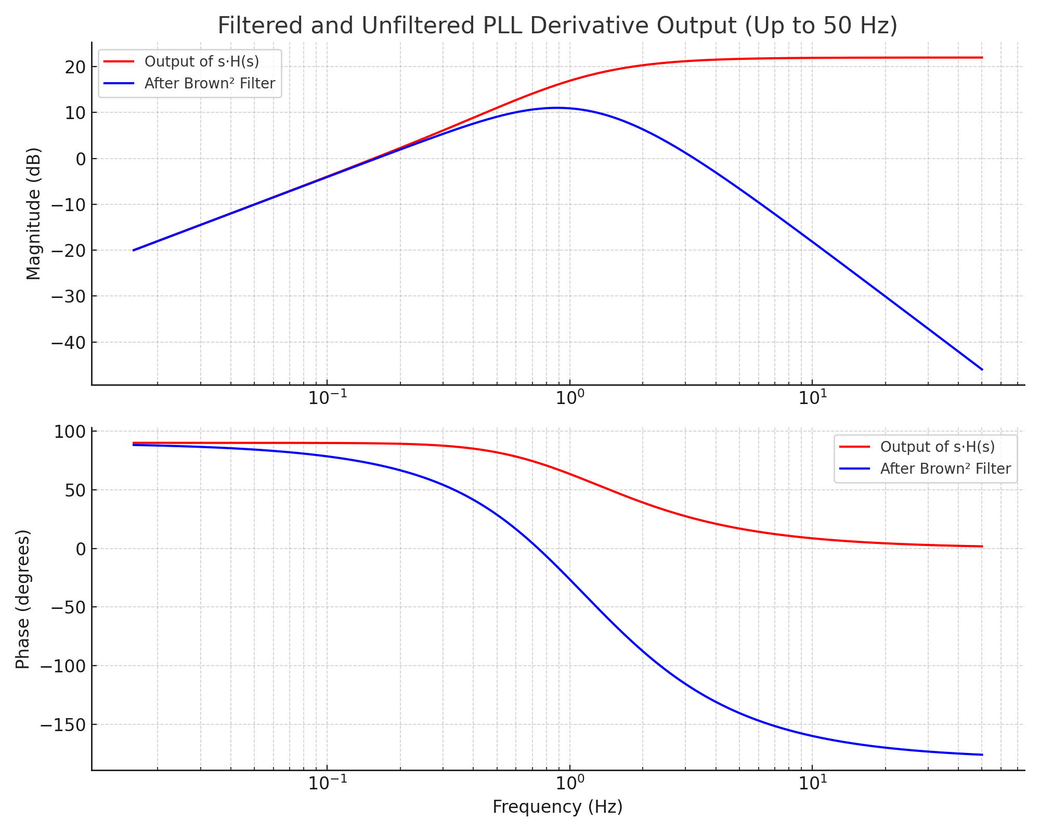

• The raw derivative (s·H(s)) shows significant high-frequency amplification.  
• The Brown² filter reduces high-frequency noise while preserving trend responsiveness near the PLL's natural frequency.

# Frequency Response of Brown's Double Exponential Smoothing Filter

Brown’s Double Exponential Smoothing filter is a two-stage filter designed to capture both the level and the trend in a time series. Unlike a simple exponential filter (single smoothing), it applies exponential smoothing twice, enabling it to adapt to linear trends more effectively.

## Filter Definition

The filter operates in two stages:  
 • First smoothing: S₁(t) = α x(t) + (1 - α) S₁(t-1)  
 • Second smoothing: S₂(t) = α S₁(t) + (1 - α) S₂(t-1)  
The forecast is computed using: x̂(t+1) = 2 S₁(t) - S₂(t)

## Transfer Function (Z-domain)

The Z-domain transfer function of the second smoother is:  
 H(z) = α² / (1 - (1 - α) z⁻¹)²  
This is equivalent to a second-order IIR low-pass filter.

## Frequency Response

To understand the filter's behavior in the frequency domain, we evaluate the transfer function on the unit circle:  
 z = e^{jω}, ω ∈ [0, π]  
The magnitude response becomes:  
 |H(e^{jω})| = α² / [1 - 2(1 - α)cos(ω) + (1 - α)²]

This formula shows that low frequencies (ω ≈ 0) pass through with near-unit gain, while high frequencies (ω ≈ π) are increasingly attenuated. The smaller the α, the stronger the smoothing and the steeper the attenuation.

## Slope and Prediction Insight

The difference between the first and second smoothing stages, S₁(t) - S₂(t), represents the recent trend or slope. This difference is scaled by α / (1 - α) to estimate the slope, allowing the filter to make a one-step forecast that incorporates both the level and trend of the signal:  
 Trend ≈ (α / (1 - α)) * (S₁ - S₂)

This trend-following behavior is particularly useful in forecasting applications where the underlying data is expected to follow a consistent linear trajectory in the short term.

Figure: Frequency response (in dB) of Brown’s double exponential filter for various α values.

# Relation Between Laplace and Z Transform in Exponential Filters

This document explains how the Laplace-domain representation of an exponential filter relates to its discrete-time Z-transform equivalent, particularly in the context of Brown's exponential smoothing.

## Continuous-Time (Laplace Domain)

A first-order low-pass filter in the Laplace domain is represented as:  
 H(s) = 1 / (τs + 1)  
Where:  
 • τ is the time constant,  
 • s is the Laplace transform variable.

## Discrete-Time (Z Domain)

The equivalent Z-domain representation of a single exponential smoother is:  
 H(z) = α / [1 - (1 - α) z⁻¹]  
Where:  
 • α ∈ (0, 1] is the smoothing factor,  
 • (1 - α) = β is the decay factor (memory).

## Mapping Between Domains

The approximate transformation from Laplace to Z-domain using backward Euler is:  
 s ≈ (1 - z⁻¹) / T  
Substituting into the Laplace transfer function yields:  
 H(z) ≈ 1 / [ (τ/T)(1 - z⁻¹) + 1 ]  
Letting α = T / (τ + T), this simplifies to:  
 H(z) = α / [1 - (1 - α) z⁻¹]

## Parameter Equivalence

To relate α and τ directly:  
 α = T / (τ + T)  
 τ = T * (1 - α) / α  
Thus, larger τ means slower response and smaller α (heavier smoothing).  
Smaller τ gives faster response and larger α (less smoothing).

## Interpretation of β

The term β = 1 - α represents the filter's memory. A larger β means the filter gives more weight to older samples, resulting in stronger smoothing.

## Example: Frequency Response

The graph below shows the frequency response of the Brown double exponential filter in dB for several α values. It demonstrates that smaller α values result in stronger attenuation of high-frequency components.

Figure: Frequency response (in dB) of Brown’s double exponential filter for various α values.

Generated by ChatGPT · OpenAI

**Brown Filter Response for the trend measurement:**

**Brown Filter Response for the Amplitude measurement:**

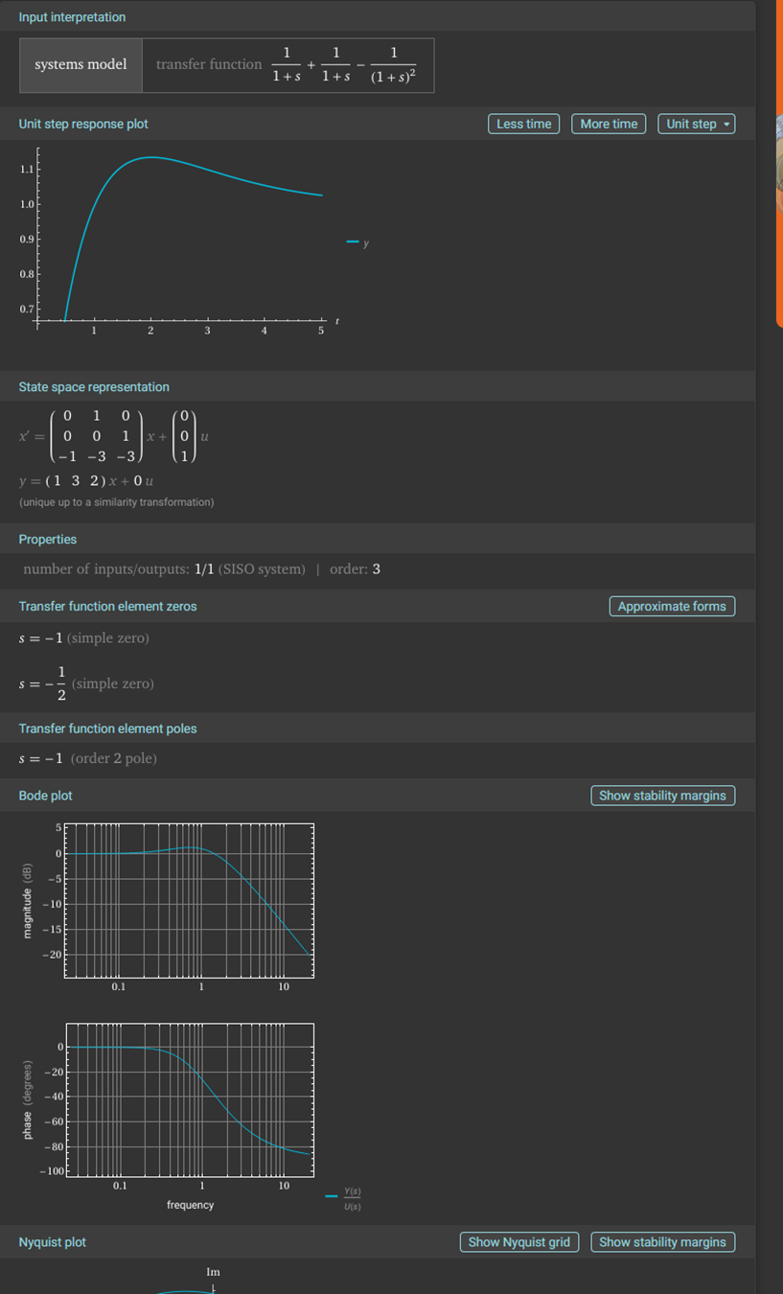

**Brown Filter Response for the Amplitude with no trend component:**

**Equivalent model for a derivative Brown Filter Response:**

