# Frequency Response of Brown's Double Exponential Filter

This document presents the frequency response of Brown's Double Exponential Smoothing filter. The plots show how the filter attenuates signals at different frequencies depending on the smoothing factor α.

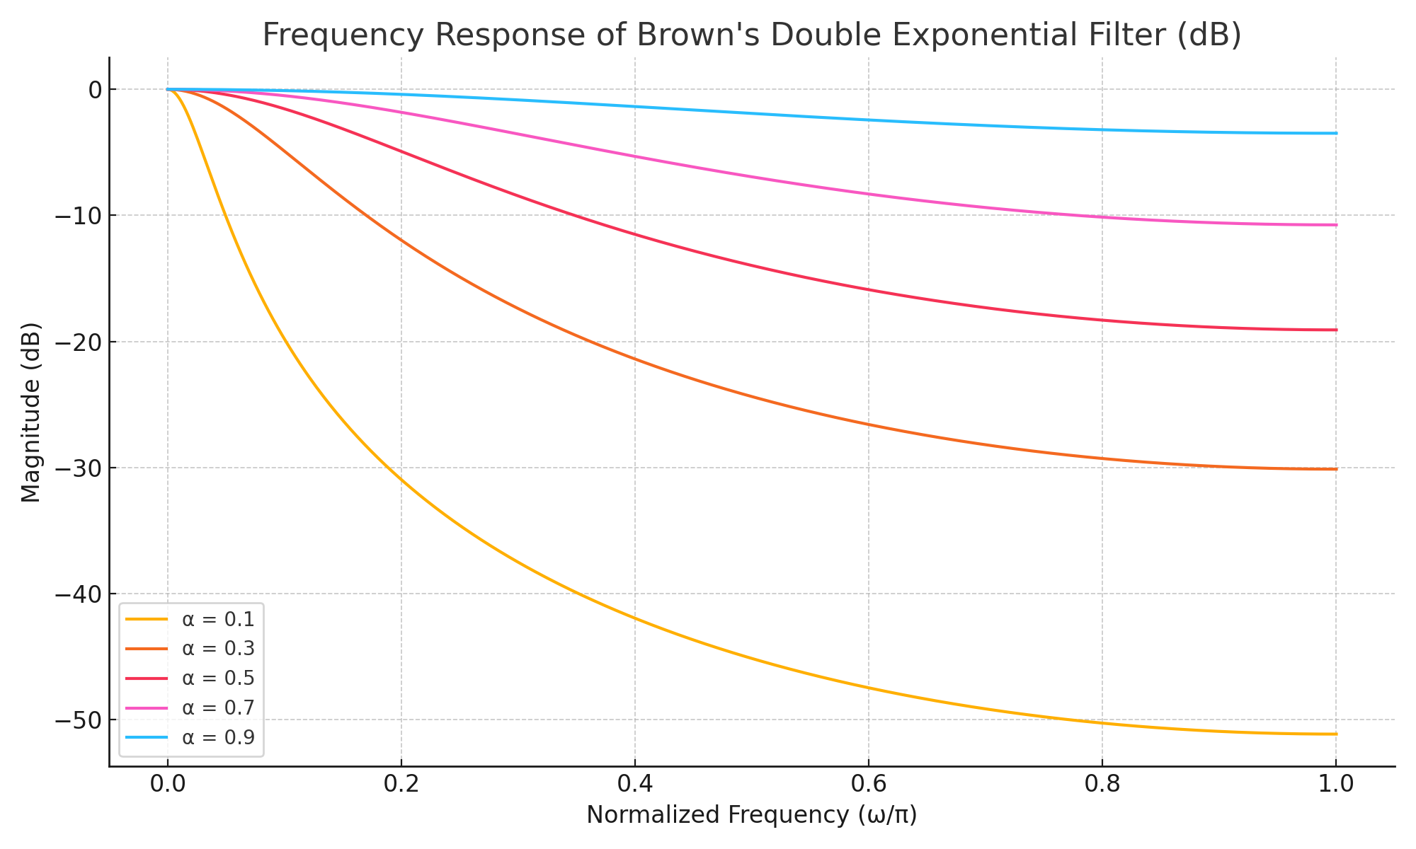

Figure: Frequency response in decibels for different α values.