# Frequency Response of Brown's Double Exponential Smoothing Filter

Brown’s Double Exponential Smoothing filter is a two-stage filter designed to capture both the level and the trend in a time series. Unlike a simple exponential filter (single smoothing), it applies exponential smoothing twice, enabling it to adapt to linear trends more effectively.

## Filter Definition

The filter operates in two stages:  
 • First smoothing: S₁(t) = α x(t) + (1 - α) S₁(t-1)  
 • Second smoothing: S₂(t) = α S₁(t) + (1 - α) S₂(t-1)  
The forecast is computed using: x̂(t+1) = 2 S₁(t) - S₂(t)

## Transfer Function (Z-domain)

The Z-domain transfer function of the second smoother is:  
 H(z) = α² / (1 - (1 - α) z⁻¹)²  
This is equivalent to a second-order IIR low-pass filter.

## Frequency Response

To understand the filter's behavior in the frequency domain, we evaluate the transfer function on the unit circle:  
 z = e^{jω}, ω ∈ [0, π]  
The magnitude response becomes:  
 |H(e^{jω})| = α² / [1 - 2(1 - α)cos(ω) + (1 - α)²]

This formula shows that low frequencies (ω ≈ 0) pass through with near-unit gain, while high frequencies (ω ≈ π) are increasingly attenuated. The smaller the α, the stronger the smoothing and the steeper the attenuation.

## Slope and Prediction Insight

The difference between the first and second smoothing stages, S₁(t) - S₂(t), represents the recent trend or slope. This difference is scaled by α / (1 - α) to estimate the slope, allowing the filter to make a one-step forecast that incorporates both the level and trend of the signal:  
 Trend ≈ (α / (1 - α)) * (S₁ - S₂)

This trend-following behavior is particularly useful in forecasting applications where the underlying data is expected to follow a consistent linear trajectory in the short term.

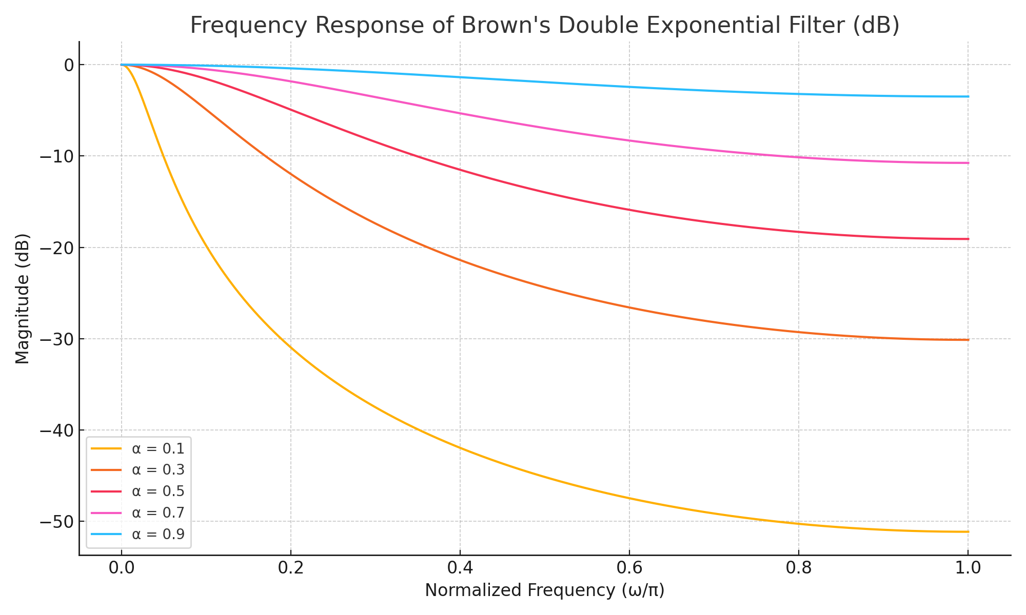

Figure: Frequency response (in dB) of Brown’s double exponential filter for various α values.