CPSC 491

Team 4

Sebastian Vargas

Individual Work

(1)

This week I set out to set up a simple HTML that could have camera access and snap pictures with a button. I would look up tutorials and write up HTML5/JavaScript files to run in a web browser that can take a picture and save it on the local machine.

(2)

This week, I was able to follow a tutorial to help me set up a basic HTML page that could display the camera input in real time as well as snap a photo. This is what the page looks like

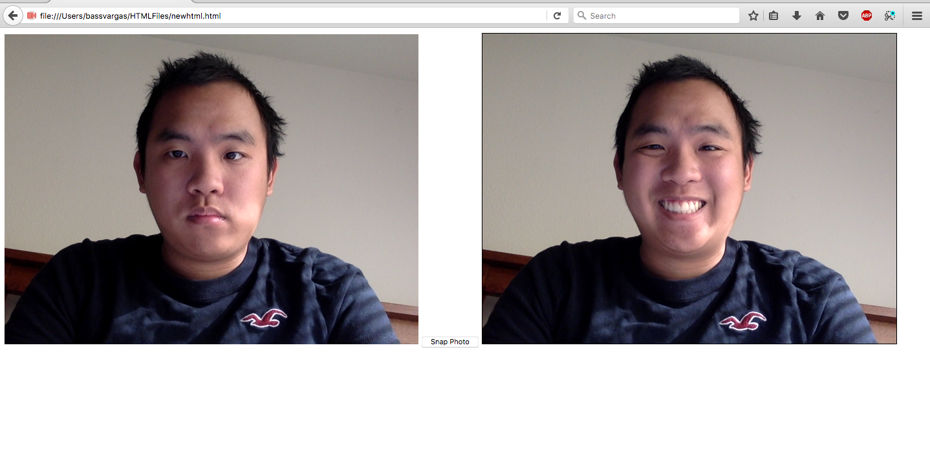

(3)

Doing this made me realize that I needed to brush up more on JavaScript and how that works in the context of HTML pages as it was a challenge for me to navigate the code. I am familiar with HTML and JavaScript; however, the tutorials I followed had HTML pages that were formatted differently to what I was used to. I am currently stuck on saving the picture taken to the local machine. One thing I will do to improve for next week is read up more on JavaScript and how it works with HTML.