CPSC 491 Assignment 5

Sebastian Vargas

(1)

Last week, I set out to complete a chrome extension that can access the idle API and auto fill passwords. I would write a chrome extension that would check whether the current window was idle or not, and would autofill a password upon completion. Also, I would attempt to help Brian with his camera extension.

(2)

With regards to the idle chrome API, I was able to follow a tutorial that would show how long ago the idle state was changed.

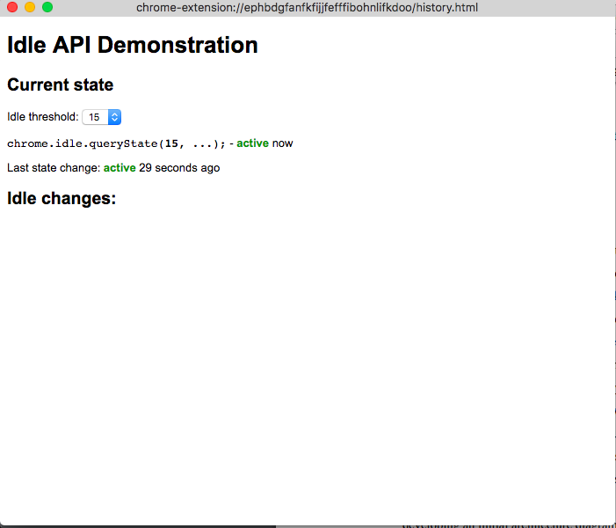

It helped me understand the idle API a bit more, but I then realized that I still needed to read up on how extensions work exactly. There isn't a lot of tutorials for the specific chrome extension features we want, so we would have to do a lot of trial and error. I was not completely comfortable with the idle API, so I decided to put off the password integration until I had a better grasp of how to work with chrome APIs.

While working with Brian on his camera extension, we came to the realization that it might be harder to have it be an extension since Google has required every site to have an SSL certificate to access the camera feed directly.

(3) This week, our progress is relatively better in the sense that we are progressing towards our end product and that we are encountering issues early on to read up on before we commit to a larger product; however, I feel like we could be further in the development process.