Chrome Extension Research

CPSC 491 Team 4

Sebastian Vargas

So this week, I spent some time researching how to build a chrome extension.

https://developer.chrome.com/extensions/getstarted

I followed the tutorial in the above link and created a small extension that changed the back ground color of a webpage.

I learned how chrome extensions should be packaged and what they entail.

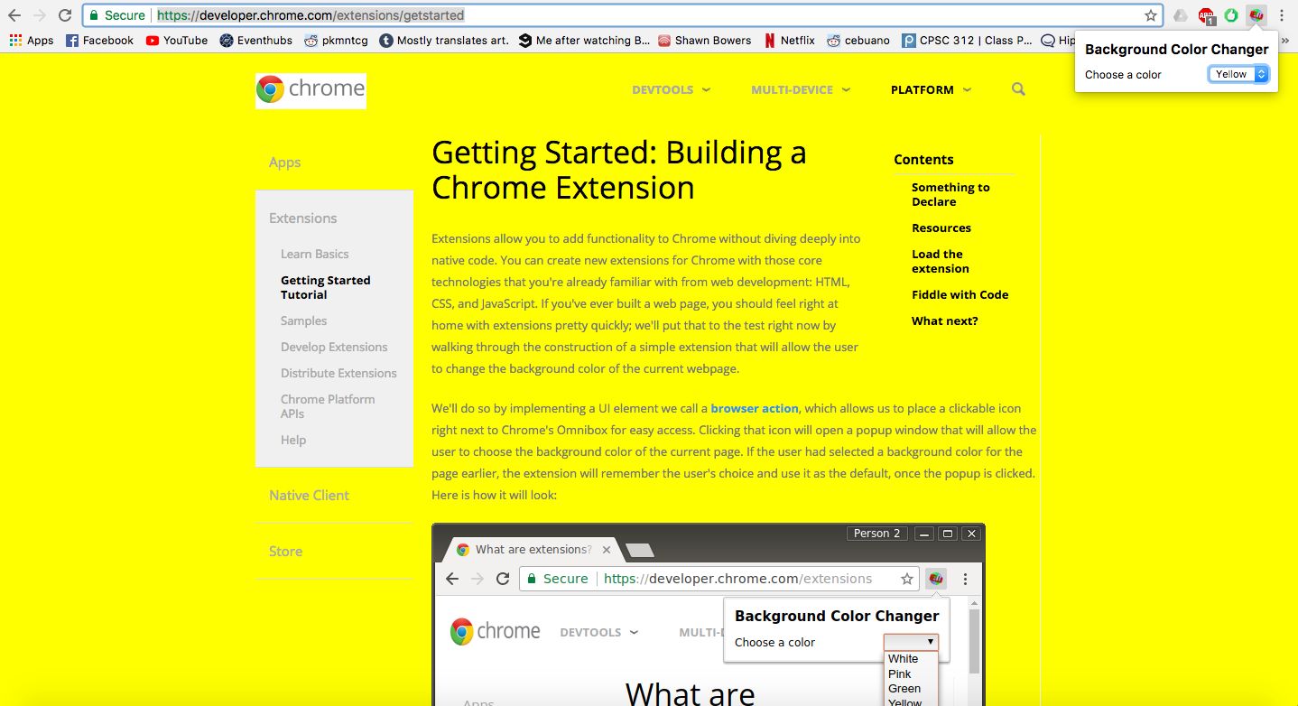

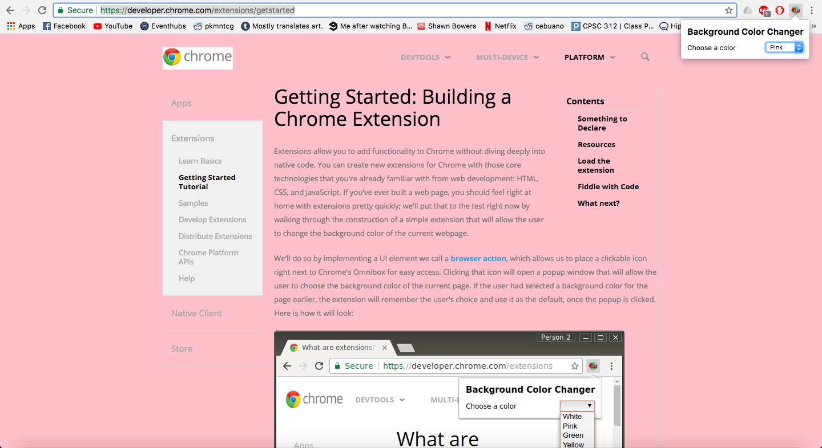

Here are some screen shots of the extension in action.

I have also discovered that it is possible to write a chrome extension in python.

https://pythonspot.com/en/create-a-chrome-plugin-with-python/

I implemented a very simple python-to-chrome extension piece following the tutorial above.

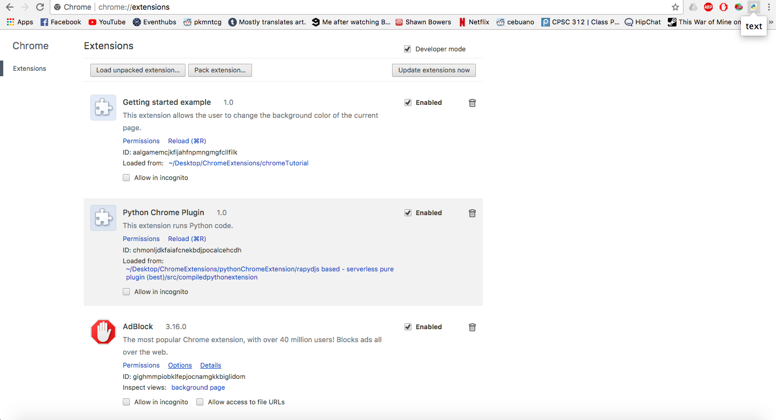

All it does is display "text", but getting the rapydscript installed took more time than I'd like.