# abj DEB model

Maxence Dumortier – 09/01/2024

Table of contents

abj DEB model 1

1. Model 2

2. Code structure 2

3. Parameters 3

1. Simulation parameters 3

2. Forcing variables parameters 3

3. State variables – Initial conditions 4

4. Primary parameters (rates are at reference temperature Tref) 4

5. Auxiliary and compound parameters 5

4. Model equation 5

1. Forcing variables 5

2. Metamorphosis and metabolic acceleration 6

3. Temperature correction 6

4. Scaled functional response 6

5. Fluxes equations 6

6. Starvation scenarios 7

7. Differential equations of state variable 8

8. Observable variables 8

## Model

The objective is to simulate the growth, development, and reproductive behavior of a fish and the growth of the otolith radius and opacity over his life cycle.

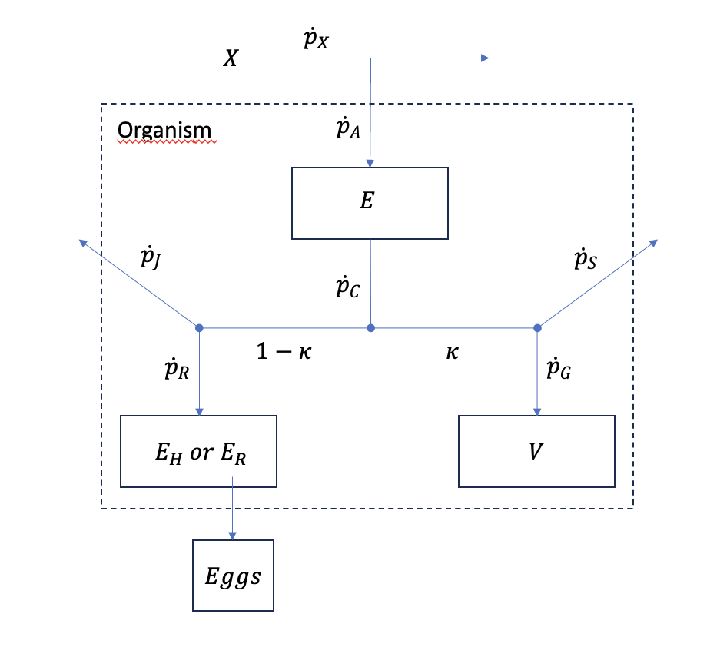

Forcing variables :

Food

: Ambient temperature

States variables:

: Reserve

Structure

Maturity

Reproduction buffer

Flux:

 : Ingestion flux

: Assimilation flux

: Mobilisation flux

: Somatic maintenance flux

: Growth flux

: Maturation or reproduction flux

: Maturity maintenance flux

Parameter:

: allocation rule

Figure 1: Conceptual diagram of a Standard Dynamic Energy Budget (DEB) model showing the flux of an individual fish

## Code structure

**Main Script (main.m):** This is the main script of the project and the only one that needs to be executed.

**Initialization Parameters (set_par.m):** This file contains initial parameter values. It needs to be modified according to the specific species.

**Integration Function (integration.m):** This function is used to solve differential equations of the model with ode (defined in 'flux.m') and obtain values for all state variables.

**Flux calculation Function (flux.m):** This function defines the dynamics of flux and state variables.

**Acceleration Function (acc.m):** This function sets volume at birth and metamorphosis, as well as acceleration factors depending on the life stage.

**Event Functions (vol_birth.m, vol_meta.m, vol_pub.m):** These functions are used as event functions for the integration of state dynamics. They set times and volumes at threshold periods such as birth and puberty.

**Food Variation Function (food.m):** This function handles food variation in the environment.

**Temperature Variation Function (temp.m):** This function manages ambient temperature variation in the environment.

**Parameter Correction Function (corr_T.m):** This function corrects the initial values of parameters in accordance with the temperature (forcing variables).

**Compute observable variables (get_obs.m):** function to produce ‘observable’ variables from state variables.

**Plot state and forcing variables (plot_SFV.m):** function to plot state and forcing variables.

**Plot observables (plot_obs.m):** function to plot observables

## Parameters

### Simulation parameters

|  |  |  |  |  |
| --- | --- | --- | --- | --- |
| **Symbol** | **Value** | **Definition** | **Unit** | **Symbol in script** |
|  |  | Simulation duration | d | time |

### Forcing variables parameters

|  |  |  |  |  |
| --- | --- | --- | --- | --- |
| **Symbol** | **Value** | **Definition** | **Unit** | **Symbol in script** |
| **Temperature** | | | | |
|  |  | Temperature at | K | T |
|  |  | Amplitude of the sinusoidal variation |  | T_alpha |
|  |  | Phase offset or initial variation |  | T_phi |
|  |  | Period of the sinusoidal variation |  | T_P |
| **Food** | | | | |
|  |  | Food density at |  | X |
|  |  | Amplitude of the sinusoidal variation |  | X_alpha |
|  |  | Phase offset or initial variation |  | X_phi |
|  |  | Period of the sinusoidal variation |  | X_P |

### State variables – Initial conditions

|  |  |  |  |  |
| --- | --- | --- | --- | --- |
| **Symbol** | **Initial Value** | **Definition** | **Unit** | **Symbol in script** |
|  |  | Reserve | J | E_0 |
|  |  | Structural volume | cm3 | V_0 |
|  |  | Cumulated energy invested into development | J | E_H0 |
|  |  | Reproduction buffer | J | E_R0 |
|  |  | Otolith length | cm | L_O0 |
|  |  | Otolith volume | cm3 | V_O0 |

### Primary parameters (rates are at reference temperature Tref)

|  |  |  |  |  |
| --- | --- | --- | --- | --- |
| **Symbol** | **Initial Value** | **Definition** | **Unit** | **Symbol in script** |
| **Arrhenius temperature** | | | | |
|  |  | Arrhenius temperature | K | T_A |
|  |  | Critical lower temperature tolerance (species-specific) | K | T_low |
|  |  | Critical higher temperature tolerance (species-specific) | K | T_high |
|  |  | Arrhenius temperature for the rate of decrease at the lower boundary | K | T_AL |
|  |  | Arrhenius temperature for the rate of decrease at the upper boundary | K | T_AH |
| **Core Parameters** | | | | |
|  |  | Maximum surface specific assimilation rate | J.d-1.cm-2 | p_Am |
|  |  | Volume-specific somatic maintenance | J.d-1.cm-3 | p_M |
|  |  | Surface-specific somatic maintenance | J.d-1.cm-2 | p_T |
|  |  | Energy conductance | cm.d-1 | v |
|  |  | Allocation rule | - | kap |
|  |  | Reproduction efficiency | - | kap_R |
|  |  | Maturity maintenance rate coefficient | d-1 | k_J |
|  |  | Volume-specific cost of structure | J.cm-3 | E_G |
| **Maturity threshold** | | | | |
|  |  | Maturity threshold at birth | J | E_Hb |
|  |  | Maturity threshold at metamorphosis | J | E_Hj |
|  |  | Maturity threshold at puberty | J | E_Hp |
| **Structural volume threshold** | | | | |
|  |  | Structural volume at birth | Cm3 | V_b |
|  |  | Structural volume at metamorphosis | Cm3 | V_j |
|  |  | Structural volume at puberty | Cm3 | V_p |

These parameters are expressed at the temperature (Tref = 293.15 K) and are species-specific.

### Auxiliary and compound parameters

|  |  |  |  |  |
| --- | --- | --- | --- | --- |
| **Symbol** | **Initial Value** | **Definition** | **Unit** | **Symbol in script** |
| **Compounds parameters** | | | | |
|  |  | Half-saturation coefficient (dimension depends on the food’s dimension) |  | X_K |
|  |  | Maximum reserve density | J. cm-3 | E_m |
|  |  | Reserve density | J. cm-3 | resDens |
|  |  | Scaled reserve density | - | e |
| **Otolith module parameters** | | | | |
|  |  | Coupling coefficient to growth | cm.d-1 | v_G |
|  |  | Coupling coefficient to dissipation | cm.d-1 | v_D |
| **Auxiliary parameters (observable variables)** | | | | |
|  |  | Shape coefficient | - | del_M |
|  |  | Otolith shape coefficient | - | del_O |
|  |  | Total water fraction of the organism | - | c_w |
|  |  | Specific density of the structure | g(dw).cm-3 | d_V |
|  |  | Specific weight of the reserve | g(dw).mol-1 | w_E |
|  |  | Specific weight of the structure | g(dw).mol-1 | w_V |
|  |  | Chemical potential of reserve | J.mol-1 | mu_E |
|  |  | Chemical potential of structure | J.mol-1 | mu_V |

## Model equation

### Forcing variables

|  |  |
| --- | --- |
| **Equations** | **Formula** |
| **Food** | |
| Food density at t | with : mean value of food density |
| **Temperature** | |
| Temperature at t | with : mean value of temperature |

### Metamorphosis and metabolic acceleration

|  |  |  |  |  |
| --- | --- | --- | --- | --- |
| **Symbol** | **Initial Value** | **Definition** | **Unit** | **Symbol in script** |
|  |  | Acceleration factor | **-** | s_M |

### Temperature correction

|  |  |
| --- | --- |
| **Equations** | **Formula** |
| Arrhenius expression (simplest version) |  |
| Arrhenius expression (optimal range version) |  |
| Temperature correction | with : parameters at , here:   : corrected values of the parameters at the temperature |

### Scaled functional response

|  |  |  |  |  |
| --- | --- | --- | --- | --- |
| **Symbol** | **Value** | **Definition** | **Unit** | **Symbol in script** |
|  |  | Scaled functional response (feeding process) | - | f |

### Fluxes equations

|  |  |
| --- | --- |
| **Fluxes (J.d-1)** | **Formula** |
| Assimilation  (before birth (), no assimilation) |  |
| Somatic maintenance |  |
| Mobilisation (Catabolic utilisation) |  |
| Maturity maintenance |  |
| Maturation / reproduction |  |
| Dissipation |  |
| Growth |  |

### Starvation scenarios

Starvation occur when there is not enough energy to pay somatic maintenance (not enough mobilisation) :

|  |
| --- |
| **Case n° 1** |
| * The organism isn’t an adult * Energy meant for the maturity enougth to cover the missing somatic maintenance energy * Maturity energy pay somatic maintenance energy * no maturation occurs |
|  |
| **Case n° 2** |
| * The organism isn’t an adult * Not enough energy meant for maturity to cover missing energy to pay somatic maintenance * The organism die |
|  |
| **Case n° 3** |
| * The organim is an adult * Enough energy in the reproduction buffer to pay somatic maintenance * The missing energy is taken from the reproduction buffer * No growth |
|  |
| **Case n° 4** |
| * The organism is an adult * Not enough energy in reproduction buffer to pay somatic maintenance * The organism die |
|  |

### Differential equations of state variable

|  |  |
| --- | --- |
| **State variables** | **Formula** |
| Reserve |  |
| Structure |  |
| Otolith volume |  |
| Reproduction/development |  |

### Observable variables

|  |  |  |  |  |
| --- | --- | --- | --- | --- |
| **Symbol** | **Equation** | **Definition** | **Unit** | **Symbol in script** |
|  |  | Standard length | cm | L_w |
|  |  | Dry weight of structure | g | W_V |
|  |  | Dry weight of reserve | g | W_E |
|  |  | Dry weight of reproduction buffer | g | W_ER |
|  |  | Dry weight | g | W |
|  | The variation in water content as a function of lipid content is not taking into account | Wet weight | g | W_w |
|  |  | Energy content of structure | J | E_V |
|  | Could also be calculated with dry weight | Energy density of the organism. | J.g-1 | E_w |
|  |  | Fecundity (number of eggs) | # | F |
|  |  | Gonado-somatic index | - | GSI |
|  |  | Otolith radius | cm | L_O |
|  |  | Otolith opacity | - | O |