Bacteremia & Fungemia Surveillance Module
(DRAFT VERSION FOR COLAB TESTING- April 2025)
Table of Contents

Introduction 2
Settings and Patient Locations 2
Data Reporting Requirements 2
Minimum Requirements for Reporting dQMs 3
Definitions 4
Measure Logic 5
Outpatient Community-onset Bacteremia & Fungemia (O-COB) Event: 6
Community-onset Bacteremia & Fungemia (COB) Event: 6
Hospital-Onset Bacteremia & Fungemia (HOB) Event: 7
Matching Organism Criteria 8
Figure 3: Bacteremia & Fungemia Event Algorithms 10
Appendices 14
Appendix A. Examples of Bacteremia & Fungemia Events 14
Examples of O-COB Events 14
Examples of COB Events 14
Examples of HOB Events 15

Introduction
Bloodstream infections (BSIs) are associated with high morbidity and mortality [1]. Some BSIs are classified as Central Line-Associated Bloodstream Infections (CLABSIs), which has been a focus of surveillance and infection prevention efforts for many years. As a result, CLABSIs have decreased from historical levels [2]. Less attention has been given to the prevention of bloodstream infections not associated with central lines.

The NHSN Bacteremia & Fungemia Surveillance module provides a mechanism for automated reporting of bacteremia and fungemia events as part of patient-safety and quality improvement efforts. It provides acute care hospitals with an approach for tracking a broad scope of bloodstream infections, leveraging Healthcare Level Seven International® (HL7®) Fast Healthcare Interoperability Resources® (FHIR®) to enable algorithmic determinations from clinical data available in electronic health records (EHRs). Ongoing surveillance is designed to minimize burden of data collection on facilities, while enabling facility-level prevention targets and national benchmarking.

Settings and Patient Locations
All inpatient facilities (for example, general acute care hospitals, critical access hospitals, children’s hospitals, oncology hospitals, long term acute care hospitals, and inpatient rehabilitation facilities) enrolled in NHSN are eligible to enroll and participate in the Bacteremia & Fungemia module. Long-term care facilities (LTCFs) and outpatient dialysis facilities are not yet eligible to participate in the Bacteremia & Fungemia module. Bacteremia & Fungemia events are determined for applicable inpatient locations, emergency departments and 24-hour observation locations.

Facilities are required to map all facility locations in which surveillance is performed according to the guidance in the CDC Locations and Descriptions Manual. Facilities newly enrolled in NHSN must map locations according to the CDC Locations and Descriptions manual; for facilities already enrolled in NHSN, the HOB module uses the locations that have been mapped in the Patient Safety Component.
Note:
- Data for all inpatient areas that qualify for the NHSN Bacteremia & Fungemia Module reporting, including procedural areas like operating rooms, will be analyzed. This is different than NHSN Facility-wide Inpatient (FacWideIN) in some NHSN modules that exclude procedural areas, such as the laboratory-Identified (LabID) event reporting for the Multidrug-Resistant Organism & Clostridioides difficile Infection Module.

Data Reporting Requirements
All participating inpatient facilities reporting data to the NHSN Bacteremia & Fungemia module must be able to report data electronically in adherence to HL7 FHIR US Core FHIR R4.0.1 data standards and specifications and NHSN instructions for reporting dQMs [3-5]. Technical reporting requirements are specified separately in the CDC NHSN dQM FHIR Implementation Guide. Facility personnel responsible for reporting data to NHSN must coordinate with their information-systems providers to allow generation of standard formatted file(s) that are imported into NHSN according to these standards and instructions. The NHSN Bacteremia & Fungemia module does not support manual data entry or Clinical Document Architecture (CDA) submission. NHSN performs FHIR queries on the 20th day of the calendar month; a monthly report reflects measures for the previous month.

Minimum Requirements for Reporting dQMs
- All information required for facility enrollment in NHSN is on file, including mapping of facility locations according to the CDC Locations and Descriptions Manual.
- A completed NHSN Patient Safety Component Annual Hospital Survey is on file for the reporting year.
- A monthly FHIR bundle that conforms to HL7 NHSN dQM Reporting Implementation Guide and the CDC NHSN dQMs Content Package Implementation Guide.
- A Digital Measure Reporting Plan completed for the reporting month, which indicates the facility has committed to:
  - Agreement the facility will permit access to data on the FHIR server for the required data elements.
  - Conformance of the data transmitted by the facility to the NHSN Bacteremia & Fungemia Surveillance protocol.
  - Adherence to technical specifications for value sets, including mapping local or non-standardized codes in the facility EHR to established value sets [Link to dQM Value Set File on nhsn.gov]. This includes mapping of any local codes used for medications to RxNorm, laboratory tests to LOINC, specimen and test result codes to SNOMED, and location codes to HSLOC. Facilities must work with their EHR vendors to download all the required value sets for mapping local or non-standardized codes to established value sets [Link to dQM Value Set File on nhsn.gov].
- An acceptable minimal month of data required for generating a monthly intra-facility analytic report, including all the following:
  - Patient identifiers (patient medical record number and encounter number, patient date of birth, patient sex).
  - FHIR “MedicationRequest” and “MedicationAdministration” resources results with medication identifiers, including date/time of request (order) and administration.
  - For the Bacteremia and Fungemia module, FHIR “Specimen” and “Observation” resource results with blood culture results, including specimen collected date and time and specimen type.
Measures are calculated only for submissions meeting the minimum requirements listed above.

Definitions

ED/OBS encounter: Any patient visit to an emergency department (ED) or observation (OBS) location. One patient visit equals one encounter. ED/OBS are considered outpatient locations.

Hospital Stay: NHSN defines a hospital stay to be inclusive of any: (a) ED/OBS encounters, (b) inpatient admissions, or (c) ED/OBS encounters that lead to inpatient admissions (within 1 hour of ED/OBS encounters).

Inpatient admission: For NHSN reporting purposes, the ‘date admitted to the facility’ is hospital day (HD) 1. NHSN defines an inpatient as any patient cared for or housed on an inpatient location. Local status may differ from NHSN definition; all days spent in an inpatient unit, regardless of local admission status and/or billing status are included in the counts of admissions and inpatient days. For NHSN reporting purposes, the date admitted to the facility is the calendar date that the patient physically locates to an inpatient location.

Reporting Period: Reporting calendar month of data reporting to NHSN
Adult: Patients who are ≥18 years old on the calendar day of the start of the Hospital Stay.

Pediatric: Patients who are < 18 years old on the calendar day of the start of the Hospital Stay.

NICU: Patients who are housed in a NICU location at the time of index blood culture collection

Oncology/Neutropenia: Patient either 1) located in an Oncology ward, or 2) with neutropenia define an absolute neutrophil count (ANC) <1000 cell/microL observed for ≥2 days in a +/- 7-day window period around the index blood culture

O-COB: Outpatient Community-onset Bacteremia & Fungemia Event

COB: Community-onset Bacteremia & Fungemia Event

HOB: Hospital-onset Bacteremia & Fungemia Event

Measure Logic

Events within the Bacteremia & Fungemia module are defined as follows, with onset assigned based on the patient location, date admitted to an inpatient location within the facility and date of blood culture specimen collection. HOB, COB and O-COB events are all identified by NHSN under this module.

Initial Patient Population for the Bacteremia & Fungemia module:
All encounters for patients of any age in an ED, observation, or inpatient location and/or all encounters for patients of any age with an ED, observation, inpatient, or short stay status during the reporting period.
Eligible Populations (based on patient physical location):

O-COB: All patients present in ED or Observation location during the reporting period.
COB: All patients on inpatient day 1 – 3 of their hospital stay present in an inpatient location during the reporting period.
HOB: All patients on inpatient day 4 or later of their hospital stay present in an inpatient location during the reporting period.

Outpatient Community-onset Bacteremia & Fungemia (O-COB) Event:
An O-COB event occurs when a patient has a bacterial or fungal organism identified from a blood specimen collected while the patient is in an outpatient location (specifically ED or Observation).
- A patient can have a single O-COB event per Hospital Stay
- The date for the O-COB will be attributed to the earliest date that a blood specimen is collected that has a bacterial or fungal organism identified while the patient is in an ED or Observation location
- All organisms identified from blood specimens collected while in an ED or Observation location will be attributed to a single O-COB event

O-COB Exclusions:
- Bacterial skin commensals: The organism must NOT be included in the value set for bacterial skin commensals and is further subject to the numerator exclusion below.
- Prior O-COB event: A patient with a previous O-COB event is excluded from additional O-COB events during the same Hospital Stay.

Community-onset Bacteremia & Fungemia (COB) Event:
A COB event occurs when a patient has a bacterial or fungal organism identified from a blood specimen collected on hospital day 1 through 3 (where the date of admission to an inpatient location is hospital day 1).
- A patient can have a single COB event per Hospital Stay
- The date for the COB will be attributed to the earliest date that a blood specimen is collected that has a bacterial or fungal organism identified during hospital day 1 through 3
- All organisms identified from blood specimens collected during hospital day 1 through 3 will be attributed to a single COB event.

COB Event Exclusions:
- Bacterial skin commensals: The organism must NOT be included in the value set for bacterial skin commensals and is further subject to the numerator exclusions below.
- Previous matching O-COB Event: A bacterial or fungal organism identified from a blood culture collected on hospital day 1 through 3 is excluded from a COB event if the patient has an O-COB event during the same Hospital Stay with a matching organism. The matching algorithm is defined below.
- Previous COB event: A patient with a previous COB event is excluded from additional COB events during the same Hospital Stay.

COB events can also be identified by the following:
- NICU
- Oncology/Neutropenia

Hospital-Onset Bacteremia & Fungemia (HOB) Event:
Hospital Onset Bacteremia and Fungemia: An HOB event occurs when a patient has a bacterial or fungal organism identified from a blood specimen collected on the 4th calendar day of admission or later (where the date of admission to an inpatient location is calendar day 1).
- A patient can have a single HOB event per Hospital Stay
- The date for the HOB will be attributed to the earliest date that a blood specimen is collected that has a bacterial or fungal organism identified on or after hospital day 4
  - HOB Infection Timeframe: Any subsequent positive blood culture findings during the subsequent 14 days will be considered part of the initial HOB event

HOB Event Exclusions:
- Bacterial skin commensals: The organism must NOT be included in the value set for bacterial skin commensals and is further subject to the numerator exclusions below.
- Previous matching COB or O-COB Event: A bacterial or fungal organism identified from a blood culture collected on hospital day 4 or later is excluded from an HOB event if the patient has an O-COB or COB event during the same Hospital Stay with at least one matching organism. The matching algorithm is defined below.
- Previous HOB event: A patient with a previous HOB event is excluded from additional HOB events during the same Hospital Stay.

Note: HOB events due to organisms in the following value set will be flagged as “community-associated organisms” as they primarily cause community-associated infections and are not known to (or rarely) cause healthcare-associated infections
  - For full list of organisms designated as community-associated organisms, see XXX value set

HOB events can also be identified by the following:
- NICU
- Oncology/Neutropenia

Matching Organism Criteria
- Step 1:
  - The reported SNOMED codes for each identified organism will be compared, if they are the same, the two organisms are considered a match.
- Step 2:
  - If both organisms have species-level identification (species-level column contains a value) and the species-level identifications are the same, the two organisms are considered a match
- Step 3:
  - If both organisms do not have species-level identification, but both have genus-level identification, compare organisms based on genus-level identification. If genus-level identifications are the same, the organisms are considered a match.
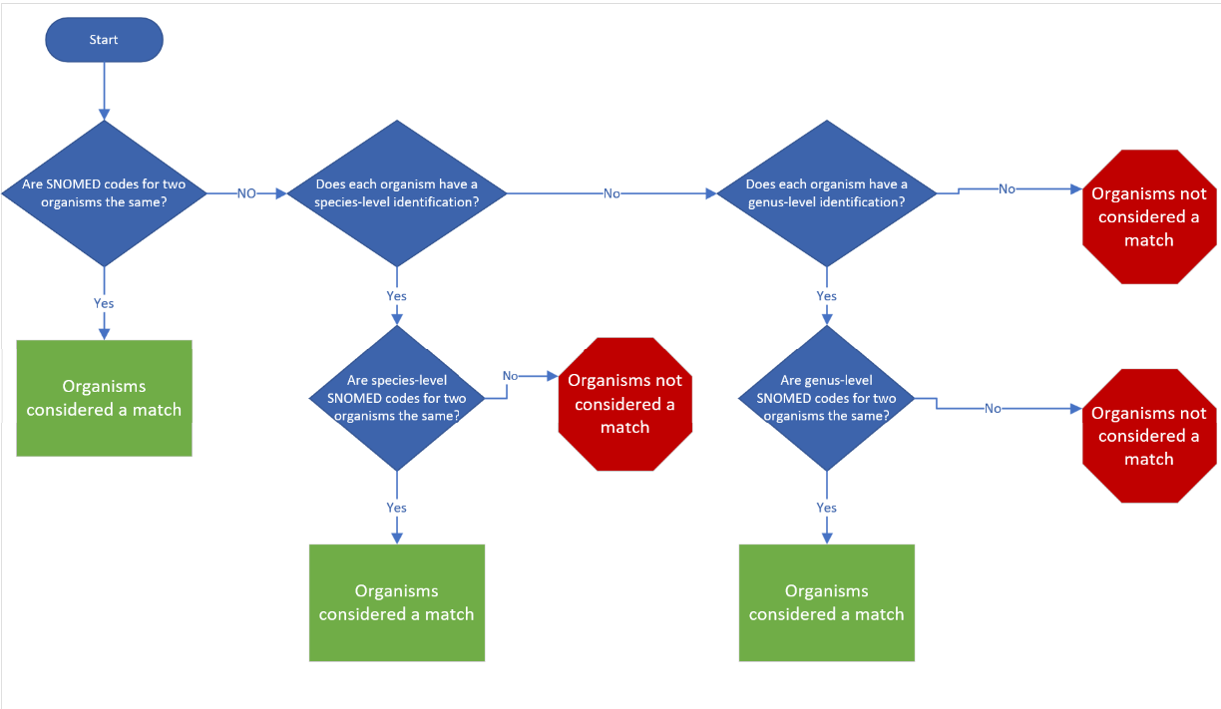

See Matching Organism Explanation Table for examples.

Figure 3: Bacteremia & Fungemia Event Algorithms
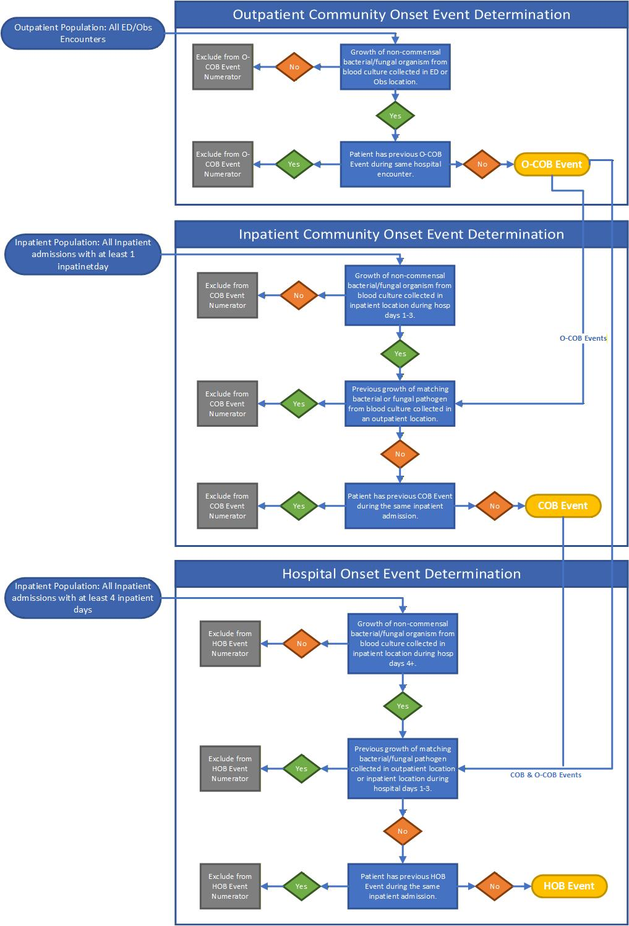
Data Analyses

The following section describes the analytic features available for the Bacteremia and Fungemia Module. All Bacteremia & Fungemia data that are submitted to NHSN can be analyzed. Users will not need to generate data sets to access their data. All data present in NHSN for the facility/facilities are made available in the analysis reports. Analysis will be performed on available data. If data or months of data are missing, the analysis reports may be inaccurate and/or incomplete.

The Bacteremia & Fungemia Event Module provides user feedback on several data points to facilitate infection control and quality improvement interventions:
- Monthly total HOB events and rates are offered with the ability to stratify by reporting units or patient population (e.g., adult, pediatric, NICU). Note these event counts may include events among active admissions where exclusion criteria have not yet been applied.

NOTE:
Analysis will be performed on available data. If data are missing, coded data elements are inaccurately mapped to standardized terminology, coded data are sent with inactive codes, etc., the analysis reports may be inaccurate and/or incomplete. As the data required for some event determination may span calendar months (for example, a patient with a blood culture collected at the end of the month but result is not finalized before the data is submitted to NHSN), analysis for the immediately prior month will be considered preliminary and will be updated/finalized upon receipt of the following month’s data.

Analysis Reports
Line List:
The line list provides a detailed patient-level review of all module events, including information of NHSN’s assignment of Bacteremia & Fungemia events.

Rate Tables:
Rate tables are available within the Bacteremia & Fungemia Surveillance Module. Rate tables provide measures of incidence and prevalence, and can be generated by calendar month, quarter, half-year, or year. Rates will automatically be generated for each unit, and facility wide. Numerators and denominators are tallied on the month that they occur and not based on the date of admission.

Each metric can be stratified by location and age group (Adult and Pediatric).

Onset | Metric | Numerator | Denominator | Multiplier | Notes
Outpatient Community Onset | O-COB Prevalence Rate | Number of outpatient O-COB events occurring within the measurement period | Number of outpatient (ED/OBS) encounters occurring within the measurement period | x 100
Inpatient Community Onset | Inpatient COB Prevalence Rate | Number of inpatient COB events occurring within the measurement period | Number of inpatient stays where at least one of the first three inpatient calendar days falls within the measurement period | x 100
Hospital Onset | HOB Crude Risk | Number of inpatient stays with at least one HOB event occurring within the measurement period | Number of inpatient stays where there are any inpatient days eligible for a hospital-onset event during the measurement period | x 100 | The denominator for HOB admission risk will include only those inpatient stays who were eligible for an HOB event in the analysis time period:  - Stays where day 4 (or later) of their admission occurred during the analysis time period.  - If an event occurs, then a stay will not be included in the denominator of subsequent measurement periods.
Hospital Onset | HOB Incidence Density | Number of HOB events | Number of inpatient days eligible for a hospital-onset event during the measurement period | x 10,000 | Eligible patient days are defined as:  - Inpatient day 4 until discharge or index HOB event date.

References

- Surbhi Leekha, Robinson GL, Jacob JT, et al. Evaluation of hospital-onset bacteraemia and fungaemia in the USA as a potential healthcare quality measure: a cross-sectional study. BMJ Quality & Safety. 2024;33(8):487-498. doi: https://doi.org/10.1136/bmjqs-2023-016831.
- Centers for Disease Control and Prevention. Current HAI progress report. CDC.gov. Published November 4, 2022. https://www.cdc.gov/hai/data/portal/progress-report.html
- Centers for Disease Control and Prevention. About NHSNLink and FHIR. www.cdc.gov. https://www.cdc.gov/nhsn/fhirportal/about.html
- Centers for Disease Control and Prevention. http://hl7.org/fhir. NHSN dQM Reporting Home - National Healthcare Safety Network (NHSN) Digital Quality Measure (dQM) Reporting Implementation Guide v1.0.0. Fhir.org. Published 2024. Accessed December 4, 2025. https://build.fhir.org/ig/HL7/nhsn-dqm/
- Centers for Disease Control and Prevention. http://hl7.org/fhir. Index - FHIR v4.0.1. Hl7.org. Published 2019. Accessed December 4, 2025. http://hl7.org/fhir/R4

Appendices

Appendix A. Examples of Bacteremia & Fungemia Events

Examples of O-COB Events
Inpatient Admission Day | N/A | Day 1 | Day 2 | Day 3 | Day 4 | Day 5 | Day 6+
Location | ED | Inpatient | Inpatient | Inpatient | Inpatient | Inpatient | Inpatient
Blood Culture with growth of S. aureus | +  (O-COB event)
The positive blood culture (S. aureus) collected in an ED location is an O-COB event.

Inpatient Admission Day | N/A | N/A | Day 1 | Day 2 | Day 3 | Day 4 | Day 5
Location | ED | ED | Inpatient | Inpatient | Inpatient | Inpatient | Inpatient
Blood Culture with growth of S. aureus | +  (O-COB Event)
Blood Culture with growth of E. coli |  | +  (Added to  O-COB Event)
The positive blood culture (S. aureus) collected in an ED location is an O-COB event. The second blood culture collected in an ED location is not a separate event as there is only one O-COB event per hospital stay. The organism identified (E. coli) is added to the organism list for the initial O-COB event.

Examples of COB Events
Inpatient Admission Day | N/A | Day 1 | Day 2 | Day 3 | Day 4 | Day 5 | Day 6+
Location | ED | Inpatient | Inpatient | Inpatient | Inpatient | Inpatient | Inpatient
Blood Culture with growth of S. aureus |  | +  (COB Event)
Blood Culture with growth of E. coli |  |  | +  (Not eligible  for new COB)
The positive blood culture (S. aureus) collected on day 1 in an inpatient location is a COB event. The second blood culture collected on inpatient admission day 2 is not a separate event as there is only one COB event per hospital stay. The organism identified (E. coli) is added to the organism list for the initial COB event.

Inpatient Admission Day | N/A | Day 1 | Day 2 | Day 3 | Day 4 | Day 5 | Day 6+
Location | ED | Inpatient | Inpatient | Inpatient | Inpatient | Inpatient | Inpatient
Blood Culture with growth of E. coli | +  (O-COB Event)
Blood Culture with growth of S. aureus |  |  | +  (COB Event)
The positive blood culture (S. aureus) collected in an ED location is an O-COB event. The second blood culture collected on inpatient admission day 2 is a COB event as the organism (S. aureus) does not match the organism identified for the O-COB event (E. coli).

Inpatient Admission Day | N/A | Day 1 | Day 2 | Day 3 | Day 4 | Day 5 | Day 6+
Location | ED | Inpatient | Inpatient | Inpatient | Inpatient | Inpatient | Inpatient
Blood Culture with growth of E. coli | +  (O-COB Event)
Blood Culture with growth of E. coli |  |  |  | +  (Excluded)
The positive blood culture (E. coli) collected in an ED location is an O-COB event. The second blood culture collected on inpatient admission day 3 is not eligible for a COB event as the organism matches the organism identified for the O-COB event (E. coli).

Examples of HOB Events
Inpatient Admission Day | N/A | Day 1 | Day 2 | Day 3 | Day 4 | Day 5 | Day 6+
Location | ED | Inpatient | Inpatient | Inpatient | Inpatient | Inpatient | Inpatient
Blood Culture with growth of S. aureus |  |  |  |  | +  (HOB Event)
The positive blood culture (S. aureus) collected on inpatient admission day 4 is considered an HOB event if no prior events with matching organism.

Inpatient Admission Day | N/A | Day 1 | Day 2 | Day 3 | Day 4 | Day 5 | Day 6+
Location | ED | Inpatient | Inpatient | Inpatient | Inpatient | Inpatient | Inpatient
Blood Culture with growth of E. coli | +  (O-COB Event)
Blood Culture with growth of S. aureus |  |  |  |  | +  (HOB Event)
The positive blood culture (E. coli) collected in an ED location is an O-COB event. A positive blood culture (S. aureus) collected on inpatient admission day 4 is considered an HOB event as it is not an organism match to the O-COB event.

The following examples do NOT meet HOB Event criteria

Inpatient Admission Day | N/A | Day 1 | Day 2 | Day 3 | Day 4 | Day 5 | Day 6+
Location | ED | Inpatient | Inpatient | Inpatient | Inpatient | Inpatient | Inpatient
Blood Culture with growth of S. aureus |  | +  (COB Event)
Blood Culture with growth of S. aureus |  |  |  |  |  | +  (Excluded)
The positive blood culture collected during the community onset period (inpatient admission day 1) is a COB event. A positive blood culture collected after inpatient admission day 4 that matches an organism that was collected prior to inpatient admission day 4 is NOT considered an HOB event.

Inpatient Admission Day | N/A | Day 1 | Day 2 | Day 3 | Day 4 | Day 5 | Day 6+
Location | ED | Inpatient | Inpatient | Inpatient | Inpatient | Inpatient | Inpatient
Blood Culture with growth of E. coli |  | +  (COB Event)
Blood Culture with growth of E. coli/ S. aureus |  |  |  |  |  | +  (Excluded)
If multiple organisms are identified from a blood culture, the positive blood culture is excluded from an HOB event if any of the organisms match an organism from an O-COB or COB event during the current hospital stay.

Inpatient Admission Day | Day 10 | Day 11 | Day 12 | Day 13 | Day 14 | Day 15 | Day 16
Location | Inpatient | Inpatient | Inpatient | Inpatient | Inpatient | Inpatient | Inpatient
Blood Culture with growth of P. aeruginosa | +  (HOB Event)
Blood Culture with growth of E. coli |  |  |  |  |  |  | +  (Added to the HOB event)
If a patient has a previous HOB event (P. aeruginosa) during the current hospital stay, any additional organisms identified from positive blood cultures during the 14-day HOB infection timeframe (E. coli) are added to the organism list for the initial HOB event.

Inpatient Admission Day | Day 10 | Day 11 | Day 12 | Day 13 | Day 26 | Day 27 | Day 28
Location | Inpatient | Inpatient | Inpatient | Inpatient | Inpatient | Inpatient | Inpatient
Blood Culture with growth of P. aeruginosa | +  (HOB Event)
Blood Culture with growth of E. coli |  |  |  |  |  |  | +  (Excluded)
If a patient has a previous HOB during the current hospital stay, a subsequent positive blood culture outside of the 14-day HOB infection timeframe is excluded from an HOB event, regardless of organism identified or time since prior event.

Inpatient Admission Day | N/A | Day 1 | Day 2 | Day 3 | Day 4 | Day 5 | Day 6+
Location | ED | Inpatient | Inpatient | Inpatient | Inpatient | Inpatient | Inpatient
Blood Culture with growth of S. epidermidis |  |  |  |  |  | +  (Excluded)
The positive blood culture includes an organism (epidermidis) in the bacterial skin commensals value set; therefore, the culture is NOT considered a qualifying event.

