Quality Testing

Testing Procedure

CONTENTS

Model-in-the-loop testing 3

Model-in-the-loop testing Procedure 3

Import the Signals 3

Importing of Test Cases 5

Coverage Analysis 6

Resources and additional links 7

# Model-in-the-loop testing

Model-in-the-loop (MIL) testing and simulation is a technique used to abstract the behavior of a system or sub-system in a way that this model can be used to test, simulate and verify that model.

MIL needs to validate the expected results compared to actual results from the respective model in the subsystem.

## Model-in-the-loop Testing Procedure

1. The first step is to write the test cases in excel file format and values are written keeping in mind the range of factors such as Simulation Time, Input, and Output Signals concerning to the functionality of the model.

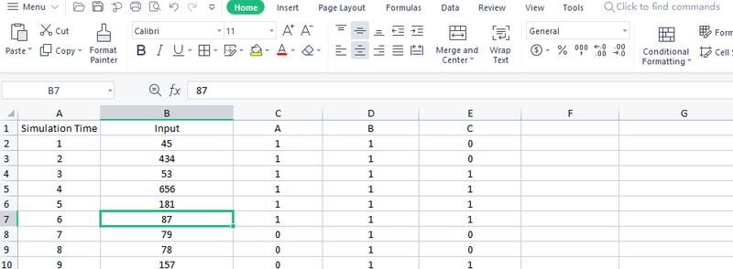

Figure 1. Data Analyzing

### Procedure

The second step is to import the test cases, and double-click the block icon of the **Signal Builder** dialog box will appear. The Signal Builder block's dialog box allows you to define the waveforms of the signals output by the block. You can specify any piece-wise linear waveform. And the follow these instructions as given below.

1. On the **Tools menu, click Import from file option** to upload the test cases of Excel files of which data are required to be imported.
2. Select the checkboxes and then **choose to Replace the existing datasheet** under
3. Placement for selected data.
4. Click **select all options** it will extract the values and you will find the option below.
5. Click on apply to the dialog box and then select No import without saving.

After completing these steps, click **OK** to update the signal values into the signal builder.

# Import the Signals

In the Import dialog box, select the signals and groups to be imported and they will be placed in the Signal Builder interface. The Status History pane of the **Import Dialog** will help you in configuring the import properly.

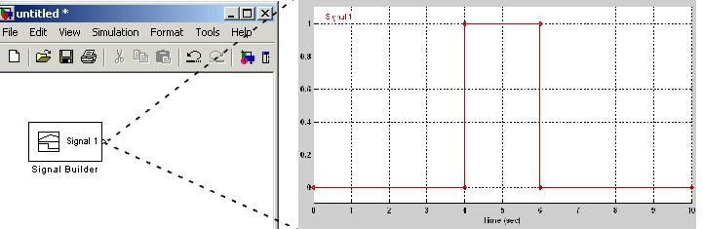

Figure 2. Signal Builder

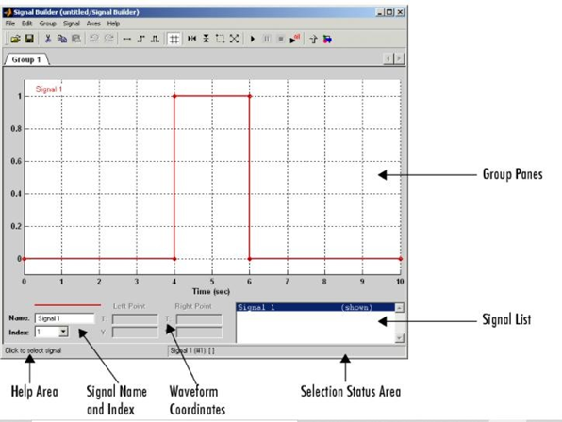

Figure 3 signal builder tools

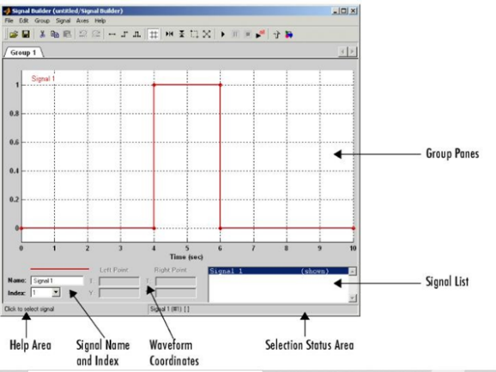

Figure 4 Graph analytics**.**

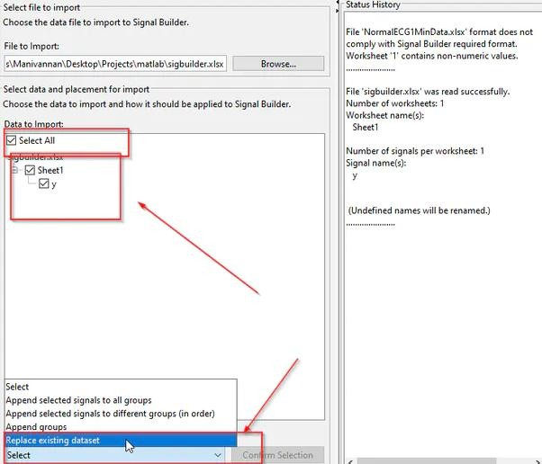

Figure 5. Select File to Import

# Importing of Test Cases

Once the importing of test cases is completed to the signal builder, now for an instance, we are taking this model to perform MIL testing in which the main subsystem is connected to the Signal builder (with generated signals from its test cases). And feedback is given on the output side with Sum blocks (+ and -) along with display block this is said to be the nullification of values which aims to compare the results of test cases it should be the same as the results from the main subsystem model. This step is mandatory to perform MIL and SIL testing to verify the correctness of the main subsystem model.

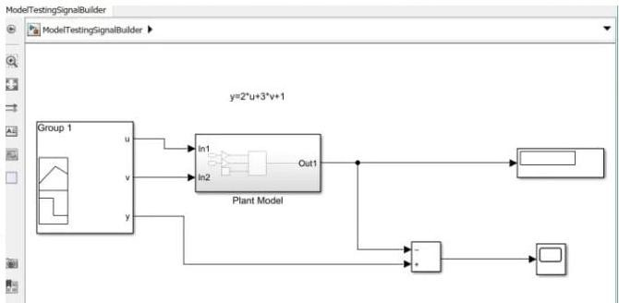  
Figure 6.Creation of Model

# Coverage Analysis

After this, we will **Enable coverage analysis for the entire system.** In the structural coverage level, we will **select MCDC coverage. And** test report gets generated once the coverage logic window opens and uplifts the block is highlighted in green, then that block is executed successfully or if it is in red the blocks are not executed and rectify

it which shows error. So the coverage report will give rise to insights about how the model is performed and analysis that ensures the testing completeness in models and generated code.

Finally, you can generate a report of detailed information which enables you to dynamically capture results and figures which will present in MATLAB code and document those results in a single report that can be shared with others in your organization and saved as a PDF for the future reference.

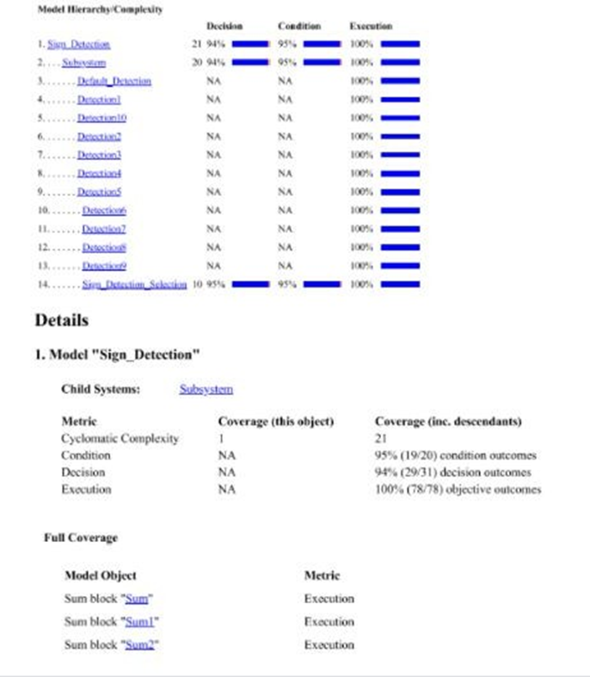

Figure 7.Library Creation

# Resources and additional links

1.Test Script- <https://www.mathworks.com/help/slrequirements/ug/linking-to-a-test-file.html>

2.Test Cases- https://www.mathworks.com/help/slrequirements/ug/link-test-case-to-requirements-documents.html