Train4less.ie

**FlorinAndreas | Vitalie Brescanu | Milena Sahni**

**1/1/2018**

Group Project

CTEDB Finglas Training centre

# Group Members responsibilities

Shared tasks:

Brainstorming on company name

Checking domain availability and hosting price

Discussing the reasons for our choices

Creating Home page Desktop and Mobile wireframe

Creating Flow chart

## Milena Sahni Individual tasks

Writing Project plan document

Gathering text content for Home and Team pages

Draw Wireframes for Team Page

Choose fonts and colour scheme

Include jQuery slider

Build Home and Team pages

## Vitali Brescanu Individual tasks

Sketching all wireframes in Adobe Photoshop for mobile and Desktop

Drawing mobile and desktop wireframe for Contact us and Free trial pages

Include site map and contact Form

Include mobile menu to pages

Build Contact us and Free trial pages

## Florin Andreas Individual tasks

Drawing mobile and desktop wireframes for Membership and Classes and Team pages

Gathering and optimizing images for all pages

Gather content for Membership and Classes pages

Build Membership and Classes pages

Include PDF

# Reasons for brand name

After initial brainstorming, we as a group thought “Train4less” is a good description of gym’s offerings. It promotes an excellent price and excellent training services. Hosting on Blacknight for train4less.ie domain costs 4.99 € per year.

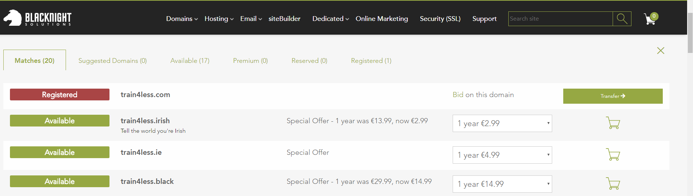

# Objectives

Offer better and more personalized services for standard gym price.

Motivate visitors to revisit the page and lead them towards healthy lifestyle

Offer free nutrition tips and collect email addresses of potential customers

Offer the free trial to attract new clientele

# Aims

Stand out from the competition in the area.

Continuously gain new clientele.

Keep loyalty of existing client base.

# Target Audience

We wish to target:

All healthy lifestyle enthusiasts

Anybody who is training at home

Anybody who wishes to join a gym

Anybody who appreciate stronger personal approach

Flow chart

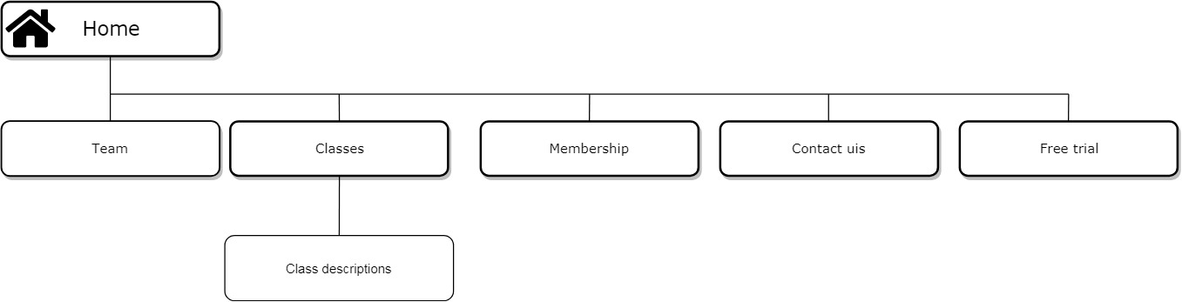

Web site will have 6 separate pages, with home page advertising all gym’s offerings and will clearly navigate user to all 5 remaining information channels. All pages will be wire framed with mobile first in mind requiring minimum changes on desktop version

# Fonts & colour scheme

Text:  
#fff

#000

Background on buttons and few containers, borders, links active, hover, selected:

#413c3a

#c86caa

font-families: Oswald, sans-serif and Open Sans

<link href="https://fonts.googleapis.com/css?family=**Open+Sans|Oswald|Raleway**" rel="stylesheet">

# Sizes of containers:

Calculation based on 1152px screen,

## Desktop:

Navigation width: 700px

Container size: 800px =70%

3 column

266.6px = 30% each

2 column=30% image 70% text

4 columns

25% each

## Mobile:

container size:95%

all images , text width:100%

# Content Home Page

## Slider texts:

Train with our personal trainers

More

Get trained in our classes

More

Get advice from our trained Nutritionist

More

## Heading2: Offerings

### Subheading:

Image caption: Heading3:Personal Training

Text: Personal training is a way to go. We know that and we have the best environment to achieve what you are aiming for. You can simply book a private session with one of our specialists and discuss what is right for you. Membership is free of cost on a trial bases. Price of instruction can be calculated during the private session with Instructor.

Button: More

Image caption: Heading3: Classes

Text

Classes in our gym have very convenient timetable, you can attend same class at different times and you can attend as many classes as you want if you are a member or during your trial period. Please check our membership offerings.

Image caption: Heading3: Nutrition advice

Text:

Nutrition goes hand by hand with good health and it affects the results you are achieving, therefore we offer also this service in our gym. We have received excellent feedback on all our services in the past, so we are proud on our team for a reason. As a small family business we are focusing on more personalized approach for every client.

Button: More

## Heading2: HOW DO WE DIFFERENTIATE

Text:

We offer quality for less. Please check the price of our membership, social media and public ratings and visit us for free trial to experience pleasant and representative enviroment of our gym and we promise you never leave

### Heading3: Subscribe for daily free nutrition tips

# Content Team Page

Name: Vitali Brescanu

Position: Gym class instructor

Qualification:

National Certificate in Gym Instruction (NSC)  
Certificate in Fitness Instruction – Gym Based Exercise (VTCT)

Experience:

5years of experience

Feedback:” Vitali is excellent class instructor. Motivation is a key and he keeps the group motivated”

Name: Florin Andreas

Position: Gym personal trainer

Qualification:

Certificate in Fitness Instruction – Gym Based Exercise (VTCT)

Experience:

10 years of experience

Feedback: “I recommend training sessions with Florin. I achieved results quicker than ever before. ”

Name: Milena Sahni

Position: Nutritionist, Yoga and Pilates Instructore

Qualification: [Award in Nutrition for Physical Activity ITEC RQF Level 3 (EQF Level 4)](https://www.nightcourses.com/course/itec-rqf-level-3-eqf-level-4-award-in-nutrition-for-physical-activity/" \o "Award in Nutrition for Physical Activity ITEC RQF Level 3 (EQF Level 4))

[National Certificate in Gym Instruction (NSC)](https://www.nightcourses.com/course/itec-rqf-level-3-eqf-level-4-award-in-nutrition-for-physical-activity/" \o "Award in Nutrition for Physical Activity ITEC RQF Level 3 (EQF Level 4))

Experience:

2 years of experience

Feedback: “I exercised daily with no accurate result. Milena helped me to understand it was due to poor nutrition habits. Everyone who attends the gym should get a session.”

# Content Membership Page

## Heading2: FLEXIBLE MEMBERSHIP OPTIONS TO SUIT YOUR INDIVIDUAL NEEDS

### **Heading3:** DAY PASS

Single person Membership

€5 For a day session!

### Heading3: 1 MONTH MEMBERSHIP

€30 per month.

Initial Joining Fee €20

You are committing to a single payment of €20 joining fee and €30 monthly fee. After this your membership payments of €30 will continue on a monthly basis.

### Heading3: 12 MONTH MEMBERSHIP

€169 per year (or €14.08 per month)

NO Initial Joining Fee

You are committing to a single payment of €169

### Heading3: GROUP OF 4 MEMBERS

€599 per year (or €149.75 per person for 1 year)

NO Initial Joining Fee

You are committing to a single payment of €599

Stop by a studio and our staff members will explain the options so you can choose what’s best for you. First time? Drop in for a free session – it is on us.

Try it free today

Start burning today

# Content Classes Page

## Heading2: ACTIVITIES

The Train4Less Fitness Department has a large team of first-class coaches and instructors and is equipped with state-of-the-art sports technology. All Train4Less members have a completely free ADVISORY interview : a personalized start plan where one of our coaches will make a program adapted to their physical.

Image captions:

### Heading3: Cardio

### Heading3: Body and mind

### Heading3: Strength

### Heading3: Timetable Available

Pictures Cover Tittle

Hiit, Tabata, Cal Aesthetics, Step & Tone, Aquafit, Heated Yoga, Karate, Spin, Kettlebells, Boxercise, Power Hour, Shape Tone Strenght, Zumba, Wod, 15-15-15

# Content Class Description

All titles are Headings 2

## HIIT

Give 100% effort in a quick, intense burst of exercise followed by a short and sometimes active rest. Great for improving fitness and stripping fat.

## Tabata

A high intensity interval training for anyone looking to increase athletic capacity, lose weight, reduce fat or if you don’t have a lot of time for fitness.

## Cal Aesthetics

Cal Aesthetics is a body weight centred class that focuses on building endurance and strength through a range of beginner to advanced, functional movements. Includes deep stretches and mobility work to keep your body working at its most efficient.

## Step & Tone

A form of aerobic power, distinguished from other types of aerobic exercise by its use of an elevated platform (the step). Designed to improve cardiovascular fitness and overall muscle tone.

## Aquafit

This class, done mostly vertically and without swimming, is suitable for all fitness levels. Aquafit is offered in a group fitness class setting and focuses on aerobic endurance, resistance training and creating an enjoyable atmosphere.

## Heated Yoga

Classes are offered by Milena and Joshephine of YogaYoga. The classes are an intense form of yoga taught in a heated room. This class is designed for all levels of students from absolute beginners to the advanced practitioner.

## Karate

A martial art developed in the Ryukyu Islands. Classes are offered to adults and children from 6 years, and are for all levels from beginner to the most advanced students.

## Spin

A vigorous cardio workout using stationary bikes. It improves endurance, muscle tone and helps relieve stress, all while burning those calories.

## Kettlebells

Offers a different type of training using dynamic moves targeting almost every area of fitness: endurance, strength, balance, agility, and cardio endurance.

## Boxercise

This circuit class trains the whole body by using boxing style stations and techniques. Time flies as you work on body movement, agility and momentum. If you stick with the boxer-size workout you’ll get fit and enhance muscle definition, without the bulk. It’s a great way for relieving stress too!

## Power Hour

Power Hour is an hour long class which balances cardio and strength training with 15 minute interval training to finish. Prepare to be pushed to your absolute limits and then some. Our instructors will have no mercy.

## Shape Tone Strenght

A class combining high repetition weight training with aerobic conditioning. It will tone and condition your body, can help you lose weight and ultimately change your body shape. Suitable for all levels.

## Zumba

Pretty much the most awesome workout ever. Dance to great music, with great people, and burn a ton of calories without even realising it. Keeping it short and sweet for you!!

## WOD

“Workout Of the Day” can include many different exercises, routines and personal challenges. Each class will be different from the last and will be body weight, strength, endurance or cardio focused, including kettlebells and barbell. Class length is however long it takes you to complete. So if it takes you 20 minutes, then your class is only 20 minutes, but you will earn that 20 minutes.

## 15 – 15 – 15

15 minutes of cardio, 15 minutes of strength training, and 15 minutes of stretching and core work. A class designed to give you the ultimate challenge and total body workout. We guarantee you’ll sweat and feel your whole body working. Exercises are modified to each individual, all levels welcome.

# Content Contact Page

# Heading1: Contact us

## Heading2: Address

Finglas Training Centre CDETB

Poppintree Industrial Estate Jamestown Road Finglas, Ballymun, Dublin 11

## Heading2: Opening hours

Monday – Friday 7:00 am. – 22:00 pm.  
Saturday 8:00 am. – 17:30 pm.  
Sunday Closed

### Heading3: email

[finglasday@ftc.cdetb.ie](mailto:finglasday@ftc.cdetb.ie)

### Heading3: telephone

[01 8140200](tel:01%208140200)

# Content Free Trial Page

Heading2: Please fill in this form for free 30 days trial

*Please note money will only be taken from your account after 30 days , unless you decide to cancel your trial before than

*Please check your email for the membership unique 12-digit pass

# Timetable for the Project

FROM Tuesday 15 th of May 15:00

Group is building 2 static templates for Home Page. One for mobile and second for desktop. Template divides into 3 sections:

Milena Sahni: Navigation and Slider banner

Vitali Brescanu: Offerings section

Florin Andreas: How we are different and Subscribe section and Footer

## FROM Wednesday 16th of May 12:45

Milena Sahni:

Tweek Home page and build jquery slider. Build Team Page mobile and desktop version. Create styles for headings, links , buttons, and usage of colours

Florin Andreas:

Build Membership and Classes Pages mobile and Desktop version. Include PDF download

Vitali Brescanu:

Build Free trial and Contact Page mobile and desktop version. Build mobile menu plugin, include site map

## FROM Thursday 17th of May 14:00

Florin Andreas: Build Class description Page

Milena Sahni and Vitali Brescanu: Testing cross-browser and cross-platform, Storyboard