**Icons**

Black and white

<https://thenounproject.com/search/?q=gym>

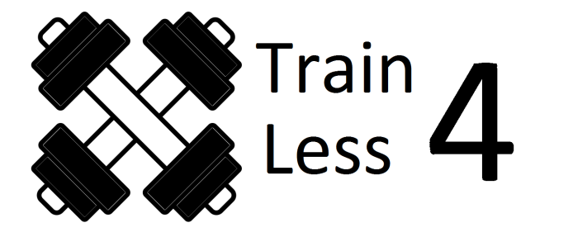

Dimension: 200x 83

Size: 33.1KB

Banner on all pages:

Dimension:1980:200



**Pictures**

<https://unsplash.com/search/photos/gym>

<https://pixabay.com/en/photos/?q=gym&hp=&image_type=all&order=&cat=&min_width=&min_height>=

Banner pic

 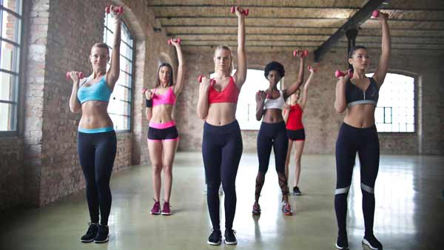

Dimension: 1920x 1080 Mobile: dimension 600x338

Size: 121KB Size: 25.4KB

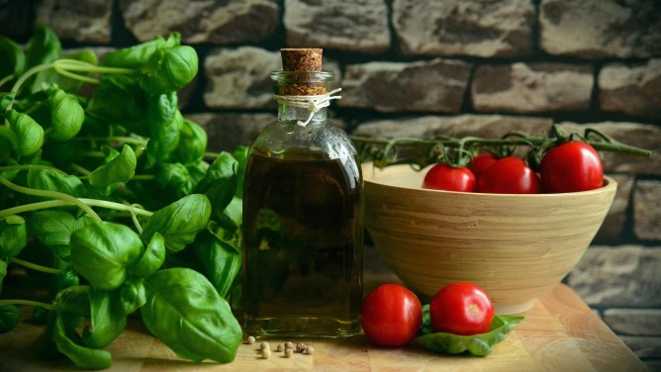

Dimension: 1920x 1080 Mobile: dimension 600x338

Size: 124KB Size: 23.9KB

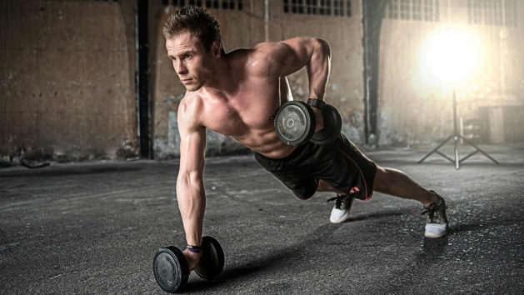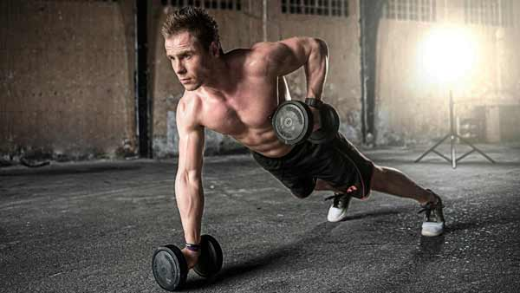

Dimension: 1920x 1080 Mobile: dimension 600x338

Size: 175KB Size: 23.7KB

**Home picture:**

**All pictures**

**300 x 300**

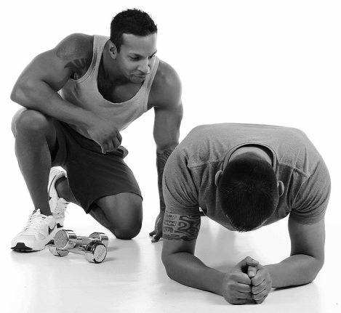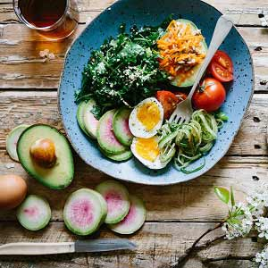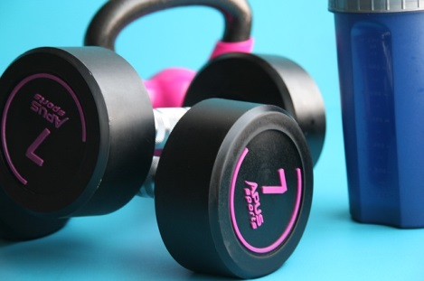

**Team picture:**

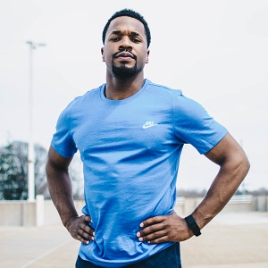

Dimension: 300x 300

Size: 33.1KB



Dimension: 300x 300

Size: 30.2KB

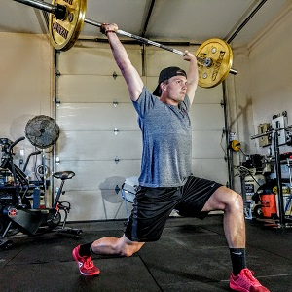

Dimension: 300x 300

Size: 48.8KB

**Classes picture:**

**All pictures**

**300 x 300**

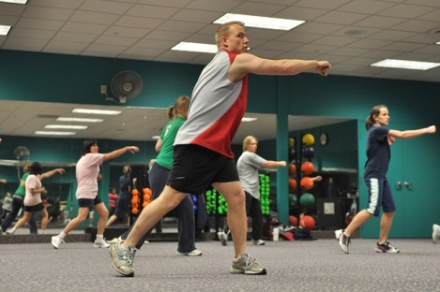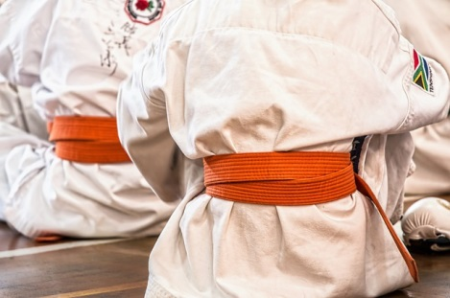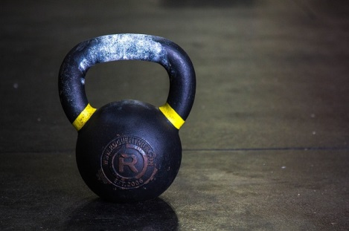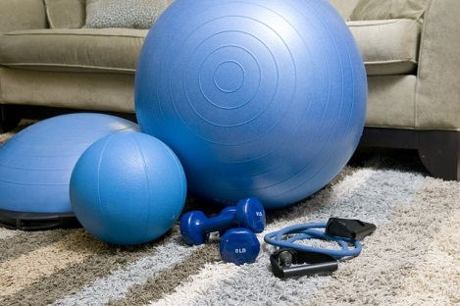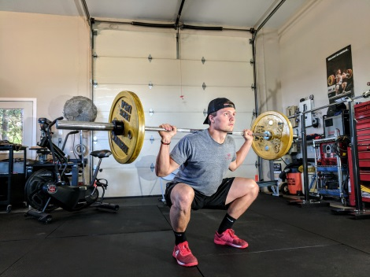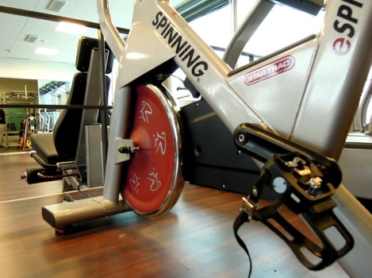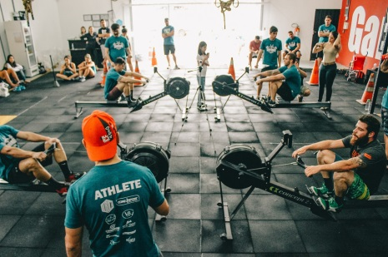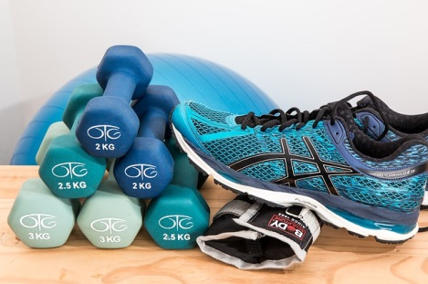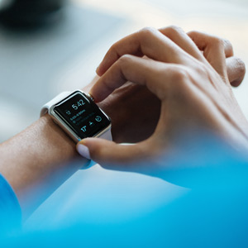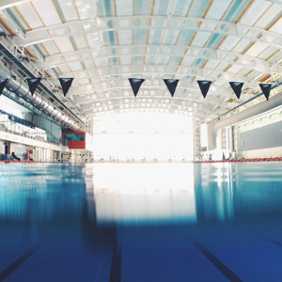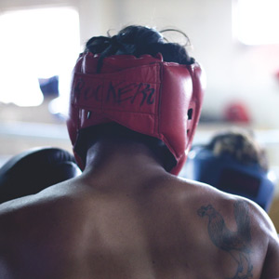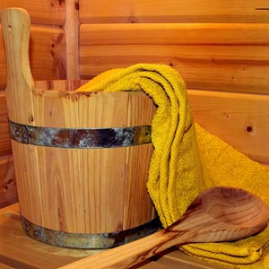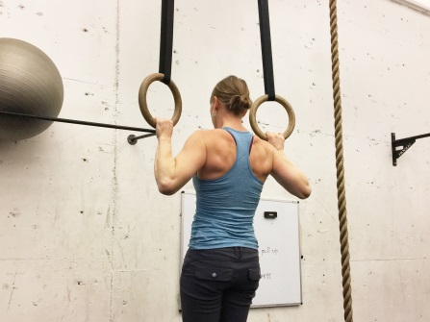

**Membership:**

Dimensions: 1980x406

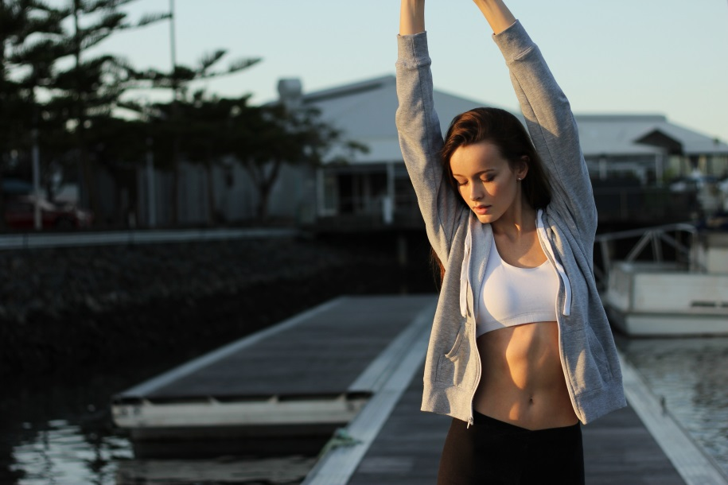

**Free Trial**

**C:\Users\dweb15\Desktop\train4less\Images\freetrial\paypal.pngC:\Users\dweb15\Desktop\train4less\Images\freetrial\visa.pngC:\Users\dweb15\Desktop\train4less\Images\freetrial\americanexpress.pngC:\Users\dweb15\Desktop\train4less\Images\freetrial\bitcoin.pngC:\Users\dweb15\Desktop\train4less\Images\freetrial\master.png**