Soil organic matter buffers fertilizer supply disruptions
Matthew D. Wallenstein and Dale Manning

Organization of this document
This Supplementary Information is organized into six parts. (i) Supplementary Methods provides the full specification of the coupled biophysical–economic framework: SOM pool dynamics under both the Century/RothC and microbially-explicit 4-pool engines, the monthly nitrogen balance, the partial-equilibrium economic structure, scenario definitions, and regional parameterization (Supplementary table 1, Supplementary Figure S1). (ii) Supplementary Note 1 reports targeted empirical benchmarks (Broadbalk yield response and SOC trajectories; the 2022 fertilizer-crisis hindcast) and a parameter-sensitivity check on the SOC-buffering result (Supplementary Figures S2–S4). (iii) Supplementary Notes 2–6 are structural and economic robustness tests supporting the regional and sustained-disruption results: microbially-explicit 4-pool versus Century stabilization (Supplementary Figure S5, Supplementary table 2), pairwise regional diagnostics across the eight modeled regions, halved fertilizer-demand elasticities (Supplementary Figures S7–S8), within-region SOC heterogeneity (Jensen’s inequality), and a 1,000-draw joint-prior Monte Carlo ensemble (Supplementary Figure S9). (iv) Supplementary Note 7 documents the country-level soil-buffer / fertilizer-exposure screen behind the geographic visualization in main-text figure 3, including dataset construction, classification thresholds, and four sensitivity treatments. Supplementary Figures S10 and S11 are auxiliary diagnostics referenced directly from the main text. (v) Supplementary Table S4 and Supplementary Figures S12–S13 document the crop-response calibration and the OFRA tropical validation. (vi) Supplementary Note 8 documents the model's verification tests and the reproducibility status of every figure in the paper.

Supplementary Methods

Detailed biophysical model description
The architecture of the coupled framework, including both the Century/RothC and microbially-explicit 4-pool SOM engines, is shown in Supplementary Figure S1 below. Detailed equations and parameter values are provided in the subsections that follow.

SOM pool structure and dynamics
SOM is partitioned into three pools following Century/RothC-style first-order SOM pool models [13, 14]: an active pool (4% of total SOC, turnover rate k = 0.33 yr⁻¹, approximately 3-year turnover), a slow pool (38% of total SOC, k = 0.037 yr⁻¹, approximately 27-year turnover), and a passive pool (58% of total SOC, k = 0.0007 yr⁻¹, greater than 1,000-year turnover). Decomposition of each pool releases nitrogen according to pool-specific C:N ratios (active: 8, slow: 12, passive: 12). A fraction of decomposed carbon transfers to more recalcitrant pools through humification (40% of active pool decomposition transfers to the slow pool; 3% of slow pool decomposition transfers to the passive pool), representing the progressive stabilization of organic matter.

Monthly nitrogen balance
Within each year, the monthly nitrogen balance resolves mineralization, crop uptake, and losses across the 12-month cycle. Monthly mineralization follows Q₁₀ temperature dependence (Q₁₀ = 2.0), modified by a soil moisture correction factor derived from precipitation, potential evapotranspiration, and field capacity. For each month, the model tracks mineral nitrogen as a state variable, carrying residual mineral nitrogen from the previous month into the next. This carryover is a key feature: mineral nitrogen that is not taken up or lost in one month remains available, creating a temporal buffer that smooths nitrogen availability across the growing season. The monthly resolution captures the synchrony between mineralization peaks (warm, moist months) and crop demand windows, ensuring that the model distinguishes between mineralized nitrogen available during active crop uptake and nitrogen mineralized outside the growing season, which is subject to loss before it can contribute to yield.
During the crop growing window (defined by region-specific planting and maturity months), crop nitrogen uptake follows a Mitscherlich (diminishing returns) function limited by both nitrogen availability and the nitrogen uptake efficiency, defined as the maximum fraction of available soil mineral nitrogen that crops capture during the growing season. The baseline nitrogen uptake efficiency is 0.75, meaning crops can capture at most 75% of the mineral nitrogen available in a given month. The effective seasonal NUE drops to approximately 55% because crop nitrogen demand is concentrated in mid-season growth months while mineral nitrogen availability is distributed across the full growing window; nitrogen present in months of low crop demand is only partially recovered. Outside the growing season, mineral nitrogen is subject to leaching and denitrification losses but not crop uptake. Leaching is temperature- and precipitation-dependent, with higher losses during wet, warm months. Denitrification follows a base rate modified by temperature and moisture.

Fertilizer application and biological nitrogen fixation
Synthetic fertilizer is applied in an even split across planting and the following month, concentrating inputs at the period of highest crop demand. Biological nitrogen fixation (BNF) is region-specific, parameterized from legume rotation N credits and free-living fixation using regional FAOSTAT crop area shares and methodology from Herridge et al. [38]. Regional BNF values, expressed per cereal hectare as derived from the legume-share components, are: North America 31.9 kg N ha⁻¹ yr⁻¹, Europe 18.3, East Asia 13.8, South Asia 22.1, Southeast Asia 23.0, Latin America 37.7, Sub-Saharan Africa 15.0, Former Soviet Union/Central Asia 13.8 kg N ha⁻¹ yr⁻¹. Latin America’s elevated BNF reflects substantial soybean integration. Sub-Saharan Africa’s moderate BNF reflects cowpea and groundnut in mixed farming, constrained by phosphorus limitation. BNF is held static during disruption scenarios; dynamic BNF response to N scarcity through crop rotation shifts represents a behavioral adaptation that warrants future coupling with the economic framework.

Carbon input and SOM formation pathways
Carbon inputs to SOM derive from crop residue and root biomass. Above-ground residue carbon is calculated as yield multiplied by the residue-to-grain ratio, carbon fraction, and a regionally varying residue retention fraction (0.50 in South Asia, where residues are harvested for fuel and fodder; to 0.90 in North America and Europe). Root carbon inputs use region-specific root:shoot ratios (0.60–1.0) and are not subject to the residue retention fraction. A regionally calibrated carbon retention efficiency (CRE, range 0.20–0.35) determines the fraction of total carbon inputs that enters SOM pools, partitioned 60:40 between active and slow pools. CRE values are calibrated so that each region’s initial SOC is approximately at equilibrium under current management. CRE is held constant during disruption scenarios, underestimating SOC loss because real CRE declines as substrate quality degrades with sustained nitrogen limitation. Similarly, Century/RothC pool fractions (active 4%, slow 38%, passive 58%) are temperate-biome defaults; highly weathered tropical soils in Sub-Saharan Africa may have lower passive pool fractions due to different organo-mineral stabilization dynamics, which would reduce baseline mineralization and increase vulnerability. This is a source of conservative bias in the SSA results.

Microbially-explicit 4-pool SOM scheme
The Century/RothC framework represents SOM stabilization through abiotic humification transfers between pools. An alternative class of models, grounded in microbially-explicit SOM formation theory and microbially-explicit SOM formation frameworks [15–18], routes SOM formation through microbial biomass together with a parallel direct sorption pathway: residue carbon enters a particulate organic matter (POM) pool and decomposes to dissolved organic matter (DOM); DOM is then either assimilated by microbial biomass (MBC) with a carbon use efficiency (CUE) that determines the fraction retained as biomass versus respired, with necromass partitioning upon microbial death into mineral-associated organic matter (MAOM), POM, and DOM, or sorbs directly from DOM to MAOM. At the model's equilibrium roughly half of MAOM formation arrives by each route. MAOM accumulation is constrained by mineral sorption capacity (Qmax), and MAOM desorption is modulated by a priming function linked to fresh carbon inputs. The microbially-explicit 4-pool representation is supported by isotopic and molecular evidence showing that microbial necromass accounts for approximately 50% of SOM in many soils [15] and that mineral-associated carbon derives primarily from microbial products rather than from direct sorption of plant inputs [16, 18].
The annual four-pool update is, in order: POM receives the year's residue-carbon input and decomposes at k(POM→DOM) = 0.08 yr⁻¹; DOM is removed at the combined rate k(uptake) + k(sorption)·(1 − MAOM saturation), with k(uptake) = 10 yr⁻¹ and k(sorption) = 2 yr⁻¹, the removed carbon splitting between microbial uptake and direct sorption in proportion to those rates; microbial assimilation retains the fraction CUE of the uptake flux and respires (1 − CUE); microbial biomass follows the analytic solution of dMBC/dt = assimilation − k(MBC)·MBC with k(MBC) = 3 yr⁻¹, and the implied turnover partitions as necromass to MAOM (0.55, scaled by unfilled sorption capacity), POM (0.20) and DOM (0.10), the remainder respired; MAOM gains necromass and direct sorption, desorbs at k(MAOM) = 0.007 yr⁻¹ scaled by a priming factor (sensitivity 0.5, bounded 0.5–2.0) driven by POM decomposition relative to baseline, and is capped at the sorption ceiling Qmax. CUE varies with nitrogen availability as CUE = CUE_min + (CUE_max − CUE_min)·f/(f + K_N), with CUE_max = 0.40, CUE_min = 0.20 and K_N = 0.5, where f is total plant-available nitrogen relative to its baseline. Net nitrogen mineralization follows from the stoichiometric balance of DOM consumption (C:N 20) against microbial demand (C:N 8) plus the nitrogen in the non-recycled fraction of necromass; pool C:N ratios are POM 25, DOM 20, MBC 8 and MAOM 10.
Pools are initialized from fractional allocation of the regional SOC stock (POM 0.25, MAOM 0.70, MBC 0.03, DOM 0.02) and iterated to stationary equilibrium in the same way as the Century engine. The sorption ceiling is Qmax = 65 t C ha⁻¹ at 100% clay+silt, applied with a uniform clay+silt fraction of 0.55 in all regions; the sensitivity of the engine comparison to this texture assumption is reported in Supplementary Note 2. Every four-pool parameter is enumerated in the deposited parameter ledger alongside the Century parameters.

Supplementary Figure S1: Coupled model architecture
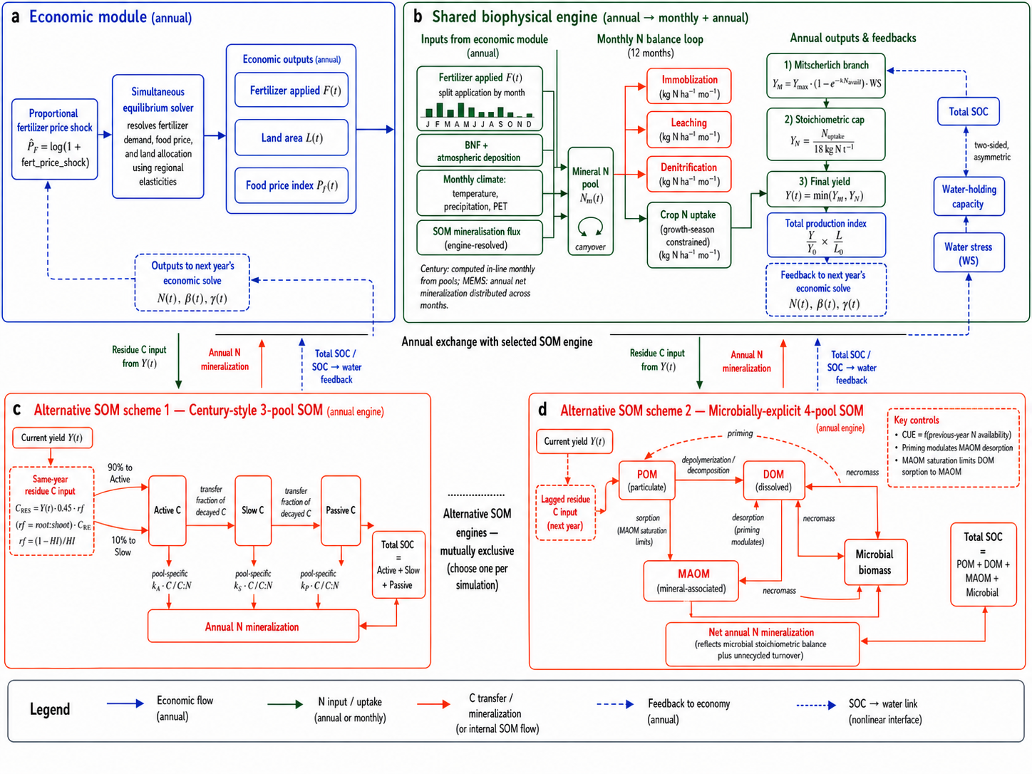
Supplementary Figure S1. Coupled economic–biophysical model architecture. The economic module (top) resolves fertilizer demand, food prices, and land allocation via partial equilibrium at annual timesteps across eight global regions. The biophysical module (middle) runs a 12-month nitrogen balance loop, computing crop N uptake, immobilization, leaching, and denitrification each month and resolving annual yield through a Mitscherlich response, a stoichiometric N-cost cap, and a SOC-mediated water-stress factor. SOM dynamics (bottom) are pluggable, with two alternative schemes shown side by side and only one active per simulation: a, microbially-explicit 4-pool SOM scheme: residue carbon routes through particulate organic matter (POM), dissolved organic matter (DOM), microbial biomass with N-availability-dependent carbon-use efficiency, and mineral-associated organic matter (MAOM) with sorption saturation. b, Century 3-pool engine: first-order decay with humification cascade across active, slow, and passive pools at fixed carbon-use efficiency. Solid arrows denote forward economic, N, and C fluxes; dashed arrows denote feedback pathways (soil N to fertilizer demand; SOC to water-holding capacity; ΔSOC to N mineralization).

Spinup protocol
Both the Century and microbially-explicit 4-pool variants are initialized at dynamic steady state through iterative spinup. Starting from ISRIC SoilGrids regional mean SOC values, the model is run under constant current-management conditions (regional fertilizer application rates, crop yields at FAOSTAT targets, and mean monthly climate) until SOC change over a 50-year window falls below 0.2% (~0.004% yr⁻¹) or 2,000 years elapse. All regions reached steady state within 800 years. The Century model distributes equilibrium SOC across active (4%), slow (38%), and passive (58%) pools. The microbially-explicit 4-pool scheme distributes equilibrium SOC across POM, DOM, MBC, and MAOM pools according to the steady-state solution of the microbial processing chain. This iterative spinup eliminates initialization transients that could confound the Century vs. 4-pool comparison.

Detailed economic model description

Partial equilibrium structure
Three behavioral channels operate sequentially across the scenario tiers introduced in the main text:
Scenario S1 (fertilizer-demand response only) activates the direct fertilizer-price elasticity ε_F,PF only; food price resolves through market clearing but does not feed back into fertilizer demand, and land area is held fixed. Scenario S2 additionally allows endogenous food-price and land responses, with the regional land-response channel active alongside ε_F,PF; fertilizer demand does not respond to food price until S3. Scenario S3 retains these land and food-price responses and additionally activates both the cross-price fertilizer channel ε_F,PY and the soil-N depletion feedback ε_F,N under sustained disruption; S3 is the default headline price-mediated scenario. Scenarios SC1 and SC2 retain the S3 behavioral channels and additionally impose a physical 20% cap on regional fertilizer availability: SC1 holds the cap permanently, while SC2 relaxes the cap linearly toward baseline over 20 years. To represent the structure of the economic responses, we use the partial-equilibrium framework specified in the next subsection (Structural equations of the economic component).
The key economic parameters governing regional vulnerability are the price elasticity of fertilizer demand (ε_{F,PF}, ranging from −0.20 for North America to −0.50 for Sub-Saharan Africa), the price elasticity of food demand (η, ranging from −0.30 for North America to −0.70 for Sub-Saharan Africa), and land supply elasticity ($ε_{L},PY$). These elasticities (see Structural equations subsection above) are drawn from the FDME meta-elasticities framework [23, 25], with regional calibration against empirical estimates. The published elasticities apply to total purchased fertilizer at the regional level; in our framework these elasticities act on the synthetic-fertilizer demand channel, while the SOM-mineralized N flux is not price-responsive (it is a function of soil state) [24, 34].
The economic equilibrium uses gross input shares to partition the aggregate fertilizer price elasticity between nitrogen from synthetic and organic (mineralization) sources, ensuring that the elasticity framework is consistent with the biophysical model’s representation of nitrogen supply. Fertilizer demand, food production, and land allocation are solved simultaneously at each timestep, with the previous year’s soil state feeding forward into the current year’s nitrogen balance.

Structural equations of the economic component

Architecture and timesteps
The model couples a partial-equilibrium economic layer with a biophysical soil-N layer, with each region indexed by r and each year by t. The economic equilibrium (regional fertilizer market, food market, land market) is resolved annually. The biophysical layer runs on a monthly timestep within each year: mineralization, immobilization, leaching, denitrification, and crop uptake are computed monthly from climate forcings and the current SOM stocks, while SOM pool carbon (active, slow, passive) is updated once per year from residue inputs after harvest. The cross-reference to the main-text Methods aggregation note applies: regional supply elasticity is evaluated at the regional mean SOC, so a single farm’s soil status enters the model only through its own production response, not through regional price clearing.
Four channels couple the two layers: (i) the soil-supplied share of crop N demand, endogenous to SOC; (ii) a Mitscherlich response of yield to seasonal crop N uptake, capped by stoichiometric N cost; (iii) a SOC-to-water-holding-capacity channel that scales potential yield through a regional water-deficit term; (iv) residue-carbon return from harvested yield, which updates SOC for year t+1.
All economic variables are written as log-changes from the no-shock baseline (subscript 0): $\hat{F}\text{=}ln\left(\frac{F}{F^{0}}\right), {\hat{P}}_{F}\text{=}ln\left(\frac{P_{F}}{P_{F},0}\right),$ and so on. All elasticities are treated as constant over the simulation horizon. Regional values are listed inline below where relevant and consolidated in Supplementary table 1.

Fertilizer demand
Regional fertilizer use responds to the regional fertilizer price with constant elasticity $ε_{F},PF$ (regional values −0.20 in North America, −0.50 in Sub-Saharan Africa), to the regional food price with cross-elasticity $ε_{F},PY$ (positive: higher output prices raise fertilizer use; default 0.10, with 0.03 in SSA), and, under sustained disruption in S3, SC1 and SC2, to the regional soil mineralized-N flux through $ε_{F},N$ (default −0.50: producers compensate for declining soil N by raising external inputs where they are available):
${\hat{F}}_{r},t \text{=} ε_{F},PF · {\hat{P}}_{F},r,t \text{+} ε_{F},PY · {\hat{P}}_{Y},r,t \text{+} ε_{F},N · {\hat{N}}_{r},t$ (1)
The published $ε_{F},PF$ values apply to total purchased fertilizer. The SOM-mineralized N flux is a function of soil state and is not price-responsive. The effective response of total crop N supply to a price shock therefore depends on the regional split between purchased and mineralized N, which is itself endogenous to SOC.

Food demand and market clearing
Food demand for the regional crop aggregate responds to food price with constant elasticity η (regional values −0.30 to −0.70):
${\hat{Q}}_{r},t \text{=} η · {\hat{P}}_{Y},r,t$ (2)
Aggregate supply is a Cobb–Douglas log-linearisation of regional production in its three inputs (land, mineralized soil N, applied fertilizer):
${\hat{Y}}_{r},t \text{=} α · {\hat{L}}_{r},t \text{+} β · {\hat{N}}_{r},t \text{+} γ · {\hat{F}}_{r},t$ (3)
α is the output elasticity with respect to land, calibrated regionally as a growth-accounting cost share (0.08 in Europe, 0.15 in SSA and Latin America). β and γ are local Mitscherlich elasticities, recomputed each year at the current operating point and partitioned between mineralized soil N (β) and applied fertilizer (γ) by gross input share. Where the stoichiometric N-cost cap on yield binds, β + γ collapse to unity in the linear regime. These elasticities are reported as diagnostics; the clearing itself equates demand with the realized biophysical production response as described above. Market clearing ${\hat{Y}}_{r},t \text{=} {\hat{Q}}_{r},t$ closes the food market and determines P̂_Y,r,t:
${\hat{Y}}_{r},t \text{=} {\hat{Q}}_{r},t$ (4)

Land allocation
Land area responds to food-price changes with a derived coefficient $λ_{L}$ that combines three regional elasticities: a land-demand elasticity with respect to land price ($ε_{LD},PL$, default −0.30), a land-demand cross-elasticity with respect to food price ($ε_{LD},PY$, 0.15 to 0.25), and a land-supply elasticity with respect to land price ($ε_{LS},PL$, 0.30 to 0.70):
${\hat{L}}_{r},t \text{=} λ_{L}· {\hat{P}}_{Y},r,t,λ_{L}\text{=}\frac{\left(ε_{LS},PL · ε_{LD},PY\right)}{\left(ε_{LS},PL \text{-} ε_{LD},PL\right)}$ (5)
$λ_{L}$ therefore varies across regions: ~0.07 in Europe and other land-constrained regions, ~0.11 in North America, and ~0.18 in frontier regions (Latin America, Sub-Saharan Africa) where $ε_{LS},PL$ is highest. The frontier-versus-constrained partitioning follows GTAP-style land-use accounting.

Linkage to biogeochemistry
The economically determined fertilizer rate $F_{r,t}$ is passed to the monthly N-balance routine, which routes synthetic fertilizer, biological N fixation, atmospheric deposition, and SOM mineralization through monthly immobilization, leaching, denitrification, and demand-profile crop uptake (uptake each month is the lesser of a fixed fraction of the mineral pool and the seasonal demand share). Annual crop N uptake N_up,r,t is the sum across the 12 months. Per-hectare yield is then the lower of a Mitscherlich response and a stoichiometric N-cost cap, both modulated by the SOC-driven water-stress factor ws_r,t:
$y_{r},t \text{=}min\left[ y_{max}· \left(1 \text{-}exp\left(\text{-}c · N_{up},r,t\right)\right)· \frac{ws_{r},t , N_{up},r,t}{n_{cost}}\right]$ (6)
where n_cost = 18 kg N per tonne grain (grain N fraction 1.8%, applied uniformly across regions and crops in the default calibration). The water-stress factor ws is one minus the product of a regional baseline water deficit and a SOC-mediated WHC adjustment, formulated as a smooth two-sided response (linear on the SOC-loss side, saturating on the SOC-gain side [21]).
Residue carbon return for year t+1 has an above-ground component subject to retention and a root component that bypasses retention; both are deposited at the regional carbon retention efficiency (CRE):
$ResC_{r},t \text{=} y_{r},t · \left(residue:grain\right)· \left(C fraction\right)· CRE · \left[ residue retention \text{+} \left(root:shoot ratio\right)\right]$ (7)
$SOC_{r},t\text{+}1$ is then advanced by the Century 3-pool engine (and a parallel microbially-explicit 4-pool implementation used for structural sensitivity, Supplementary Note 2). Residue partitions into the active and slow pools; active decays to slow with humification fraction h_a→s; slow decays to passive with h_s→p; passive decays without further transfer. This closes the loop: economic-driven changes in F_r,t flow through N_up and y into ResC, which alters SOC, which alters next year’s mineralized N flux and water-stress factor.

Calibration sources
Fertilizer-demand and food-demand elasticities are drawn from the FDME meta-elasticities framework [23, 25] with regional calibration against the empirical literature [24, 34]. The cross-elasticity $ε_{F},PY$ follows a partial-equilibrium derivation under standard producer behavior. Land-supply and land-demand elasticities follow GTAP-style frontier-versus-constrained partitioning [22]. The stoichiometric N-cost cap and Mitscherlich curvature parameter c are calibrated to reproduce regional baseline yields under regional baseline fertilizer and BNF inputs.
To make the yield-response calibration explicit: the Mitscherlich ceiling y_max is set, region by region, so that at current total nitrogen availability (mineralization from the region's initial SOC pools, baseline biological fixation, and the regional synthetic-nitrogen rate) the response reproduces the observed production-weighted FAOSTAT cereal yield. Operationally, y_max is obtained by numerically solving (Brent's method) for the ceiling at which the model's year-2 simulated yield—under the region's current nitrogen inputs and monthly climate—equals the FAOSTAT target; because the simulation includes water stress, immobilization, and SOM feedbacks, this differs from a closed-form Mitscherlich inversion. Static yield_max_regional values in the model configuration are legacy fallback parameters, not the reported calibration. The curvature c is a single cross-regional constant (0.015); regional differences in the shape of the response therefore arise from y_max and from nitrogen availability, which is endogenous to SOC, rather than from c. Three distinct yield quantities must be distinguished. (i) At zero total available nitrogen the response tends to the model's minimum-biomass floor. (ii) At zero synthetic nitrogen but with contemporary soil-organic-matter mineralization and biological fixation, the model produces an emergent unfertilized yield well above that floor (approximately 3.7 t ha-1 in North America and 2.3 t ha-1 in Europe, falling to approximately 1.3 t ha-1 in Sub-Saharan Africa, where mineralization is low); this is a model prediction, not a calibration target. (iii) A separate region-specific empirical yield floor, drawn from the world's longest unfertilized experiments and pre-industrial records (Morrow Plots and Sanborn Field, North America; Rothamsted Broadbalk and Hoosfield, Europe; ICRISAT Vertisol trials, South Asia; TSBF unfertilized controls, Sub-Saharan Africa; Pryanishnikov Institute trials, Former Soviet Union), sets the long-term depleted-soil asymptote toward which yield declines as sustained disruption erodes soil carbon; it is a lower bound, not the contemporary control yield. Only y_max is calibrated (to reproduce the FAOSTAT current yield at current nitrogen availability); c is a fixed constant and the empirical floor is a bound. Regional calibration targets, the resulting y_max, the emergent zero-synthetic-nitrogen yields, and the empirical floors are listed in Supplementary Table S4. As an independent check on the response shape, the modeled fertilizer-era mineralization share is benchmarked against the graduated Nil, N3PK, and FYM treatments of the Rothamsted Broadbalk experiment (Supplementary Note 1).

Scenario activation
Scenario | Active channels | Notes
S1 (price-only) | $$ε_{F},PF$$ | All other behavioral channels (ε_F,PY, ε_F,N, λ_L) set to zero. Food price still resolves through market clearing but does not feed back into fertilizer demand or land.
S2 (land response) | $$ε_{F},PF, λ_{L}$$ | Adds the regional land elasticities; rising food prices induce land conversion at the regional λ_L.
S3 (full price-mediated; default headline) | $$ε_{F},PF, ε_{F},PY, λ_{L}$$ | Activates the cross-price fertilizer response and the soil-N depletion feedback (ε_F,N), so the price-mediated headline scenario is self-consistent with SC1/SC2 on the depletion channel.
SC1 (physical supply cap, permanent) | S3 channels +$ε_{F},N$ | Permanent 20% physical cap on regional fertilizer availability. The cap binds whenever economic demand exceeds supply, overriding the price-mediated quantity.
SC2 (supply cap with capacity recovery) | S3 channels + $ε_{F},N$ | Same initial 20% cap as SC1, with the cap relaxing linearly toward baseline over 20 years; the fertilizer-price shock relaxes proportionally as supply recovers.

Notation
Hats denote log-changes from the no-shock baseline; subscript 0 denotes the baseline level.
Symbol | Meaning
$$F_{r},t, {\hat{F}}_{r},t$$ | Regional synthetic fertilizer use (kg N ha⁻¹ yr⁻¹); log-change form
$$P_{F},r,t, {\hat{P}}_{F},r,t$$ | Regional fertilizer price; log-change form
$$Q_{r},t, {\hat{Q}}_{r},t$$ | Regional food demand (regional crop aggregate); log-change form
$$Y_{r},t, {\hat{Y}}_{r},t$$ | Regional crop production = $y_{r},t · A_{r},t$; log-change form
$$P_{Y},r,t, {\hat{P}}_{Y},r,t$$ | Regional food price; log-change form
$$A_{r},t \left( L_{r},t\right), {\hat{L}}_{r},t$$ | Regional cropland area (Mha); log-change form${\hat{L}}_{r},t \text{=}ln\left(A_{r},t÷A_{r},0\right)$
$$y_{r},t$$ | Per-hectare yield (t ha⁻¹)
$$N_{up},r,t, {\hat{N}}_{r},t$$ | Annual crop N uptake from monthly balance (kg N ha⁻¹); log-change of mineralized-N flux
$$SOC_{r},t$$ | Regional mean soil organic carbon (t C ha⁻¹)
$$SOM$$ | Broader organic-matter substrate from which mineralization supplies N
$$ws_{r},t$$ | Water-stress factor (0–1); function of SOC, regional WHC sensitivity, and baseline water deficit
$$α$$ | Output elasticity of supply with respect to land (regional, 0.08–0.15)
$$β, γ$$ | Local Mitscherlich elasticities of yield with respect to soil N and applied fertilizer, recomputed annually; diagnostic only, they do not enter the market clearing
$$η$$ | Food-demand price elasticity (regional, −0.30 to −0.70)
$$ε_{F},PF$$ | Price elasticity of fertilizer demand (regional, −0.20 to −0.50)
$$ε_{F},PY$$ | Cross-elasticity of fertilizer demand to food price (regional, 0.03–0.10)
$$ε_{F},N$$ | Soil-N depletion-feedback elasticity (default −0.50; active in S3, SC1 and SC2)
$$ε_{LD},PL, ε_{LD},PY, ε_{LS},PL$$ | Land demand and supply elasticities
$$λ_{L}$$ | Derived land-response coefficient = $\frac{\left(ε_{LS},PL · ε_{LD},PY\right)}{\left(ε_{LS},PL \text{-} ε_{LD},PL\right)}$
$$CRE$$ | Regional carbon retention efficiency
$$n_{cost}$$ | Stoichiometric N requirement per tonne grain (18 kg N t⁻¹, uniform across regions)

Price shock scenario details
The primary analysis examines a single-year fertilizer price spike, in which the price of nitrogen fertilizer increases by 100% (doubling) for one year before returning to baseline. The farmer’s response is governed by regional price elasticity of fertilizer demand: a region with ε_{F,PF} = −0.50 (Sub-Saharan Africa) reduces purchases by approximately 29%, while a region with ε_{F,PF} = −0.20 (North America) reduces by approximately 12%.
The regional supply elasticity is evaluated at the regional mean SOC, so an individual farm's soil status enters only through its own production response, not through regional price clearing (cf. main-text Methods aggregation note). This approach is conservative: it does not capture within-region variation in farm-level economic parameters (credit access, input substitution capacity), which would likely amplify the SOC gradient in practice.
We also examine price spikes of varying magnitude (0–300% increase) and sustained S3 price-shock scenarios generated by a +104% fertilizer price shock calibrated to produce an approximately 20% fertilizer-use reduction under S1; with the soil-N depletion feedback ε_F,N active, the realized fertilizer-use reduction under S3 averages approximately 19% over the sustained-disruption period (production-weighted across regions and averaged over the disruption years). Supply-constrained variants (SC1 and SC2) impose physical ceilings on fertilizer availability in addition to price effects, representing scenarios where trade disruptions physically remove nitrogen from the global supply rather than merely raising its cost.

Regional fertilizer and crop price values
Regional fertilizer prices are 2019–2023 averages (smoothing crisis-period distortions) drawn from IFA and FAO commodity price series: Sub-Saharan Africa $2.30/kg N (non-subsidised retail, reflecting transport and distribution premiums), South Asia $1.20/kg N, Latin America $1.15/kg N, North America $1.10/kg N. Regional crop prices are production-weighted cereal price averages drawn from FAOSTAT producer-price series: Sub-Saharan Africa $300/t, South Asia $280/t, Latin America $260/t, North America $250/t. Net-revenue impacts (crop revenue net of nitrogen-fertilizer expenditure; a partial measure, not whole-farm gross margin) are expressed as percentage changes from the no-shock baseline at each SOC level (formula in main Methods).

Regional parameterization details
The model is parameterized across eight global agricultural regions covering approximately 1,230 Mha of cropland and 99 Tg N yr⁻¹ of synthetic nitrogen (Supplementary table 1). Regional soil organic carbon values are drawn from ISRIC SoilGrids [26] (cropland-specific estimates where available), ranging from 9 t C ha⁻¹ in Sub-Saharan Africa (reflecting degraded tropical cropland on Oxisols and Ultisols; interquartile range 5–14 t C ha⁻¹ across cropland pixels) to 50 t C ha⁻¹ in North America (interquartile range 32–68 t C ha⁻¹). Synthetic nitrogen application rates are from FAOSTAT [5], ranging from 7 kg N ha⁻¹ in Sub-Saharan Africa to 250 kg N ha⁻¹ in East Asia.
The fraction of crop nitrogen supplied by mineralization rather than synthetic inputs, the soil nitrogen buffer ratio, provides a measure of each region’s internal nitrogen supply capacity. This ratio ranges from 20% in East Asia (where intensive fertilization dominates nitrogen supply) to 53% in Latin America (where soils supply roughly half of crop nitrogen). Regional climates are parameterized with monthly temperature and precipitation profiles that drive the monthly nitrogen balance, ensuring that seasonal mineralization and loss dynamics reflect actual growing conditions.
The monthly temperature and precipitation normals are 2001-2020 values from the ERA5 reanalysis (obtained via the Open-Meteo archive) for a benchmark cropping location in each region (for example, the US Corn Belt, the North China Plain, and the Indo-Gangetic Plain), and potential evapotranspiration is computed from the same series by the Hargreaves method.
Crop calendar. Planting and maturity months are fixed, region-specific assumptions representing each region's dominant cereal season: North America June–October; Europe November–August (winter wheat); East Asia July–November; South Asia December–May (rabi wheat); Southeast Asia July–December; Latin America November–April; Sub-Saharan Africa May–October; Former Soviet Union/Central Asia May–September. These months are consistent with the global crop-calendar compilation of Sacks et al. [41]. The growing window they define sets the monthly crop nitrogen demand profile and the fertilizer application timing described above.

Supplementary table 1: Regional parameterization
Parameter | NA | EU | EA | SA | SEA | LATAM | SSA | FSU
Cropland (Mha) | 170 | 130 | 120 | 200 | 90 | 160 | 230 | 130
SOC (t C ha⁻¹) | 50 | 42 | 35 | 25 | 32 | 45 | 9 | 35
Synth. N (kg N ha⁻¹ yr⁻¹) | 76 | 85 | 250 | 110 | 89 | 50 | 7 | 38
BNF (kg N ha⁻¹ yr⁻¹) | 31.9 | 18.3 | 13.8 | 22.1 | 23.0 | 37.7 | 15.0 | 13.8
Fertilizer demand elasticity ($εF,PF$) | −0.20 | −0.25 | −0.30 | −0.40 | −0.40 | −0.30 | −0.50 | −0.30
Food demand elasticity (η) | −0.30 | −0.35 | −0.45 | −0.60 | −0.55 | −0.50 | −0.70 | −0.45
Residue retention | 0.90 | 0.90 | 0.75 | 0.50 | 0.70 | 0.80 | 0.55 | 0.85
Carbon retention efficiency | 0.28 | 0.26 | 0.23 | 0.34 | 0.31 | 0.31 | 0.20 | 0.35
Soil N buffer ratio (%) | 43 | 33 | 20 | 32 | 50 | 53 | 46 | 45
NA = North America, EU = Europe, EA = East Asia, SA = South Asia, SEA = Southeast Asia, LATAM = Latin America, SSA = Sub-Saharan Africa, FSU = Former Soviet Union. SOC from ISRIC SoilGrids [26]; synthetic N from FAOSTAT [5]; elasticities from FDME framework [22, 24] with regional calibration [23, 34].

With the coupled model specified above, the following Notes assess empirical credibility, structural sensitivity, economic robustness, aggregation effects, joint parameter uncertainty, and the spatial exposure screen. Note 1 reports targeted empirical benchmarks (Broadbalk yield response, Broadbalk SOC trajectories, the 2022 fertilizer-crisis demand-side hindcast) and a parameter-sensitivity check on the within-region SOC-buffering result.

Supplementary Note 1: Empirical benchmarking and sensitivity checks
Because the framework is designed to quantify a fertilizer-shock resilience mechanism rather than to provide site-specific yield forecasts, we evaluated model credibility through targeted empirical benchmarks and sensitivity checks. Broadbalk provides an empirical benchmark for contemporary fertilizer-responsive yield behavior and long-term SOC directionality. The 2022 fertilizer crisis hindcast provides a directional benchmark for the demand-side component. Mineralizable-N sensitivity tests evaluate whether the within-region SOC-buffering result depends on a single SOC-to-mineralizable-N parameterization. These tests are not intended as a full validation of the coupled framework, but they evaluate the main components supporting the manuscript’s central claims.

Claim-check
Claim supported | Check | Dataset / analysis | Interpretation
Contemporary fertilizer-responsive yield behavior is represented at the right order of magnitude | Broadbalk empirical benchmark | Modern-period Nil and N3PKMg yield comparison (2000–2015) | Tests contemporary yield response, not full historical reconstruction
Long-term SOC dynamics respond directionally to contrasting nutrient histories | Broadbalk SOC trajectories | Nil and FYM SOC trajectories, 1843–2015 | Qualitative benchmark of SOC decline and accumulation
Fertilizer price shocks reduce N use unevenly across regions | 2022 fertilizer-crisis benchmark | FAOSTAT Fertilizers by Nutrient, observed regional N-use changes | Tests direction and rank ordering of demand response, not yield response
SOC-buffering result is not an artifact of one mineralizable-N parameterization | Mineralizable-N sensitivity | Initial active-pool fraction, slow-pool turnover, and bulk soil C:N perturbations | Tests whether the within-region SOC gradient persists under alternative SOC-to-N assumptions

Broadbalk empirical benchmark
The Broadbalk treatments referred to throughout this Note are: Nil (no nutrient inputs), N3PKMg (144 kg N ha⁻¹ as ammonium nitrate, plus phosphorus, potassium and magnesium), and FYM (35 t ha⁻¹ farmyard manure applied annually). We used Broadbalk as a targeted empirical benchmark of contemporary fertilizer-responsive yield behavior and long-term SOC directionality, rather than as a full historical simulation. Yield benchmarking was restricted to the modern reference period (2000–2015) because the framework uses a contemporary yield ceiling and does not represent historical changes in wheat yield potential, cultivar genetics, pest pressure, or non-N nutrient co-limitations across the 1843–2015 Broadbalk record. Under this benchmark, the model reproduced the direction and approximate magnitude of the treatment contrast but overpredicted yield in both the Nil (predicted 1.48 vs. observed ~1.0 t ha⁻¹, +48%) and N3PKMg (predicted 10.65 vs. observed midpoint ~8.5 t ha⁻¹ from a reported 8–9 t ha⁻¹ range, +25%) treatments. The larger bias in Nil is consistent with the model’s representation of unfertilized yield through stoichiometric N-to-grain conversion without the full suite of non-N co-limitations that emerge under long-term nutrient depletion. Long-term SOC trajectories captured the direction of SOC loss under Nil and SOC gain under FYM, although the models overpredicted the FYM asymptote, particularly in the microbially-explicit 4-pool configuration. These comparisons support the use of the biophysical core for contemporary fertilizer-shock scenarios while reinforcing that modeled SOC-resilience magnitudes should be interpreted as scenario-based rather than site-specific estimates.
We additionally validated the modelled Sub-Saharan African maize nitrogen response against the OFRA (Optimizing Fertilizer Recommendations in Africa) on-farm response-function database (Wortmann et al. 2017, Nutrient Cycling in Agroecosystems), extracting 364 maize–nitrogen response functions for sub-Saharan Africa. Observed OFRA maize control (zero added N) yields have a median of 3.55 t/ha (interquartile range 2.37–5.00) and ceilings a median of 4.48 t/ha (interquartile range 3.10–6.91). The modelled Sub-Saharan African ceiling (y_max = 3.97 t/ha) falls below the observed ceiling median but within the interquartile range (3.10–6.91), and the modelled degraded-soil control (approximately 1.3 t/ha) lies below the OFRA on-station control distribution, consistent with the model representing degraded regional-mean smallholder soils rather than managed research plots. This complements the temperate Broadbalk benchmark with an independent tropical check (Supplementary Figure S13).
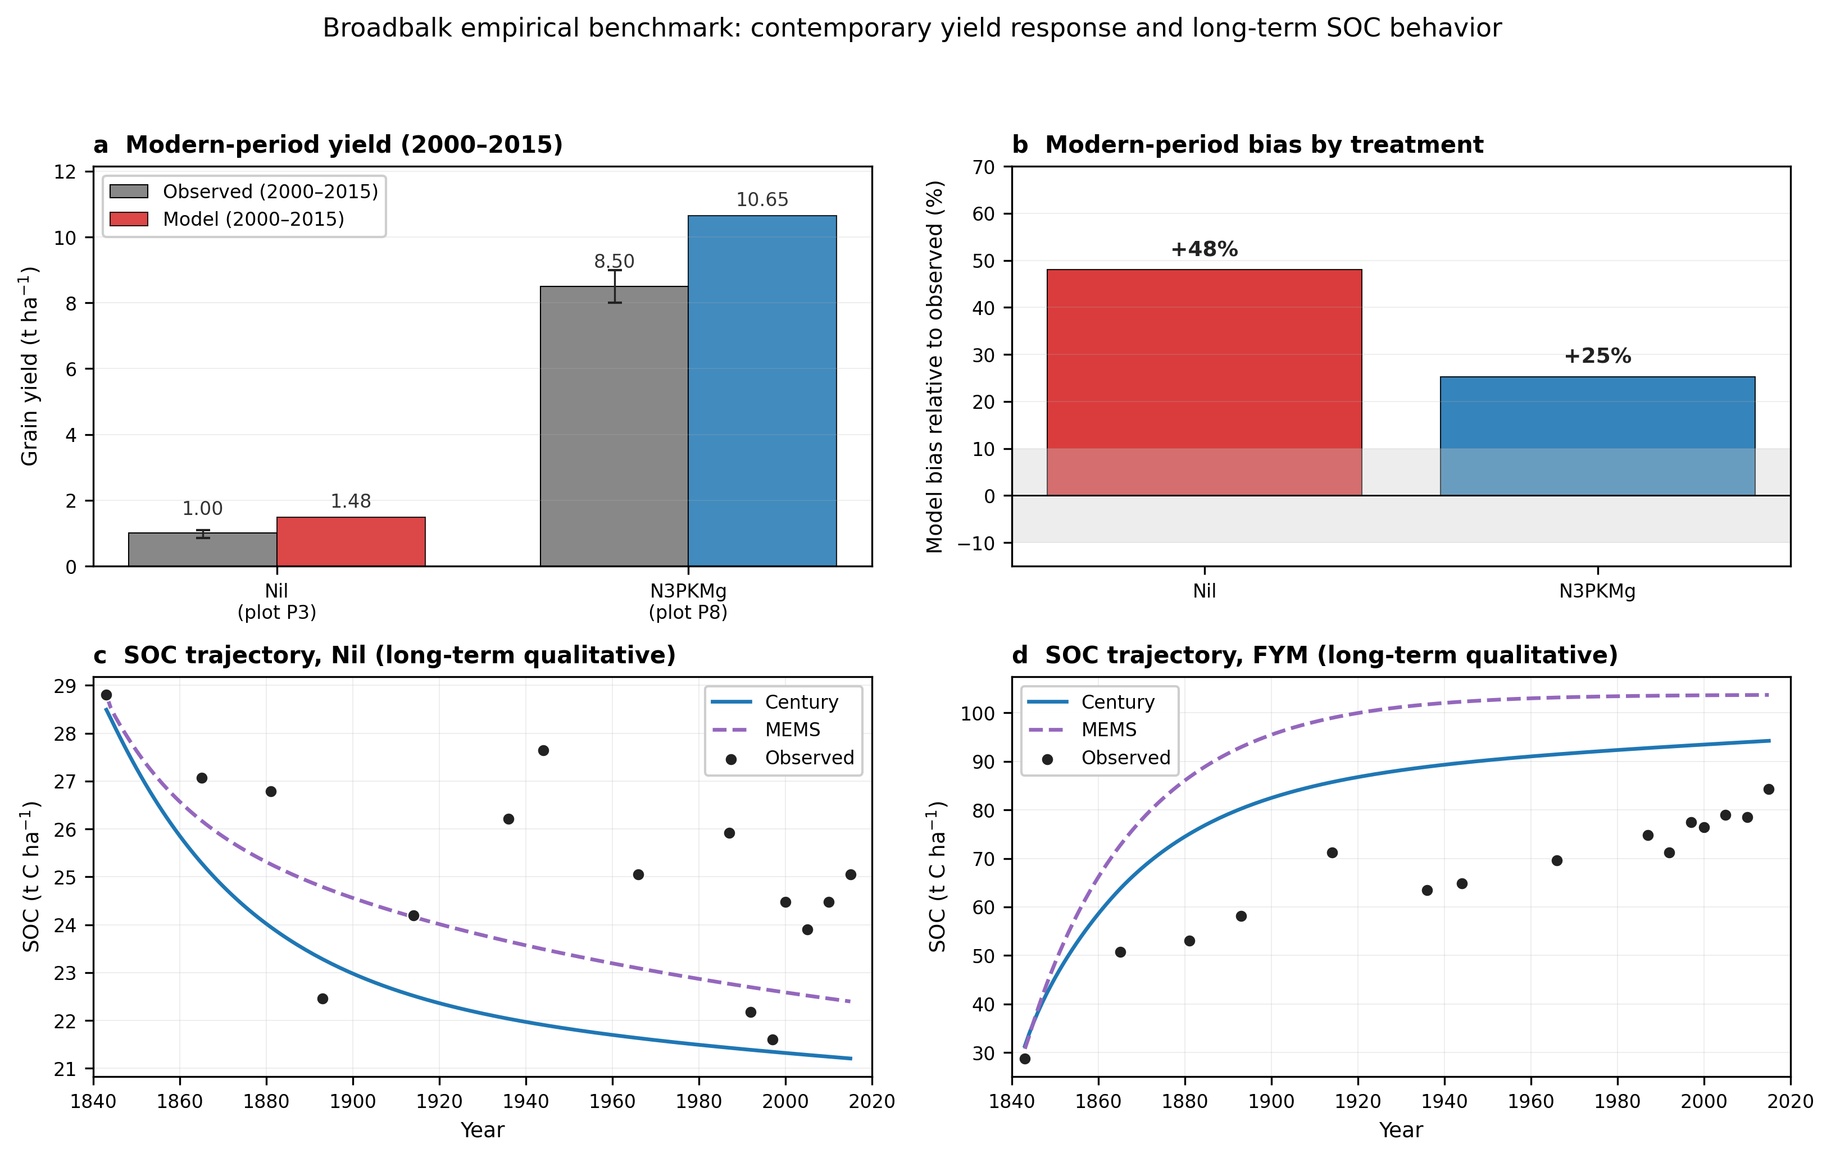
Supplementary Figure S2. Broadbalk benchmark of contemporary yield response and long-term SOC behavior. a, Observed and modeled grain yield for the modern reference period (2000–2015) in the Nil and N3PKMg Broadbalk treatments. Yield benchmarking is restricted to the modern period because the framework uses a contemporary yield ceiling, whereas a full 1843–2015 comparison would require time-varying yield potential to reflect historical changes in cultivar genetics and management. Observed values are reference-period treatment means extracted from the project validation dataset, summarising Broadbalk 2000–2022 treatment means from the Rothamsted Broadbalk handout (2024); for N3PKMg the value plotted is the midpoint of a reported 8–9 t ha⁻¹ range, with the range shown as an error bar. b, Relative model bias for the same modern-period yield benchmark. The model overpredicts both treatments, with larger bias for Nil. c,d, Observed and modeled long-term SOC trajectories for Nil and FYM treatments, 1843–2015. These panels are used as qualitative benchmarks of SOC decline under prolonged nutrient depletion and SOC accumulation under manure addition, rather than as site-specific validation of the full coupled framework. Together, these comparisons support the use of the biophysical core for contemporary fertilizer-shock scenarios while indicating that modeled SOC-resilience magnitudes should be interpreted as scenario-based rather than site-specific predictions.

Mineralizable-N sensitivity
Within the Century/RothC structure used here, the within-region SOC-buffering result was effectively insensitive to the tested initial active-pool fraction values, because steady-state spinup largely re-equilibrated SOM pool partitioning. The result was also robust to ±25% perturbations in slow-pool turnover. The dominant remaining sensitivity was the bulk soil C:N assumption: a ±20% perturbation around the regional baseline shifted the yield-change gap between SOC = 50% and SOC = 100% by approximately ±10% in both Sub-Saharan Africa and North America, while preserving the direction of the gradient. The qualitative conclusion that higher-SOC farms experience smaller yield losses under fertilizer-price shocks was therefore robust across the tested parameterizations, although the magnitude of the buffering effect remained somewhat sensitive to assumptions about the SOC-to-mineralizable-N relationship.
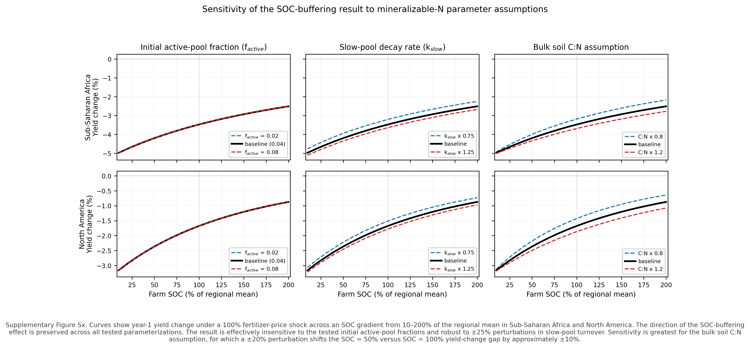
Supplementary Figure S3. Sensitivity of the SOC-buffering result to mineralizable-N parameter assumptions. Curves show year-1 yield change under a 100% fertilizer-price shock across an SOC gradient from 10–200% of the regional mean in Sub-Saharan Africa and North America. The direction of the SOC-buffering effect is preserved across all tested parameterizations. The result is effectively insensitive to the tested initial active-pool fraction values and robust to ±25% perturbations in slow-pool turnover. Sensitivity is greatest for the bulk soil C:N assumption, for which a ±20% perturbation shifts the SOC = 50% versus SOC = 100% yield-change gap by approximately ±10%.

2022 fertilizer crisis benchmark of demand-side response
The 2022 fertilizer crisis provides a directional benchmark for the demand-side component of the coupled framework. Under a calibrated ~15% global supply reduction (+68% modeled fertilizer price increase), the model reproduced the direction and rank ordering of fertilizer-use contractions among unsubsidized regions (Spearman ρ = 1.0 excluding South Asia; Sub-Saharan African nitrogen use fell 14%, European use declined 5%, North American use declined 3%) while overpredicting the magnitude of fertilizer demand reductions. This pattern is consistent with short-term buffers not represented in the framework, including forward purchasing, inventory drawdowns, subsidies, and within-season timing adjustments. South Asia remains an instructive exception: observed nitrogen use increased (positive on the y-axis) 2% despite the modeled demand reduction, consistent with the capacity of India’s fertilizer subsidy program to buffer price transmission (Supplementary Figure S4).
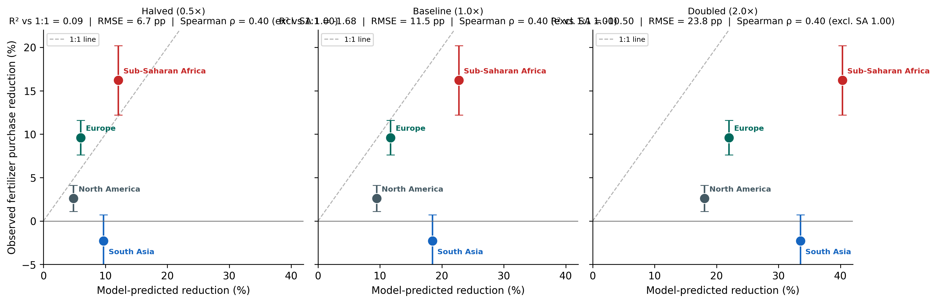
Supplementary Figure S4. Robustness of the 2022 directional benchmark to price-elasticity parameterization. The 2022 crisis hindcast (calibrated ~15% global supply reduction, +68% modeled fertilizer price increase) compared against FAOSTAT observed nitrogen use changes under baseline regional elasticities and under uniform halving and doubling of εF,PF. Direction and rank ordering are preserved across all three parameterizations; the model systematically overpredicts the magnitude of demand reductions, consistent with short-term buffers (forward purchasing, inventory drawdowns, government subsidies) not captured in the framework.

Note 2 substitutes the alternative microbially-explicit 4-pool SOM scheme for the Century/RothC stabilization model used in the main analysis, and asks whether the sustained-disruption SOC-loss trajectories are robust to the choice of stabilization mechanism.

Supplementary Note 2: Structural sensitivity (microbially-explicit 4-pool versus Century SOM frameworks)
When the Century SOM engine is replaced by the microbially-explicit 4-pool SOM scheme, relative feedback magnitude ranges from 0.9× to 2.2× across regions. Alternative-engine/Century SOC-loss ratios range from 0.9× in Sub-Saharan Africa, where low initial SOC limits scope for further decline, to 2.2× in East Asia, where the small Century-engine loss makes the ratio most sensitive to the engine difference. The median ratio is 1.65× at 30 years. The engines differ in several coupled respects: in Century, crop residue carbon transfers directly to stable pools through humification, while in the microbially-explicit 4-pool scheme it traverses particulate organic matter (POM) → dissolved organic matter (DOM) and then either passes through microbial biomass carbon (MBC) into mineral-associated organic matter (MAOM) or sorbs directly from DOM to MAOM (at equilibrium roughly half of MAOM formation follows each route). Carbon on the microbial route pays a respiratory cost concentrated at microbial assimilation (1−CUE on every C atom traversing the biomass pool) and at the non-recycled fraction of microbial necromass. The larger losses under the 4-pool scheme arise from the combined effects of its alternative stabilization, respiration, desorption, and baseline-state dynamics: holding CUE constant indicates that CUE downregulation explains 6–59% of the 4-pool−Century loss difference where that difference is positive (Supplementary table 2), and the remaining difference cannot be uniquely attributed to a single mechanism. Absolute year-30 losses are 0.5–2.1% of the baseline stock under Century and 1.0–3.1% under the 4-pool scheme, larger under the 4-pool scheme in seven of eight regions; the largest ratio (2.2× in East Asia) occurs where the Century loss is smallest (0.48%), so ratios should be read alongside the absolute losses in Supplementary table 2, and the disruption-attributable carbon budget is shown in Supplementary Figure S5.
Both engines run the same ERA5 forcing, realized-yield market clearing, water-stress response and production-path yield calibration, and are initialized at their own stationary spin-up equilibria; the comparison applies the sustained 20% physical supply-loss scenario (SC1) over a 30-year horizon and normalizes each engine to its own baseline (Supplementary table 2, Supplementary Figure S5). The comparison is exploratory structural sensitivity rather than a controlled experiment: the 4-pool equilibrium departs from the observed regional SOC (for example 45.7 against 50.0 t C ha⁻¹ in North America, 29.2 against 25.0 in South Asia, and 13.5 against 9.0 in Sub-Saharan Africa), so baseline SOC, yield, residue input and mineralization differ between the engines and percent-based normalization does not remove those differences. In absolute terms the 4-pool scheme loses more disruption-attributable carbon than Century in every region, including Sub-Saharan Africa (0.26 against 0.12 t C ha⁻¹ over 30 years), so the sub-parity Sub-Saharan African ratio partly reflects its larger equilibrium baseline. Under the microbially-explicit scheme the equilibrium nitrogen supply also cannot carry the Sub-Saharan African baseline yield fully to its FAOSTAT target (equilibrium yield 1.37 t ha⁻¹ against 1.50); the shortfall is disclosed rather than retuned. The MAOM sorption ceiling assumes a uniform clay+silt fraction of 0.55; varying it from 0.35 to 0.75 moves the median ratio from 1.77 to 1.56 and the Sub-Saharan African ratio from 1.00 to 0.85, so these ratios are indicative of structural direction rather than calibrated magnitudes.

Supplementary table 2
Year-30 SOC losses under each engine and their ratio, and partitioning of the 4-pool−Century loss difference between CUE downregulation and non-CUE mechanisms.
Region | Century SOC loss, yr 30 (%) | 4-pool SOC loss, yr 30 (%) | CUE contribution (%) | Non-CUE mechanisms (%) | Alternative-engine/Century SOC-loss ratio (×)
North America | 1.03 | 2.13 | 9 | 91 | 2.1×
Europe | 1.65 | 2.60 | 13 | 87 | 1.6×
East Asia | 0.48 | 1.04 | 42 | 58 | 2.2×
South Asia | 2.09 | 2.59 | 59 | 41 | 1.2×
Southeast Asia | 1.64 | 3.10 | 16 | 84 | 1.9×
Latin America | 1.28 | 2.22 | 6 | 94 | 1.7×
Sub-Saharan Africa | 2.14 | 1.94 | — | — | 0.9×
Former Soviet Union | 2.14 | 3.04 | 6 | 94 | 1.4×
CUE contribution isolated by running the microbially-explicit 4-pool scheme with CUE held constant at its baseline value; the difference from the full microbially-explicit 4-pool run is attributed to CUE downregulation, expressed as a share of the 4-pool−Century loss difference. The non-CUE share reflects the combined effects of the scheme's alternative stabilization, respiration, desorption, and baseline-state dynamics, and is not further partitioned by mechanism (the disruption-attributable budget is shown in Supplementary Figure S5). Sub-Saharan Africa is excluded because the microbially-explicit 4-pool scheme produces lower SOC loss than Century in this low-SOC, MAOM-undersaturated regime (relative magnitude < 1), which makes the CUE/non-CUE decomposition ill-defined. Reported decomposition is for the sustained 20% physical supply-loss scenario (SC1), used to compare the microbially-explicit 4-pool scheme and Century under the same supply-reduction stress test.

Supplementary Figure S5: disruption-attributable carbon budget under the sustained 20% supply-loss scenario (SC1)
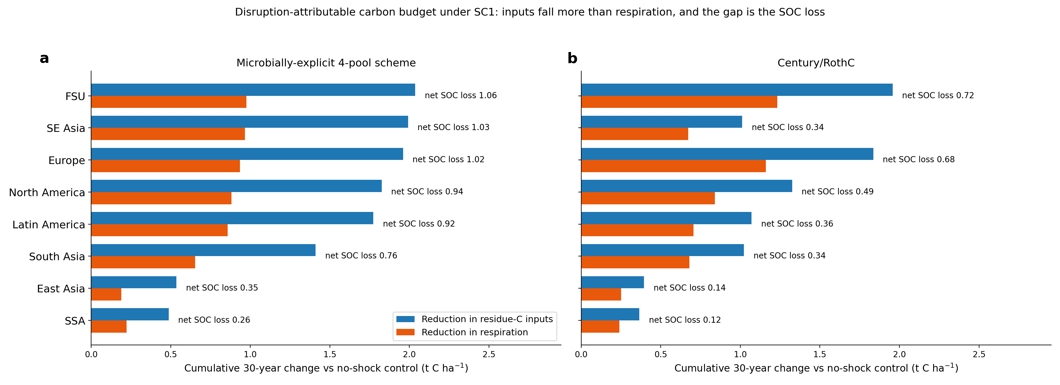
Supplementary Figure S5. Disruption-attributable 30-year carbon budget under the sustained 20% physical supply-loss scenario (SC1), relative to a no-shock control. a, Microbially-explicit 4-pool scheme: reduction in cumulative residue-carbon inputs and in cumulative respiration; the gap between the two bars is the SOC loss attributable to the disruption. b, The same budget for Century/RothC. Respiration declines less than inputs under both engines, and the attributable loss is larger under the 4-pool scheme in every region, reflecting the combined effects of the scheme's alternative stabilization, respiration, desorption, and baseline-state dynamics (the CUE step accounts for 80–87% of total 4-pool respiration).

Supplementary Note 3: Pairwise regional diagnostics of modeled vulnerability
With eight modeled regions and structural descriptors that covary across regions, we summarize cross-regional model behavior using pairwise rank associations. The goal is to show how modeled vulnerability is structured by soil, climate, productivity and economic descriptors, not to attribute independent causal shares. Throughout this note, Spearman ρ values are descriptive diagnostics across the eight modeled regions, not inferential tests on a population sample. We summarize the diagnostic in one figure (Supplementary Figure S6) and one table (Supplementary table 3).
Total year-10 yield penalties are most strongly associated with regional structural descriptors that reflect the underlying biophysical and productivity context of each region. Larger modeled losses occur in regions with a lower calibrated yield ceiling (y_max, ρ = −0.90), drier baseline conditions (water deficit ρ = +0.70), currently lower SOC stocks (ρ = −0.61), and lower biological N fixation potential (ρ = −0.28). These descriptors covary substantially across the eight regions: regions with a low calibrated yield ceiling (y_max) tend to have low SOC and higher water deficit, and should be interpreted as a single structural-context axis rather than as four independent drivers. The same pattern holds for year-1 yield penalties (Supplementary table 3) at similar magnitudes. We emphasize that this is a structural diagnostic of the modeled system, not a normative ranking of regions; regions on the more vulnerable end of this axis are also the regions with the largest SOC-rebuilding upside (figure 1, main text).
Economic descriptors show directionally consistent associations with modeled vulnerability but weaker magnitudes in the eight-region diagnostic. Higher fertilizer-demand elasticity magnitude is associated with larger year-10 yield losses (ρ = +0.54), reflecting that more elastic demand translates a given price shock into a larger fertilizer-use reduction. Food-demand elasticity magnitude shows the same direction at comparable magnitude (ρ = +0.51). The land-response coefficient λ_L shows a moderate positive association (ρ = +0.47); frontier regions (Latin America, Sub-Saharan Africa) combine higher λ_L with higher baseline biophysical vulnerability, so this association reflects the same productive-context axis as the soil and climate descriptors rather than an independent economic effect. Fertilizer cost share would in principle be a useful descriptor of margin sensitivity; however, regional fertilizer- and crop-price values used in the model are reported for only four regions (NA, SA, LATAM, SSA), so we do not include cost share in the cross-regional diagnostic.
The soil N buffer ratio (the share of crop N supplied by SOM rather than current-season fertilizer) is weakly associated with year-10 total yield penalty across the eight modelled regions (Spearman ρ = +0.19; Pearson R² = 0.10, the single cross-regional metric used throughout). The buffer ratio combines two opposing mechanisms operating on different timescales. Within the year of a shortfall, a higher buffer ratio means more of the missing fertilizer is replaced by SOM mineralization, dampening yield loss (year-1 capacity buffering; main-text figure 1). Under sustained disruption, however, reliance on soil-supplied N has a cost: lower yields reduce residue return, accelerating SOM depletion (long-term buffer erosion; main-text figure 2 and the sustained-disruption scenarios). The cross-regional ρ ≈ +0.19 reflects the net of these two opposing mechanisms at the year-10 horizon, not the absence of soil buffering. Within-region buffering is separately resolved in main-text figure 1a,b; long-term erosion is separately resolved in main-text figure 2a,b. The conclusion is that cross-regional vulnerability cannot be ranked from the buffer ratio alone; the within-region SOC gradient identifies the management-relevant resilience lever.

Supplementary Figure S6: Pairwise regional diagnostics
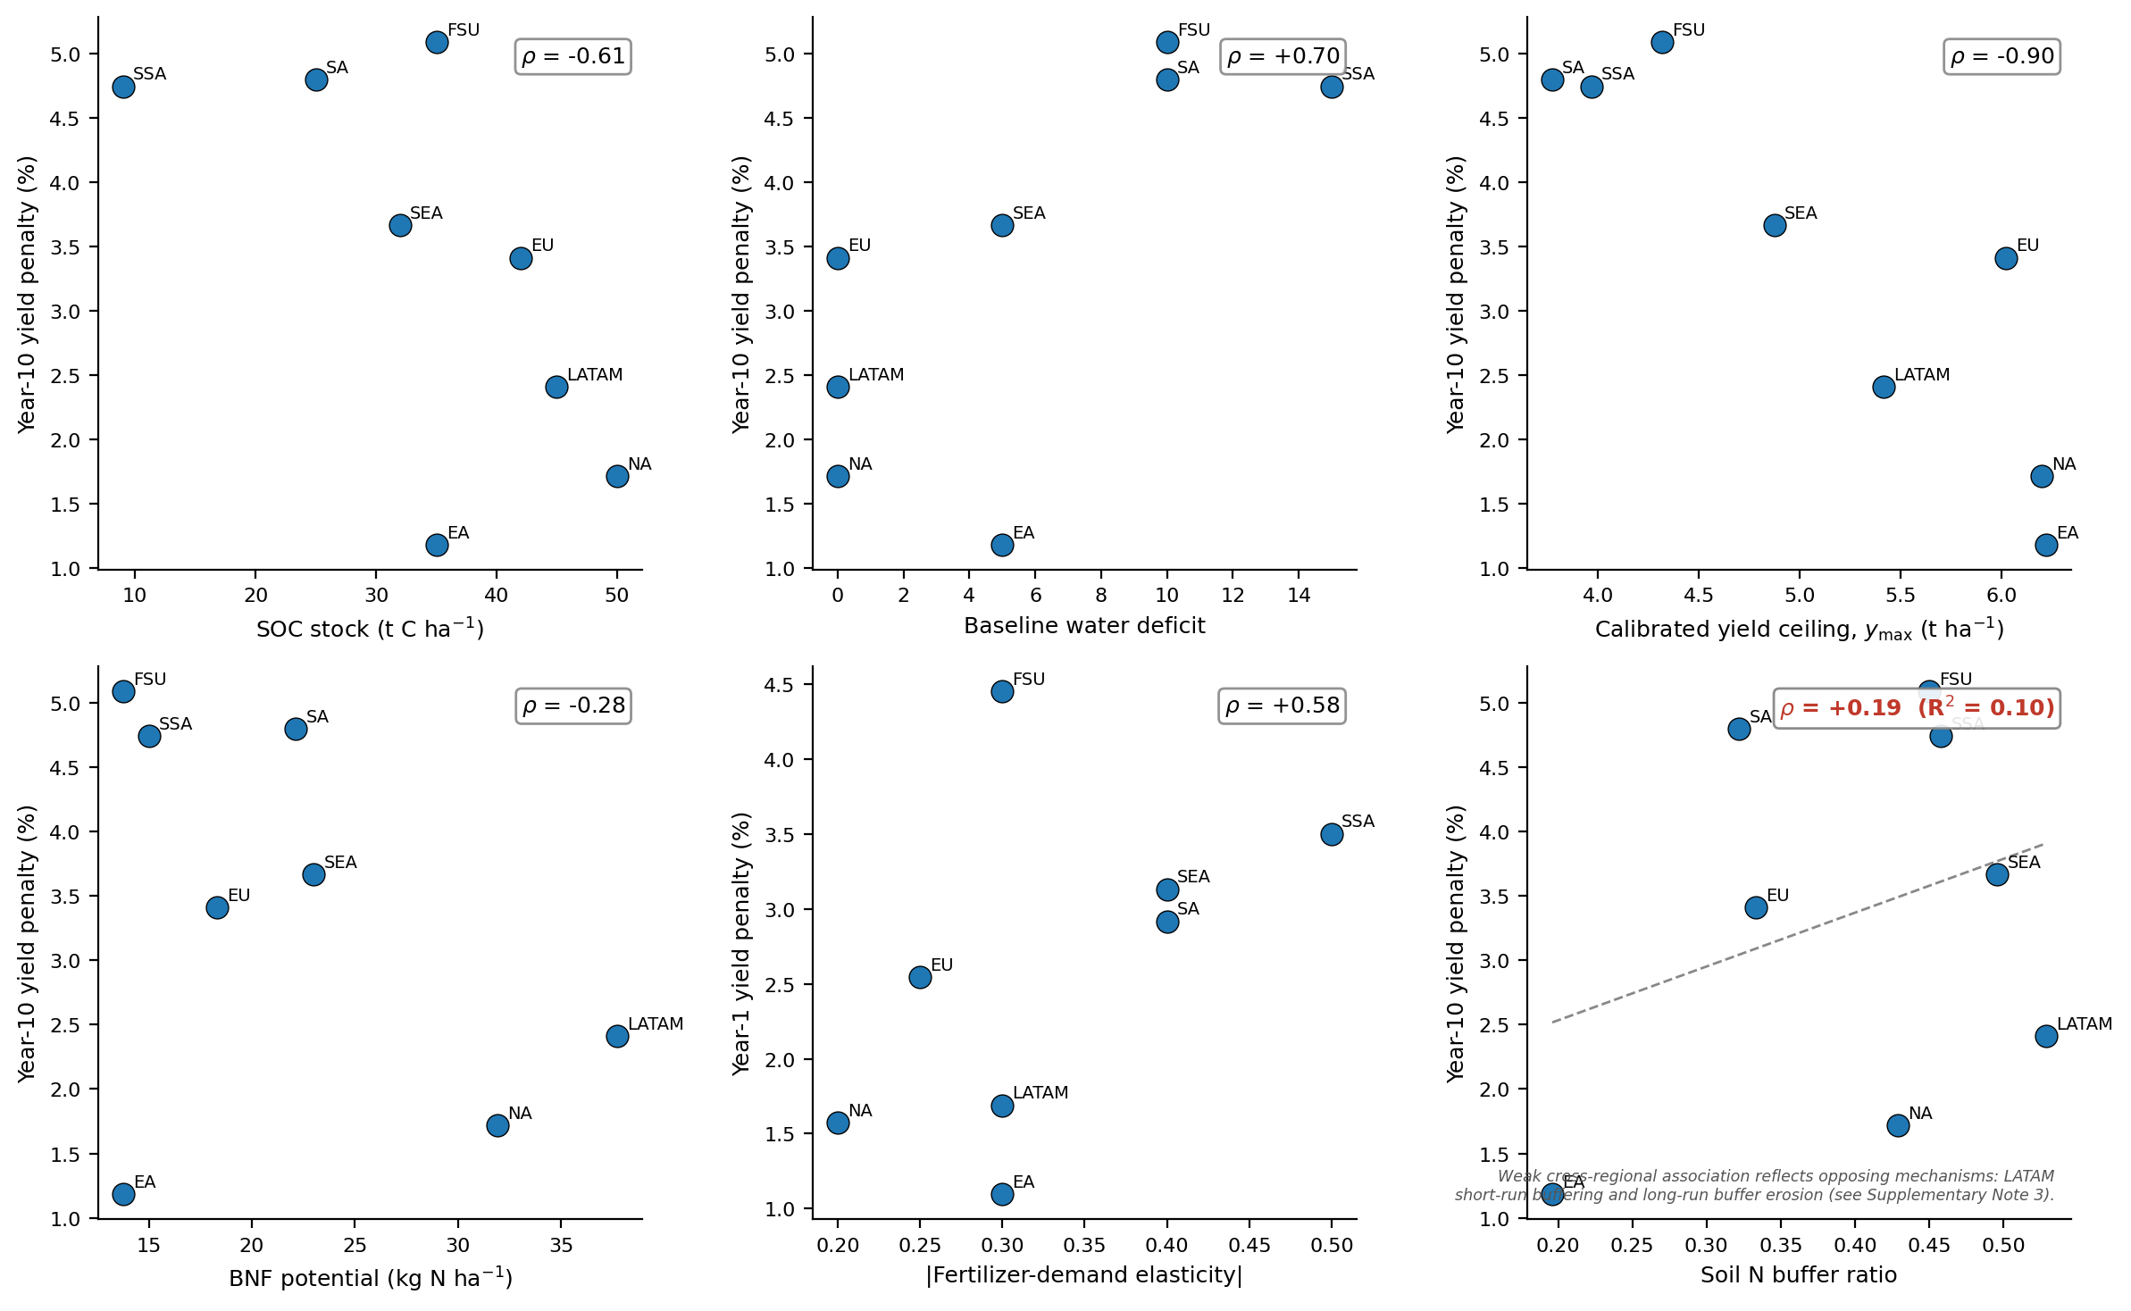
Supplementary Figure S6. Pairwise regional diagnostics across the eight modeled regions. Each panel shows year-10 (or year-1, panel e) yield penalty against a candidate descriptor; regions are labeled (NA, EU, EA, SA, SEA, LATAM, SSA, FSU). Spearman rank correlation ρ is printed in each panel. (a) SOC stock; (b) baseline water deficit; (c) calibrated yield ceiling (y_max); (d) BNF potential; (e) fertilizer-demand elasticity magnitude versus year-1 yield penalty; (f) soil N buffer ratio (annotation flags the opposing-mechanisms interpretation; see Note 3 paragraph 4). Values are descriptive diagnostics across the eight modeled regions and are not used for statistical inference.

Supplementary table 3: Pairwise Spearman rank associations
Descriptor | Year-1 yield penalty | Year-10 total yield penalty
SOC stock (t C ha⁻¹) | −0.61 | −0.61
Soil N buffer ratio | +0.40 | +0.19
Baseline water deficit | +0.69 | +0.70
Calibrated yield ceiling, y_max (t ha⁻¹) | −0.81 | −0.90
BNF potential (kg N ha⁻¹) | −0.30 | −0.28
Synthetic N rate (kg N ha⁻¹) | −0.55 | −0.38
|Fertilizer-demand elasticity| | +0.58 | +0.54
|Food-demand elasticity| | +0.51 | +0.51
Land-response coefficient λ_L | +0.53 | +0.47
Values are descriptive Spearman rank associations across the eight modeled regions. They summarize model behavior and are not used for statistical inference. $λ_{L}$ is the derived land-response coefficient$\frac{\left(ε_{LS},PL · ε_{LD},PY\right)}{\left(ε_{LS},PL \text{-} ε_{LD},PL\right)}.$Year-1 net-revenue change is not included in this table because audited regional fertilizer- and crop-price pairs are reported for only four of the eight regions in the deposited model output.

Supplementary Note 4: Robustness of resilience results to economic parameter assumptions
Two complementary sensitivity analyses test whether the central within-region SOC buffering result and the cross-regional vulnerability ranking are robust to the price elasticity of fertilizer demand (εF,PF) used in the calibration. Supplementary Figure S7 examines the within-region farm-level result by halving εF,PF in all regions; Supplementary Figure S8 examines the cross-regional sustained-disruption trajectory under uniform halving of εF,PF. Together, these analyses show that the magnitude of regional impacts is more sensitive to fertilizer-demand elasticity than the presence of the SOC-buffering effect itself.

Supplementary Figure S7: Within-region sensitivity to halved price elasticities of fertilizer demand
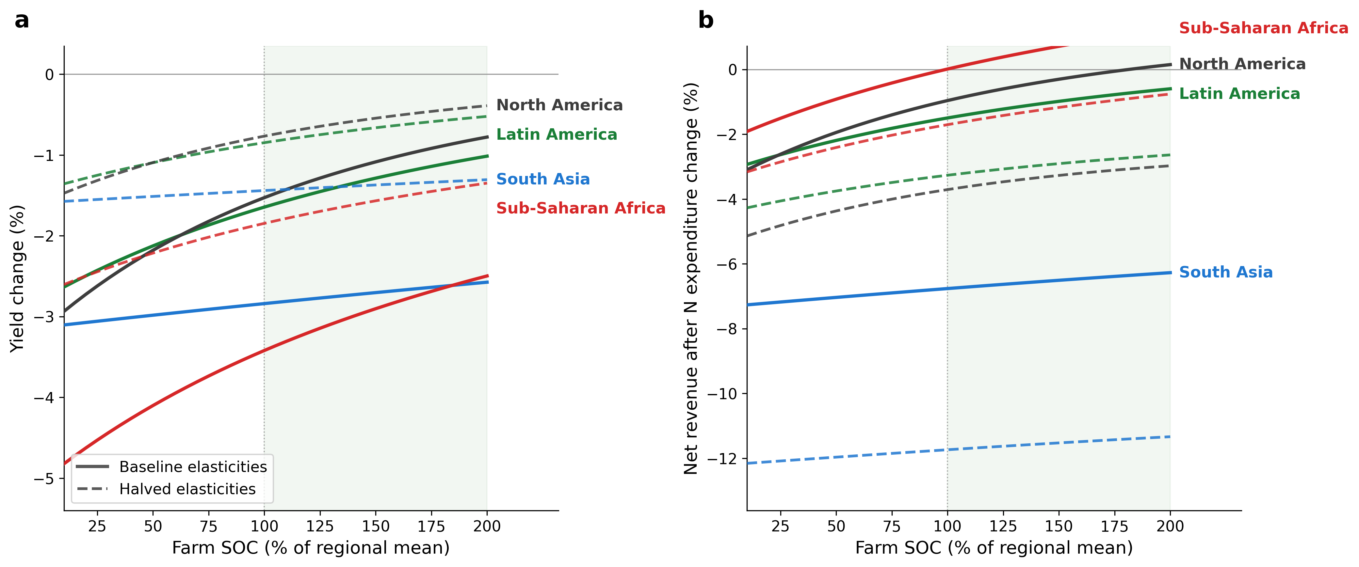
Supplementary Figure S7. Sensitivity of farm-level resilience to halved price elasticities of fertilizer demand, evaluated across an extended SOC gradient (10–200% of regional mean). a, Yield change as a function of farm SOC under a 100% fertilizer price spike, comparing baseline regional elasticities (solid) with all εF,PF halved (dashed). All four regions improve monotonically with SOC across the full range;Sub-Saharan Africa shows the largest yield improvement (2.3 percentage points from low to high SOC). With halved elasticities, farmers cannot substitute as flexibly and continue applying more fertilizer, so yield penalties are smaller (dashed curves sit above solid). b, Change in crop revenue net of nitrogen-fertilizer expenditure under the same scenarios. Halved elasticities produce substantially larger net-revenue losses (1.7 to 5.0 percentage points deeper at the regional mean SOC, largest in South Asia where the nitrogen cost share is highest) because farmers absorb more of the fertilizer-cost increase without the elastic substitution channel that otherwise cushions margins. The SOC buffering benefit is robust to elasticity assumptions in net-revenue terms: the net-revenue gap between SOC = 50% and SOC = 100% of the regional mean remains positive in all four regions under halved elasticities (0.3–1.0 percentage points at baseline against 0.2–0.7 percentage points when halved). The corresponding yield gap scales with the elasticity itself and is close to half as large under halved elasticities, so the ordering is preserved while the magnitude is not. Together, these panels show that the qualitative conclusion that higher-SOC farms are more buffered against price shocks does not depend on the elasticity assumption, and they make explicit the elasticity-mediated trade-off between yield response and net-revenue response.

Supplementary Figure S8: Cross-regional sensitivity to economic parameters
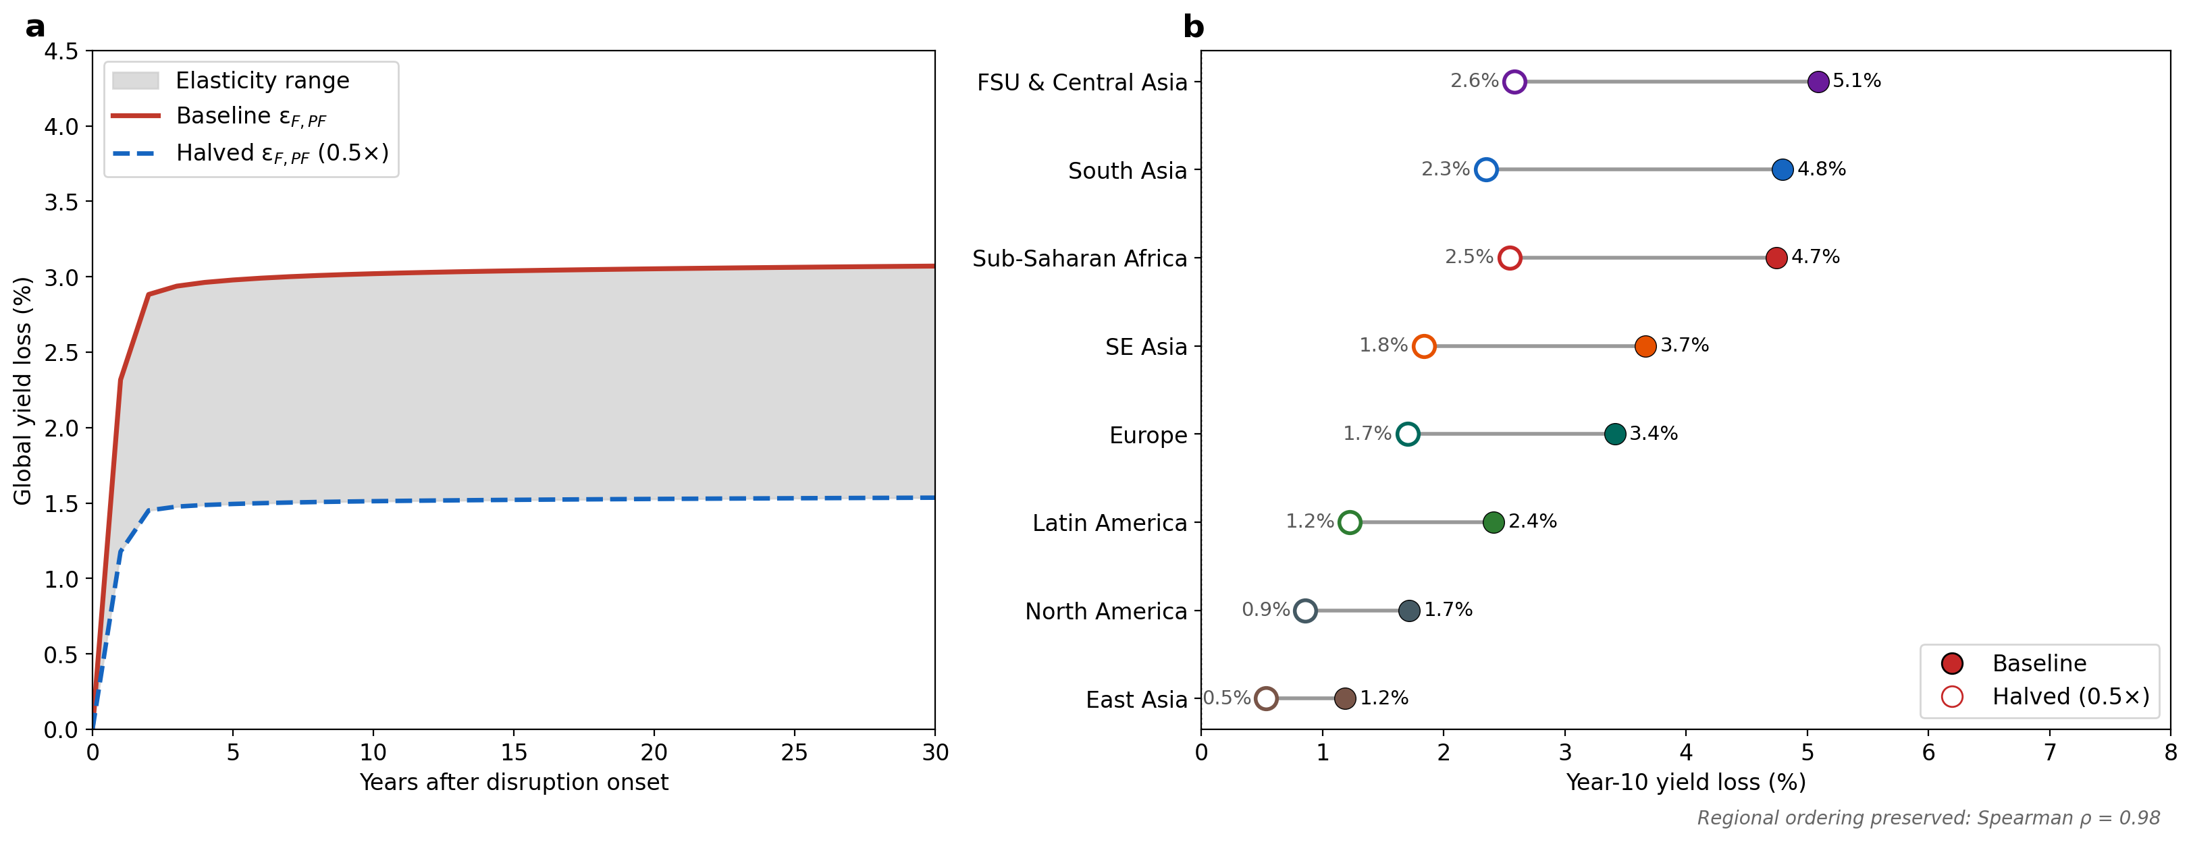
Supplementary Figure S8. Economic-parameter sensitivity for the sustained S3 price-shock scenario shown in main-text figure 2. The +104% fertilizer price shock was calibrated to drive an approximately 20% global fertilizer-use reduction under S1; in S3, the active soil-N depletion-feedback term (ε_F,N) partially offsets the reduction, yielding an approximately 19% realized reduction over the sustained-disruption period. a, Global weighted yield loss trajectory over 30 years, comparing baseline (solid red) with all regional εF,PF halved (dashed blue). Shaded envelope represents the range spanned by the two parameterizations. b, Year-10 yield loss by region under the same scenarios, shown as paired points (filled = baseline, hollow = halved) connected by horizontal lines. Global year-10 loss: 3.0% under baseline, ~1.5% under halved elasticities (~50% reduction in predicted impact). Regional ordering is preserved (Spearman ρ = 0.98). Panel-b percentages are year-10 yield loss expressed as percent of the no-shock baseline at each SOC level. The framework’s qualitative conclusions, including the ranking of regional vulnerability and the shape of the recovery trajectory, are insensitive to the choice of price elasticity within the ±50% range examined. Absolute magnitudes scale approximately linearly with εF,PF.
Food-price impacts. The model resolves a regional output-price response P̂_Y,r,t at every annual timestep through market clearing under regional supply and demand elasticities. Under the sustained S3 disruption (price shock calibrated to drive a 20% reduction under S1; ~19% realized under S3), regional output-price indices rise by 2.4–10.3% in year 1, a production-weighted global increase of 5.2%, and by year 10 span 2.6% (East Asia) to 11.9% (FSU/Central Asia), a production-weighted global increase of 6.7%; the largest increases arise where food demand is least elastic rather than where yield losses are largest. These are the prices that clear the realized biophysical production response, so no separate linearized supply schedule stands behind them. The food-price channel partially offsets fertilizer-demand reductions through ε_F,PY = +0.10, but its quantitative effect on regional fertilizer use is small relative to the direct ε_F,PF channel (approximately 0.5 percentage points production-weighted, and 0.1 to 0.9 percentage points across individual regions). Food-price effects are reported here rather than in main-text figure 2 to keep the main figure focused on yield and margin; full P̂_Y trajectories per region are available in the canonical reproducibility package (data/food_price_response.csv, written by code/repro/make_food_price_table.py). In unconstrained runs P̂_Y is a reduced-form regional price index implied by the linearized clearing condition and the assumed elasticities, and is not a calibrated food-price forecast.

Supplementary Note 5: Jensen’s inequality and representative-soil aggregation
Regional yield responses are computed at the regional means SOC, rather than as a cropland-area-weighted aggregates over the within-region SOC distribution. Because the Mitscherlich response is concave in available N, aggregate yield across a heterogeneous soil distribution is strictly less than yield at the mean soil (Jensen’s inequality), and the shock-induced yield reduction is correspondingly larger for farms on the low-SOC tail. The price responses reported here therefore likely understate the true price response in regions with wide within-region SOC variance, particularly Sub-Saharan Africa. The ordinal ranking in figure 2 is preserved; absolute magnitudes scale with within-region SOC variance. A spatially explicit aggregation linking the model to gridded soil data is a natural extension.

Supplementary Note 6: Joint-prior Monte Carlo ensemble across biophysical and economic parameters
The headline impact estimates in the main text are computed at the central parameter values for each region. Supplementary Notes 1, 4, and the structural sensitivity in Note 2 each test one structural assumption at a time. To complement those one-at-a-time checks with a joint-uncertainty assessment, we ran a Monte Carlo ensemble over the full coupled system. Eight parameters that the prior sensitivity analyses identify as first-order drivers were varied jointly: (i) the maximum monthly N uptake fraction, (ii) the Mitscherlich curvature parameter c, (iii) the slow-pool turnover rate k_{slow}, (iv) the regional carbon retention efficiency (CRE), (v) a residue-retention multiplier, (vi) the regional fertilizer-demand price elasticity ε_{F,P_F}, (vii) the food-demand price elasticity η, and (viii) the magnitude of the imposed fertilizer-price shock. Each parameter was sampled from a truncated normal centered on the central value used in the main text, with standard deviations chosen to span the empirical or literature range of plausible values (e.g., ±30% on price elasticities, ±20% on k_{slow}, ±10% on residue retention). These priors are not Bayesian posteriors; they describe a structured exploration of joint parameter uncertainty. Full prior specifications are archived in mc_priors.json in the Zenodo deposit.

One thousand joint draws were generated, and each draw was propagated through the full coupled monthly N-balance + Century three-pool SOM + price-clearing system at three SOC levels per region (50%, 100%, 150% of the regional mean). This yielded 24,000 region×SOC×draw yield evaluations (year-1 yield loss), plus 12,000 evaluations of the year-1 change in crop revenue net of nitrogen-fertilizer expenditure across the four regions with audited price pairs.

Three findings are robust to joint-prior uncertainty. First, SOC buffering is universal in the ensemble: in all 1,000 draws, low-SOC farms sustain larger year-1 yield losses than high-SOC farms in every region, and high-SOC farms retain higher year-1 crop revenue net of nitrogen-fertilizer expenditure than low-SOC farms in each of the four regions with audited price pairs. The buffering signal is not an artifact of any particular parameter choice. Second, the global cropland-area-weighted year-1 yield loss has an ensemble median of 2.51% with a 5–95% range spanning 3.3 percentage points, consistent with the main-text central estimate. Third, the cross-region buffer ratio (low-SOC minus high-SOC year-1 yield loss, in percentage points of yield) has an ensemble median of 0.88 ppt across regions; the ensemble distribution shows real variation in the magnitude of buffering across draws, but its sign is preserved.

Ranking results are more parameter-sensitive than buffering. The ranking is sensitive to the nitrogen-price inputs: under the audited price pairs (nitrogen-cost share ~15% in South Asia against ~4% in Sub-Saharan Africa), Sub-Saharan Africa is the worst priced region for year-1 net revenue in none of the 1,000 draws, and Sub-Saharan Africa is not the worst region for year-1 yield loss in any draw: the Former Soviet Union/Central Asia region carries the largest year-1 yield loss in 99.8% of draws, and Southeast Asia exceeds Sub-Saharan Africa in 25.4% of draws, because central yields in those regions are more strongly N-limited at the regional mean SOC. The decoupling of physical yield loss from economic exposure is a robust feature of the joint-prior ensemble.

Supplementary Figure S9: Joint-prior Monte Carlo ensemble across biophysical and economic parameters
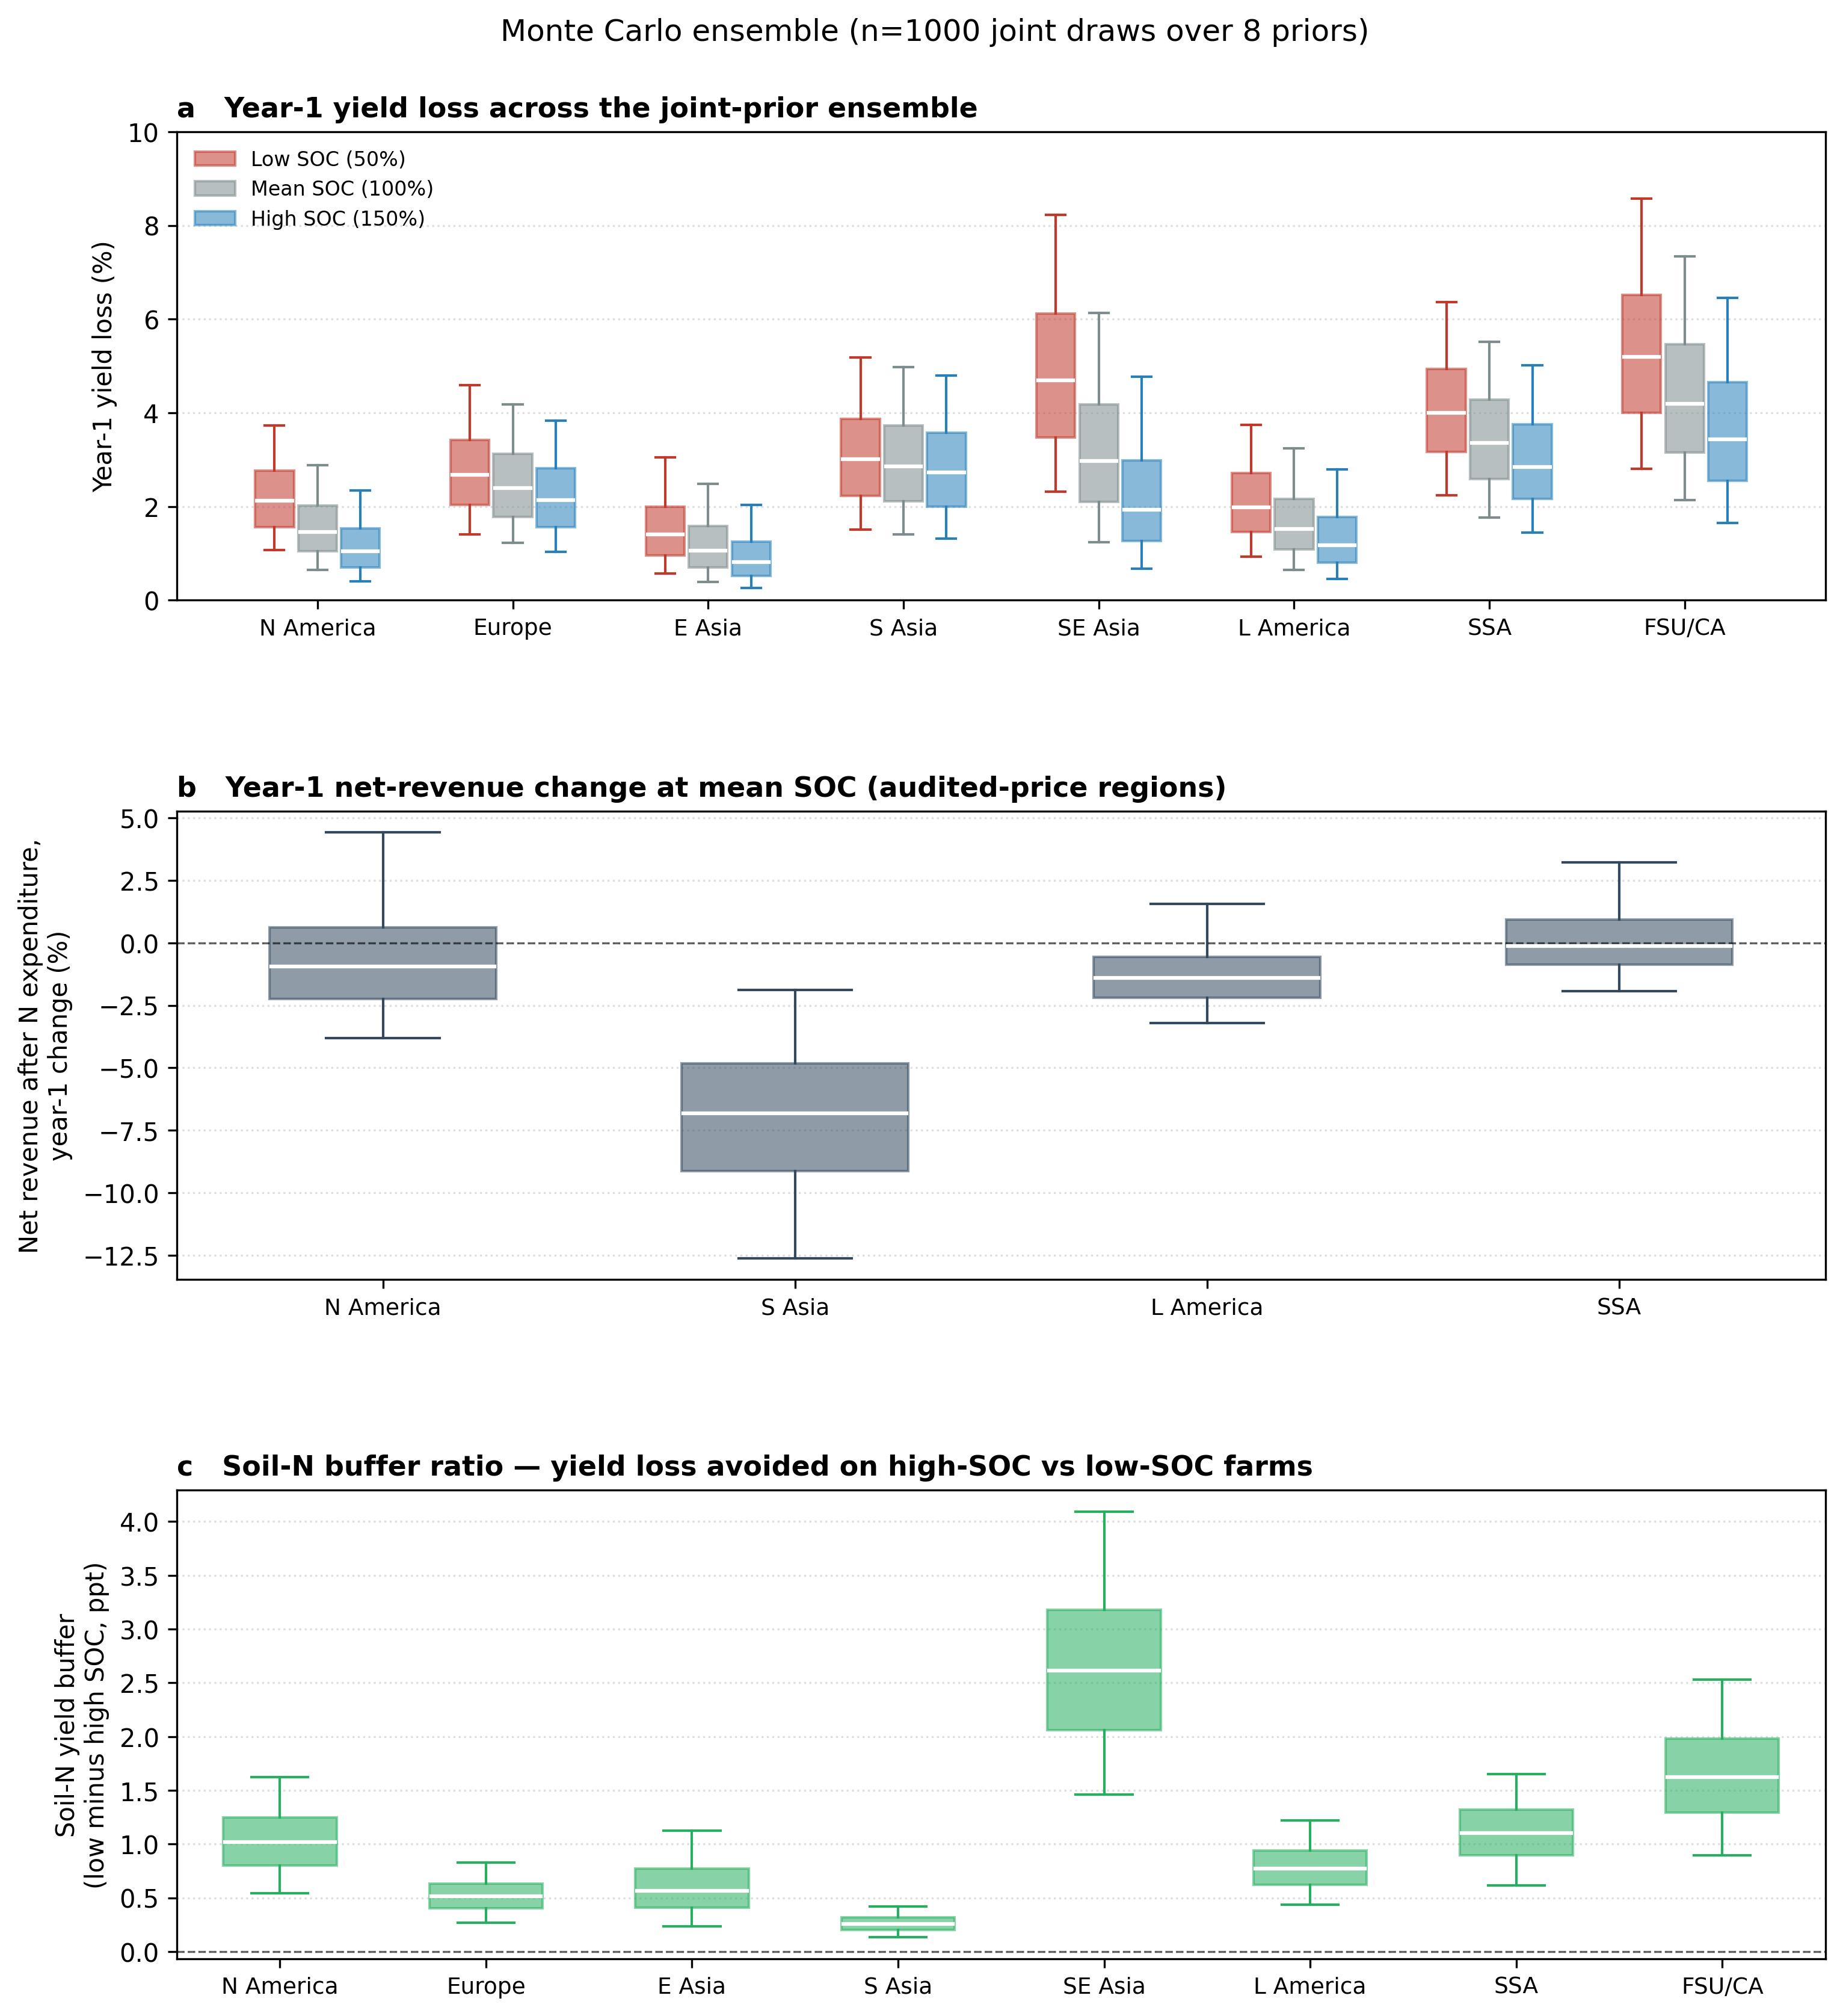
Supplementary Figure S9. Joint-prior Monte Carlo ensemble across 1,000 draws for the coupled model. Each draw is propagated through the full monthly N-balance + Century SOM + price-clearing system. a, Year-1 yield loss (%) by region at three SOC levels (low: 50% of regional mean SOC; mean: 100%; high: 150%). Boxes span the interquartile range; whiskers span the 5–95% range; medians shown in white. Low-SOC bars (red) lie above high-SOC bars (blue) in every region in all 1,000 draws. b, Year-1 change in crop revenue net of nitrogen-fertilizer expenditure (%) at SOC = 100%, for the four regions with audited price pairs. Under the audited prices Sub-Saharan Africa is most negative in none of the 1,000 draws, and it is not the largest yield-loss region in any draw. c, Soil-N yield buffer (low-SOC minus high-SOC year-1 yield loss, in percentage points). Distribution is positive in every region in all 1,000 draws, with a cross-region median of 0.88 ppt.

Supplementary Note 7: Spatial soil-buffer / fertilizer-exposure screen

Data sources and processing
The country-level soil-buffer / fertilizer-exposure screen integrates five datasets. (i) Soil organic carbon and nitrogen stocks 0–30 cm are taken from SoilGrids 2.0 [26] at 250 m native resolution, aggregated to 5 arc-minute resolution. The cropland-weighted soil organic N buffer proxy is computed as SOC/(C:N) per pixel and area-weighted to the country level using MIRCA2000 [39] (Zenodo 7422506) maximum total annual cropped area as the spatial weight. (ii) Synthetic N application is taken from FAOSTAT “Inputs” (Item: Nutrient nitrogen N (total); Element: Agricultural Use, average 2018–2020). (iii) Cropland area for the N-intensity denominator and for panel d bar heights is FAOSTAT “Land Use” (Item: Cropland; Element: Area, average 2018–2020). (iv) Fertilizer import reliance is computed from FAOSTAT “Trade Detailed” as net imports divided by apparent consumption, where apparent consumption = production + imports − exports, net imports = max(0, imports − exports), and the ratio is clipped to 0–1; values are averaged 2018–2020. This treatment avoids overstating dependence in re-export hubs, where gross imports inflate a simple imports-over-supply ratio. (v) Country boundaries and continental groupings follow Natural Earth Admin 0 (1:50 m).

Area accounting (FAOSTAT vs MIRCA2000)
Two cropland datasets contribute to main-text figure 3 and serve complementary roles. FAOSTAT cropland area (a single annual statistical area per country, averaged 2018–2020) provides the denominator for synthetic N application intensity and the bar heights in panel d. MIRCA2000 maximum total annual cropped area, a 5 arc-minute spatial grid, serves as the spatial weight for aggregating the SoilGrids soil organic N proxy from pixels to country-level cropland-weighted means. The two are not interchangeable: MIRCA’s global cropped total (~1,158 Mha) is lower than FAOSTAT cropland (~1,567 Mha) because MIRCA represents circa-2000 satellite-derived cropland extent and counts double-cropped cells twice, whereas FAOSTAT reports a single statistical area per country. Each dataset is used for the role it is best suited to support: MIRCA for the spatial structure of cropland-weighted soil aggregation, FAOSTAT for the national area accounting that underlies the N-intensity denominator and panel d.

Buffer and exposure classification
The buffer dimension is the cropland-weighted soil organic N stock proxy (t N ha⁻¹), classified into terciles across the 154 cropland-bearing countries (each country counted once, unweighted by cropland area). The default thresholds are: low buffer < 6.53 t N ha⁻¹, intermediate 6.53–9.30 t N ha⁻¹, and high buffer ≥ 9.30 t N ha⁻¹. The exposure dimension is high if either (a) synthetic N application intensity ≥ 150 kg N ha⁻¹ cropland or (b) fertilizer import reliance ≥ 0.70 with N intensity ≥ 25 kg N ha⁻¹; low if N intensity < 50 kg N ha⁻¹ and import reliance < 0.30; intermediate otherwise. The intent is to isolate countries with limited soil organic N buffering capacity and structural exposure to fertilizer shocks. The screen does not adjudicate food-security vulnerability, which depends on additional factors (national stocks, trade flexibility, social safety nets, intra-country distribution) beyond the scope of this mechanism.

Buffer-tercile sensitivity (cropland-weighted thresholds)
Defining buffer terciles using cropland-area-weighted thresholds (rather than unweighted across cropland-bearing countries) shifts the low-buffer boundary upward because countries with large cropland areas (notably China and India) carry more weight in the threshold calculation. Under cropland-area-weighted terciles, China moves from low to intermediate buffer, reducing the global low-buffer / high-exposure cropland share from 17.4% to 4.85%. The remainder of the focal class is largely unchanged in regional composition. We retain the unweighted-across-countries terciles as the default because they isolate the soil-buffer signal independent of how cropland is concentrated in any single country.

SOC-only buffer sensitivity
Substituting SOC stock 0–30 cm directly for SOC/(C:N) as the buffer proxy preserves the country ranking for the lowest-buffer tercile in 86% of countries (135 of 154). The high-input East Asian and Central Asian countries that drive the focal class are robust to this substitution because both their SOC stocks and their soil organic N proxies fall in the lowest tercile. SOC/(C:N) is retained as the default because soil organic N stock is the mechanistically relevant quantity for the mineralizable N buffer characterized in the Supplementary Methods and Supplementary Note 1.

Stake-floor sensitivity (small-cropland exclusion)
Excluding countries below 0.1 Mha (~100,000 ha) FAOSTAT cropland from tercile construction removes 31 small-cropland states with limited contribution to global cropland but high statistical leverage on tercile cutoffs. The low-buffer tercile threshold rises modestly (from 6.53 to 6.81 t N ha⁻¹), reclassifying three additional intermediate-buffer countries to low buffer. The global low-buffer / high-exposure cropland share is unchanged at 17.4% to one decimal place. Small-cropland exclusion does not alter the substantive geography of the screen.

Buffer–exposure correlation
The cropland-weighted soil organic N proxy and synthetic N application intensity are weakly negatively correlated across cropland-bearing countries (Spearman ρ = −0.18, n = 154), indicating that low-buffer geographies and high-intensity geographies overlap modestly but are not coincident. This weak correlation is what makes the four-class screen informative: the focal low-buffer / high-exposure class would collapse to either the low-buffer or high-exposure class alone if buffer and exposure were strongly aligned. The geography in panel c reflects this partial decoupling.

Pasture-denominator sensitivity
As a denominator sensitivity for pasture-heavy countries, we recalculated synthetic N intensity using FAOSTAT cropland plus permanent meadows and pastures rather than cropland alone.This reduced the low-buffer / high-exposure focal class from 17.4% to 1.41% of the weighted denominator and reclassified 24 countries, including Australia, China, Brazil, South Africa, Uzbekistan and Turkmenistan, from low buffer / high exposure to intermediate or low exposure. This sensitivity does not replace the main classification because it answers a different question: it spreads cropland fertilizer use over permanent pasture and rangeland that often receives little synthetic N, thereby diluting cropland-level fertilizer exposure in pastoral economies. We therefore retain cropland area as the denominator for the main screen, while interpreting pasture-heavy countries, especially Australia, cautiously.

Interpreting the mapped focal class
Because the main classification uses country-level terciles, the mapped focal class should be interpreted as cropland located in countries classified as low buffer / high exposure, not as a pixel-level estimate of vulnerable cropland.

The two figures that follow are auxiliary diagnostics referenced directly from the main text. (v) Supplementary Table S4 and Supplementary Figures S12–S13 document the crop-response calibration and the OFRA tropical validation. Supplementary Figure S10 evaluates monthly N uptake capture efficiency as a near-term lever complementary to durable SOC buffering. Supplementary Figure S11 shows how the within-region SOC gradient widens with the severity of the fertilizer price shock.

Supplementary Figure S10: In-season N capture, an NUE component, as a buffering lever
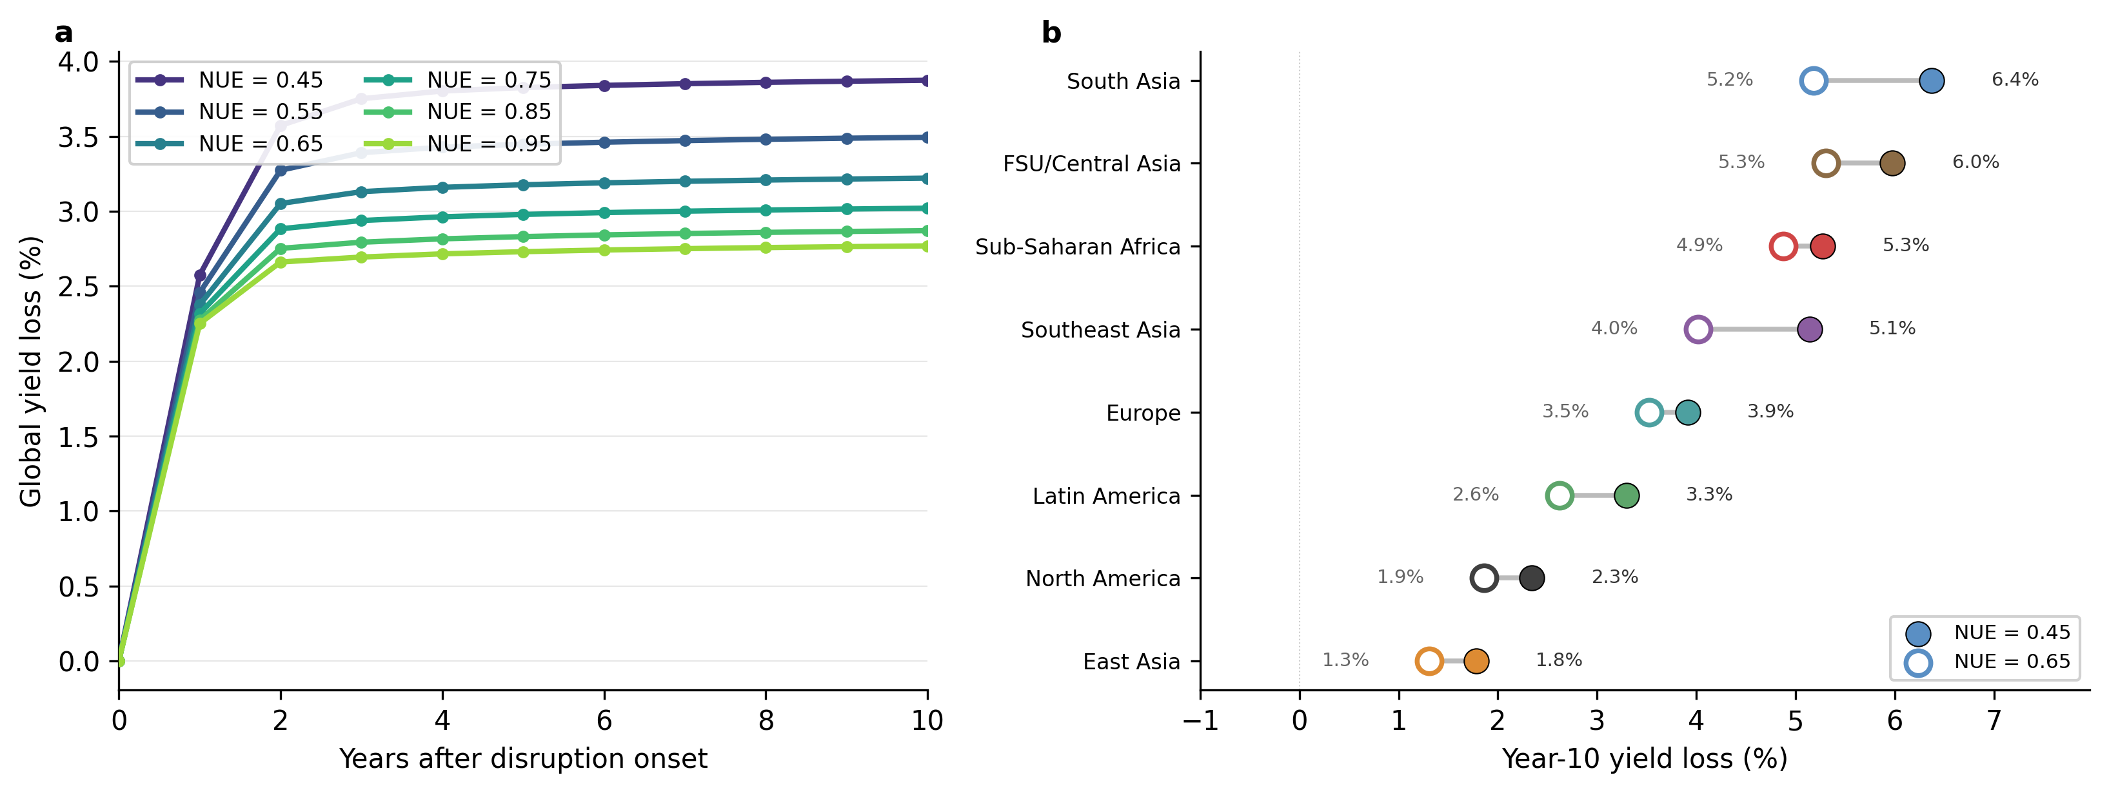
Supplementary Figure S10. In-season N capture, an NUE component, as a buffering lever. Monthly N uptake capture efficiency represents the in-season mineral-N capture component of NUE, not total field-scale NUE: the model’s baseline value of 0.75 corresponds to an effective seasonal NUE of approximately 55% because crop demand and mineral N availability are not perfectly synchronised within the growing season, and other field-scale NUE components (e.g., gaseous and leaching losses outside the capture window) are represented elsewhere in the N balance. a, Global production-weighted yield loss trajectories under the sustained S3 price-shock scenario (a +104% fertilizer price shock calibrated to produce an approximately 20% fertilizer-use reduction under S1; with ε_F,N active,the realized reduction under S3 averages approximately 19% over the sustained-disruption period) at six monthly N uptake capture efficiency levels (0.45–0.95). b, Regional yield loss at year 10 across the monthly N uptake capture efficiency range. Dumbbell spans from monthly N uptake capture efficiency = 0.95 (blue) to monthly N uptake capture efficiency = 0.45 (red); diamond marks monthly N uptake capture efficiency = 0.65. The first 20-point improvement (0.45–0.65) captures 59% of the achievable reduction in global year-10 yield loss, and lowers the Sub-Saharan African year-10 loss from 5.3% to 4.9%, an approximately 8% reduction. The panel resolves the monthly N uptake capture efficiency lever at each region’s mean SOC and does not vary SOC.

Supplementary Figure S11: SOC gradient widens with price shock severity
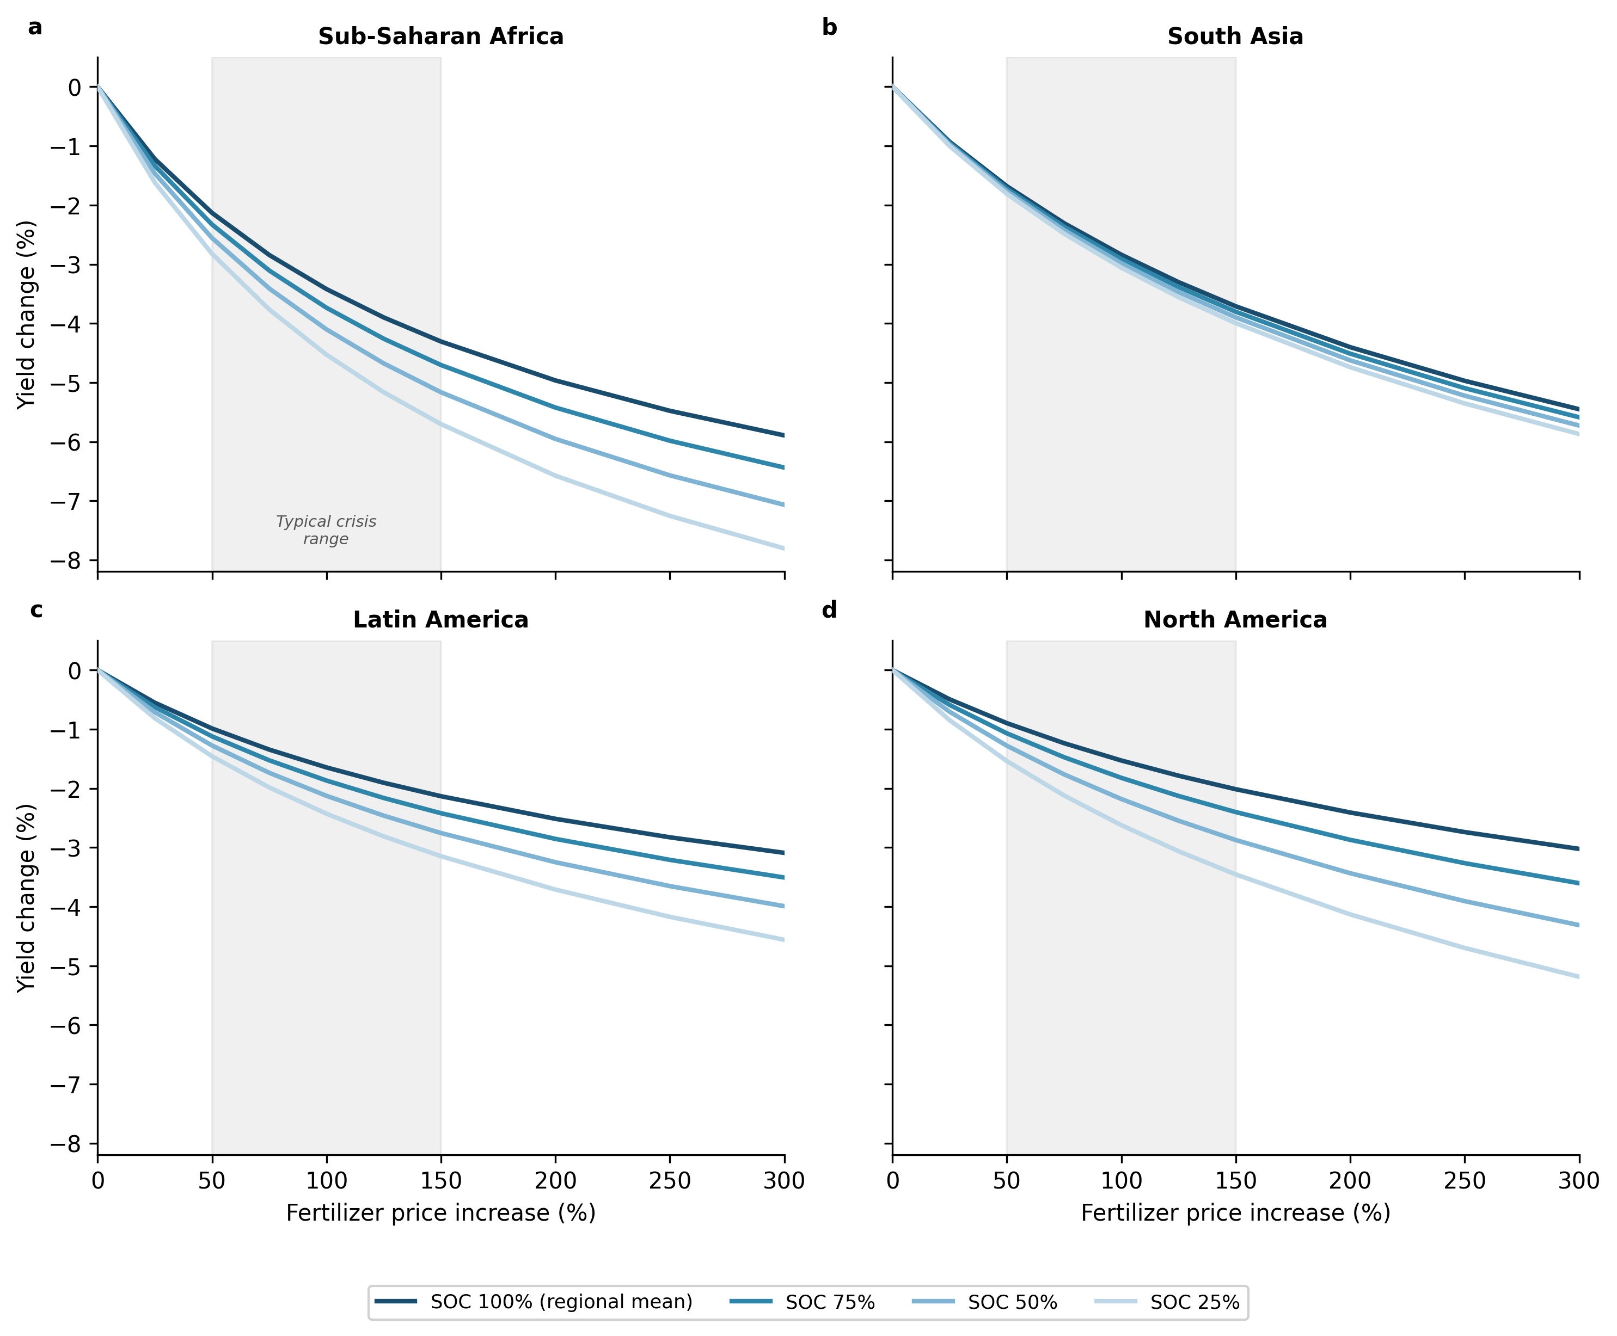
Supplementary Figure S11. SOC gradient widens with price shock severity. Yield loss curves across fertilizer price increases (0–300%) for four SOC levels (25%, 50%, 75%, 100% of regional mean) in each of four regions. Y-axes are standardized across panels for direct cross-regional comparison. Gray shading: typical crisis range (50–150% price increase).The spread between SOC 25% and 100% is 0.1–1.5 percentage points across the typical crisis range and widens to 0.4–2.2 percentage points at a 300% price increase, with the steepest separation in North America and Sub-Saharan Africa.

Supplementary Note 8: Model verification and reproducibility
The deposited model carries built-in verification tests that guard its internal consistency, and every number reported in the manuscript, in this Supplementary Information and in the deposited figures regenerates from the deposited code.
The spin-up applies the same baseline water-stress multiplier that the simulation applies at zero SOC change, so the pool configuration handed to each run is a fixed point of the simulation's own dynamics, and the mineralization baseline is normalized to the year-0 recorded mineralization, which sets the normalized mineralization anomaly to zero at t = 0 by construction. A zero-shock invariance test is included in the reproducibility deposit: with the shock set to zero, every region must remain at its baseline yield; it passes with year-10 yield ratios of at least 0.9998 in all eight regions.
When the physical fertilizer supply ceiling binds, the constrained equilibrium is solved subject to the ceiling inside the market-clearing residual, and a market-clearing test in the deposit verifies structural consistency at every timestep of every published run (clearing residual below 10⁻⁸).

The low-SOC end of main-text figure 2a carries a caveat that applies to any ten-year gradient of this kind. A farm rescaled to 10 percent of regional mean SOC is far from SOM equilibrium, so over ten years its pools rebuild, its mineralization rises above its own year-0 baseline, and the fertilizer-demand response to mineral N reduces fertilizer use. In Sub-Saharan Africa at 10 percent of regional mean SOC, mineralization supplies 11.3 kg N ha⁻¹ by year 10 against roughly 2 to 3 kg N ha⁻¹ of fertilizer, so fertilizer is a small share of the nitrogen supply and a proportional cut costs proportionally less yield. The low-SOC end of that panel is therefore a joint statement about shock exposure and about ten-year SOM relaxation. No supply cap binds anywhere along the gradient.
The generators for every figure and table — main-text figures 1 and 2, the Monte Carlo ensemble of Note 6 and Supplementary Figure S9, the halved-elasticity farm gradient of Supplementary Figure S7, the monthly N uptake capture efficiency sweep of Supplementary Figure S10, the severity sweep of Supplementary Figure S11, and the regional food-price response quoted above — are part of the reproducibility deposit, which declares each artifact and its generator in a build graph and verifies a register of every quoted number against its generating artifact. The Monte Carlo ensemble and every sweep run on the same ERA5 forcing as the canonical run.
The microbially-explicit 4-pool engine behind Supplementary Note 2, Supplementary table 2 and Supplementary Figure S5 is likewise part of the deposit and regenerates through the same build graph, running the same ERA5 forcing, market clearing and calibration path as the Century engine.
Additional supplementary figures and tables
Supplementary Table S4. Regional crop nitrogen-response calibration.
Region | FAOSTAT y_obs (t/ha) | N_current (kg/ha) | N no-synth (kg/ha) | y_max (t/ha) | c | Floor (t/ha) | y(no-synth) sim (t/ha)
N America | 5.5 | 223.9 | 147.9 | 6.198 | 0.015 | 1.10 | 3.71
Europe | 5.0 | 210.1 | 125.1 | 6.022 | 0.015 | 1.00 | 2.29
E Asia | 6.0 | 355.0 | 105.0 | 6.220 | 0.015 | 0.90 | 3.13
S Asia | 3.2 | 186.5 | 76.5 | 3.773 | 0.015 | 0.50 | 1.83
SE Asia | 4.2 | 185.5 | 96.5 | 4.874 | 0.015 | 1.20 | 3.03
L America | 4.5 | 183.6 | 133.6 | 5.414 | 0.015 | 0.90 | 3.43
Sub-Saharan Africa | 1.5 | 37.7 | 30.7 | 3.967 | 0.015 | 0.40 | 1.29
FSU/C Asia | 2.8 | 143.0 | 105.0 | 4.318 | 0.015 | 0.90 | 1.69
y_max is calibrated per region to the FAOSTAT current yield at current N availability; c = 0.015 is a fixed cross-regional constant; the floor is the empirical long-term depleted-soil lower bound (not the control target); y(no-synth) sim is the simulated year-2 zero-synthetic-N yield with contemporary SOC mineralization and BNF.

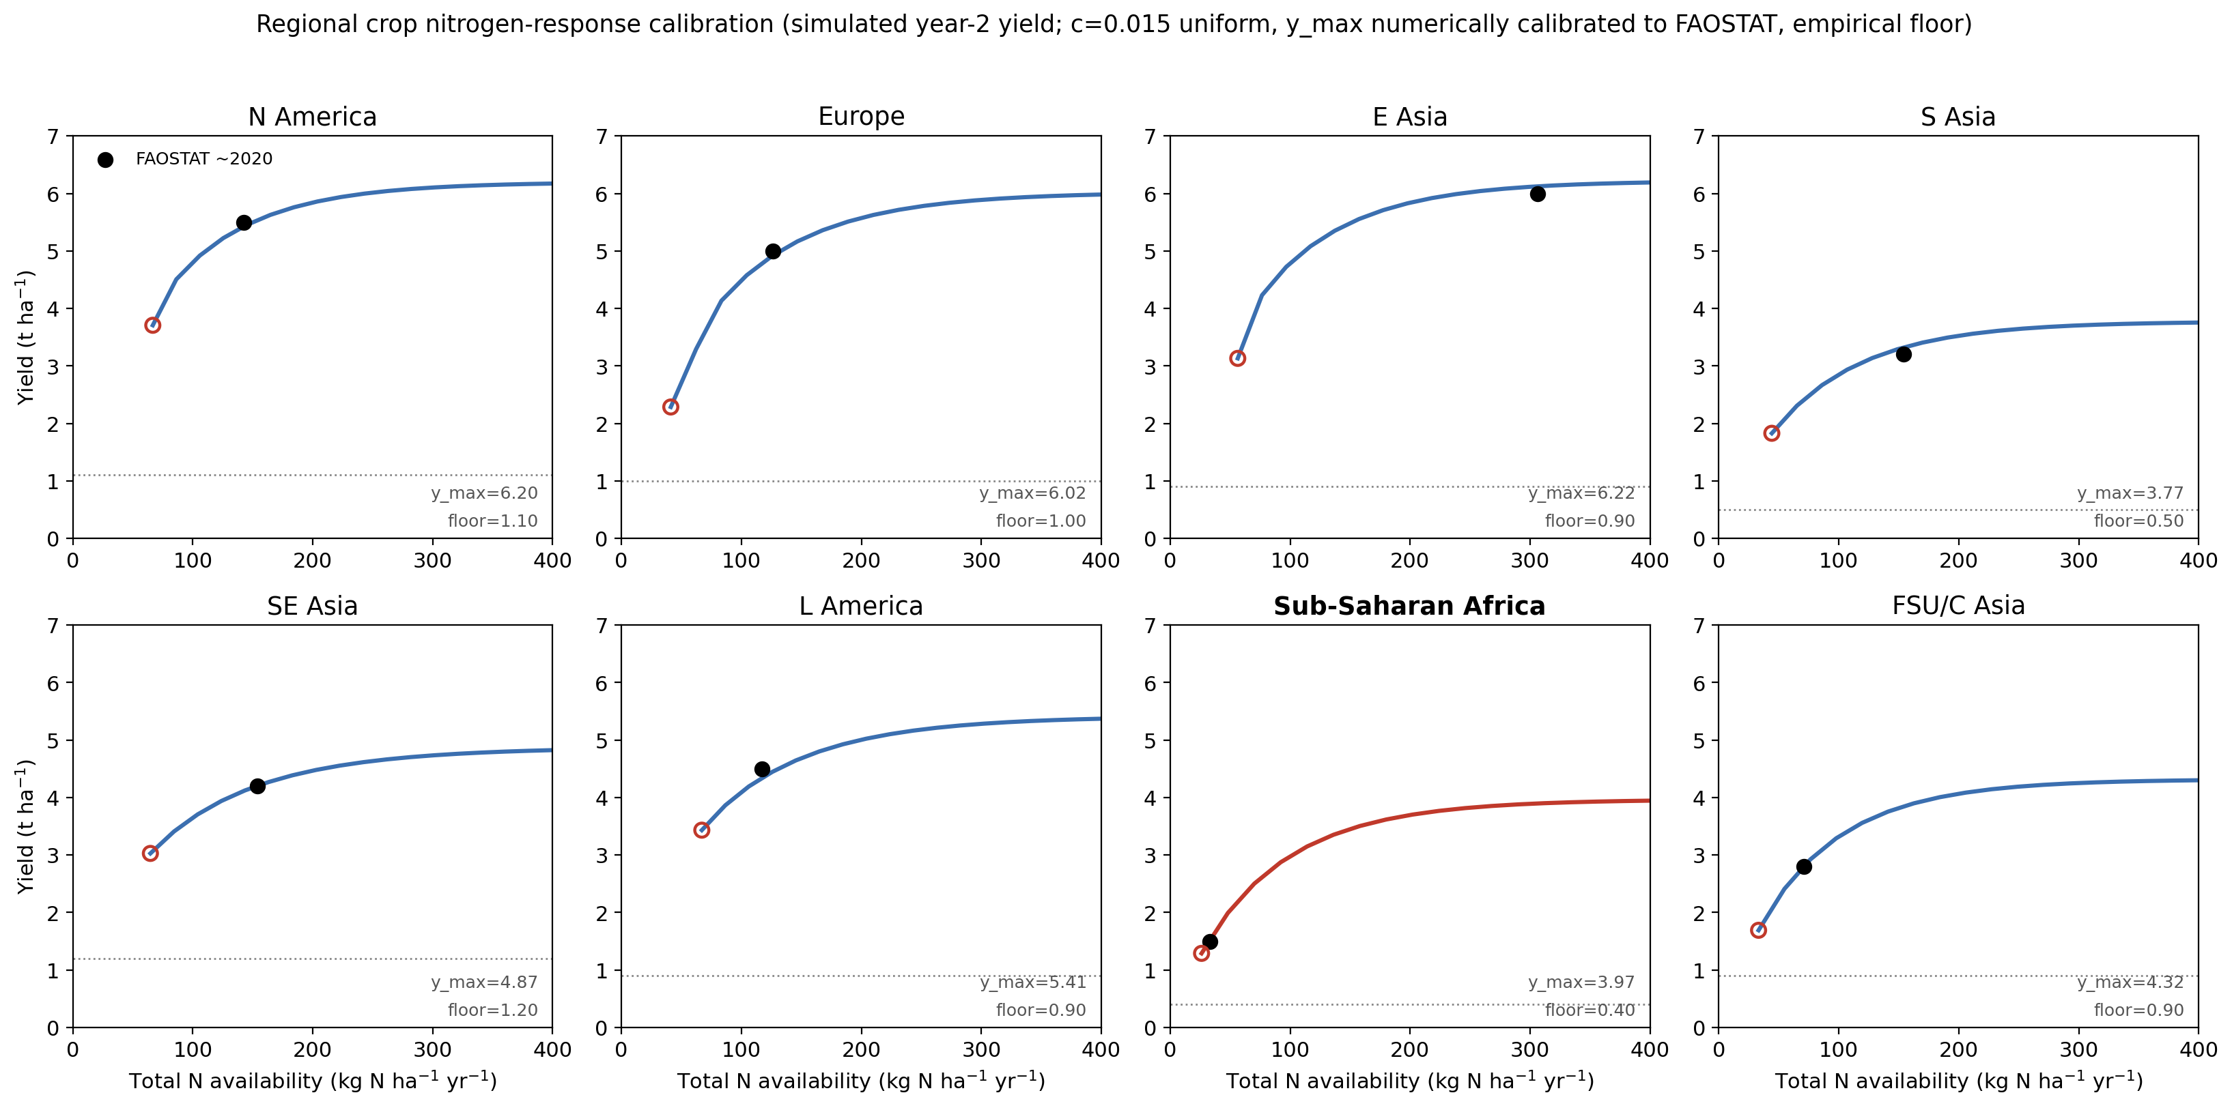
Supplementary Figure S12. Regional crop nitrogen-response calibration: each region’s Mitscherlich curve with its FAOSTAT calibration anchor (filled) and empirical floor (dotted). c = 0.015 uniform; regional y_max carries the differences.

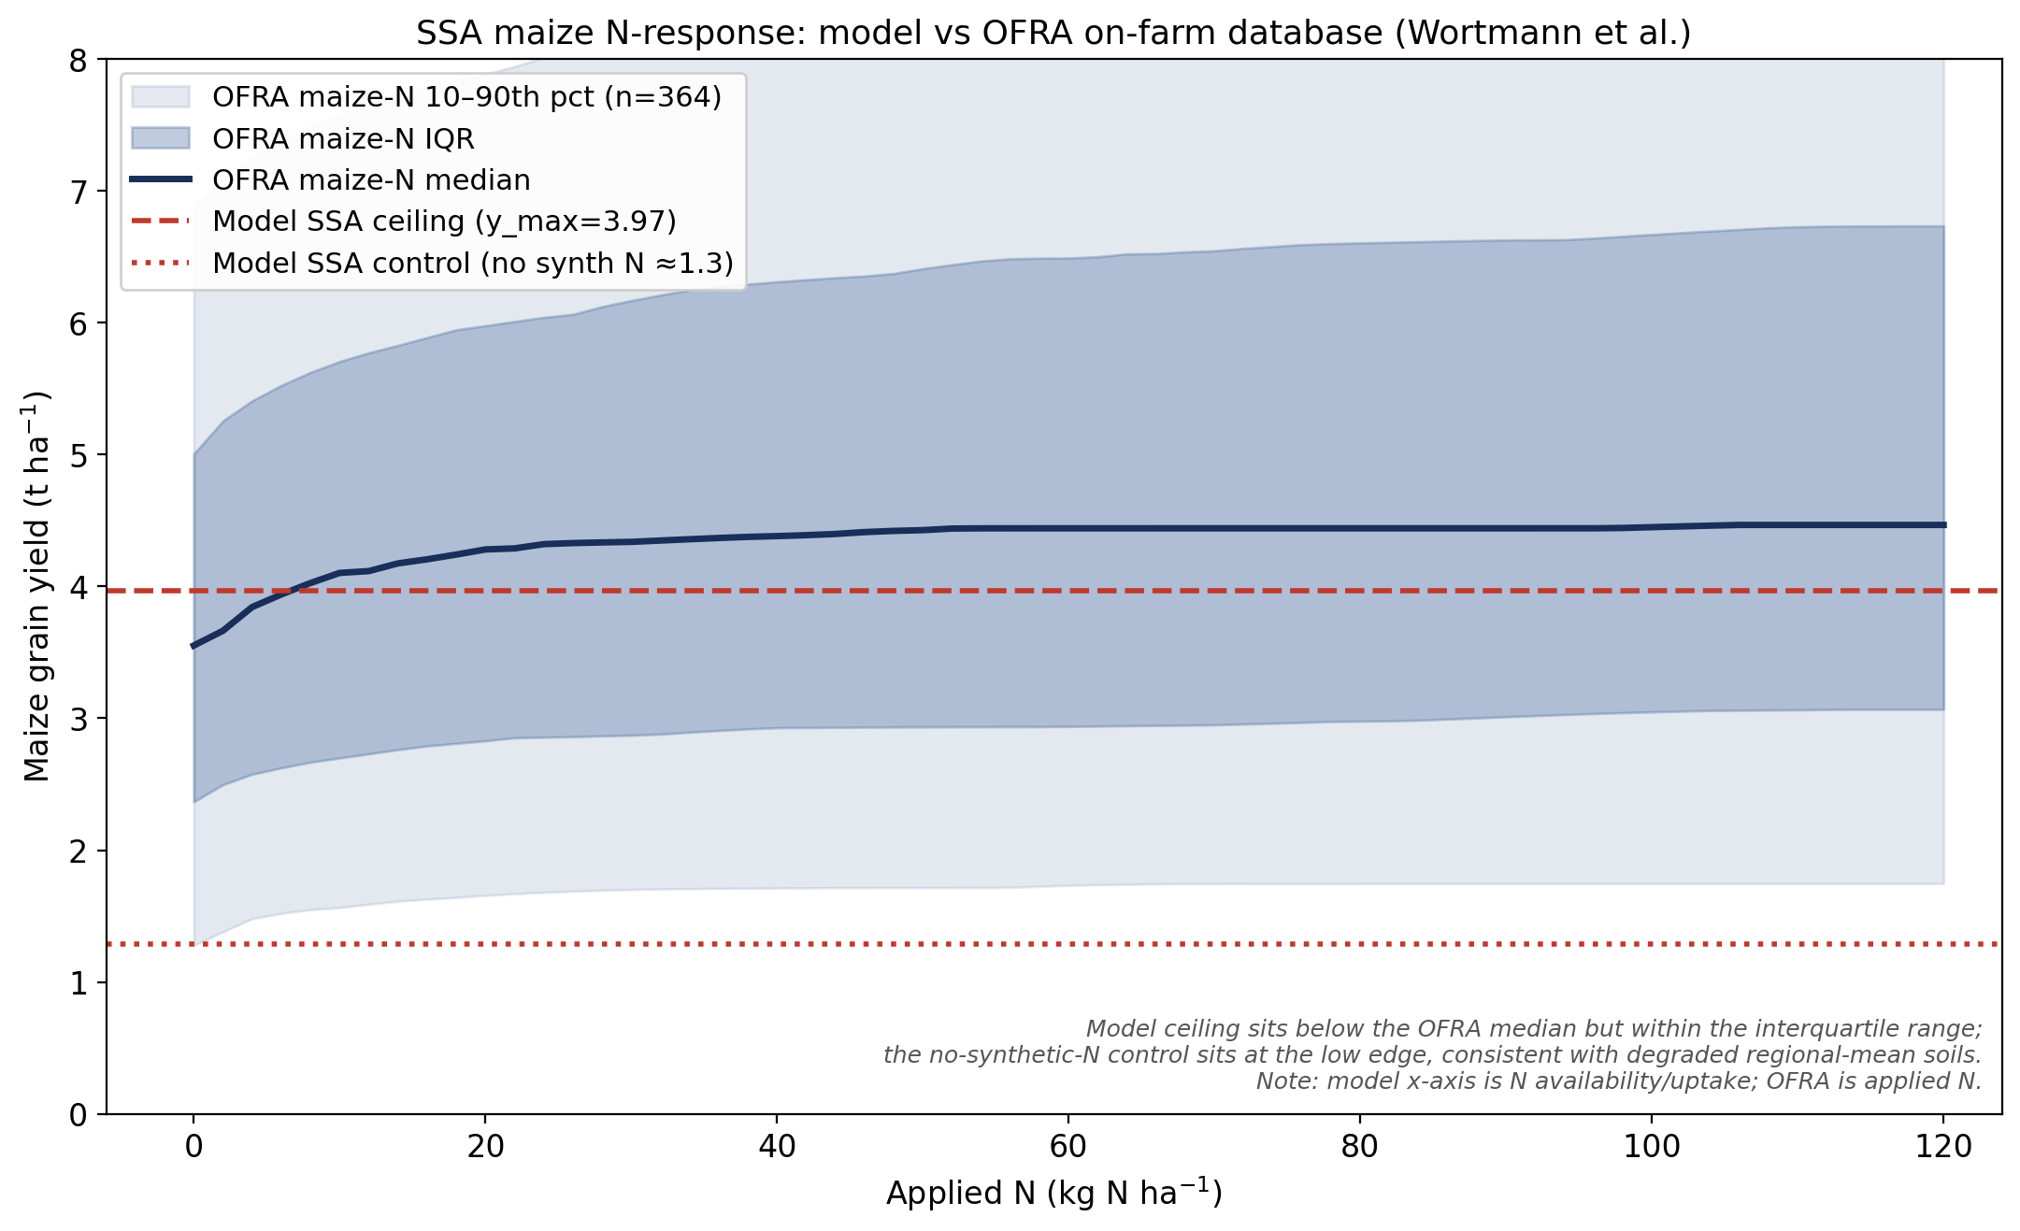
Supplementary Figure S13. Sub-Saharan African maize nitrogen-response validation against the OFRA on-farm database (364 maize-N response functions; Wortmann et al. 2017). The modelled SSA ceiling falls below the observed ceiling median but within the interquartile range; the control falls at the low edge of the observed envelope. Note: model x-axis is N availability/uptake; OFRA is applied N.

Supplementary References
References 1–37 are listed in the main manuscript.
[38] Herridge D F, Peoples M B and Boddey R M 2008 Global inputs of biological nitrogen fixation in agricultural systems Plant Soil 311 1–18 (doi: 10.1007/s11104-008-9668-3)
[39] Portmann F T, Siebert S and Döll P 2010 MIRCA2000 – Global monthly irrigated and rainfed crop areas around the year 2000: a new high-resolution data set for agricultural and hydrological modeling Glob. Biogeochem. Cycles 24 GB1011 (doi: 10.1029/2008GB003435)
[41] Sacks W J, Deryng D, Foley J A and Ramankutty N 2010 Crop planting dates: an analysis of global patterns Glob. Ecol. Biogeogr. 19 607–20 (doi: 10.1111/j.1466-8238.2010.00551.x)

