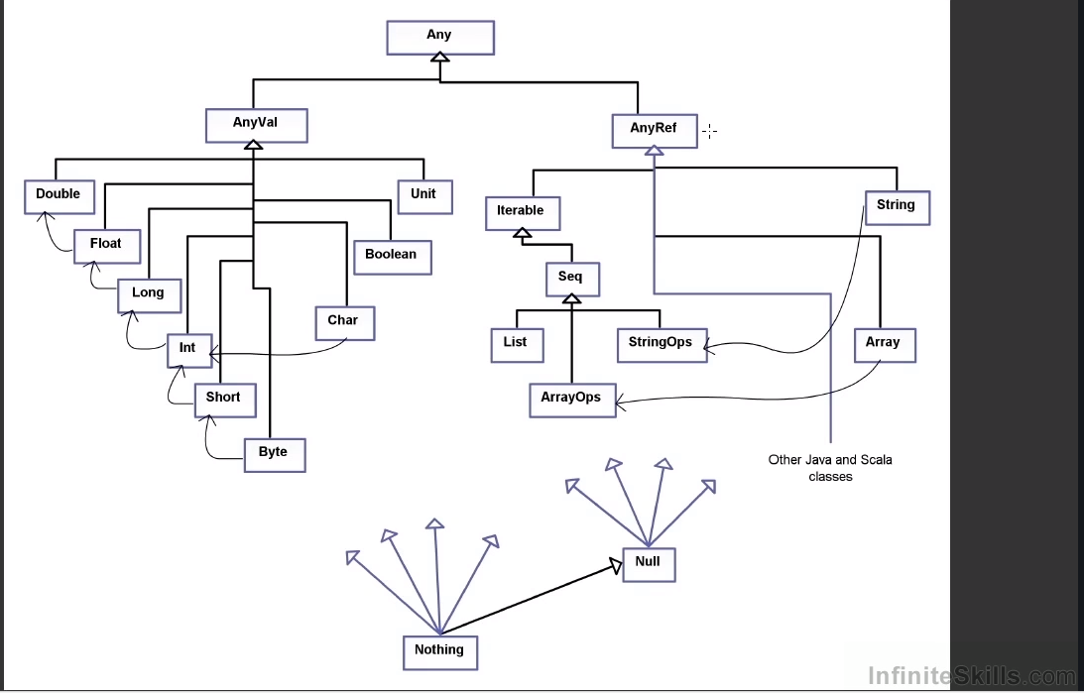

() is equivalent of void.

“Nothing” is a subtype of absolutely everything.