Python API Tutorial: Getting Started with APIs

API stands for "Application Programming Interface." In simple terms, it's a set of rules and protocols that allow how different software applications can communicate and interact with each other. APIs define the methods and data formats that applications can use to request and exchange information. To retrieve data from a web server, a client application initiates a request, and the server responds with the requested data.
APIs act as bridges that enable the smooth exchange of data and functionality, enhancing interoperability across various applications. Let's learn about how to work with APIs in Python.

Making API Requests in Python
In order to work with APIs, some tools are required, such as requests module and we need to first install them in our system.
Command to install 'requests':
pip install requests
Once we have installed it, we need to import it in our code to use it.
Command to import 'requests':
import requests

Example 1: Fetching Live Stock Price
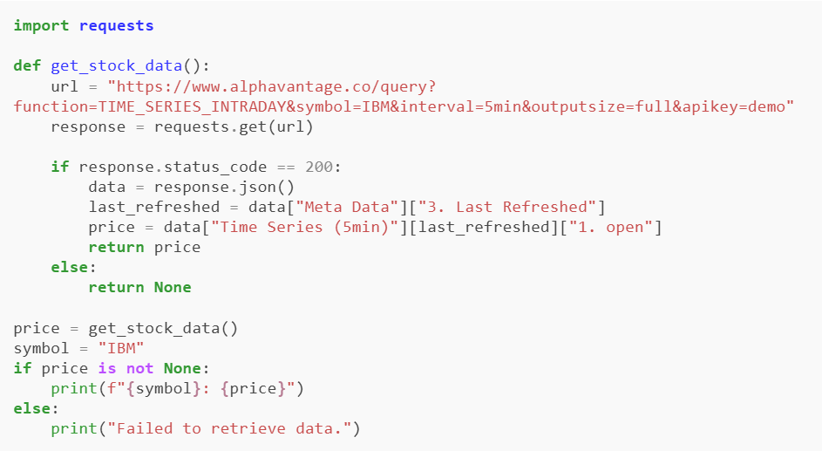

Explanation:
- Sends a GET request to Alpha Vantage API.
- Checks if the request was successful (status_code == 200).
- Parses JSON response to extract latest opening stock price.
- Prints the price or error message.

Think of an API as a digital waiter: your Python code orders specific data (like weather updates or stock prices), the API takes that request to a server, and then it delivers the response back to your program.

Key API Concepts to Know
- Endpoint: The specific URL where the API receives requests (e.g., /api/v1/users).
- HTTP Methods: Actions you want to perform, such as GET (fetch data), POST (send/create data), PUT (update data), and DELETE (remove data).
- JSON: JavaScript Object Notation, the standard, dictionary-like text format used to transmit data over APIs.
- API Key: A unique password or token used to authenticate your script so the provider knows who is accessing their system.

