FUNduro volunteer hours

MVP Features

1. User posts volunteer hours
2. User gets list of instances
3. User gets sum of categorized hours
4. User gets sum of all volunteer hours by category YTD

Wireframe

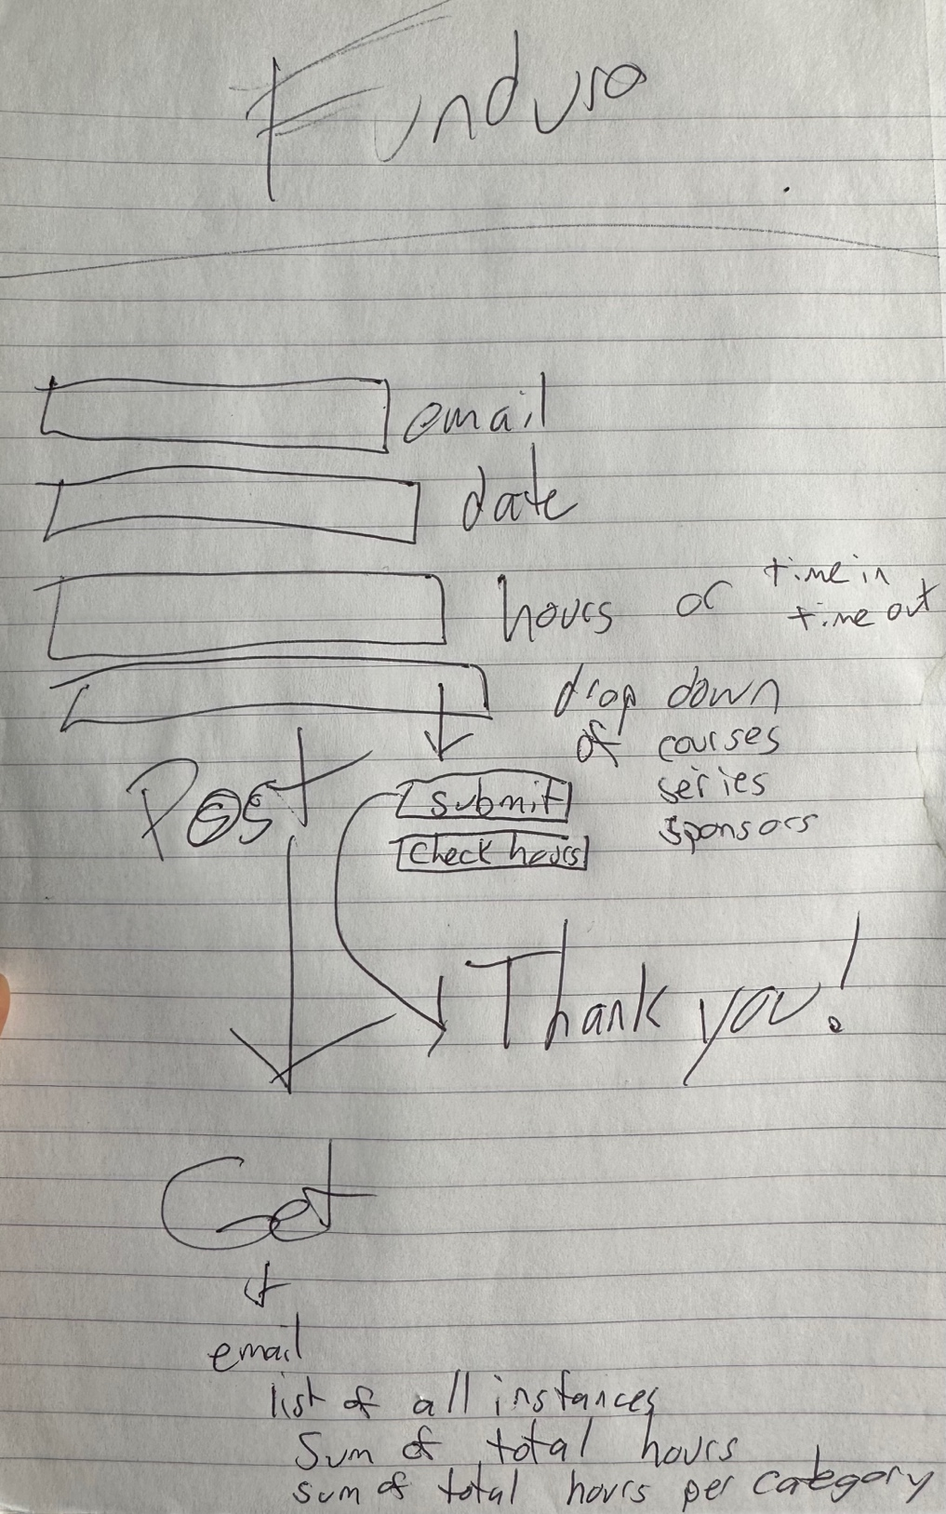

Coding to-do list

1. Create the UI landing page HTML, CSS, and .js in public directory
2. Setup a controller and index .js in the server directory
3. Build HTML for user to check hours by inputting their email and clicking “check hours”
4. Style the page with CSS
5. Write the code to execute “check hours” in front and back end
6. Design and seed the database
7. Connect the database to the server
8. Sequelize code to get user instances, user total hours, and sum of all hours per category for all users and sum of all hours from the categorized list
9. Build HTML for user to add date, hours(or time in: time out), and a drop down selector for category of hours
10. Write the code to execute “submit hours” in front and back end
11. Polish