MiniCPM3Attention MLA原文复现

1. 实现kv-cache的真正压缩（与原始相比压缩了20倍）
2. 实现矩阵的融合(qk_nope_merge)

首先要实现权重的转换，将原始的矩阵进行拆分，构造qk_merge_nope, q_b_rope和v_b

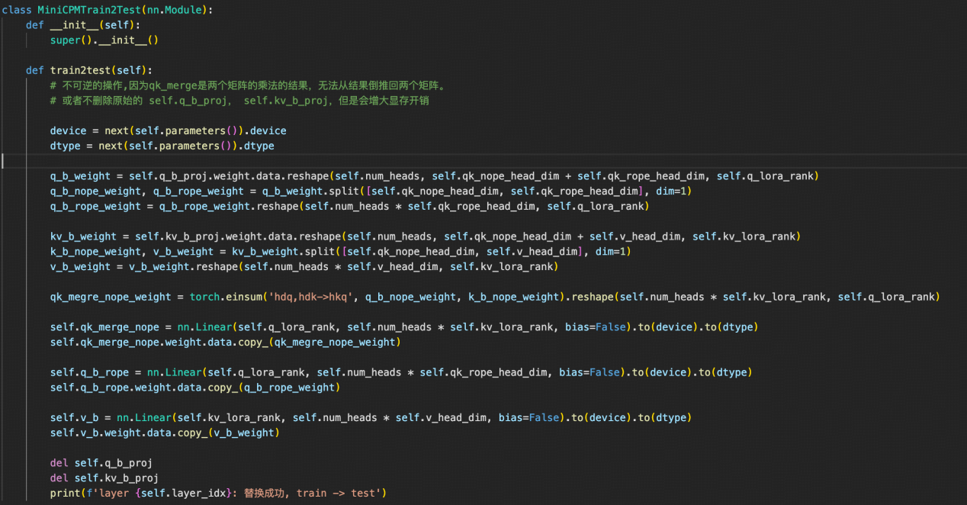

重写forward方法，主要实现

1. 存储压缩的kv以及key_rope_states
2. 两次attn_score的计算，然后进行加法（类似mlp的tp）

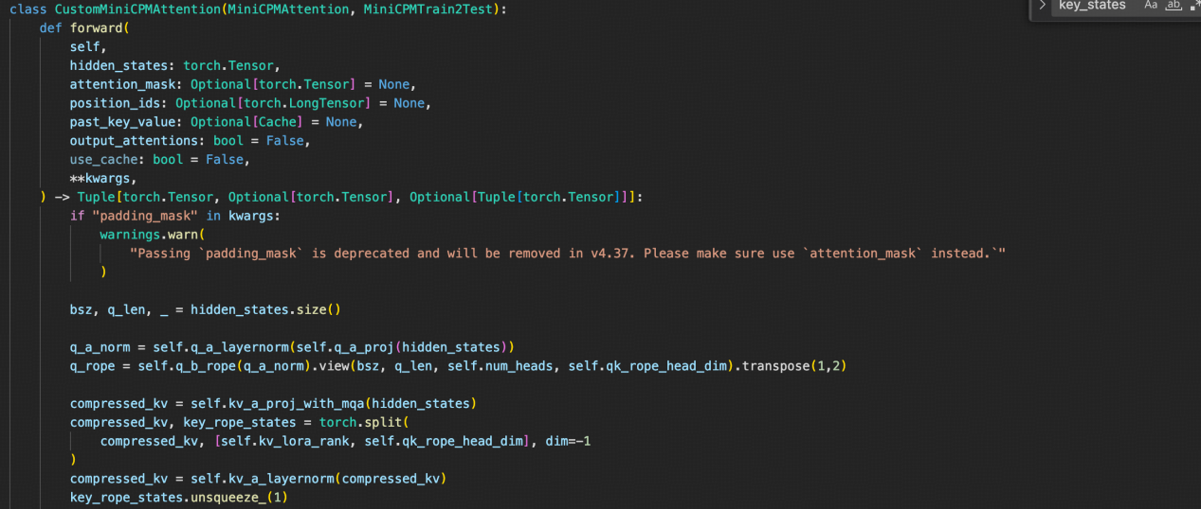

在此段之后的forward代码就一样了

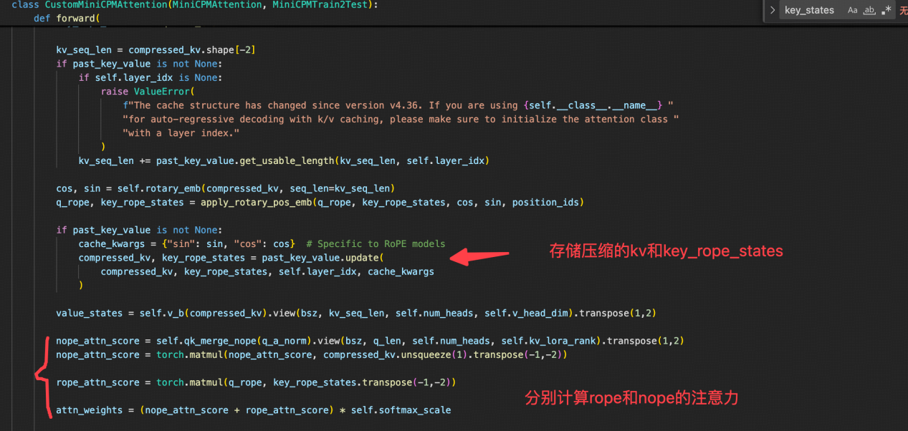

原始代码更改

主要适配新增加的Attention模块

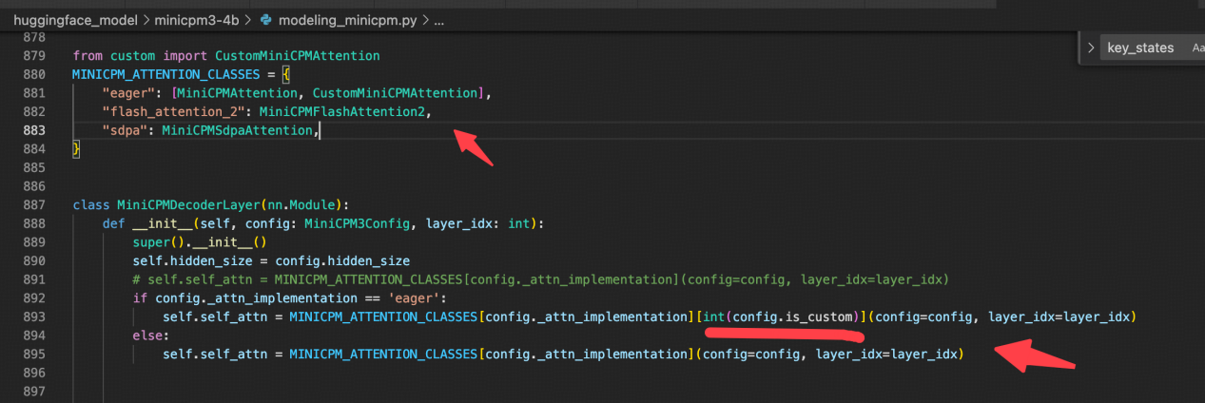

性能测试

1. 测试两种attention的输出，主要验证模型权重的转换是否正确

示例代码

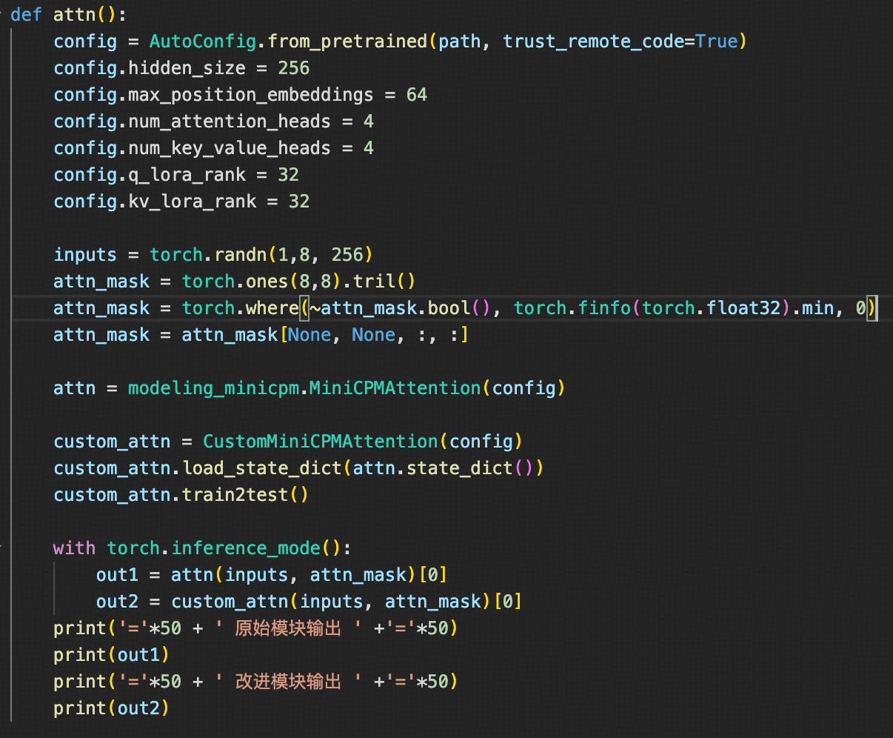

结果正确，说明权重转换没问题

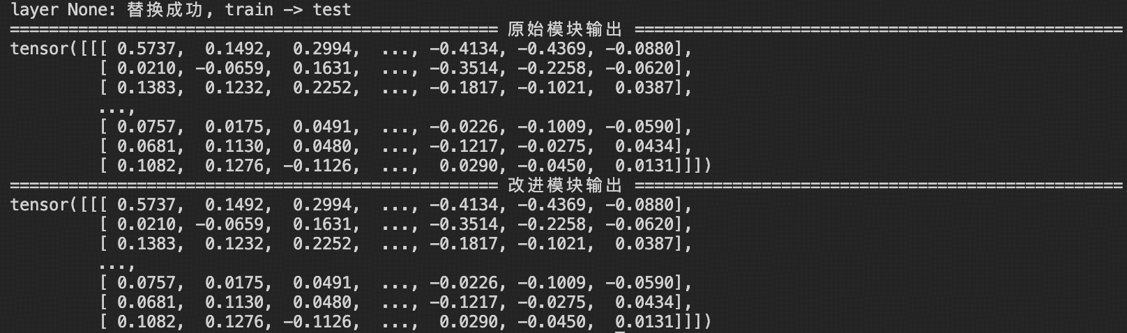

推理代码

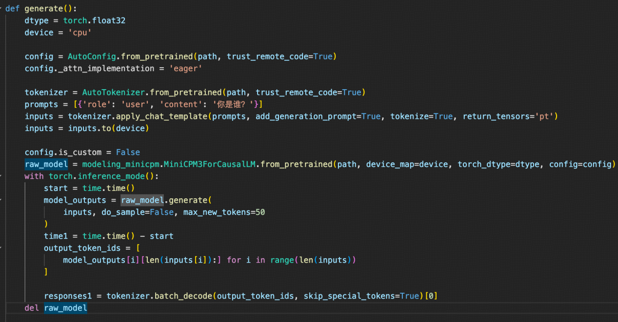

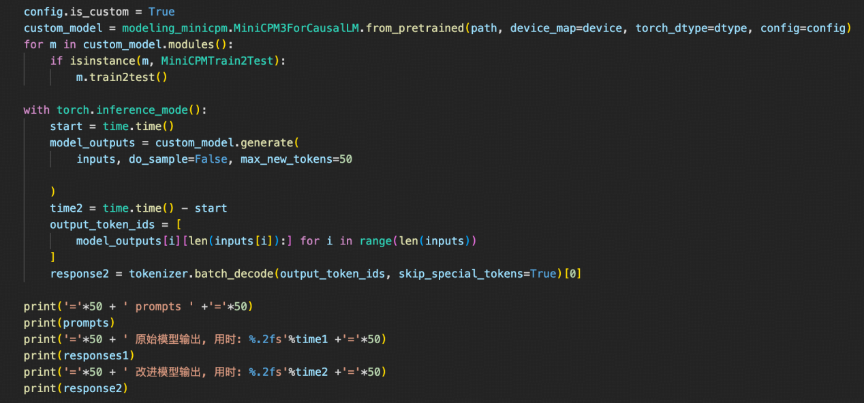

CPU&FP32实验结果

输出一致，速度有快有慢，QAQ。





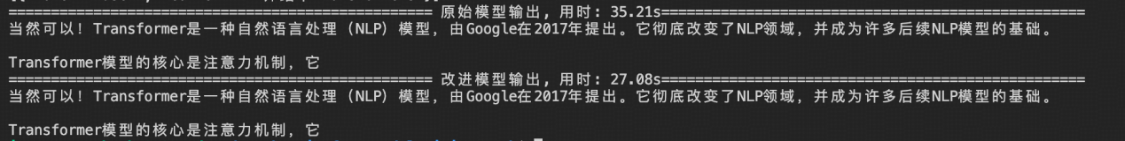

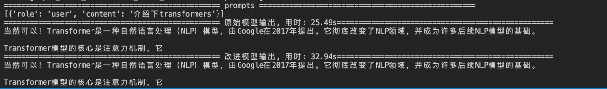

笔记本4080&BF16 实验结果

输出速度对比

raw vs custom

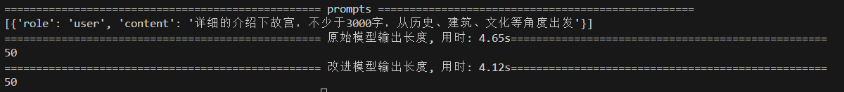



# 下面的例子可能不够充分，flash-attn2可能对更长的序列更占优势，由于4080显卡只有12G显存，无法充分实验。500token的情况下，速度基本一致

Flash-attn2 vs custom



Sdpa vs custom



细节分析

1. kv cache节省分析，minicpm3_config如下

num_head = 40

num_kv_head = 40

v_head_dim = 64

k_head_dim = qk_nope_dim + qk_rope_dim = 96

kv_lora_rank = 256

单个token单层的内存消耗量(bf16 or fp16)

raw_mem = (40 * 64 + 40 * 96) * 2

custom_mem = (256 + 64) * 2

save_rate = raw_mem / custom_mem = 20

因此改进后，kv-cache的开销减少20倍

1. 计算换内存

细心的coder们应该发现了，难道使用推理模式下的mla，可以大大节省显存，就没有缺点吗？其实解码时，每次前向都需要将历史压缩的kv取出来，然后将全部的kv全部进行一次升维的映射（是不是感觉这样等于又没有使用kv_cache啊， 叫它“半”cache吧，毕竟只有attn的部分操作需要取出全部，embeding和mlp不需要）。

1. 实际上模型的参数增加了一些

这个merge操作增加了参数





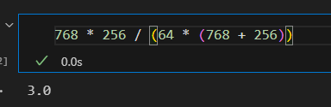

总结

主要是在原始attention的基础上进行修改，复现了论文中MLA的操作，而flash-attn和sdpa，得到输出结果是经过softmax处理后，是非线性变化，无法进行reduce操作得到真实值，可能在推理速度上不如它们快，但是绝对是省显存的。由于本人能力有限，不会写C++和CUDA，事实上，nope和rope的操作是可以同时进行的，充分发挥GPU的并行，可以进一步提升效果。

附件

#custom.py  
from typing import Any, Dict, Tuple

from torch import Tensor

from modeling_minicpm import *

class MiniCPMTrain2Test(nn.Module):

def __init__(self):

super().__init__()

def train2test(self):

# 不可逆的操作,因为qk_merge是两个矩阵的乘法的结果，无法从结果倒推回两个矩阵。

# 或者不删除原始的 self.q_b_proj， self.kv_b_proj，但是会增大显存开销

device = next(self.parameters()).device

dtype = next(self.parameters()).dtype

q_b_weight = self.q_b_proj.weight.data.reshape(self.num_heads, self.qk_nope_head_dim + self.qk_rope_head_dim, self.q_lora_rank)

q_b_nope_weight, q_b_rope_weight = q_b_weight.split([self.qk_nope_head_dim, self.qk_rope_head_dim], dim=1)

q_b_rope_weight = q_b_rope_weight.reshape(self.num_heads * self.qk_rope_head_dim, self.q_lora_rank)

kv_b_weight = self.kv_b_proj.weight.data.reshape(self.num_heads, self.qk_nope_head_dim + self.v_head_dim, self.kv_lora_rank)

k_b_nope_weight, v_b_weight = kv_b_weight.split([self.qk_nope_head_dim, self.v_head_dim], dim=1)

v_b_weight = v_b_weight.reshape(self.num_heads * self.v_head_dim, self.kv_lora_rank)

qk_megre_nope_weight = torch.einsum('hdq,hdk->hkq', q_b_nope_weight, k_b_nope_weight).reshape(self.num_heads * self.kv_lora_rank, self.q_lora_rank)

self.qk_merge_nope = nn.Linear(self.q_lora_rank, self.num_heads * self.kv_lora_rank, bias=False).to(device).to(dtype)

self.qk_merge_nope.weight.data.copy_(qk_megre_nope_weight)

self.q_b_rope = nn.Linear(self.q_lora_rank, self.num_heads * self.qk_rope_head_dim, bias=False).to(device).to(dtype)

self.q_b_rope.weight.data.copy_(q_b_rope_weight)

self.v_b = nn.Linear(self.kv_lora_rank, self.num_heads * self.v_head_dim, bias=False).to(device).to(dtype)

self.v_b.weight.data.copy_(v_b_weight)

del self.q_b_proj

del self.kv_b_proj

print(f'layer {self.layer_idx}: 替换成功, train -> test')

if torch.cuda.is_available():

torch.cuda.empty_cache()

class CustomMiniCPMAttention(MiniCPMAttention, MiniCPMTrain2Test):

def forward(

self,

hidden_states: torch.Tensor,

attention_mask: Optional[torch.Tensor] = None,

position_ids: Optional[torch.LongTensor] = None,

past_key_value: Optional[Cache] = None,

output_attentions: bool = False,

use_cache: bool = False,

**kwargs,

) -> Tuple[torch.Tensor, Optional[torch.Tensor], Optional[Tuple[torch.Tensor]]]:

if "padding_mask" in kwargs:

warnings.warn(

"Passing `padding_mask` is deprecated and will be removed in v4.37. Please make sure use `attention_mask` instead.`"

)

bsz, q_len, _ = hidden_states.size()

q_a_norm = self.q_a_layernorm(self.q_a_proj(hidden_states))

q_rope = self.q_b_rope(q_a_norm).view(bsz, q_len, self.num_heads, self.qk_rope_head_dim).transpose(1,2)

compressed_kv = self.kv_a_proj_with_mqa(hidden_states)

compressed_kv, key_rope_states = torch.split(

compressed_kv, [self.kv_lora_rank, self.qk_rope_head_dim], dim=-1

)

compressed_kv = self.kv_a_layernorm(compressed_kv)

key_rope_states.unsqueeze_(1)

kv_seq_len = compressed_kv.shape[-2]

if past_key_value is not None:

if self.layer_idx is None:

raise ValueError(

f"The cache structure has changed since version v4.36. If you are using {self.__class__.__name__} "

"for auto-regressive decoding with k/v caching, please make sure to initialize the attention class "

"with a layer index."

)

kv_seq_len += past_key_value.get_usable_length(kv_seq_len, self.layer_idx)

cos, sin = self.rotary_emb(compressed_kv, seq_len=kv_seq_len)

q_rope, key_rope_states = apply_rotary_pos_emb(q_rope, key_rope_states, cos, sin, position_ids)

if past_key_value is not None:

cache_kwargs = {"sin": sin, "cos": cos} # Specific to RoPE models

compressed_kv, key_rope_states = past_key_value.update(

compressed_kv, key_rope_states, self.layer_idx, cache_kwargs

)

value_states = self.v_b(compressed_kv).view(bsz, kv_seq_len, self.num_heads, self.v_head_dim).transpose(1,2)

nope_attn_score = self.qk_merge_nope(q_a_norm).view(bsz, q_len, self.num_heads, self.kv_lora_rank).transpose(1,2)

nope_attn_score = torch.matmul(nope_attn_score, compressed_kv.unsqueeze(1).transpose(-1,-2))

rope_attn_score = torch.matmul(q_rope, key_rope_states.transpose(-1,-2))

attn_weights = (nope_attn_score + rope_attn_score) * self.softmax_scale

if attn_weights.size() != (bsz, self.num_heads, q_len, kv_seq_len):

raise ValueError(

f"Attention weights should be of size {(bsz, self.num_heads, q_len, kv_seq_len)}, but is"

f" {attn_weights.size()}"

)

assert attention_mask is not None

if attention_mask is not None:

if attention_mask.size() != (bsz, 1, q_len, kv_seq_len):

raise ValueError(

f"Attention mask should be of size {(bsz, 1, q_len, kv_seq_len)}, but is {attention_mask.size()}"

)

attn_weights = attn_weights + attention_mask

# upcast attention to fp32

attn_weights = nn.functional.softmax(

attn_weights, dim=-1, dtype=torch.float32

).to(value_states.dtype)

attn_weights = nn.functional.dropout(

attn_weights, p=self.attention_dropout, training=self.training

)

attn_output = torch.matmul(attn_weights, value_states)

if attn_output.size() != (bsz, self.num_heads, q_len, self.v_head_dim):

raise ValueError(

f"`attn_output` should be of size {(bsz, self.num_heads, q_len, self.v_head_dim)}, but is"

f" {attn_output.size()}"

)

attn_output = attn_output.transpose(1, 2).contiguous()

attn_output = attn_output.reshape(bsz, q_len, self.num_heads * self.v_head_dim)

attn_output = self.o_proj(attn_output)

if not output_attentions:

attn_weights = None

return attn_output, attn_weights, past_key_value

#test.py

import modeling_minicpm

from transformers import AutoConfig, AutoTokenizer

from custom import *

import torch

import time

path = '/data/models/MiniCPM3-4B'

def attn():

config = AutoConfig.from_pretrained(path, trust_remote_code=True)

config.hidden_size = 256

config.max_position_embeddings = 64

config.num_attention_heads = 4

config.num_key_value_heads = 4

config.q_lora_rank = 32

config.kv_lora_rank = 32

inputs = torch.randn(1,8, 256)

attn_mask = torch.ones(8,8).tril()

attn_mask = torch.where(~attn_mask.bool(), torch.finfo(torch.float32).min, 0)

attn_mask = attn_mask[None, None, :, :]

attn = modeling_minicpm.MiniCPMAttention(config)

custom_attn = CustomMiniCPMAttention(config)

custom_attn.load_state_dict(attn.state_dict())

custom_attn.train2test()

with torch.inference_mode():

out1 = attn(inputs, attn_mask)[0]

out2 = custom_attn(inputs, attn_mask)[0]

print('='*50 + ' 原始模块输出 ' +'='*50)

print(out1)

print('='*50 + ' 改进模块输出 ' +'='*50)

print(out2)

def generate():

dtype = torch.bfloat16

device = 'cuda'

max_new_tokens = 500

config = AutoConfig.from_pretrained(path, trust_remote_code=True)

tokenizer = AutoTokenizer.from_pretrained(path, trust_remote_code=True)

prompts = [{'role': 'user', 'content': '详细的介绍下故宫，不少于3000字，从历史、建筑、文化等角度出发'}]

inputs = tokenizer.apply_chat_template(prompts, add_generation_prompt=True, tokenize=True, return_tensors='pt')

inputs = inputs.to(device)

#flash_attention_2

config._attn_implementation = 'flash_attention_2'

config.is_custom = False

raw_model = modeling_minicpm.MiniCPM3ForCausalLM.from_pretrained(path, device_map=device, torch_dtype=dtype, config=config)

raw_model.eval()

p1 = raw_model.num_parameters()

with torch.inference_mode():

torch.manual_seed(42)

start = time.time()

model_outputs = raw_model.generate(

inputs, do_sample=False, max_new_tokens=max_new_tokens

)

time1 = time.time() - start

output_token_ids1 = [

model_outputs[i][len(inputs[i]):] for i in range(len(inputs))

]

responses1 = tokenizer.batch_decode(output_token_ids1, skip_special_tokens=True)[0]

del raw_model

torch.cuda.empty_cache()

time.sleep(3)

config._attn_implementation = 'eager'

config.is_custom = True

custom_model = modeling_minicpm.MiniCPM3ForCausalLM.from_pretrained(path, device_map=device, torch_dtype=dtype, config=config)

for m in custom_model.modules():

if isinstance(m, MiniCPMTrain2Test):

m.train2test()

p2 = custom_model.num_parameters()

custom_model.eval()

with torch.inference_mode():

torch.manual_seed(42)

start = time.time()

model_outputs = custom_model.generate(

inputs, do_sample=False, max_new_tokens=max_new_tokens

)

time2 = time.time() - start

output_token_ids2 = [

model_outputs[i][len(inputs[i]):] for i in range(len(inputs))

]

response2 = tokenizer.batch_decode(output_token_ids2, skip_special_tokens=True)[0]

print(f'原始模型参数: {p1/1e9}B, 改进模型参数: {p2/1e9}B')

print('='*50 + ' prompts ' +'='*50)

print(prompts)

print('='*50 + ' 原始模型输出长度, 用时: %.2fs'%time1 +'='*50)

print(len(output_token_ids1[0]))

# print(responses1)

print('='*50 + ' 改进模型输出长度, 用时: %.2fs'%time2 +'='*50)

print(len(output_token_ids2[0]))

# print(response2)

if __name__ == '__main__':

generate()