Our e-statement index file has 2 formats. One, The current version: pipe delimited; this one you already know. Two, the old format: fixed length delimited.

The fixed length delimited index follows a similar format

•         1. AFP file name using 50 characters

•         2. Account number using the next 50 characters

•         3. Start date using the next 50 characters

•         4. End date using the next 50 characters

•         5. Total images using the next 50 characters

•         6. Account name using the next 50 characters.

For each CID, the applications will have an uniformed format (ie. all BFCU’s applications are using fixed length). For future reference, if you are unsure which format to use while creating JOB_TYPE == ‘f’ (estatement) please ask the person assigning the task. I forgot to check the format so this is my mistake.

2.       For date fields, we need to remove dashes before putting the value into writerecord (or remove while writing).

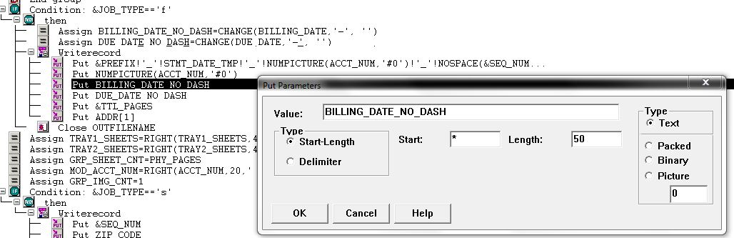

Thanks,