The project used in this tutorial: **UCCUMS11**

**Symiter**

# Data File:

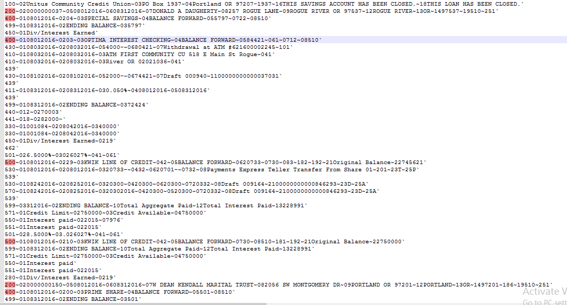

## Fields and Records:

* Each record is identified by the first field number (ex: 100, 200, 400…...)
* Each filed is separated by the ‘~’ character. First two number of each field uses as field no (Ex: 400~**01**08312016~**02**08312016~**05**00255; here 01, 02, 05 is the fields number) and the rest is data.
* Records and fields can be missing. Like there may be field no 01,02 than 04.
* Details information can of each fields and records can be found in the file: **Symitar_StatementDataOnlyFormat_Ref_2015_Dec.pdf**
* Also, see Mapping and Sow for more information about these fields.

## Mapping Example:

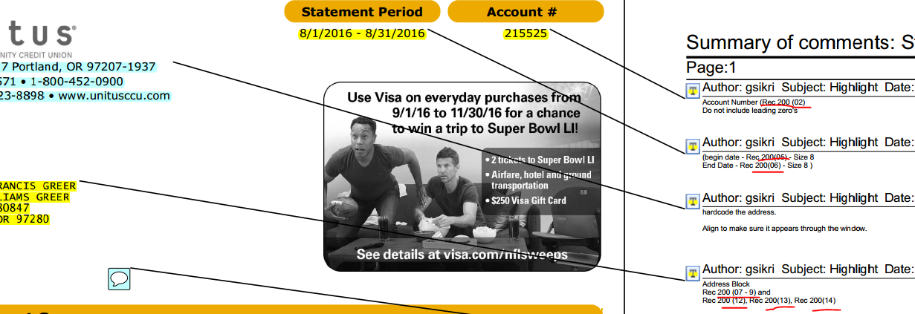

In this mapping are provide as “record line (field no)” EX: 200(07-9) means fields no 7,8,9 of record 200.

## Records(Most Used):

***100*** – One time record, generally holds information about that institution.

***200*** – Holds information about that user. All information of that customer is kept in between two 200 record. This means each 200 generates a new document. Each 200 holds at least one Deposit or Loan (400 or 500 records) account.

***400*** – Indicates a new Share/Deposit accounts. All information about that account is kept in between 400 and 499 record. There can be multiple or no Deposit or Saving account in a user.

(There can be several types of Deposit. Like Checking, saving etc. are Deposit accounts. There will be information about these in the mapping or SOW)

***430*** – Account Transactions

***410*** – Transaction’s Additional Description

***500*** – Same as 400, indicates a ‘Loan Account’.

# Data Extraction (Papyrus):

Before we start, You can implement you own login for data extraction. This is to demonstrate how I’ve done.

**Steps:**

1. Extract all share and loan accounts in a array.
2. Keep information about the start and ending line’s index of each account in another array. (Some time sorting can be implemented based on some criteria, you have to sort this array)
3. Also, there can be suppression logic. Based on some field value. Extract data and check before printing each account.
4. *DocFormat: FIELD_VAL_ALL*

INPUT : FIELDS_NO (‘,’ Delimited String)

: RECORD_LINE (The line to be processed)

OUTPUT : FIELDS_VALUE (Array)

**USAGE:**

RECORD_LINE =

FIELDS_NO = ‘1,2,5,7,9’

USE DOCFORMAT FIELD_VAL_ALL

FIELDS_VALUE [1] = (Value of 1 no field)

FIELDS_VALUE [5] = (Value of 5 no field)

FIELDS_VALUE [9] = (Value of 9 no field)