DSI Team,

Currently, the size of our resources is too big and causing issues for our eTax team.

We need you guys to help us compress the tax form backers for ALL of the standard tax forms.

When completed please provide me the PSEG, OVL, OGL and **the original TIFF used for creating the PSEG.**

I have created a list of the PSEGs below so it is easier to keep track:

S142S15B.300

S198E15B.300

S199M15B.300

S199B15B.300

S199Q15B.300

S199D15B.300

S109815B.300

S199O15B.300

S19SA15B.300

S18SA15B.300

S199C15B.300

S1ESA15B.300

S199A15B.300

S199S15B.300

S149815B.300

S199I15B.300

S199R15B.300

S1098152.300

S142S152.300

S142S153.300

S1498152.300

S198SA152.300

S199A152.300

S199B152.300

S199C152.300

S199D152.300

S199I152.300

S199O152.300

S199Q152.300

S199R152.300

S199S152.300

S19SA152.300

S198E152.300

S1ESA152.300

S18SA152.300

S199M152.300

Steps for compression:

1.       Use the Image Editor to Dither the image by going to **Image -> Dither** and changing the color to B/W

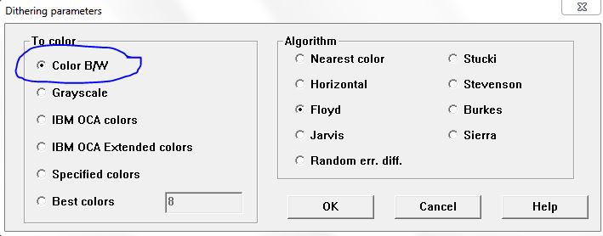

2.       When you save, make sure to use the following options:

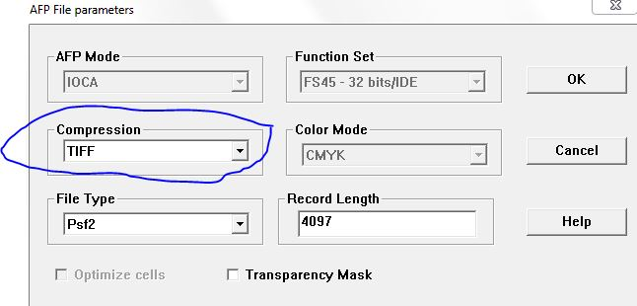

3.       Proceed with creating the OGL/OVL.

Since there are a lot of backers, **make sure you guys use the latest word doc** and double check them before sending them to me.

Let me know if you have any questions.

Thanks,

Kevin.

[KevinH.Yang@infoimageinc.com](mailto:KevinH.Yang@infoimageinc.com)