Hi DSI Team,

**Introduction:**

Every year near the end of the year (and January of next year) we have what we call “tax season”. The majority of our clients produce tax forms for their clients and we assist in formatting these forms. There are around 20 forms that we produce (but not all forms are used for every client). These forms change from year to year and we make modifications to accommodate these changes. There are also data specification changes and new clients that we must accommodate as well.

**Form Overlays:**

All of the forms consists of a front and a back. The front provides all amount values and account holder information in boxes. The back provides instructions for filling out the forms. These are constructed by overlays or PSEG & overlays. We produce standard and non-standard version of these. The standard is a 1/3 version of both the front and back forms on the bottom 1/3 of the perforated paper. The full-page non-standard is a full page version of the standard. There are also customized versions of the forms for some clients that are client specific.

**Current Action Item:**

I want you guys to work on the standard back pages for now.

This is the most straightforward part of taxes and is a good place to start.

Also, I am only include 4 of these to start as I don’t want to have the workload appear too overwhelming.

We refer to these forms as follows:

a.       1098

b.      1099INT

c.       1099A

d.      1099C

I have attached 2 sets of items.

1.       The PDF copies are from the IRS website. These should act as your point of reference for taxes. We base almost all forms from these. (1099INT.pdf, 1098.pdf, 1099A.pdf, 1099C.pdf)

2.       The Word documents are provided by our AC team and will be what you use to work with. (F1099intx.docx, F1098x.docx, F1099ax.docx, F1099cx.docx)

Instructions.

1.       Before starting, please help us double check that all the verbiage from the word documents match the PDF from the IRS website. All words from the back should match.

2.       Remove all highlights on the word documents.

3.       Create a PSEG from the word document. Usually we go from word -> PDF -> TIFF -> PSEG. Any combination that works is ok.

These PSEGs have a standard naming convention: S1<<3 letter form ID>><<2 letter year ID>><<F or B>>.300

Example: S199I15B.300. 99I = form ID, 15 = 2015, B for back.

As a first time, I will provide you the names to use for the PSEG. Use these names:

a)      1098 backer -> S109815B.300

**b)      1099INT backer ->S199I15B.300**

c)       1099A backer -> S199A15B.300

d)      1099B backer -> S199C15B.300

Make sure PSEGs are no larger than 3.5 inches vertical and 8.5 inches horizontal

4.       Create backer overlays using the PSEGs you created in step 3.

The program you will need to use is called **Overview AFP Designer** and should be in your ISIS products.

Go to**File -> New** and create a new OGL file using a similar naming convention as the PSEG

a)      1098 backer -> 09815B.OGL

b)      1099INT backer -> 99I15B.OGL

c)       1099A backer -> 99A15B.OGL

d)      1099C backer -> 99C15B.OGL

5.       Go to **Settings -> Overlay -> Size**. Make sure the size of the overlay is 3.5 inches vertical and 8.5 inches horizontal.

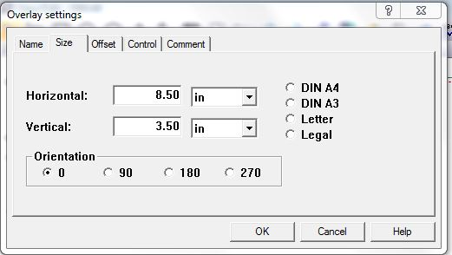

6.       Now it’s time to import the PSEG you created in step 3.

Click the place icon on the toolbar.



Select **Segment**.

In the place menu. Select **Append** and find the PSEG you created.

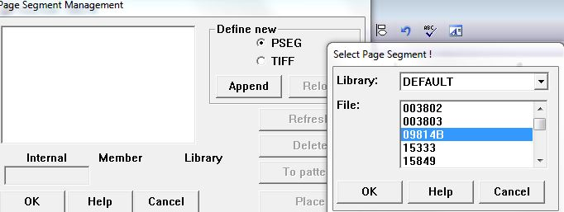

7.       Adjust the PSEG (you can click and drag the item on the overlay). It should be around center.

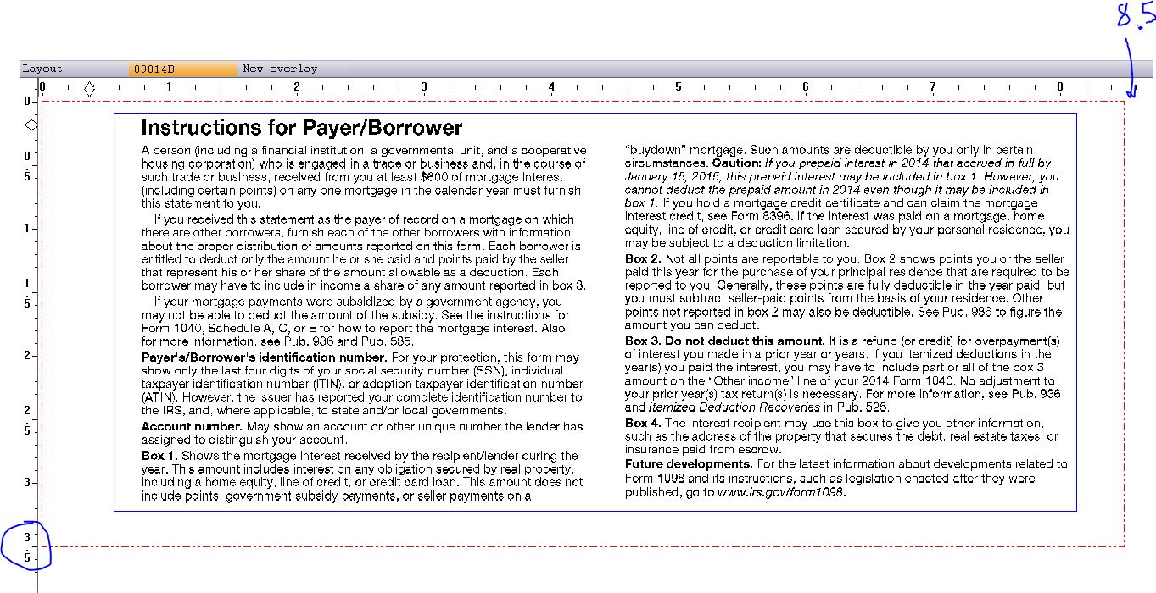

8.       Save the OGL. Then compile (File -> OGL Compiler) to create a OVL file.

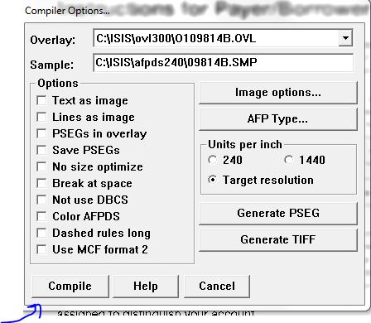

9.       Double check that the verbiage still matches the verbiage in the IRS PDF files. Nothing should be dropped. This includes quotes (‘) or (“) and bolding/italics.

10.    Send me 3 files for each form: PSEG, Overlay (OVL) and the OGL file.

Let me know if there are any questions.

I will give you more once these 4 are completed.

Please save these instructions under a tax tutorial folder so that all DSI members (current and future) will have a reference.

Thanks,

Kevin.

[KevinH.Yang@infoimageinc.com](mailto:KevinH.Yang@infoimageinc.com)