**Job Type ‘f’ full description by kevin:**

Hi Rony,

We need you to add in logic for e-statements.

I will provide you a brief walkthrough but feel free to ask me if you have additional questions.

First you will need to define the output individual AFPs.

1.       You will need to add in a &JOB_TYPE == ‘f’ option before you print the document. This is usually the first line of your print doc. In my example, this is the 5th line which is ok (as long as nothing is printed yet).

2.       You will need to change the output. Generally the majority of the cloned programs will still have the output ‘OUTFILENAME’. This is the case in the DFA you are using. We will borrow this definition since it’s not being used.

3.       You need to change the file path of the output. In my example, the file path and file name are changed together, this is fine. I am using the variable ‘OUTTEMP1’ to represent this. Our processing location is: **/&{D_DIR}/&{CID}/&{PREFIX}-indiv/** . The 3 variables mentioned are already defined in your DFA.

4.       You need to change the file name of the output. The format is: **&{PREFIX}_&{STATEMENT_DATE}_&{ACCOUNT_NUMBER}_&{SEQUENCE_NUMBER}_&{SEG_NUMBER}.afp .**Sequence number is the count of the documents starting from 1. You can use &SEQ_NUM but you will need to increment this variable before steps 1-4. &SEG_NUMBER is assigned from the environment, see 2nd picture.

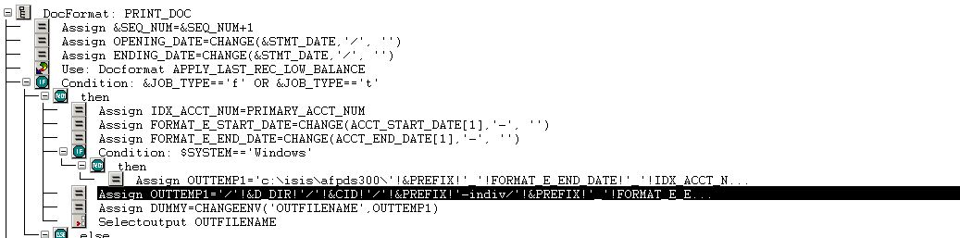

( this happens before anything is printed )

(this goes in _beforefirstdoc)

Next you will need to create an estatement index file.

1.       Create a condition for &JOB_TYPE == ‘f’ before you end your document. Make sure you have already called ‘End Group’.

2.       Write the index file to ‘ZIPFILE’. Your name for the writerecord can be anything. Delimiter is | (see example below).

3.       The first value is the same as the file name you defined in step 4 above.

4.       The 2nd value is the account number

5.       The 3rd value is the beginning date.

6.       The 4th value is the ending date.

7.       The 5th value is the image count.

8.       The 6th value is the name.

9.       All other values are optional. I don’t think you need anything else right now.

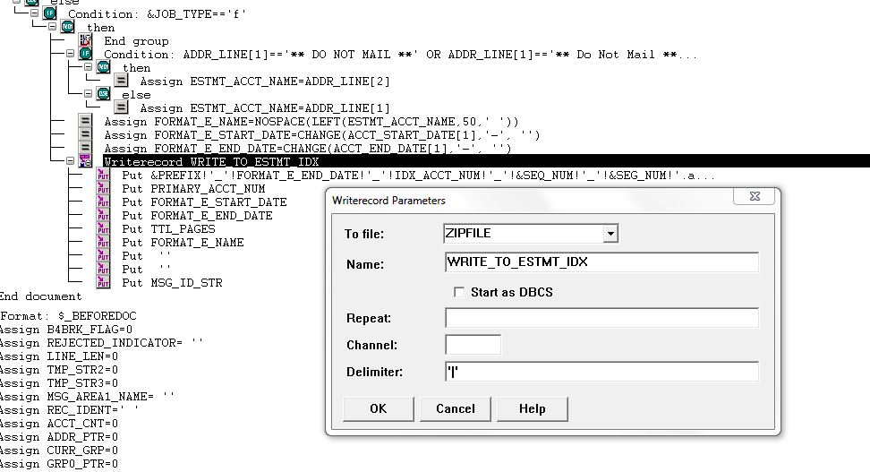

Please let me know if you have any questions.