**In beforefirst doc:**

Declare

&total_checks

&total_missing_checks

&total_missing_accounts

&missing_check_threshold=1( not sure if this is necessary)

Declare writerecord (CRIPPLE) 2nd image

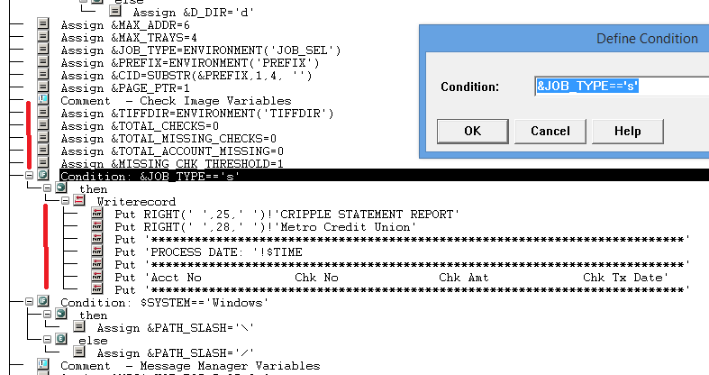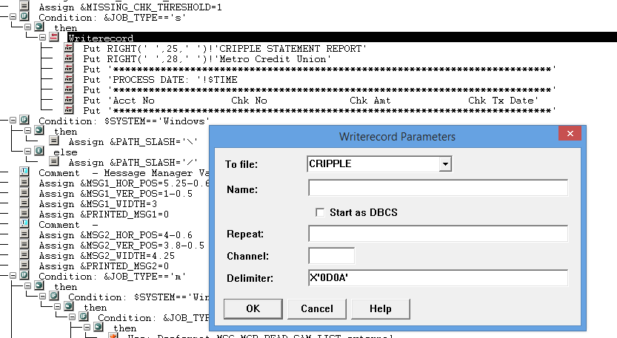

**In beforedoc:**

Declare &h_gutter(horizontal gap between checks)

Declare &v_gutter

Delare all margin

Declare account_checks which gonna total checks for current customer

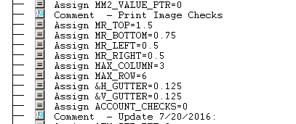

**Create check_image_array**

**<cid>_<account_no>_<chk_date>_<chk_amount_no_comma>_<chk_no>_<F or B>.tiff> | <account_no> | <chk_date> | < chk_amount_no_comma > | < chk_no >|<F or B>**

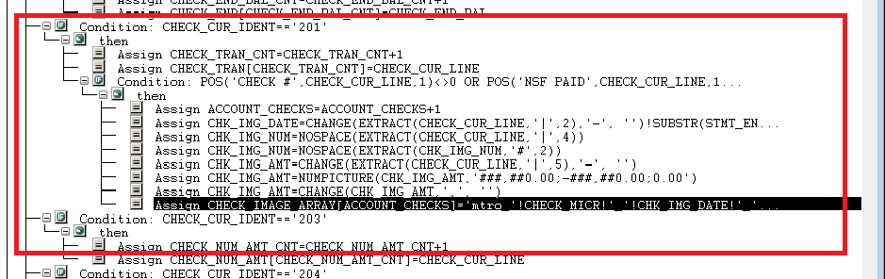

**Call external dfa:**

Call external dfa and create check index:

Index information:account no, check number, check date, amount

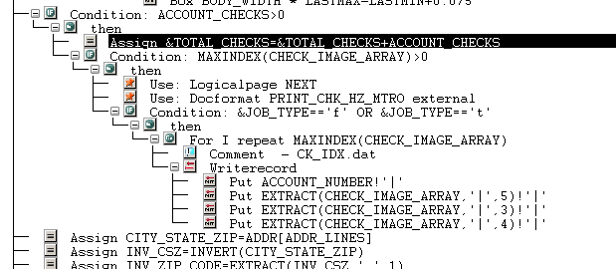

Afterlastdoc:

Calculate cripple percentage and insert info into cripple report

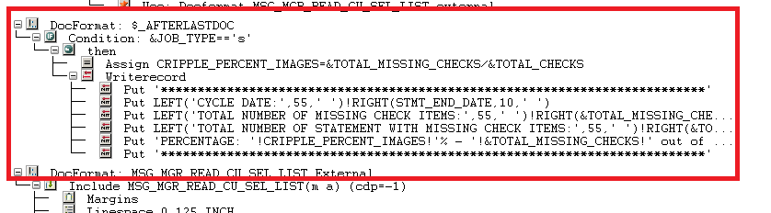

Beforefirstdoc:

/*Check Image Variables*/

&TIFFDIR = ENVIRONMENT('TIFFDIR') ;

&TOTAL_CHECKS = 0 ;

&TOTAL_MISSING_CHECKS = 0 ;

&TOTAL_ACCOUNT_MISSING = 0 ;

&MISSING_CHK_THRESHOLD = 1 ;

IF &JOB_TYPE=='s' ;

THEN ;

WRITERECORD TO CRIPPLE

DELIMITER X'0D0A' ;

PUT RIGHT(' ',25,' ')!'CRIPPLE STATEMENT REPORT' DELIMITED ;

PUT RIGHT(' ',28,' ')!'Metro Credit Union' DELIMITED ;

PUT '**********************************************************'

'****************' DELIMITED ;

PUT 'PROCESS DATE: '!$TIME DELIMITED ;

PUT '**********************************************************'

'****************' DELIMITED ;

PUT 'Acct No Chk No Chk Amt '

' Chk Tx Date' DELIMITED ;

PUT '**********************************************************'

'****************' DELIMITED ;

ENDIO;

ENDIF ;

Beforedoc:

/*Print Image Checks*/

MR_TOP = 1.5 ;

MR_BOTTOM = 0.75 ;

MR_LEFT = 0.5 ;

MR_RIGHT = 0.5 ;

MAX_COLUMN = 3 ;

MAX_ROW = 6 ;

&H_GUTTER = 0.125 ;

&V_GUTTER = 0.125 ;

ACCOUNT_CHECKS = 0 ;

**Build_check_image array:**

ACCOUNT_CHECKS = ACCOUNT_CHECKS+1 ;

CHK_IMG_DATE = CHANGE(EXTRACT(CHECK_CUR_LINE,'|',2),'-', '')!

SUBSTR(STMT_END_DATE,7,4, '') ;

CHK_IMG_NUM = NOSPACE(EXTRACT(CHECK_CUR_LINE,'|',4)) ;

CHK_IMG_NUM = NOSPACE(EXTRACT(CHK_IMG_NUM,'#',2)) ;

CHK_IMG_AMT = CHANGE(EXTRACT(CHECK_CUR_LINE,'|',5),'-', '') ;

CHK_IMG_AMT = NUMPICTURE(CHK_IMG_AMT,'###,##0.00;-###,##0.00;'

'0.00') ;

CHK_IMG_AMT = CHANGE(CHK_IMG_AMT,',', '') ;

CHECK_IMAGE_ARRAY[ACCOUNT_CHECKS] = 'mtro_'!CHECK_MICR!'_'!

CHK_IMG_DATE!'_'!CHK_IMG_AMT!'_'!CHK_IMG_NUM!'_F.tif'!'|'!

CHECK_MICR!'|'!CHK_IMG_DATE!'|'!CHK_IMG_AMT!'|'!CHK_IMG_NUM!''

**Call external dfa and build check index:**

IF ACCOUNT_CHECKS>0 ;

THEN ;

&TOTAL_CHECKS = &TOTAL_CHECKS+ACCOUNT_CHECKS ;

IF MAXINDEX(CHECK_IMAGE_ARRAY)>0 ;

THEN ;

USE

LOGICALPAGE NEXT ;

USE

FORMAT PRINT_CHK_HZ_MTRO EXTERNAL ;

IF &JOB_TYPE=='f' OR &JOB_TYPE=='t' ;

THEN ;

FOR I

REPEAT MAXINDEX(CHECK_IMAGE_ARRAY) ;

/*CK_IDX.dat*/

/*Account Number|*/

/*Check Number|*/

/*Check Date|*/

/*Check Amount|*/

WRITERECORD TO CK_IDX

DELIMITER '' ;

PUT ACCOUNT_NUMBER!'|' DELIMITED ;

PUT EXTRACT(CHECK_IMAGE_ARRAY,'|',5)!'|' DELIMITED ;

PUT EXTRACT(CHECK_IMAGE_ARRAY,'|',3)!'|' DELIMITED ;

PUT EXTRACT(CHECK_IMAGE_ARRAY,'|',4)!'|' DELIMITED ;

ENDIO;

ENDFOR ;

ENDIF ;

ENDIF ;

ENDIF ;

Afterlastdoc:

IF &JOB_TYPE=='s' ;

THEN ;

CRIPPLE_PERCENT_IMAGES = &TOTAL_MISSING_CHECKS/&TOTAL_CHECKS ;

WRITERECORD TO CRIPPLE

DELIMITER X'0D0A' ;

PUT '**********************************************************'

'****************' DELIMITED ;

PUT LEFT('CYCLE DATE:',55,' ')!RIGHT(STMT_END_DATE,10,' ')

DELIMITED ;

PUT LEFT('TOTAL NUMBER OF MISSING CHECK ITEMS:',55,' ')!

RIGHT(&TOTAL_MISSING_CHECKS,10,' ') DELIMITED ;

PUT LEFT('TOTAL NUMBER OF STATEMENT WITH MISSING CHECK ITEMS:',

55,' ')!RIGHT(&TOTAL_ACCOUNT_MISSING,10,' ') DELIMITED ;

PUT 'PERCENTAGE: '!CRIPPLE_PERCENT_IMAGES!'% - '!

&TOTAL_MISSING_CHECKS!' out of '!&TOTAL_CHECKS DELIMITED ;

PUT '**********************************************************'

'****************' DELIMITED ;

ENDIO;

ENDIF ;