Print Image

The data file pattern varies project to project. The customer statement is already presented in a manner that a single customer data extraction is the first agenda for print image data file.

A single customer data usually partitioned or anchored with a form feed (a special character) or client will let you know in the moc up. Sometimes you have to decide by communicating with client (or by common sense) which verbiage or character should be used as anchor.

Below a print image data file is presented where at first the focus is to extract just a single customer data.

Sample Project: EXBKLN11.prj

The data file snapshot in next page-

**Single customer data extraction:**

In print image data file, customer statements are presented in several pages. It can also fit in a single page. Here, for this data file new page starts when a line has “1” in column 1. You can say, this “1” is form feed for this data file.

In the snap of next page you will see blue marks that indicates new pages.

To extract single customer data we need to populate an array that holds those data that belongs to that particular customer.

We need unique properties of a customer that will be used as anchor. Here you can consider anchor as the verbiage or character that makes us stop extracting a single customer data.

A customer has unique account number. So we can use account number as anchor.

Now suppose the cursor is on the 1st line. We will start populating VAR array (that holds customer data) from the beginning of 1st line.

For this data file account number resides on line 6 position 1-20 according to moc. We will store this account number for first time and when we find another account number line in subsequent pages we will compare this account number with the previously stored account number. If it mismatches, a new customer is found. Otherwise continue populating customer data in array.

When account number mismatches, the cursor already in the next customer. So we have to keep track how many lines are read for next customer. Then we have to use “skip” command to move the cursor up so that in next doc the cursor starts in the expected line.

For better understanding see the “MAIN” docformat, that have single customer data extraction.

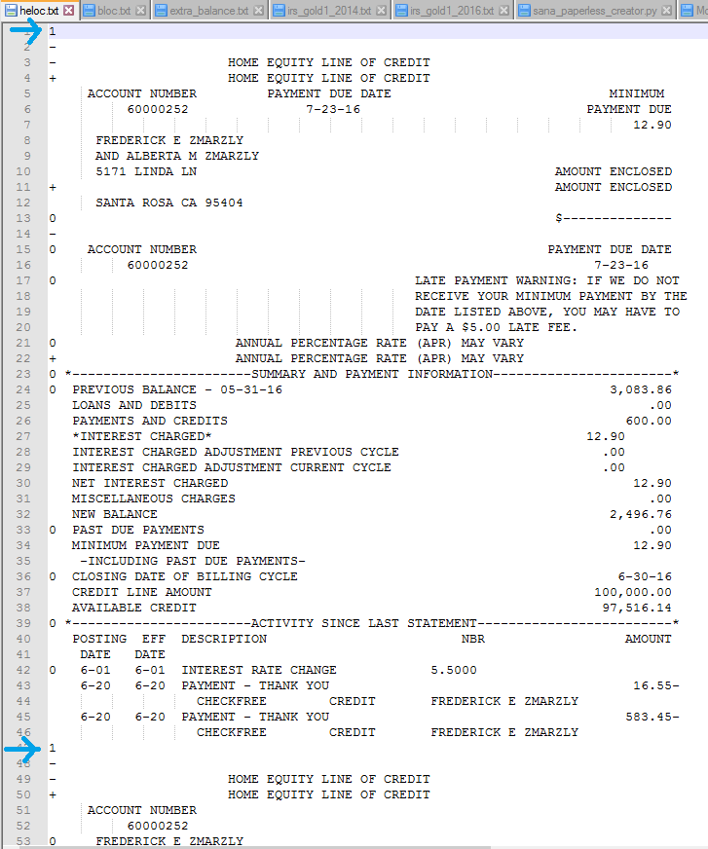

Once single customer information extraction is done (see VAR array), loop through the array to extract expected value. The moc will help to extract values.

You can see the data file for BFCULS21 project. It can be considered as an ideal print image data file. It has form feed.